Pathway B Level B2 Writing
Imaginative text- The Three Fairies
Student information | The student is in Year 3. They were born in Sudan and speak Arabic as their home language. They started school in Foundation in Victoria.
Task | The students were learning about fairytales. The class had read and examined models of narratives and the teacher had shown them how to plan for writing a narrative. The text was written independently and edited by a peer. The student’s plan, draft and final copy is provided.  The analysis is based on the student’s draft before correction.

1 Plan  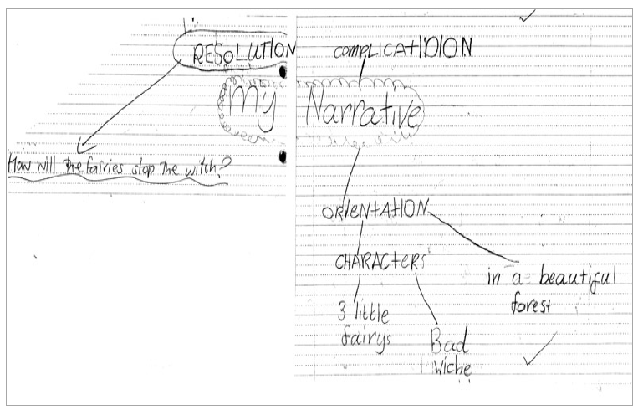 | 2 Draft  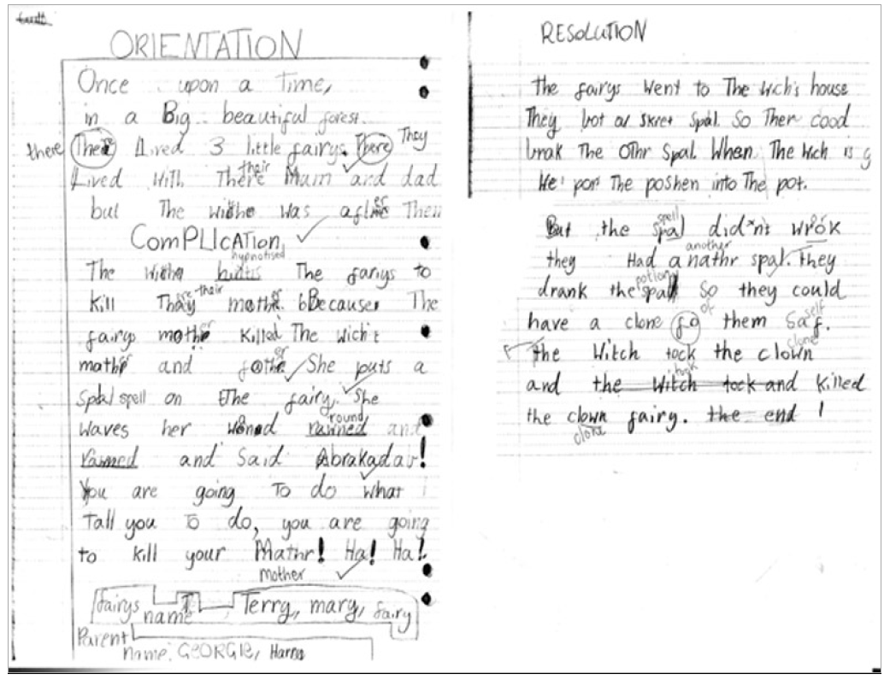

3 Final
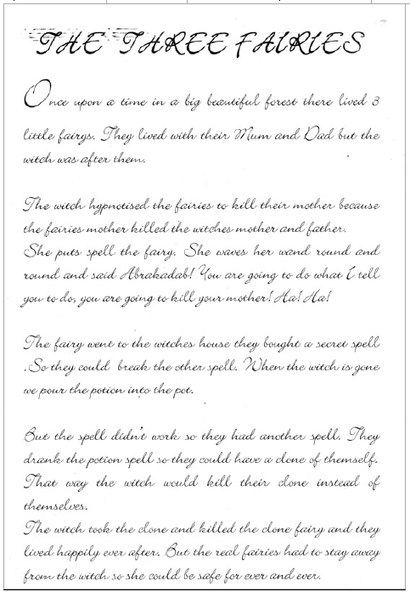

Section | Text |  | This sample of student work demonstrates that the student can:
1 Plan | Refer to work sample | - Write using language that is beginning to reflect the features of written language more than the features of spoken language (VCEALA379)  - Plan, with support, the format of a text according to its communicative purpose (VCEALA381)  - Plan before writing (VCEALA386)
2 Draft | ORIENTATION  Once upon a Time, in a Big beautiful forest The lived 3 little fairys. There Lived with There Mum and dad but The wiche was after Then  COMPLICATION  The wiche hintis The fariys to kill Thay mothr. Because The fairys mothr killed The wich’s mothr and fothr. She puts a spal on The fairy. She waves her woned rawned and rawned and Said Abrakadab!  You are going To do what Tall you To do, you are going to kill your mathr! Ha! Ha!  RESOLUTION  The fairys went to The wich’s house They bot a skret spal. So Ther cood brak The other Spal When The wich is g He por The Poshen into The pot.  But the Spal did’nt work they Had a nathr spal. they drank the spal so they could have a clone for them saf. The Witch tock the clown and the witch took and killed the clown fairy. The end | - Draft a piece of writing focusing on meaning, and revise after re-reading or discussion (VCEALA382)  - Use heading and text formats appropriate to the task (VCEALL387)  - Write simple paragraphs with a logical sequence of sentences (VCEALL388)  - Write sentences with some common errors (VCEALL390)  - Use a range of verb forms correctly (VCEALL391)  - Use simple extended descriptive phrases (VCEALL392)  - Use a number of common conjunctions to link ideas to create compound and complex sentences (VCEALL393)  - Select some descriptive vocabulary appropriate to context (VCEALL396)  - Spell frequently used words with common patterns with increased accuracy (VCEALL398)  - Experiment with complex punctuation (VCEALL399)
3 Final | Refer to work sample | - Use a small range of software functions to create simple digital texts (VCEALL400)

Overall, this student can also:  - Write creative texts based on models provided or studied in class (VCEALC378)  - Create a small range of texts based on modelling (VCEALA380) | Possible next steps for this student’s learning:  - Using time markers such as next or then to sequence events and create suspense (VCEALL389)  - With teacher support, identifying and correcting recurring spelling errors such as mothr/mother, fothr/father and a nthr/another (VCEALL398) (VCEALA384)  - Creating character profiles by brainstorming adjectives or adjectival phrases to describe the personalities and physical attributes of each character (VCEALC378)  - Incorporating characters, settings or events from stories in their culture in own writing (VCEALA385)
This student’s performance in this task suggests that they are working within the range of Level B2 in Writing. The assessing teacher will need to consider a range of student samples in order to determine whether this student is at the beginning of B2, consolidating B2 or at the B2 standard in Writing.  At beginning Level B2 students:  - write their own simple texts for different purposes in guided contexts  - draw on models provided and use repetitive structures in an attempt to write longer texts  - produce writing that is still reflective of their everyday spoken English and which includes marked EAL features (for example, sometimes leaving out articles and verb endings and making errors with verb tenses) as they become more confident in experimenting with oral and written English.  - attempt to spell new words using their own pronunciation and write familiar words accurately.  At consolidating Level B2 students:  - continue to write their own simple creative and informational texts for classroom purposes with support and they begin to include some details that help orient the reader  - produce writing that begins to include features of written-like language however it is still influenced mostly by their spoken language  - produce writing that shows varying control over grammatical features such as subject–verb agreement, tense, noun-pronoun reference and articles  - spell most monosyllabic and many high frequency words accurately.  At Level B2 Achievement Standard students:  - write for a range of purposes on familiar topics  - write simple, organised texts demonstrating a developing use of specific vocabulary and simple sentence structures  - demonstrate an understanding of the purposes of common text types, and their structures and features  - produce written texts that include basic information and detail  - use a number of common conjunctions to link ideas, using pronoun references with some noun–pronoun agreement, simple phrases to express basic comparisons, and some basic punctuation with consistency  - make plausible attempts to spell new words based on known English letter–sound relationships and use a range of strategies for spelling words, checking word lists or keeping personal dictionaries  - base new sentences on known sentence structures  - draw on a developing knowledge of the writing process to plan and write simple texts, and with support, redraft them  - use more advanced software functions to write, edit and present their texts. | Pathways and transitions considerations:  A Year 3 student working within the range of Level B2 in any one language mode is not ready to transition to the English curriculum regardless of their proficiency in the other two language modes. This student will continue on Pathway B of the EAL curriculum in all language modes.

