Pathway B Level B2 Writing
Informative text - Stop taking my things
Student information | The student was born in New Zealand and their home language is Somali. The student began school in New Zealand and came to Victoria in Year 2. The student is currently in Year 3.
Task | The class had been reading a story and retold a familiar story. The student was a very reluctant writer. In this task, the student used the ideas from the story as a stimulus for writing.
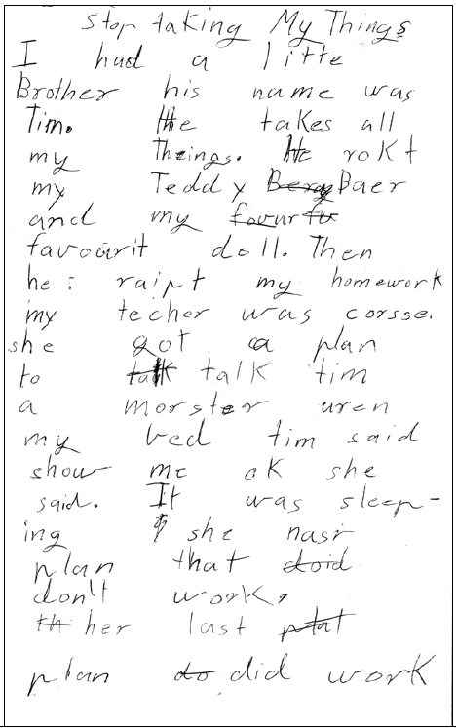

Section | Text | This sample of student work demonstrates that the student can:
1 | Stop taking My Things | - Use heading and text formats appropriate to the task (VCEALL387)
2 | I had a little Brother his name was Tim. He takes all my Theings. He rokt my Teddy Bera Baer and my favurfv favourit doll. Then he raipt my homework my techer was corsse. she got a plan to talk talk tim a morster uren my bed tim said show me ok she said. It was sleep-ing she nasr plan that doid don’t work.  th her last plal plan do did work | - Write creative texts based on models provided or studied in class (VCEALC378)  - Write sentences with some common errors (VCEALL390)  - Use a range of verb forms correctly (VCEALL391)  - Use simple time sequence markers and pronoun references to connect ideas in a text (VCEALL389)

This student’s performance in this task suggests that they are working within the range of Level B2 in Writing. The assessing teacher will need to consider a range of student samples in order to determine whether this student is at the beginning of B2, consolidating B2 or at the B2 standard in Writing.  At beginning Level B2 students:  - write their own simple texts for different purposes in guided contexts  - draw on models provided and use repetitive structures in an attempt to write longer texts  - produce writing that is still reflective of their everyday spoken English and which includes marked EAL features (for example, sometimes leaving out articles and verb endings and making errors with verb tenses) as they become more confident in experimenting with oral and written English  - attempt to spell new words using their own pronunciation and write familiar words accurately.  At consolidating Level B2 students:  - continue to write their own simple creative and informational texts for classroom purposes with support and they begin to include some details that help orient the reader  - produce writing that begins to include features of written-like language however it is still influenced mostly by their spoken language  - produce writing that shows varying control over grammatical features such as subject–verb agreement, tense, noun-pronoun reference and articles  - spell most monosyllabic and many high frequency words accurately.  At Level B2 Achievement Standard students:  - write for a range of purposes on familiar topics  - write simple, organised texts demonstrating a developing use of specific vocabulary and simple sentence structures  - demonstrate an understanding of the purposes of common text types, and their structures and features  - produce written texts that include basic information and detail  - use a number of common conjunctions to link ideas, using pronoun references with some noun–pronoun agreement, simple phrases to express basic comparisons, and some basic punctuation with consistency  - make plausible attempts to spell new words based on known English letter–sound relationships and use a range of strategies for spelling words, checking word lists or keeping personal dictionaries  - base new sentences on known sentence structures  - draw on a developing knowledge of the writing process to plan and write simple texts, and with support, redraft them  - use more advanced software functions to write, edit and present their texts. | Possible next steps for this student’s learning:  - Planning ideas and sequence of events in the story using a visual organiser before writing (VCEALA381)  - Examining and discussing the use of more complex punctuation in model texts, for example quotation marks, commas, exclamation marks and questions marks, then using them when writing a story (VCEALL399)  - Using a range of adjectives in the correct order to expand noun groups (VCEALL396)
Pathways and transitions considerations
A Year 3 student working within the range of Level B2 in any one language mode is not ready to transition to the English curriculum regardless of their proficiency in the other two language modes. This student will continue on Pathway B of the EAL curriculum in all language modes.

