Pathway B Level B2 Writing
Informative text - How telephones work
Student information | The student is born in Australia and speaks Hindi as their home language. The student began school in Foundation in Victoria and is currently in Year 3.
Task | The students completed a number of Science experiments in a unit of work about sound, including making a telephone from paper cups and strings. The students jointly constructed an explanation about one of the experiments with the teacher. After a discussion about how a telephone made from paper cups and string works, the students were asked to write their own explanation.  The analysis is based on the student’s writing before correction.
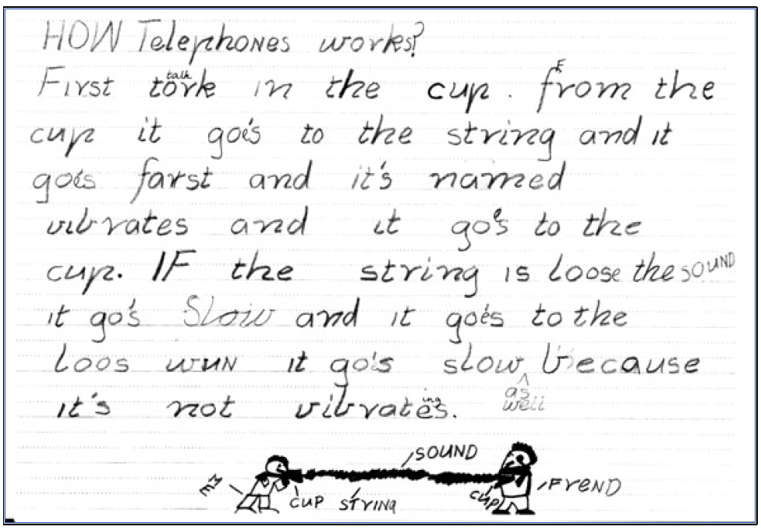
Section | Text |  | This sample of student work demonstrates that the student can:
1 | HOW TelephoNes works?  First tork in the cup. from the cup it goe’s to the string and it goes farst and it’s named vibrates and it gos to the cup. IF the string is loose the souND it go’s Slow and it goes to the loos wuN it go’s slow as well because it’s not vibrates. | - Write simple factual texts (VCEALC376)  - Add visual information to written texts (VCEALC375)  - Write using language that is beginning to reflect the features of written language more than the features of spoken language (VCEALA379)  - Use heading and text formats appropriate to the task (VCEALL387)  - Use simple time sequence markers and pronoun references to connect ideas in a text (VCEALL389)  - Write sentences with some common errors (VCEALL390)  - Experiment with complex punctuation (VCEALL399)  - Use modelled vocabulary appropriately (VCEALL395)

This student’s performance in this task suggests that they are working within the range of Level B2 in Writing. The assessing teacher will need to consider a range of student samples in order to determine whether this student is at the beginning of B2, consolidating B2 or at the B2 standard in Writing.  At beginning Level B2 students:  - write their own simple texts for different purposes in guided contexts  - draw on models provided and use repetitive structures in an attempt to write longer texts  - produce writing that is still reflective of their everyday spoken English and which includes marked EAL features (for example, sometimes leaving out articles and verb endings and making errors with verb tenses) as they become more confident in experimenting with oral and written English  - attempt to spell new words using their own pronunciation and write familiar words accurately.  At consolidating Level B2 students:  - continue to write their own simple creative and informational texts for classroom purposes with support and they begin to include some details that help orient the reader  - produce writing that begins to include features of written-like language however it is still influenced mostly by their spoken language  - produce writing that shows varying control over grammatical features such as subject–verb agreement, tense, noun-pronoun reference and articles  - spell most monosyllabic and many high frequency words accurately.  At Level B2 Achievement Standard students:  - write for a range of purposes on familiar topics  - write simple, organised texts demonstrating a developing use of specific vocabulary and simple sentence structures  - demonstrate an understanding of the purposes of common text types, and their structures and features  - produce written texts that include basic information and detail  - use a number of common conjunctions to link ideas, using pronoun references with some noun–pronoun agreement, simple phrases to express basic comparisons, and some basic punctuation with consistency  - make plausible attempts to spell new words based on known English letter–sound relationships and use a range of strategies for spelling words, checking word lists or keeping personal dictionaries  - base new sentences on known sentence structures  - draw on a developing knowledge of the writing process to plan and write simple texts, and with support, redraft them  - use more advanced software functions to write, edit and present their texts. | Possible next steps for this student’s learning:  - Read and rearrange cut up sentences to explain how telephone works (VCEALL389)  - Editing the writing and ensuring clearer noun-pronoun reference, independently or with a same language peer using home language (VCEALA383)  - Creating a list of informal, everyday vocabulary and subject-specific vocabulary, for example, the sound goes versus the sound travels, including a translation into home language (VCEALA384)
Pathways and transitions considerations:
A Year 3 student working within the range of Level B2 in any one language mode is not ready to transition to the English curriculum regardless of their proficiency in the other two language modes. This student will continue on Pathway B of the EAL curriculum in all language modes.

