Pathway B Level B1 Writing
Informative text- Sentences about animals
Student information | The student is in Year 3. He was born in Japan and speaks Japanese as his home language. He has had age-equivalent schooling in Japan.
Task | The students were learning about animals. They read model texts with the teacher and and jointly constructed information reports before writing their own. Students were asked to write sentences about different animals. They were allowed to use word lists and pictures of animals with labels.  The analysis is based on the student’s writing before correction.

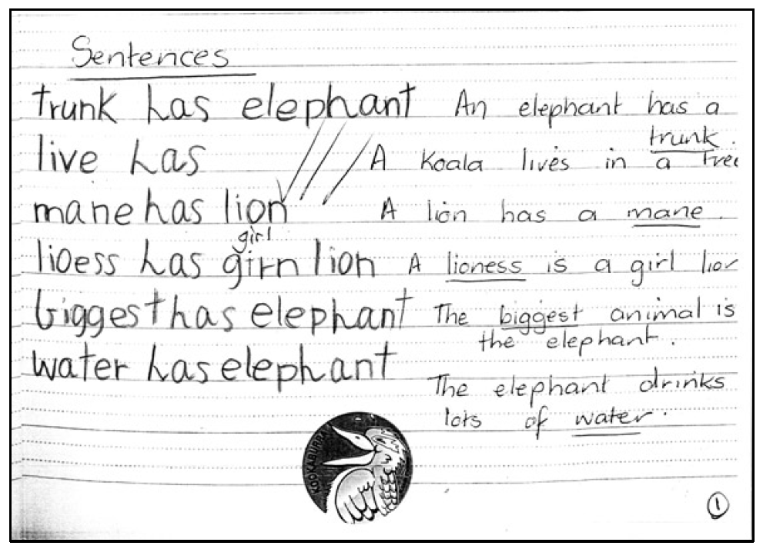

Section | Text |  | This sample of student work demonstrates that the student can:
1 | trunk has elephant  live has  mane has lion  lioess has girn lion  biggest has elephant  water has elephant | - Translate literally from home language to English (VCEALA305) *draws on language structure of home language, potentially object-verb-subject structure  - Sequence ideas simply, using short sentences or statements (VCEALL309)  - Incorporate learnt vocabulary into writing (VCEALL315) *uses topic-specific vocabulary and high-frequency word has consistently  - Spell accurately common words encountered in the classroom (VCEALL318)  - Write simple factual texts using print and computers or other digital devices for a variety of classroom purposes (VCEALC296)

This student’s performance in this task suggests that he is working within the range of Leve B1 in Writing. The assessing teacher will need to consider a range of student samples in order to determine whether this student is at the beginning of B1, consolidating B1 or at the B1 standard in Writing  At beginning Level B1 students:  - use drawing as a means of expression  - attempt to copy writing from other sources, for example environmental print, other students, the teacher’s model  - will observe shared writing tasks, watching as the teacher writes but most likely will not contribute because of their limited English  - may exhibit limited concentration during shared writing tasks  - talk about their writing and pictures drawing on their oral English language and may use their home language with same language peers or bilingual teacher.  At consolidating Level B1 students:  - begin to form letters and place text appropriately  - communicate their ideas and experiences simply through writing, drawing, copied or dictated texts  - demonstrate knowledge of some sound–letter relationships, and show evidence of some planning  - produce writing that reflects their use of oral structures  - demonstrate an early awareness that written texts in English are presented according to certain conventions which change according to context and purpose  - write or draw for specific audiences  - write simple sequenced descriptions, recounts, and procedures, following models  - link ideas using common conjunctions and show awareness of the need for basic punctuation  - model their writing on shared writing activities and published texts, and use some basic strategies, such as copying words or phrases from lists, using illustrations, and asking how to write a word  - contribute to whole-class or small-group shared writing activities.  At Level B1 Achievement Standard students:  - write and present simple texts for a variety of basic classroom and personal purposes  - communicate familiar ideas, events and experiences, writing simple narratives, recounts, descriptions and reports, with support  - use some of the basic structures and features common to these text types, demonstrating their beginning awareness that purpose influences the way texts are written and presented  - produce written texts that incorporate the basic grammatical features of their spoken English  - spell some common words correctly and their attempts at spelling show a beginning understanding of the patterns of English letter–sound relationships  - use some simple strategies for spelling words, such as checking word lists or books  - plan and edit their texts, providing additional information through visual images, with support  - use the basic features of computer software applications to write and present their texts. | Possible next steps for this student’s learning:  - Using simple sentence starters to write, such as The elephant has… or The elephant is… (VCEALL314) (VCEALL311)  - Unjumbling and reordering simple subject-verb-object sentences (VCEALL310)  - Planning and constructing an extended information text on one animal with a peer or teacher (VCEALL317)
Pathways and transitions considerations:
A Year 3 student working within the range of Level B1 in any one language mode is not ready to transition to the English curriculum regardless of their proficiency in the other two language modes. This student will continue on Pathway B of the EAL curriculum in all language modes.

