Pathway B Level B1 Writing
Persuasive text- Melbourne is the best city
Student information | The student is 9 years old and in Year 4. He was born in China and speaks Mandarin. He has had age-equivalent schooling and is able to read and write in his home language. He has been studying in an English language school for over four terms due to the impact from the COVID-19 pandemic in 2020. His parents have very little English and therefore are unable to provide a lot of support at home.
Task | Students have been learning about Australia including the states and territories, capital cities and places of interest. Students also looked at voicing opinions (agree and disagree) and supporting their opinions with reasons. For this task, students were given the topic as their opinion and asked to write a text to persuade their friends or family to come and visit Melbourne. The class had explored the structure of a persuasive text prior to writing. Key vocabulary were provided on flash cards with pictures.  The student completed the task independently using the flashcards and text structure discussed.  The analysis is based on the student’s writing before correction.

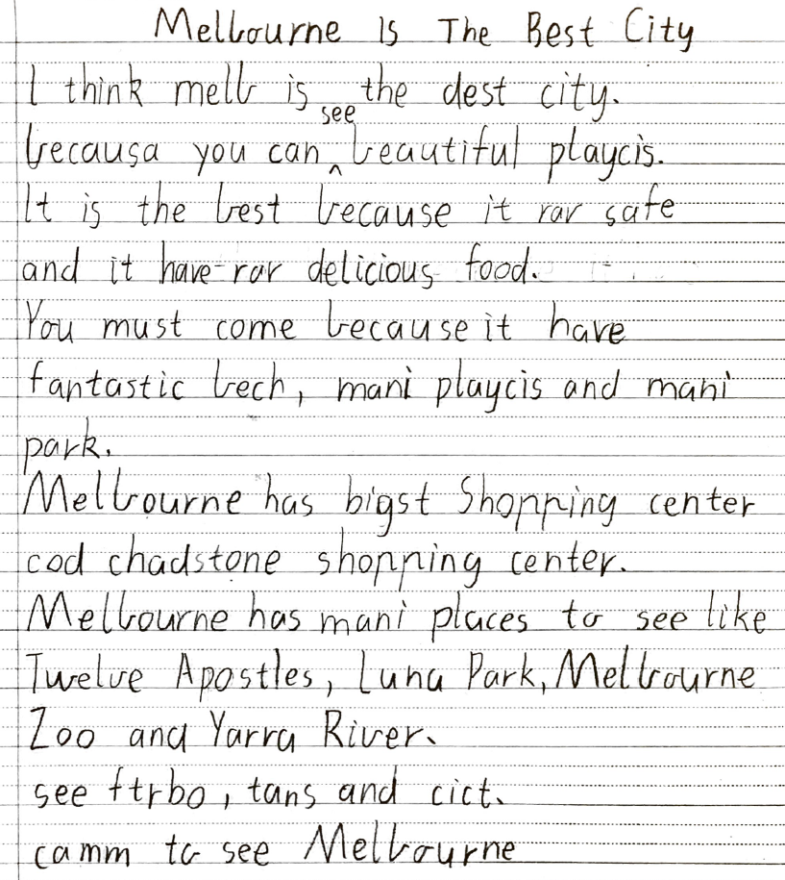
Section | Text |  | This sample of student work demonstrates that the student can:
1 | Melbourne Is The Best City  I think melb is the dest city.  becausa you can see beautiful playcis.  It is the best because it rar safe and it have rar delicious food.  You must come because it have fantastic bech, mani playcis and mani park.  Melbourne has bigst Shopping center cod chadstone shopping center.  Melbourne has mani places to see like Twelve Apostles, Luna Park, Melbourne Zoo and Yarra River.  see ftrbo, tans and cict.  camm to see Melbourne | - Create short, simple texts for particular purposes, with some support and modelling (VCEALA300)  - Organise some subject matter and write according to the structure of the text type, using modelled forms and repetitive patterns (VCEALL307)  - Use a small range of simple descriptive phrases (VCEALL312) *uses simple noun phrases such as delicious food, beautiful playcis, bigst Shopping center, fantastic bech  - Use some conjunctions to connect ideas within a sentence (VCEALL313) *uses because through modelled sentence structures  - Use formulaic structures (VCEALL314)  - Spell accurately common words encountered in the classroom (VCEALL318)

Overall, this student can also:  - Write simple imaginative or personal texts modelled on familiar forms and repetitive patterns (VCEALC298)  - Engage with a range of writing tasks (VCEALA306) | Possible next steps for this student’s learning:  - Proofreading and editing own work for spelling mistakes and/or errors, with teacher support (VCEALA302)  - Participating in a range of spelling activities focused on common letter patterns based on words that are commonly misspelt (VCEALA304)  - Using the TEEL (Topic sentence, Explanation, Evidence and Linking sentence) framework to plan the main ideas for writing, then using a writing template with the same framework to structure own writing (VCEALL308)  - Using a checklist to support consistent use of punctuation such as capital letters for proper nouns and at the start of a sentence, and full stops at the end (VCEALL319)
This student’s performance in this task suggests that he is working within the range of Level B1 in Writing. The assessing teacher will need to consider a range of student samples in order to determine whether this student is at the beginning of B1, consolidating B1 or at the B1 standard in Writing.  At beginning Level B1 students:  - use drawing as a means of expression  - attempt to copy writing from other sources, for example environmental print, other students, the teacher’s model  - will observe shared writing tasks, watching as the teacher writes but most likely will not contribute because of their limited English  - may exhibit limited concentration during shared writing tasks  - talk about their writing and pictures drawing on their oral English language and may use their home language with same language peers or bilingual teacher.  At consolidating Level B1 students:  - begin to form letters and place text appropriately  - communicate their ideas and experiences simply through writing, drawing, copied or dictated texts  - demonstrate knowledge of some sound–letter relationships, and show evidence of some planning  - produce writing that reflects their use of oral structures  - demonstrate an early awareness that written texts in English are presented according to certain conventions which change according to context and purpose  - write or draw for specific audiences  - write simple sequenced descriptions, recounts, and procedures, following models  - link ideas using common conjunctions and show awareness of the need for basic punctuation  - model their writing on shared writing activities and published texts, and use some basic strategies, such as copying words or phrases from lists, using illustrations, and asking how to write a word  - contribute to whole-class or small-group shared writing activities.  At Level B1 Achievement Standard students:  - write and present simple texts for a variety of basic classroom and personal purposes  - communicate familiar ideas, events and experiences, writing simple narratives, recounts, descriptions and reports, with support  - use some of the basic structures and features common to these text types, demonstrating their beginning awareness that purpose influences the way texts are written and presented  - produce written texts that incorporate the basic grammatical features of their spoken English  - spell some common words correctly and their attempts at spelling show a beginning understanding of the patterns of English letter–sound relationships  - use some simple strategies for spelling words, such as checking word lists or books  - plan and edit their texts, providing additional information through visual images, with support  - use the basic features of computer software applications to write and present their texts. | Pathways and transitions considerations:  A Year 4 student working within the range of Level B1 in any one language mode is not ready to transition to the English curriculum regardless of their proficiency in the other two language modes. This student will continue on Pathway B of the EAL curriculum in all language modes.

