Pathway A Level A2 Writing
Informative text - Recount of farm excursion
Student information | This student is in Foundation. They were born in Thailand and speak Thai at home. They began Foundation in Victoria.
Task | The student has been on an excursion to a farm as part of their unit of work. The teacher modelled recounts through shared writing, and also modelled how to develop a plan for writing. There were word lists available for reference in the classroom. The analysis is based on the student’s writing before correction.

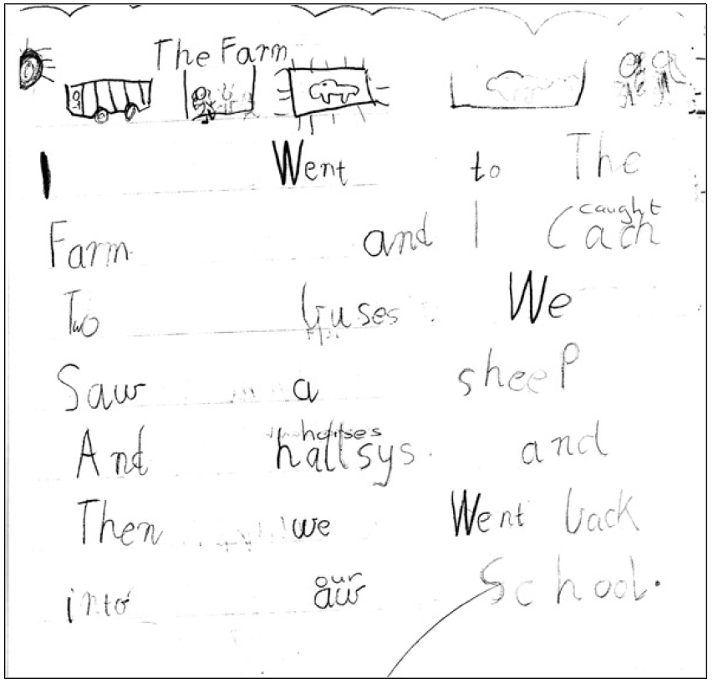

Section | Transcript | This sample of student work demonstrates that the student can:
1 | The Farm | - Adjust size of writing, colour, layout and choice of media to support meaning (VCEALL160)
2 | I Went to The Farm and I cach Two buses  We Saw a sheep And hallsys.  and Then we Went back into aw School. | - Use a variety of simple text structures (VCEALL149)  - Use a small range of basic verb forms accurately (VCEALL154)  - Use high-frequency words encountered in classroom activities (VCEALL155)  - Write legibly (VCEALL157)  - Use some punctuation consistently (VCEALL158)  - Spell with accuracy familiar words and words with common letter patterns (VCEALL159)

Overall, this student can also:  - Write a small range of everyday texts and personal texts (VCEALC138)  - Write simple sentences with minimal reliance on copying (VCEALA140)  - Identify text type appropriate to the purpose (VCEALA141)  - Demonstrate understanding that handwritten texts usually need to be planned, edited and presented (VCEALA143)  - Write sustained texts using sentences based on simple repetitive, modelled patterns (VCEALL151) | Possible next steps for this student’s learning:  - Including personal details in recount such as own thoughts, observations and feelings about the experience (VCEALC137) (VCEALL151)  - Using adjectives to describe the farm animals (VCEALL153)  - Expanding their repertoire of regular and irregular past tense verbs (VCEALL154)  - Using capital and lower-case letters appropriately in sentences (VCEALL157)  - Using full stops at the end of the sentences (VCEALL158)
This student’s performance in this task suggests that they are working within the range of Level A2 in Writing. The assessing teacher will need to consider a range of student samples in order to determine whether this student is at the beginning of A2, consolidating A2 or at the A2 standard in Writing.  At beginning Level A2 students:  - are beginning to write their own very short, simple texts  - write texts using sentence structures based on oral structures and very simple repetitive texts  - write with less need for teacher transcription as they develop an ability to use some basic conventions of writing in English  - draw heavily on phonetic strategies during their attempts at spelling.  At consolidating Level A2 students:  - can develop a simple plan for writing using pictures or drawings  - are beginning to write texts about familiar topics and experiences which include related ideas  - are becoming more aware of audience and purpose, but still require significant teacher  - support and modelling and environmental print  - use invented spelling and write some words spelt conventionally from a known spelling vocabulary.  At Level A2 Achievement Standard students:  - communicate in an expanding range of predictable social and learning situations  - express ideas and identify key points of information in classroom discussions about familiar topics, and in new topics when they are well supported by visual material, an appropriate pace of delivery, and discussion that links their prior knowledge to the new context  - follow a short sequence of instructions related to classroom procedures and learning activities  - negotiate familiar social and learning situations, using English appropriate to the situation  - adjust their speech choices in response to audience and topic  - combine known conversational formulas and vocabulary, including some from texts read in class, and apply some grammatical rules to make original utterances of varying grammatical accuracy  - sustain communication by negotiating turn-taking and by using strategies such as asking a speaker to repeat or to speak slowly, or asking what a word means. | Pathways and transitions advice:  A Foundation student who is working within the range of A2 in any one language mode is not ready to transition to the English curriculum regardless of their proficiency in the other two language modes. This student will continue on Pathway A of the EAL curriculum in all language modes.  A Foundation student should consistently demonstrate the final achievement standard in Pathway A (Level A2) in all three language modes before they transition to the English curriculum.  They will need to be equally capable across all three language modes to be able to meet the learning expectations in the English curriculum at the level taught to their mainstream peers, and without substantial language support.  They will need to be sufficiently proficient in understanding and using the academic language across the learning areas to participate in learning activities across the Victorian curriculum.  They will also need to be able to understand and use the academic English of the curriculum in subsequent years without substantial language support, when the cognitive and linguistic demands of the Victorian curriculum increase, for example in Years 3 and 4.

