Pathway A Level A2 Writing
Imaginative text- Lisa and Matt’s island adventure
Student information | The student was born in Australia and speaks Somali as their home language. They began Foundation in Victoria and are currently in Year 2.
Task | The students have been learning about narratives and have read a range of texts in the genre. They have been learning explicitly about the structure and linguistic features of a narrative and have participated in joint constructions of narratives with the teacher. The teacher has modelled how to develop a writing plan for narratives.  The analysis is based on the student’s draft before correction.

1 Plan |  | 2 Draft |  |  | 3 Final
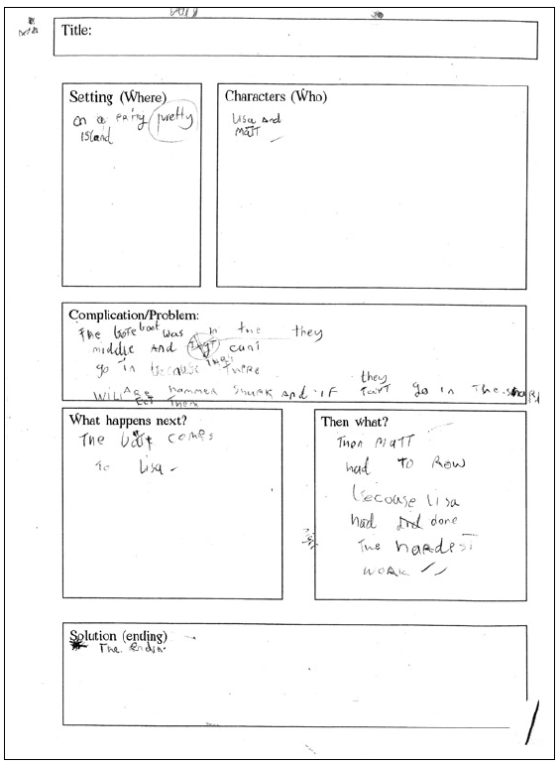 |  | 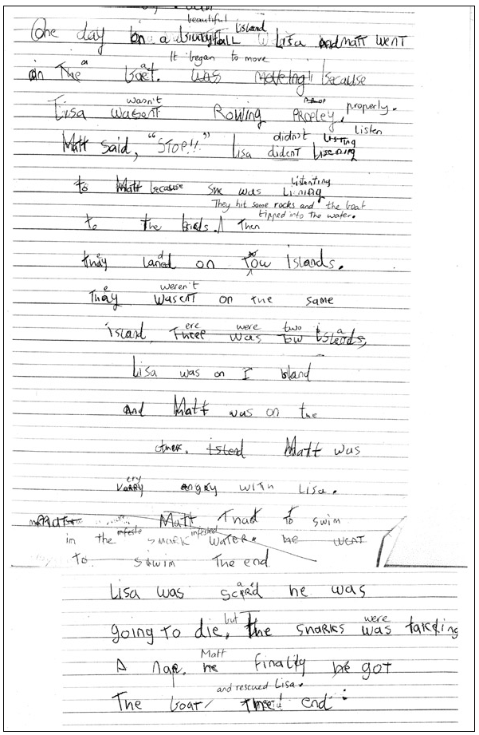 |  |  | 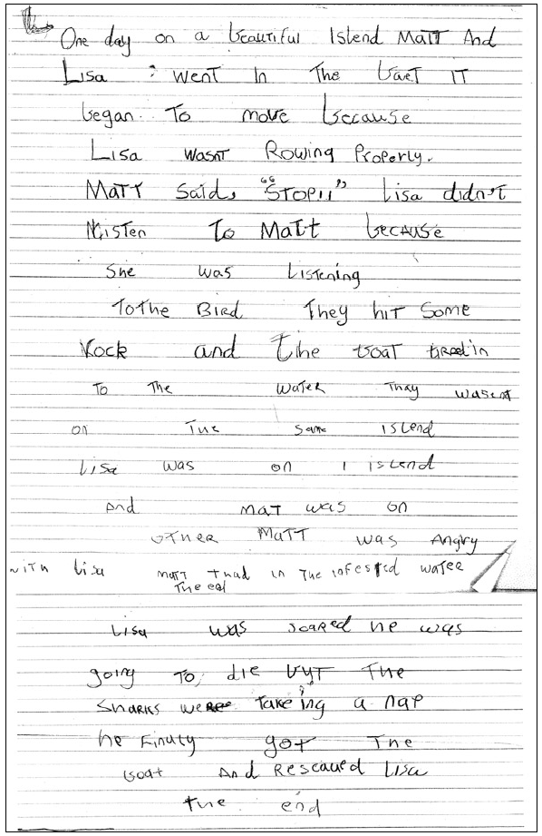
Section | Text |  |  | This sample of student work demonstrates that the student can:
1 Plan | Refer to the screenshot. |  |  | - Demonstrate understanding that handwritten texts usually need to be planned, edited and presented (VCEALA143)  - Make a simple plan before writing (VCEALL150)
2 Draft | one day on a biutyfall Lisa and Matt went in the boet was moveing because Lisa wasent Rowing PRoPley.  matt said, “STOP!!” Lisa dident lisening to matt because sne was listenting to the birds. Then thay laned on tow islands.  Thay wasent on the same island. Theee was tow islands Lisa was on 1 island and matt was on the other islend matt was vary angey with Lisa.  Matt thaot to swim in the shark water. he went to swim the end  Lisa was scerd he was going to die. The sharks was takeing A nap he finaley he got The boat  The end |  | - Show interest in patterns of spelling (VCEALA147)  - Use a variety of simple text structures (VCEALL149)  - Write sustained texts using sentences based on simple repetitive, modelled patterns (VCEALL151)  - Write sentences and phrases that reflect simple written-like structures (VCEALL152)  - Use a small range of basic verb forms accurately (VCEALL154)  - Use high-frequency words encountered in classroom activities (VCEALL155)  - Spell with accuracy familiar words and words with common letter patterns (VCEALL159) *uses knowledge of letter sounds to spell unfamiliar words
3 Final | Refer to the screenshot.

This student’s performance in this task suggests that they are working within the range of Level A2 in Writing. The assessing teacher will need to consider a range of student samples in order to determine whether this student is at the beginning of A2, consolidating A2 or at the A2 standard in Writing.  At beginning Level A2, students:  - are beginning to write their own very short, simple texts  - write texts using sentence structures based on oral structures and very simple repetitive texts  - write with less need for teacher transcription as they develop an ability to use some basic conventions of writing in English  - draw heavily on phonetic strategies during their attempts at spelling.  At consolidating Level A2, students:  - can develop a simple plan for writing using pictures or drawings  - are beginning to write texts about familiar topics and experiences which include related ideas  - are becoming more aware of audience and purpose, but still require significant teacher  - support and modelling and environmental print  - use invented spelling and write some words spelt conventionally from a known spelling vocabulary.  At Level A2 Achievement Standard, students:  - communicate ideas, events and experiences through simple texts based on familiar spoken and written language  - write for a variety of personal and classroom purposes, using known and modelled structures and features  - write everyday texts and simple stories, recounts and factual texts based on their own and shared class experiences  - use their developing oral base and reading repertoire when writing their own texts  - write texts using simple but coherently linked sentences, basic structures and well-known vocabulary  - use some common irregular past tense verbs correctly, and link clauses using basic conjunctions and connectives  - attempt to spell new words, based on known spelling patterns and base words  - use vocabulary lists, modelled texts and familiar books to find how to write new words  - write letters legibly and make some changes to their texts when editing  - use advanced features of software applications to write and present their texts. | Possible next steps for this student’s learning:  - Publishing their writing according to writing conventions, for example, writing on the lines and aligning text to the left (VCEALA144)  - Using adjectives and expanded noun groups to elaborate on characters and setting (VCEALL153)  - Using capital letters and full stops appropriately (VCEALL158)  - Understanding the meaning of different common punctuations and using them consistently in writing (VCEALL158)  - Learning about and applying spelling patterns when writing (VCEALL159)
Pathways and transitions considerations:
A Year 2 student who is working within the range of A2 in any one language mode is not ready to transition to the English curriculum regardless of their proficiency in the other two language modes. This student will continue on Pathway A of the EAL curriculum in all language modes.
A Year 2 student should consistently demonstrate the final achievement standard in Pathway A (Level A2) in all three language modes before they transition to the English curriculum.
They will need to be equally capable across all three language modes to be able to meet the learning expectations in the English curriculum at the level taught to their mainstream peers, and without substantial language support.
They will need to be sufficiently proficient in understanding and using the academic language across the learning areas to participate in learning activities across the Victorian curriculum.
They will also need to be able to understand and use the academic English of the curriculum in subsequent years without substantial language support, when the cognitive and linguistic demands of the Victorian curriculum increase, for example in Year 3 and 4.
The teacher may also exercise their professional judgement to place the student on Pathway B of the EAL curriculum rather than transitioning them to the English curriculum. The teacher reviews the student’s language proficiency across the Victorian curriculum learning areas and determine where the student is best placed on Pathway B in each of the three language modes. The student will then start on Pathway B of the EAL curriculum in all language modes.

