AT A GLANCE
English as an Additional Language (EAL) reporting resource Pathway A – Level A1 – Speaking and listening
The English as an Additional Language (EAL) reporting resource is designed to complement and support the Victorian Curriculum F-10 EAL.
A short introduction explains the purpose of the reporting resource.
The pathway, level and mode are indicated at the top of the page and in the headings of the table.
As EAL students may not reach the achievement standard described by the curriculum for more than one reporting cycle, teachers can demonstrate that during this time students are making satisfactory progress in learning English as an additional language. The reporting resource allows teachers to understand and report on the language and learning progress of EAL students before they reach the achievement standards outlined in the EAL curriculum.
Pathway A comprises two levels – A1 and A2. EAL learners at Pathway A are in the early stages of their school lives as they begin learning in an English immersion environment.
- The BEGINNING and CONSOLIDATING levels describe the progress of EAL learners before they reach the achievement standards.

- Dot points describe behavioural and linguistic performances that can be observed and monitored in the classroom. They are not hierarchical and should not be used as a checklist.

- The beginning and consolidating levels provide an opportunity to understand EAL learner progress and demonstrate student achievement when reporting to parents and carers.

- These levels also provide a richer data set for schools and teachers to use when reviewing EAL student achievement data for planning and analysis purposes.
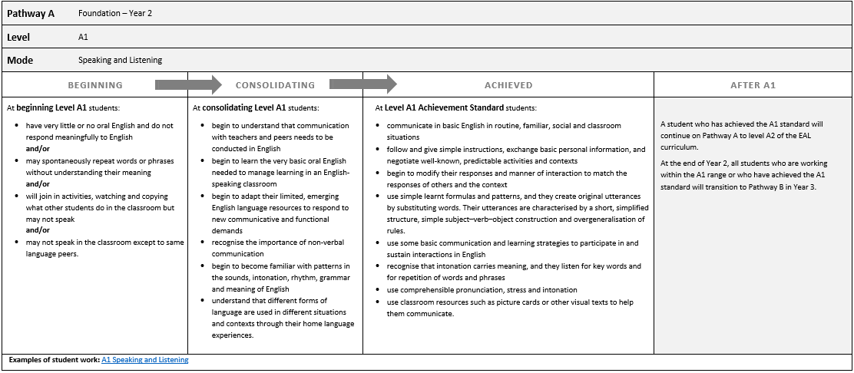
The AFTER section provides advice for teachers about transitions and pathways for EAL learners who have achieved this standard.

A link to further information about pathways and transitions is provided.

A link to annotated work samples for students working within the range of this level provides teachers with a contextual understanding of what these levels may look like.

A link to further support material for assessment and reporting is provided.

The ACHIEVED section reproduces the Achievement Standard of the Victorian Curriculum F-10 EAL for this level.

A link to the curriculum website is provided.

To view the content descriptions, elaborations and the achievement standards for the A1 and A2 levels, visit the VCAA website – Pathway A: early immersion
For support with teaching and assessing EAL learners, see Tools to Enhance Assessment Literacy for Teachers of EAL (TEAL) online assessment resource centre
For examples of student pathways and transitions for the EAL curriculum, see: Pathways and Transitions

