Using Metacognitive strategies to support student self-regulation and empowerment
‘Where students have developed strong metacognitive skills, we see them evaluating and sharing evidence about their thinking.’
Dean Bush, Assistant Principal, Seymour College

OVERVIEW
Teaching metacognitive strategies can greatly enhance learning for all students in all subject areas.
This professional practice note provides advice to support school leaders and teachers in the integration of metacognitive strategies in everyday teaching.
In addition, it includes examples of how schools can implement metacognitive strategies to assist students to build self-regulation and develop a strong sense of agency in their learning.
See: High Impact Teaching Strategies – Metacognitive Strategies.

Why do teachers use metacognitive strategies?
‘Metacognitive strategies empower students to think about their own thinking. Awareness of the learning process enhances control over their own learning. It also enhances personal capacity for self-regulation and managing one’s own motivation for learning. Metacognitive activities can include planning how to approach learning tasks, identifying appropriate strategies to complete a task, evaluating progress, and monitoring comprehension.’
High Impact Teaching Strategies
Teaching students metacognitive strategies offers students tools to “drive their brains”.

Who benefits from the use of METACOGNITIVE STRATEGIES?
‘Explicit attention to and application of thinking skills enables students to develop an increasingly sophisticated understanding of the processes they can employ whenever they encounter both the familiar and unfamiliar, to break ineffective habits and build on successful ones, building a capacity to manage their thinking.’
Victorian Curriculum and Assessment Authority
All students, regardless of their age, background or achievement level, benefit from the use of metacognitive strategies. This journey, which starts in early childhood and continues through primary school, secondary school and beyond, is mapped in the Critical and Creative Thinking capability of the Victorian Curriculum F-10 (the Curriculum).
The sophistication of the metacognitive skills students can master increases as they progress through education. Students can start with the ability to monitor progress towards the achievement of learning goals negotiated with the teacher. This negotiation and monitoring plays an important role in the learning of all students, regardless of their background or previous achievement.
Metacognitive strategies can also be differentiated to bolster the achievement of specific cohorts of students. They can be used to extend the learning of gifted and high achieving students, as well as a support strategy for low achieving students.

What is metacognition and how does it develop?
As recognised in the Capabilities of Curriculum, metacognition develops best when addressed in context and integrated in everyday teaching. This means that all teachers can assist students to concurrently learn and develop:
- subject matter knowledge (Knowledge), which for example can be knowledge of a novel recently read in class and the specific terminology used in text analysis
- subject matter skills and abilities (Skills), which can include the strategies and skills needed to conduct a character analysis and how to structure an essay
- metacognitive knowledge, skills and abilities (Metacognition), which includes an understanding of and the ability to plan for, monitor and evaluate the use of knowledge and skills; for example, how to interpret an essay question, how to identify and use the information and strategies most relevant to the question, and how to evaluate the end product.
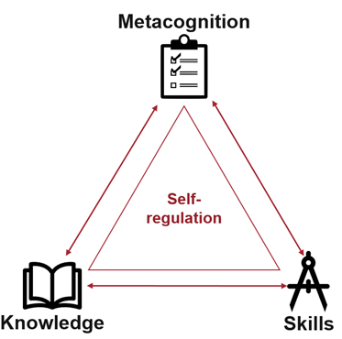

When learning is scaffolded in each of these areas, teachers can assist students to:
- learn new knowledge and skills
- practise new knowledge and skills
- develop the ability to independently apply the new knowledge and skills.

What are the Benfits of using Metacognitive strategies?
When teachers assist students to develop strong metacognitive abilities, students develop a deeper awareness of the learning process and gain control over their own learning. This leads to:
- enhanced personal capacity for self-regulation
- increased ability to manage one’s own motivation
- students becoming more independent learners.
Metacognitive strategies also play a crucial role in enabling students to become active participants in their own learning and school communities. Students who have the opportunity to exercise voice, agency and leadership in designing, developing and assessing their own learning, have a greater chance of becoming resilient and independent learners.
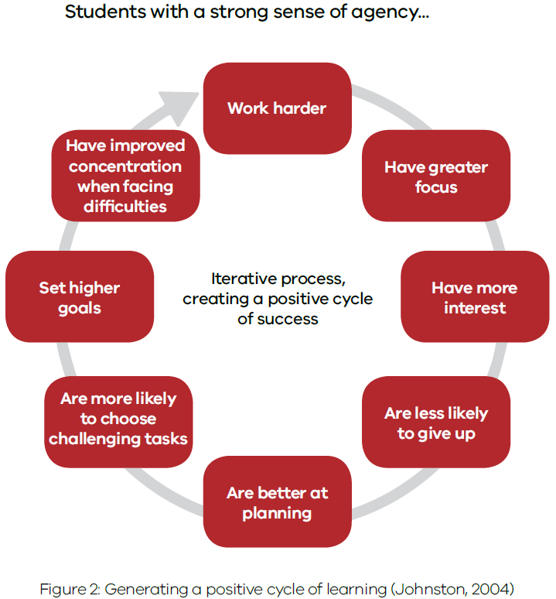
From Amplify: Generating a positive cycle of learning
A focused effort on assisting students to develop metacognitive skills:
- provides students with opportunities to collaborate and make decisions with adults around what and how they learn and how their learning is assessed
- empowers students to direct and take responsibility for their learning
- assists students to understand and contribute to the community and the world around them.

How to integrate metacognitive strategies in your classroom
A good starting point for every teacher is to assess their students’ mindsets. The presence of specific attitudes, motivations and dispositions in a learner can:
- enhance their capacity to learn
- determine their willingness to persevere with, and make sense of, discipline-based knowledge and content
- determine their willingness to persist with developing skills and capabilities that are experienced as difficult, elusive or challenging.
The following tools can help teachers do this. They can be used with students as a self-reflection tool to guide the design of learning experiences, to prompt classroom discussions, and to track student progress in the development of the right learning dispositions.
- The Mindset Works Effort Rubric places the effort in the context of mindset. This tool helps students (and adults) identify what effort looks like for them within the learning process.
- The Growth Mindset Feedback and Growth Mindset Framing tools help teachers transform their language to growth-minded language, to give feedback to students about their progress and results, so that students can see growth, and learn new concepts and skills.
- The Four Rs Tool, developed from the work and research of Professor Guy Claxton, can be a powerful way to identify strengths and development needs for each student, as well as a way to assist students to become increasingly aware and take control of their attitudes to learning, leading to improved self-regulation.
Some of the most common strategies used in everyday teaching to foster the learning and internalisation of metacognitive strategies are:
- Explicit teaching, with a focus on activating prior knowledge, introducing new knowledge and skills, modelling the application of knowledge and skills, and providing ample opportunity for independent practice and reflection.
- Supporting students to plan, monitor, and evaluate their work/learning. Explicitly teaching level-appropriate skills and structuring work around these phases will help students to gradually internalise these techniques and use them to take control of their own learning.
- Developing rubrics (and wherever possible co-designing them with students) to assist students to monitor their own learning/work and set individual learning goals that are specific, measurable, achievable, realistic and timely (SMART).
- Modelling thinking by verbalising the thought processes used to consider, analyse and solve problems. This may be as simple as ‘thinking aloud’.
- Questioning, by using questions to engage students, to monitor their progress and stimulate their thinking, and also by valuing questions from students as a form of feedback and an opportunity for clarification/extension of learning.
For more information on these and additional strategies, teachers can refer to:
- High Impact Teaching Strategies (HITS)
- HITS: Using metacognitive strategies
- Education Endowment Foundation report - Metacognition and self-regulated learning

Self-regulation through co-design of learning protocols
‘Self-regulated learning and metacognition have often been found to be context-dependent. […] This does not, however, mean that metacognitive knowledge and skills will automatically develop through content knowledge teaching.’
Education Endowment Foundation
Rosanna Primary School used metacognitive strategies to explore what deep learning looks like. This example demonstrates how a process of collaborative inquiry and co-design helps students to develop metacognitive skills and the ability to self-regulate.
Teachers worked with the Junior School Council to develop a set of new learning protocols for the school. By involving student representatives from each class, they drew upon students’ initial understanding of deep learning and pushed them further to question and understand what deep learning looks like.
‘It is a good reminder for us as teachers and leaders that what we think might work well does not actually suit students, and that students can actually offer a very different perspective. Students told us what was not going to work and what we could try as teachers to enable them to become co-creators and co-designers of the whole process.’
Jeff Jackson, AP Rosanna Primary School.
Together, teachers and students created a visual model of deep learning matched by a set of learning protocols. Students and teachers can now refer to this model to monitor and guide their learning in class and beyond.
The co-design process gave students a greater understanding and awareness of the learning process, activating their metacognition. The resulting deep learning process and protocols empower students to take ownership and responsibility for their own learning. This leads directly to developing intrinsic motivation and self-regulation of students.

Empowerment of students through building motivation and dispositions
Epping Secondary College used metacognitive strategies that help students gain control of their motivation and attitude towards learning. The school explicitly taught the process and practices required to master new skills. This case study highlights how co-designing rubrics and giving students time to reflect, set goals and articulate issues related to learning, are powerful tools to help students become self-regulating learners.
Epping involved both staff and students in the co-design of ‘process rubrics’ which describe the process students can use to improve and self-direct their learning. Rubrics enabled teachers to introduce the metacognitive knowledge to students, and assisted students to develop the skills and abilities needed to manage the learning process.
The development of the process rubrics and the formal reflection and goal setting process built transparency and a common understanding of the metacognitive strategies. Students now use the rubrics to set goals and reflect on their learning, and to seek feedback and discuss progress with their peers, parents, guardians and teachers.
‘This year I have learnt that the process of learning is more complicated than we think. We have to have a growth mindset, persistence, perseverance and commitment. It has shown me that if I work with commitment and determination, I will be more likely to reach my goals.’
Year 9 student, Epping Secondary College
Using the rubrics students have an opportunity to reflect on effort, the different strategies they use, and the processes they employ. This empowers students to become active creators of their own learning and gives them the ability to monitor and adjust their thinking to achieve their learning goals.
Rubrics assist teachers to make clear how and why students learnt something, and how and why they improved. To help with this, teachers included in each formative and summative assessments a ‘not yet’ grade. This supports students to value growth mindsets and teachers to reward effort and resilience.
‘It takes time and effort to strive and do better. You have to be willing and determined every day to make a difference and do extra homework and revise what you complete in class. This has changed the way I learn by making me prepared for the tasks given in class, it has helped me be more organised and improve my marks this year.’
Year 9 student, Epping Secondary College

RELEVANT TOOLS AND RESOURCES
This note is part of a series of professional practice notes to support school-based staff to continue improving their practice. For more information, see Professional Practice Elements.
Relevant tools and resources include:
- High Impact Teaching Strategies
- Amplify
- HITS: Using metacognitive strategies
- Victorian Curriculum F-10 - Critical and Creative Thinking
- Education Endowment Foundation report - Metacognition and self-regulated learning
- The four Rs tool - Assess the attitudes, motivations and dispositions of your students
- Mindsetworks resources for teachers
- Carol Dweck-Revisits the ‘Growth Mindset’
- Carol Dweck-The Power of Believing you can Improve
- Metacognition: The Gift that Keeps Giving

CONTACT US
For more information, or to share your feedback on this resource, please email: professional.practice@edumail.vic.gov.au.

Eisenhart, M., & DeHaan, R.L. (2005). Doctoral preparation of scientifically based educational researchers. Educational Researcher, 34(4): 3-13.
Willis. J. (2012). A Neurologist Makes the Case for Teaching Teachers About the Brain. Edutopia.
Dweck, C. (2015) Carol Dweck Revisits the 'Growth Mindset', Education Week, https://www.edweek.org/ew/articles/2015/09/23/carol-dweck-revisits-the-growth-mindset.html
Education Endowment Foundation (2019) Metacognition And Self-Regulated Learning, Guidance Report, p.24

