  - Professional practice days
overview
- From the commencement of the 2018 school year, each teacher has been entitled to be released from their scheduled duties, including teaching, to focus on the improved delivery of high quality teaching and learning.
- The work undertaken on these professional practice days (PPDs) must be consistent with departmental and school priorities and selected from the following areas: planning, preparation, assessment of student learning, collaboration, curriculum development, relevant professional development and peer observation including feedback and reflection.
- The timing and focus of each day for each teacher will be nominated by the teacher and be agreed to in consultation with the principal.
A focus on teaching practice
Professional practice days for teachers (pro rata for a teacher employed part-time) are provided to release teachers from their scheduled duties to focus on the improved delivery of high quality teaching and learning.
These days are in addition to the existing pupil-free days.
Professional practice days create opportunities for individual teachers by increasing time available to focus, reflect on and improve their individual practice, and to have the opportunity to engage in purposeful collaboration so as to improve student learning.
The Victorian Government Schools Agreement 2017 (VGSA 2017) states that the work undertaken on these days will be consistent with departmental and school priorities and selected from the following areas: planning, preparation, assessment of student learning, collaboration, curriculum development, relevant professional development and peer observation including feedback and reflection.
ENSURING ALIGNMENT with SCHOOL prioriTIES
Schools will articulate their priorities in the School Strategic Plan (SSP) and Annual Implementation Plan (AIP). Teachers will be able to reflect on their individual goals in their Performance and Development Plans (PDP) to determine the focus of their professional practice days, which will be consistent with school and departmental priorities. Activities might include working with other teachers, including a learning specialist, to develop their practice, or any of the activities previously mentioned.
The image below is a representation of the professional practice elements in the VGSA 2017 within broader school activities.
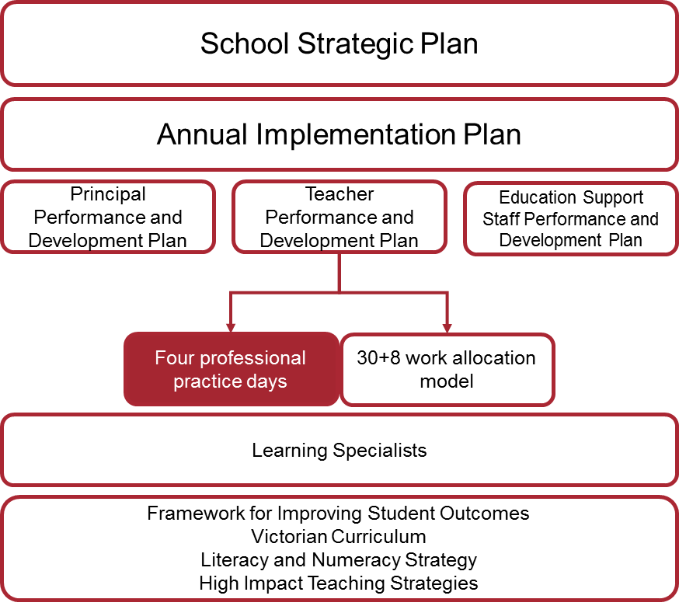
effective implementation
Improving teacher effectiveness is fundamental to improving student learning. Professional practice days provide teachers with more time to focus on improving their effectiveness, including through engaging in relevant professional learning, should they choose to do so.
Teacher learning is considered effective when:
- it is driven by student needs and focused on the implementation and mastery of new strategies (implementation as learning)
- it is a routine practice within the school, delivered through teachers using a disciplined inquiry process
- teacher experts work in classrooms with teachers learning from each other
- PDPs connect teachers with common goals or learning needs to enable peer learning.
Teachers learn from and with colleagues when they work together to focus on the evidence-based practices known to impact on student outcomes. Teachers also learn when they have the time to plan and prepare their pedagogical activities and support each other to reflect on and inform their individual teaching practice.
Many schools already privilege collaborative professional practice to increase student learning. They have the structures in place to enable targeted professional learning. Some schools are already participating in a more formal approach to collaborative professional practice through the Victorian Professional Learning Communities (PLC) initiative. Professional practice days provide an opportunity to build on and further support this work.
All schools will need to make planning decisions to effectively manage and schedule teachers’ professional practice days.
Ideas for the professional practice days
Professional practice days help teachers focus on the improved delivery of high quality teaching and learning. The aspiration is, following nomination by teachers, for teachers and their principals to agree on the timing and focus of these days.
When planning the focus of their professional practice days, teachers may consider the following ideas:
- undertaking individual work across the core areas of curriculum, pedagogy and assessment of student learning, and reflecting on and refining their practice
- dedicating time to purposeful collaboration with other teachers to jointly create a unit of work to develop deep learning experiences, common engaging in a professional learning team to reflect (both collectively and individually) on current practice; identify strengths and areas for improvement, and draw on resources such as the Literacy and Numeracy Strategy and High Impact Teaching Strategies, which offer grounded support for effective teaching of foundational literacy and numeracy skills.

OTHER SUPPORT
Frequently Asked Questions and other information can be found on the schools intranet, see: Professional practice — Victorian Government Schools Agreement 2017.
Please email professional.practice@education.vic.gov.au for more information on the professional practice days.

Clause 22 Sub Clause 12 (a) of the VGSA 2017
Clause 22 Sub Clause 12 (b) of the VGSA 2017
Clause 22 Sub Clause 12 (c) of the VGSA 2017
Adapted from the Learning Forward ‘beliefs’ as presented at the International Congress for School Effectiveness and Improvement, Ottawa 2017
Adapted from Cole, P. 2012, Linking effective professional learning with effective teaching practice. Melbourne: AITSL

