Amplify

Empowering students through voice, agency and leadership

Draft for consultation

Acknowledgements
The Department of Education and Training (the Department) acknowledges and pays respects to Elders and all Victorian Aboriginal communities. We honour and respect Traditional Owners, past and present, and value the rich culture and history of the First Peoples of this land.

Feedback
The Department welcomes questions, comments and feedback on Amplify. Your engagement and contribution will contribute to the ongoing development and improvement of this resource. To contact the Department with regard to Amplify, contact: professional.practice@edumail.vic.gov.au

© State of Victoria (Department of Education and Training) 2019
Amplify is provided under a Creative Commons Attribution 4.0 International licence. You are free to re-use the work under that licence, on the condition that you credit the State of Victoria (Department of Education and Training), indicate if changes were made and comply with the other licence terms, see: Creative
Commons Attribution 4.0 International
The licence does not apply to:
- any images, photographs, trademarks or branding, including
- the Victorian Government logo and the DET logo; and
- content supplied by third parties.
Copyright queries may be directed to copyright@edumail.vic.gov.au
ISBN 978-0-7594-0839-5
CONTENTS

Acknowledgements 2
What is Amplify? 4
Why empower students? 5
Our vision for learning 5
Empowering students for the future 5
A compelling case to amplify 6
Empowering students - Victorian Context 8
Framework for Improving Student Outcomes 8
The Essential Elements 8
The Continua of Practice 9
The Victorian Teaching and Learning Model 9
Practice Principles for Excellence in Teaching and Learning 10
High Impact Teaching Strategies (HITS) 11
Pedagogical Model 11
Structures, processes and practices that empower students 12
The role of school leaders 12
Establishing preconditions that empower students and teachers 12
Establishing systems and structures 13
Structures, processes and practices that empower students 18
The role of school Teachers 18
Establishing preconditions that empower students 18
STUDENT VOICE 20
STUDENT AGENCY 21
STUDENT AGENCY 22
Tools and resources 23
CASE STUDY: MORNINGTON SPECIAL DEVELOPMENTAL SCHOOL 25
CASE STUDY: ST ALBANS SECONDARY COLLEGE 26
CASE STUDY: CANTERBURY PRIMARY SCHOOL 27
Bibliography and professional reading 28

What is Amplify?

Amplify is a practice guide for school leaders and teachers. It explains how to create the conditions, employ the practices and develop the behaviours, attitudes and learning environments that are conducive to student voice, agency and leadership. Whatever their current starting points, school leaders and teachers can draw on this resource to facilitate rich conversations, collaborate and take actions to empower students.
Amplify presents an evidence base and practical school based examples to help school communities explore and enhance their understanding of student voice, agency and leadership as the key elements which empower students.
Young people who find their own voice in supportive school environments are more likely to develop a confident voice, a capacity to act in the world, and a willingness to lead others. By empowering students we enhance student engagement and enrich their participation in the classroom, school and community. We help students to ‘own’ their learning and development, and create a positive climate for learning.
Amplifying student voice, student agency and student leadership contributes to improved student health, wellbeing and learning outcomes.
As a powerful practice guide, Amplify:
- begins with a reflection on the structures, processes and practices that amplify student empowerment
- builds from a mutual understanding about the school’s starting point for this work
- supports school leaders, teachers and students to collaborate and plan how they will boost student voice, agency and leadership in classrooms and across all levels of schooling.
Figure 1: Voice, agency and leadership empower students
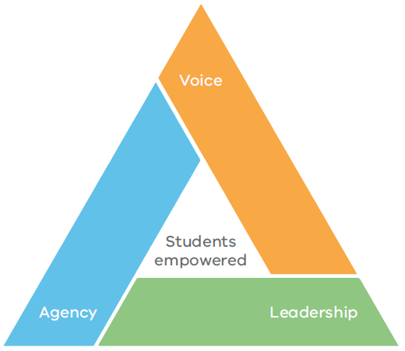

Why empower students?
Quote
All students are empowered to learn and achieve, experiencing high quality teaching practice and the best conditions for learning which equip them with the knowledge, skills and dispositions for lifelong learning and shaping the world around them.
Victoria’s vision for learning (Department of Education and Training, 2018)

Our vision for learning
Victoria’s vision for learning recognises the fundamental importance of empowering students and the contribution that student voice, agency and leadership make to improved student outcomes, health and wellbeing. Amplify draws on this vision and provides a starting point for dedicated attention to student voice, agency and leadership.
The vision outlines our aspiration for all students to achieve and grow as learners, and to generate their own course for lifelong learning. Students will be empowered to take ownership of their learning, to make purposeful contributions to their learning environments, and to tackle issues arising in the world around them.

Quote
Schools do need to be reinvented as a key part of learning eco-systems; webs of civil society institutions powerful enough to enable humanity to address the problems which both threaten it and offer spectacular opportunities. Schools in diverse settings and conditions are already innovating their foci and their methods to help their learners – not just pass tests, or even get a job – but to thrive.
(Valerie Hannon, 2017)

Empowering students for the future
We know our world is changing rapidly. We see change in contemporary communications and transportation, in new ways we access and create information, and in emerging enterprises that place consistent emphasis on new capabilities like critical and creative thinking and problem solving. We also know climate change, new technologies, and a new geopolitical landscape, make our future hard to predict and open to great possibility. Navigating such rapid change requires resilience, adaptability and perseverance.
Starting with the Victorian Curriculum F-10, we recognise the need for ‘learning for life’ and the need for students to develop the ‘Capabilities’ – Critical and Creative Thinking, Ethical, Intercultural, Personal and Social. These crossdisciplinary capabilities empower students to become independent learners and problem solvers. It is these skills that are developed, practised and demonstrated when students have the opportunity to exercise voice, agency and leadership in designing, developing and assessing their own learning.

Quote
Educating for the unknown, far from an unapproachable paradox, can be an alluring and inspiring agenda. Rather than counselling despair, educating for the unknown favours a vision of learning aggressive in its effort to foster curiosity, enlightenment, empowerment and responsibility in a complex and dynamic world. It favours a broad and visionary reach for meaningful learning.
(David Perkins, 2014)

A compelling case to amplify
There are compelling reasons to amplify student voice, agency and leadership. When students have a strong sense of agency, starting with more commitment and a strengthened focus on their learning, a positive cycle of learning is generated (Figure 2). Students who are empowered to take ownership of their learning understand and contribute to the development of learning intentions, are invested in the assessment processes and monitor their own learning and improvement.
As students become invested in their own learning, they gain a better understanding of what good learning is and the purpose of it. This enables them to evaluate their own work, and to more purposefully discuss progress and achievement with teachers, each of which has a significant effect size on achievement (Hattie, 2009).
In addition, empowering students to become partners in school decision making is recognition that students are knowledgeable experts in their lives. It acknowledges they can contribute to improving their schools and communities.

Figure 2: Generating a positive cycle of learning (Johnston, 2004)
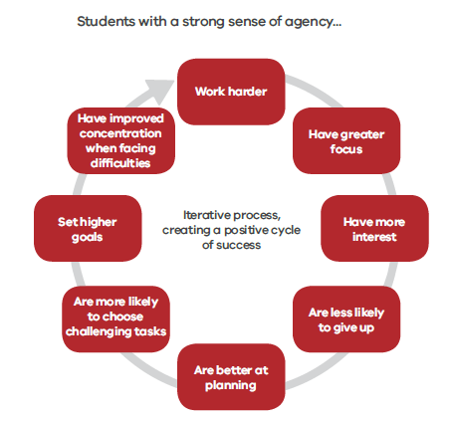

There is strong evidence that students become more engaged in learning when they have opportunities to:
- exercise agency in their own learning
- contribute to the communities in which they learn
- improve the learning program for themselves and their peers.
Research findings indicate that student voice, agency and leadership have a positive impact on self-worth, engagement, purpose and academic motivation (Quaglia, 2016), which contribute to improved student learning outcomes (Hattie, 2009).

Quote
Students have a right to be heard. In student-focused schools, student participation goes beyond students having a voice only through their representation in an SRC or similar body. When students meaningfully participate in decision making about their learning, they are more likely to remain involved in education and to achieve better results.
(VicSRC, 2017)

Figure 3: Likely impact of student voice (Quaglia Institute for School Voice and Aspirations, 2016)
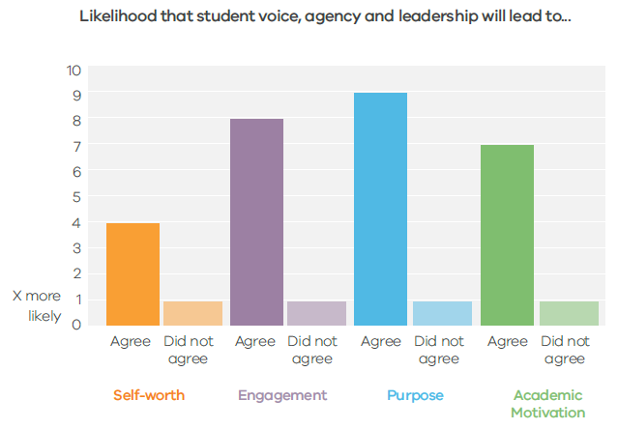

Empowering students - Victorian Context
Student empowerment through voice, agency and
leadership contributes to the Education State objective to build a world class education system which brings equity and excellence to the learning experience of every student.
The Victorian Curriculum F-10 defines learning progressions that guide student learning growth. To ensure that students progress along this continuum, teachers and school leaders create engaging learning and teaching programs, drawing on their knowledge of local context, effective pedagogy and rigorous assessment. As part of this progress, the interdisciplinary ‘Capabilities’ of the Curriculum – Critical and Creative Thinking, Ethical, Intercultural, Personal and Social – ensure students are empowered with the knowledge, skills and dispositions that enable them to exercise effective voice, agency and leadership, which in turn enables them to manage their own learning for life.

Framework for Improving Student Outcomes

Figure 4: Framework for Improving Student Outcomes
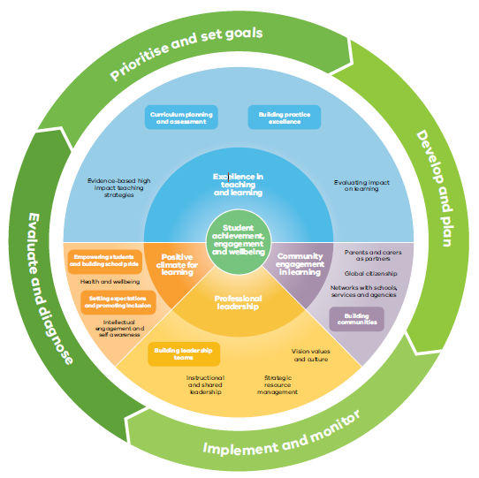

The Essential Elements
The foundation for discussions about student voice, agency and leadership in schools is Essential Element 4, one of the 8 Essential Elements in the Framework for Improving Student Outcomes (FISO). It draws specific links between amplified student voice, agency and leadership and the role of students in improving their own learning and in creating positive learning experiences.

Essential Element #4: Student voice, agency and leadership in own learning activated so students have positive school experiences and can act as partners in school improvement.
Schools build a culture where teachers and students work together and student voice is heard and respected. When this occurs it contributes to students building their confidence and self-efficacy. Teachers and school leaders receive valuable feedback that can lead to improved teaching practice and contribute to school improvement. Students feel more positive and connected to their school, see themselves as learners and better understand their learning growth.
Students have access to a range of structured leadership roles in the school that provide them with opportunities to develop a range of skills, including communication and decision making.

The Continua of Practice
The Continua of Practice for Empowering Students and Building School Pride demonstrates how effective schools can validate and embrace student voice, agency and leadership by building productive and inclusive school cultures for all adults and students.
The Continua of Practice includes the following definitions of student voice, agency and leadership: Student voice is not simply about giving students the opportunity to communicate ideas and opinions; it is about students having the power to influence change. Authentic student voice provides opportunities for students to collaborate and make decisions with adults around what and how they learn and how their learning is assessed. This is known to lead to improved educational outcomes.
Student agency refers to the level of autonomy and power that a student experiences in the learning environment. Student voice and agency are intrinsically linked. Agency gives students the power to direct and take responsibility for their learning, creating independent and self-regulating learners.
Student leadership is not confined to a small group of individuals, as leadership potential is inherent within all learners. Student leadership includes listening to and being able to clarify the issues of the students they represent and advocating on their behalf. Student leaders have an increased sense of responsibility to help others and to model leadership principles and values. Trust, autonomy and relationships are enhanced through the development of leadership qualities.

The Victorian Teaching and Learning Model
The Victorian Teaching and Learning Model brings FISO into the classroom, creating a line of sight between the whole school improvement approach and classroom practice. As Figure 5 shows, the Model incorporates a Vision for Learning, Practice Principles for Excellence in Teaching and Learning, Pedagogical Model, and High Impact Teaching Strategies (HITS).
The Victorian Teaching and Learning Model recognises the positive impact of a student-centred approach to teaching and learning. It reinforces the shared responsibility of school leaders, teachers and students to build knowledge skills and dispositions which enact student empowerment. Student voice, agency and leadership are recognised in the pedagogical resources within the Victorian Teaching and Learning Model, affirming the positive impact of a studentcentred approach to teaching.

Figure 5: Victorian Teaching and Learning Model
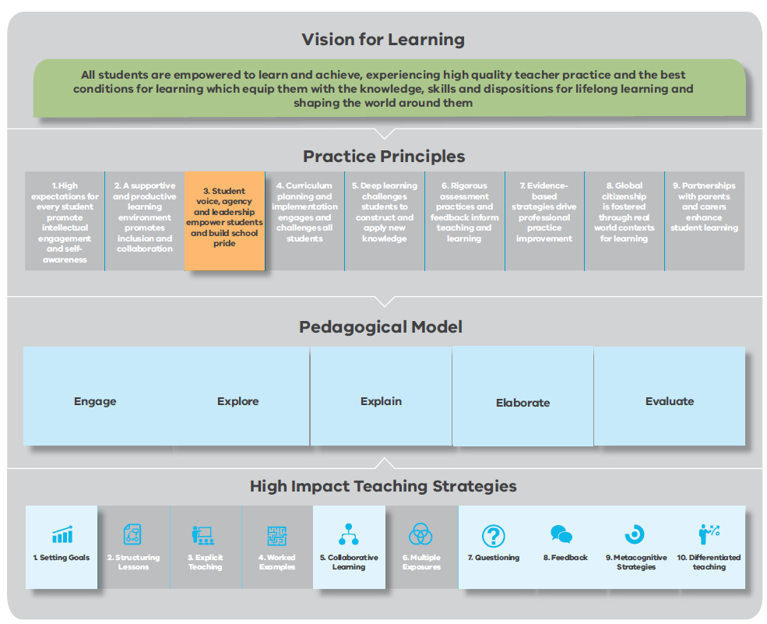

Practice Principles for Excellence in Teaching and Learning
The Practice Principle 3: Student voice, agency and leadership empower students and build school pride, builds on the FISO Continua. It does so by articulating actions teachers can take to engage students as strong agents in their own learning, and to foster their participation in decision making in their schools and communities.
Amplify explores Practice Principle 3 in more detail, offering school leaders and teachers practical guidance for reflecting on their current practice, exploring opportunities for improvement, and firmly embedding student voice, agency and leadership into learning programs.
The self-reflection tool accompanying Practice Principle 3 helps student leaders and teachers to reflect on, and assess the impact of shared efforts to improve student voice, agency and leadership over time. For a copy of the self reflection tool, see: http://www.education.vic.gov.au/Documents/school/teachers/support/practiceprinreflection.pdf

Figure 6: Practice Principle 3 – Student voice, agency and leadership empower students and build school pride
Principle 3. Student voice, agency and leadership empower students and build school pride
Action Number | Action
Action 3.1 | Teachers empower students to have a democratic voice in the running of the communities in which they learn
Action 3.2 | Teachers co-design opportunities for students to exercise authentic agency in their own learning
Action 3.3 | Teachers co-design leadership opportunities
Action 3.4 | Teachers build school pride and connectedness

High Impact Teaching Strategies (HITS)
The HITS are 10 instructional practices that increase student learning when applied with fidelity. They emerge from findings of tens of thousands of studies of what has worked in classrooms across Australia and the world. While the HITS specifically focus on teacher behaviours, they acknowledge the positive impact of bringing student voice, agency and leadership into the classroom. For example, when the first strategy, Setting Goals, is implemented with fidelity in the classroom, students actively engage with the learning goals, monitor their own learning progress, and frame future learning goals.
To view the HITS resource, see: http://www.education.vic.gov.au/school/teachers/teachingresources/practice/Pages/hits.aspx

Pedagogical Model
The Pedagogical Model accelerates and sustains practice improvement in Victorian government schools. It brings together in one coherent, practice-focused model the Vision for Learning, Practice Principles and HITS. It affirms student voice, agency and leadership as key to effective teaching practice. It highlights the importance of collaboration between teachers, students and parents for improving student learning outcomes.
The Pedagogical Model gives teachers opportunities to reflect on their current practice, view examples of best practice, and assess their professional learning needs to improve their teaching. Continua of Practice for each domain articulate teacher behaviours and practices which range from guiding students in their learning to building students’ independence and confidence.

Structures, processes and practices that empower students

The role of school leaders
Quote
Effective schools build a culture where teachers and students work together, and where student voice, agency and leadership are understood as inter-related factors that contribute to the notion of empowerment and sense of school pride. (FISO)
Effective student empowerment builds on a culture that values and nurtures student voice, agency and leadership.
This goes beyond giving students the opportunity to communicate ideas and opinions; it empowers students to influence change in their school and their community.
Authentic student voice provides opportunities for students to collaborate and make decisions with adults about what and how they learn, and how their learning is assessed.
School leaders can create and maintain a positive school climate that achieves this. A climate for learning that is respectful, trusting and collaborative recognises that student empowerment enhances the work of teachers, brings immediate benefits to student learning, and enhances school pride.

Establishing preconditions that empower students and teachers
There are preconditions that act as effective supports or foundations for school wide efforts to build student voice, agency and leadership.
Developing a culture that embraces a whole school community approach to adult-student partnerships involves all school and community members with whom students interact in the school setting. School principals, in particular, play a key role. They model practices and behaviours that support student voice and participation, ensuring these ‘are threaded through the daily interactions and communications of school life and reflect a coherent and widely supported set of values and principles (Ruddock & Flutter, 2004).’
By maintaining a shared vision and a safe learning environment, students, teachers and the wider school community develop the skills and willingness to collaborate and contribute to creating genuine student empowerment opportunities.

Precondition 1: A shared vision (FISO Dimension: Vision, values and culture) | Precondition 2: A safe learning environment (FISO Dimension: Instructional and shared leadership)
A shared vision reflects the school community’s aspirations, bringing cohesion to the improvement efforts of all members and fostering collective efficacy. A school’s vision articulates its values and desired future achievements.  Effective leaders set high expectations and prioritise student engagement, achievement and wellbeing. As part of those priorities, school leaders are responsible for honouring student voice, agency and leadership, and for developing a culture that promotes them. Effective school leaders clearly articulate the role of voice, agency and leadership in the school’s vision and values, and their importance in guiding all school work.  The school’s shared vision encapsulates a bold, ambitious case for change. It flourishes through meaningful engagement and ongoing discussion between school leaders, teachers, students and parents. These interactions ensure all community members are deeply invested in achieving the vision. | Teachers, students and parents need a learning environment that is respectful, trusting, supportive, and open to risk-taking. Watkins (2009) calls this ‘a supportive forum for experimentation’ where educators can talk about the tensions that emerge from new roles and responsibilities.  School leaders are in charge of teachers’ professional development. They are responsible for creating conditions in which teachers collaboratively investigate, plan, implement, monitor and evaluate teaching. As instructional leaders, school leaders use the improvement cycle to foster a culture through which teachers use a disciplined approach to continuous improvement – an approach based on innovation and energised by the confidence to learn from mistakes (Breakspear, 2016).

Figure 7: Framework for Improving Student Outcomes
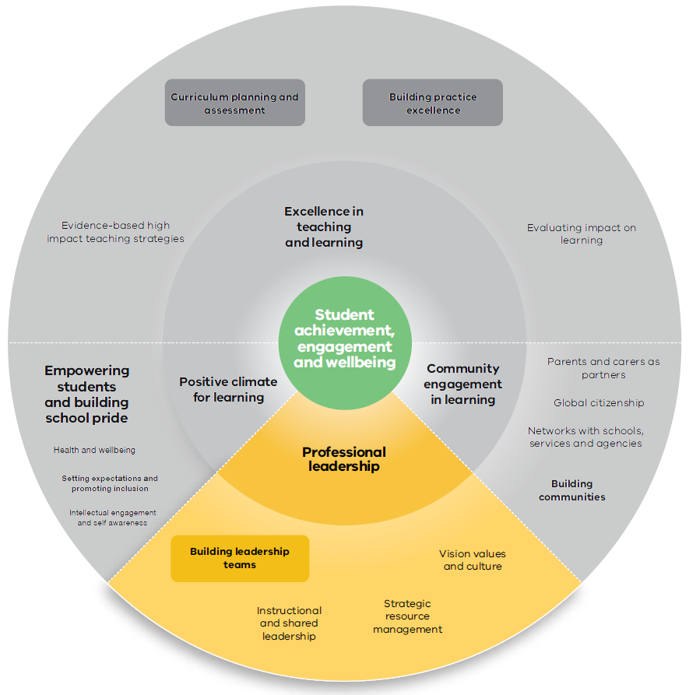

Establishing systems and structures
Authentic adult-student partnerships are predicated on a whole school and community culture that values collaborative practice, builds a sense of belonging and significance for every student, and successfully engages learners in reciprocal ways of working for mutual benefit.
Creating a school wide culture in which students participate in the design and implementation of school programs and policy, and actively contribute ideas about student-led learning, involves the establishment of systems and structures that nurture and sustain the shared vision and culture. By putting in place measures such as clear protocols, roles, time allocations and strategic resource management, school leaders empower individuals and bring coherence to the collective improvement effort.
From 2018, all Victorian government secondary school councils are required to have a student member category. Student members of school councils will have the same role and responsibilities as other council members, including full voting rights, providing new opportunities for student empowerment. Students will be expected to prepare for and attend all council meetings, in line with the requirements for school councillors. Primary schools may continue to co-opt a student to the community member category if they so choose.
School leaders are encouraged to consider establishing and championing:
- School Representative Councils
- Student Voice/Action Teams
- a clear link between the School Improvement Team (SIT) and student voice bodies
- additional supports such as teacher positions of responsibility to support student voice
- the consistent use of student feedback in all classrooms.
School leaders can encourage teacher teams to reflect on and respond to ‘Key questions for teachers’ on page 21 of this resource.
System changes might include effective implementation of Professional Learning Communities, using the FISO improvement cycle, partnering with other schools and the wider community, and providing spaces and processes for students to effectively engage with their school.

Key actions for consideration
- Review existing processes to capture school and community views and understandings of student voice, agency and leadership:
- what do we understand by the terms student voice, student agency, and student leadership?
- what processes are in place to capture, enact and embed school community views?
- to what extent is student voice, agency and leadership embedded in whole school practice?
- • at this school, what does student voice, agency and leadership look like in the classroom?
- Identify trends and correlations between different data sets to identify persisting or emerging issues in student engagement and the use of student voice, agency and leadership. This analysis could include:
- using data from the Attitudes to School Survey and the Staff Opinion Survey to understand current levels of engagement and confidence
- drawing on the FISO Dimension, Empowering Students and Building School Pride, to develop a school self-evaluation and identify potential areas for improvement.
- Use the Practice Principles Self-Reflection Tools to lead discussions about existing practice, areas for
- improvement, and specific steps to be taken.
- Involve students in the discussion and enable them to contribute their unique perspectives on learning, teaching and schooling.
- Provide ongoing support for adult-student partnerships by establishing clear structures, roles and responsibilities for implementing mutually agreed goals.
- Invite existing student representatives (for example, from the SRC or Student Voice Team) to set up new structures with broader student participation in decision making.
- Establish or broaden existing resources and structured programs to empower students (for example, Teach the Teacher Ignite program, VicSRC engagement and resources, and collaboration with network schools).

Attitudes to Schools Survey
All schools are invited to participate in the Attitudes to School Survey (AtoSS). They can use AtoSS data to monitor levels of student engagement and wellbeing, compare school level data on engagement with statewide benchmarks, and stimulate discussion within the school community about how to improve engagement.
Preparing for the Survey (Term 1)
To maximise AToSS participation, effectiveness and accuracy schools can:
• provide staff with clear information about the Surveys importance, how they can contribute to Survey administration, and the benefit of collaboratively analysing results
• build student awareness about the Surveys importance, including why it is conducted and how the data is used to inform school improvement
• build students’ data literacy – knowledge, skills and capacities – to ensure they can actively participate in analysing the results
• provide students with clear information about how the Survey will be administered and how the results will be shared with students
• clearly articulate that all Survey responses are anonymous and that data cannot be tracked to individual students.
Administering the Survey (Term 2, April - May)
Teachers organising and administering AtoSS have an important role in ensuring all students can express themselves freely, knowing their voice and opinion are valued and safeguarded. Establishing the appropriate classroom conditions and monitoring students during the survey guarantees privacy and anonymity of students. For specific information on administering AtoSS, including sample text for parent and school newsletters, see Attitudes to School Survey: http://www.education.vic.gov.au/school/teachers/management/improvement/Pages/performsurveyat.aspx
Using the data (second half of June)
After schools gain access to Survey results from the secure Survey portal, the data is shared with the school community to prompt discussions on student engagement and current and future initiatives.
Student engagement and feedback is integral to this process. To enable participation schools can support students to:
- refer to Survey data in a form that is accessible and relevant to them
- reflect on Survey results
- identify issues for action.
Student engagement in this process necessarily varies depending on their developmental stage. However, schools can support students to participate meaningfully by:
- sharing data with students at year level meetings and facilitating discussion on themes emerging from Survey results
- establishing focus groups on identified issues of concern
- assisting students to organise teams to address the areas they prioritise for action (student teams can be classroom based or coincide with broader Student Voice Teams)
- ensuring regular items from the Student Voice Team are on School Improvement Team/School Council agendas.

Student Voice Teams
Most Victorian government schools have some sort of student organisation to represent and work on behalf of students. They operate under many different names, the most common being a Student Representative Council (SRC). While the stated purpose of an SRC is to represent student views within the school, it is important that the SRC is representative of all students and that students are partners in decision-making. Research (VicSRC & DEECD, 2010) indicates that many students view their SRC as tokenistic, lacking status and authority and not truly representative. For the SRC to become part of the culture of the school and have a higher profile, students need to be provided with opportunities to develop skills in areas such as representation, communication and organisation. To ensure all students have a voice and are listened to, many schools are seeing successful outcomes in the establishment of Student Voice Teams.
What are Student Voice Teams?
- Schools establish Student Voice Teams (SVT) to:
  - ensure the voices of particular student cohorts are heard through support from a student representative group
  - empower a student action team to undertake a short-term community-based project on behalf of the school
  - convene a diverse student representative team that participates in various aspects of school review.
- Effective SVTs are supported by structures and protocols, including expectations about how they interface with other school governance structures.
- An SVT can comprise a group of students, a support teacher or teachers, and where appropriate, other adults, including parents and community based workers.
Identifying an improvement focus
- SVTs can focus on issues of concern arising from student discussion about, and analysis of, AtoSS results.
- At the start of the year, schools can provide students with an opportunity to:
  - review the most recent AtoSS results
  - consider the issues previously identified as focus areas, and review progress made by SVTs to address them
  - prioritise efforts for the year, including continuing and/or ceasing work on previous initiatives, and establishing new improvement foci.
- Topics emerging from these discussions at the start of the year can form the basis of the work of SVTs.
Establishing and running Student Voice Teams
- Some students are likely to self-nominate for participation in SVTs, others may be more reticent. Teachers supporting SVTs can assist students to capture the voices of all students by attracting a varied group of students to SVTs, and by facilitating inclusive interactions between SVT members and the whole student cohort.
- SVTs can include established roles and responsibilities, and a defined project.
- Scheduling regular meeting times (weekly or fortnightly), and booking a meeting space, constitute recognition of students’ contribution to school decision making processes. To promote inclusion and safeguard student rights, SVTs meet in regular class time.
- Depending on students’ developmental level, teachers may need to assist students to organise themselves and their work around project plans that they can manage and follow.
- SVTs interface with other school governance structures, including the School Council, the School Improvement Team and school leadership. Formalising meeting times in agendas (minimum once a term) between SVTs and the other governance structures provides students with an opportunity to review school improvement and express their ideas and concerns.
- As the school becomes more adept at assisting students to work in SVTs, adult-student partnerships become more effective and the opportunities for collaboration expand to include curriculum design and all aspects of school life. For ideas, resources and a manual on how to use Student Voice Teams, see: http://www.asprinworld.com/student_action_teams

Structures, processes and practices that empower students

The role of school Teachers
Effective teachers enable students to be active participants in their learning. They are responsive to student feedback and adapt their teaching practice to suit the needs of all students. When students experience a sense of belonging and significance through voice, agency and leadership, they are likely to articulate their sense of empowerment and school pride.
To begin with, creating space for student voice, agency and leadership may seem to challenge the need to maintain a focus on curriculum and assessment requirements. However there are highly effective practices that address this challenge. Many teachers report that student voice, agency and leadership evolve as teachers create a learning partnership approach – for example, by including students in curriculum planning, in setting goals and in the assessment process. This partnership approach does not entail teachers relinquishing their role in guiding what and how students learn but is a shift to create strong collective responsibility for learning progress and school improvement.
Empowering students is intentionally positioned at the heart of the Victorian Teaching and Learning Model. Student empowerment does not impose an additional responsibility on teachers. It is a strategy for reaching the ultimate goal of equipping students with the knowledge and skills to make them effective lifelong learners.
Graves and Fitzgerald (2003) note that ‘effective instruction often follows a progression in which teachers gradually do less of the work and students gradually assume increased responsibility for their learning.’
The concept of a gradual release of responsibility reflects the intersection of several theories. Taken together, they suggest learning occurs through interactions with others; when these interactions are intentional, specific learning occurs. To gradually release responsibility is to equip students with what they need to be engaged and self-directed learners (Fisher and Frey, 2013).
The concept of gradual release of responsibility does entail building student capacity to voice their views and opinions, to collaborate, and to lead themselves and others. The concept comes to life through authentic discussions about:
- what students learn
- how they learn
- how learning is assessed, and
- how students contribute to evaluation of broader school improvement efforts.
Teachers build their capacity to engage students in a learning process defined by a gradual release of responsibility through collaborative processes such as modelling, observation, feedback, peer support and sharing with others.

Establishing preconditions that empower students
The teacher’s task is to create a safe learning environment, an environment built on trust and respect that empowers students to share thoughts, ideas, beliefs and opinions.
When teachers are willing to listen to and learn from their students and provide consistent opportunities for them to use their voices, students develop a sense of ownership for how and what they learn.
All teachers and students need to be able to formulate, articulate and share their ideas with one another.
Some students do not always have the skills for, and understanding of, how to use their voice in meaningful ways. Some students need more practice formulating their opinions than others. But teachers can ensure that every student benefits from learning opportunities that build skills and understandings about student voice, agency and leadership.
Quote
If education is to develop young people as capable agents it can no longer rely on learning by routine. It needs to take people wider, deeper and further, to give them the experiences of what it is like to take action, to make things, to serve the community, to work with others and to take on the challenges that might once have daunted them. (Leadbeater, 2017)

Key questions for teachers
Using the FISO improvement cycle, the following questions may support teachers to reflect on the current status of student voice, agency and leadership in their classrooms. They may also assist teachers to identify where to take action and to evaluate the outcomes of action.
Evaluate and diagnose
- Am I ready to learn from my students?
- What structures and processes are in place to support student voice, agency and
- leadership in the classroom?
- Who am I listening to? Who am I missing?
- Are students acting more as leaders or followers?
Prioritise and set goals
- What skills do students need in order to express themselves?
- How do I let students know they are being heard?
- How do I gather students’ input and ideas?
- How do I meaningfully involve students in actions?
Develop and plan
- What can I do to improve student voice, agency and leadership in the classroom?
- What steps will I take to implement change?
Implement and monitor
- How will I monitor impact on student engagement and outcomes?
- • What can/did I learn about myself in the process?

STUDENT VOICE
Quote
Being listened to and being taken seriously fosters a positive relationship between learners and their educators. It encourages a positive sense of self in both parties which can have an enormous impact on individuals’ learning outcomes. Learner voice initiatives must listen and act upon ‘incomprehensible, recalcitrant or even obnoxious voices.’ It is only by including these voices that the potential of this work to achieve social justice can be realised. (Walker and Logan, 2008)
FISO definition
Student voice is not simply about giving students the opportunity to communicate ideas and opinions; it is about students having the power to influence change. Authentic student voice provides opportunities for students to collaborate and make decisions with adults around what and how they learn and how their learning is assessed. This is known to lead to improved educational outcomes.

Student voice is evident when the students: | Implementation ideas
- listen to and learn from peers and adults  - ask questions to strengthen their understanding  - share their ideas and opinions  - actively seek feedback from teachers and peers to progress their learning and reflect on their learning experience  - give feedback to peers and teachers  - negotiate learning goals and assessment  - respectfully challenge others’ views around learning and teaching  - feel confident to contribute in meaningful ways for a shared sense of ownership | - Provide opportunities for students to give feedback to peers and teachers.  - Use student feedback to diagnose issues and inform practice improvement.  - Promote dialogue as a means of learning.  - Ensure there are opportunities for regular small group or whole class discussions that create inclusive opportunities for students to share their learning interests and assessment preferences.  - Explicitly teach collaborative learning skills where students actively participate in negotiating roles, responsibilities and outcomes.  - Design learning activities which incorporate student interests and extend learning beyond the school.  - Use exit cards at the end of each lesson to confirm progress on learning and assess student engagement. (e.g. what did you learn today, what questions do you have).  - Discuss feedback one-to-one with students to stimulate their thinking about learning, and provide opportunities for them to ask questions and provide input.  - Use three-way conferences (parent, teacher and student) or peer reviews to provide feedback on pieces of work and learning progress.
Practice Principles - Actions
Practice Principle 3, Action 3.1 – Teachers empower students to have a democratic voice in the running of the communities in which they learn
This is evident when the teacher:
- considers students’ backgrounds, interests and needs to create authentic and meaningful learning opportunities
- involves students in curriculum planning and implementation
- empowers students to present their own ideas, opinions, knowledge and experience.
Indicators from other Practice Principles
The teacher:
- actively seeks student feedback about their teaching practice (Action 6.3)
- collaborates with students to identify appropriate goals to progress their learning (Action 1.2)
- assists students to frame future learning goals based on strengths and areas for improvement (Action 1.4)
- incorporates real life contexts and learning beyond the classroom (Action 4.1)
- designs open-ended learning experiences for students to investigate complex ideas (Action 5.1)
- develops team building skills which enable students to collaborate, negotiate and contribute to shared tasks (Action 2.3)
- engages students in developing explicit assessment criteria (action 6.1).

STUDENT AGENCY
Quote
Co-creation has changed how I think about my learning. I now have more control and my learning is more fun. I am sure that these skills will be beneficial to me in the future. Working with outside agencies has let me know that I can make a difference in the world. I am excited about school and these projects and I can’t wait to see what they look like when they are finished. (Year 8 student, Campbelltown Performing Arts High School)
FISO definition
Student agency refers to the level of autonomy and power that a student experiences in the learning environment. Student voice and agency are intrinsically linked. Agency gives students the power to direct and take responsibility for their learning, creating independent and self-regulating learners.

Student agency is evident when the students: | Implementation ideas
- work with teachers in making decisions about teaching and learning  - take responsibility for their learning and are, on the whole, independent and self-regulating learners  - negotiate and design learning that stretches their thinking  - can track and measure their own learning growth  - are involved in designing and implementing school policy and programs, and actively contribute ideas about student-led learning  - display the capabilities, confidence and willingness to contribute ideas and make decisions about what and how they learn  - reflect, take action and accept the responsibility that comes with being part of the problem solving. | - Develop skills and competencies that assist students to set their own goals and direct their own day-to-day learning. (See Case Study 2).  - Adopt project-based learning strategies that support students to explore real world topics deeply.  - Provide students with peer learning opportunities through which they become mentors of other students.  - Try a ‘Design for Change’ project in which students go through the design process of creating a new product or service for other people.
Practice Principles – Actions
Practice Principle 3, Action 3.2 – Teachers co-design opportunities for students to exercise authentic agency in their own learning
This is evident when the teacher:
- assists students to take ownership of their learning by identifying strategies that support them to attain learning goals
- assists students to become increasingly self-directed over time, and to gain confidence in their ability to complete learning tasks
- provides opportunities for students to reflect on the effectiveness of their learning and plan for future development
- enables students to negotiate assessment methods and criteria matched to their learning goals.
Indicators from other Practice Principles
The teacher:
- empowers students to make decisions about what and how they learn (Action 1.3)
- co-designs, with the students, learning and behaviour norms and protocols (Action 2.1)
- co-designs learning plans with students and seeks input from parents/carers (Action 2.2)
- includes students in curriculum planning (Action 4.1)
- models and develops students’ critical, creative and higher order thinking skills (Action 5.1)
- provides opportunities for students to share their learning, teach, question and challenge each other (Action 5.3)
- supports students to question and form conclusions about the value of the learning (Action 5.3)
- creates opportunities for students to investigate and connect with community and action group endeavours (Action 8.1).

STUDENT AGENCY
We have the right to participate in making decisions about matters that affect our lives (as recognised in Article 12 of the United Nations Convention on the Rights of the Child). Giving students a strong voice in our education helps prepare us for our changing world. Students are more engaged in education when we are involved in shaping our learning. (VicSRC, 2017 Student Congress Report)
Student agency is evident when the students: | Implementation ideas
- set high expectations for themselves and feel motivated and empowered to exercise agency  - have a growth mindset and believe they can learn, and build their knowledge and skills, through effort.  - can represent their school and its students as confident members of a student leadership team  - generate meaningful discussions on behalf of those students whose voices are less likely to be heard, who are disengaged, or who lack the skills and confidence to express views and opinions.  - actively participate in a student representative organisation and effectively contribute to school decision making  - want to learn about themselves, and contribute to the community and the world around them. | - Respectfully challenge students to do something they might not have considered doing before, such as designing and selling a product or taking part in an outdoor education course.  - Use inquiry-based learning methods in which students are inspired to learn more so they acquire the knowledge and skills they need to answer intriguing questions. These questions could be based on real world problems to make them more motivating.  - Establish groups where students have explicit roles to play and invite reflections on developing knowledge and skills needed to develop proficiency in these roles.  - Develop student leadership skills in all students, and work with a variety of stakeholders and partners to provide opportunities for students to practise these skills.
Practice Principles – Actions
Practice principle 3, Action 3.3 – Teachers co-design leadership opportunities by:
- explicitly teaching leadership skills
- co-designing opportunities for students to initiate school events, and to engage in planning and facilitating them
- co-designing opportunities for students to build partnerships that connect learning within and beyond the school
- supporting students to engage with the school community in different forums.
Indicators from other Practice Principles
The teacher:
- enables students to share roles, responsibilities and ownership of outcomes (Action 2.3)
- supports students to self-evaluate, building the skills to monitor, review and reflect on their progress (Action 6.3)
- empowers students to take action to develop innovative solutions that address local and global issues (8.3)
- supports and facilitates local and global student connections with peers and experts (Action 8.4)
- develops students’ skills and confidence to seek and sustain partnerships for learning (Action 8.4)
- uses technology to connect students to real world contexts and engage with authentic audiences (Action 8.2).

Amplify toolkit

The Amplify toolkit provides a collection of purposefully created Amplify implementation tools, and a curated and growing selection of external student voice, agency and leadership (SVAL) resources. To access the toolkit visit: https://fuse.education.vic.gov.au/pages/amplify
Content included in the toolkit is organised in the following categories:
- research
- Amplify implementation tools and resources
- Amplify online professional learning modules
- video and written case studies
- external resources.

The Amplify tools and resources
The Amplify tools, resources and online professional development are designed to assist teacher teams (e.g. Professional Learning Communities, Communities of Practice, Key Learning Areas) to establish a shared understanding of SVAL and design and implement SVAL initiatives that are suitable for their school context. They provide a scaffolded approach to support SVAL implementation.
The tools and resources will assist schools to collaboratively:
- Evaluate and diagnose
- investigate the meaning and importance of student voice, agency and leadership
- analyse a range of data to evaluate current SVAL practice at the whole school level
- Prioritise and set goals
- identify improvement priorities and set goals
- Develop and plan
- plan, implement and monitor a SVAL initiative
- Implement and monitor
- evaluate implemented initiatives, adapt and plan for extended implementation.
This implementation process provides opportunities for the entire school community (including teachers and students) to participate in the design and implementation of improvement activities. Through co-design, feedback, evaluation and responsive improvement, students are empowered to influence change and teachers and school leaders are engaged in practice embedded professional learning.

:

CASE STUDY: MORNINGTON SPECIAL DEVELOPMENTAL SCHOOL

ILLUSTRATION OF PRACTICE
Mornington SDS provides individualised education programs for students aged 5-18 years who have moderate to severe intellectual disability, many of whom may also have Autism, sensory and physical disabilities, and/or high medical needs. A school review in 2011 identified improving student communication as a whole school improvement strategy.
Staff re-wrote the school’s purpose and values statements and developed a new strategic plan. They were trained extensively in student voice and communication strategies, and implemented teaching practices to improve student communication across the school.
A Student Voice Team was established. This group of student-nominated class representatives meets fortnightly with a teacher and a speech therapist to discuss ideas and concerns, and to make real changes in the school. Members of the Student Voice Team are voted in by their peers and are seen as leaders of the school. Students submit proposals to the school leadership team about changes they would like implemented. Students use peer feedack surveys, and the school intranet to create a voting system.
INSIGHT
The school has seen significant and positive changes in almost all aspects of the curriculum and extra-curricular activities, and positive changes in student behaviour are particularly evident. Students who may once have demonstrated behaviours of significant concern due to frustration, now have access to communication strategies that assist them to make choices. They literally ‘have a voice’ about their education.
As well as a positive impact on student behaviour and satisfaction at school, the culture of student ownership of their learning is evident in strengthened collaborations between teachers and students in the classroom and across the school. Students are active participants in choosing their Individual Learning Goals and Managed Individual Pathwaysplans. Work programs and unit plans reflect student interests and choices.
The school believes and demonstrates that students need to be supported to take increasing responsibility for their own learning, for their physical, personal and social wellbeing, and for their relationships with others and the community.
HOW DID THIS AMPLIFY?
Voice | Agency | Leadership
Teachers listened to and acted on student concerns, leading to development of communication strategies which assist students to make choices and express opinions. | Students actively participated in identifying communication strategies and were empowered to set individual learning goals. | Students submitted proposals to the school leadership team about changes they wanted to see implemented in the school.

CASE STUDY: ST ALBANS SECONDARY COLLEGE

ILLUSTRATION OF PRACTICE
At St Albans Secondary College, student voice, agency and leadership, and teaching and learning, are developed through two pathways: feedback and the Student Leadership Action Team (SLAT).
The school has a central student-teacher feedback survey that teachers use three times a year for:
- an initial baseline assessment
- a midpoint review to check progress
- an end of year survey to set goals for the following year.
If a teacher receives feedback about an aspect of teaching and learning in their class, they may hold a forum with their class to understand the feedback and to discuss how they can improve the learning experience of students. For example, one teacher changed the format of his lessons after a workshop in which students said they wanted more time to apply the knowledge taught in a class.
SLAT was established to give students a greater role in improving teaching and learning. The first SLAT meeting involved 25 staff and students breaking into small groups to discuss the teaching and learning experience as equals.
SLAT has examined different aspects of the teaching and learning process from a student perspective. For example, SLAT held a whole school inquiry into the quality of learning intentions set at the start of lessons, to examine the level of depth and breadth required for an effective learning intention.
Watch the video case study at: https://www.youtube.com/watch?v=hZ2QrmeikEE
INSIGHT
Staff receptivity to student-teacher survey feedback was varied at first. For example, some teachers felt that students had insufficient knowledge about teaching to provide meaningful feedback. Significant work was done to help teachers use feedback in a meaningful way.
Similarly, SLAT members report that much of their initial work was really about breaking down barriers.
This initial resistance to student voice, agency and leadership was discussed by the senior leadership team in staff meetings and one-on-one discussions.
HOW DID THIS AMPLIFY?
Voice | Agency | Leadership
Teachers listened to and acted on student concerns, leading to development of communication strategies which assist students to understand the teaching and learning process and express opinions. | Students actively participated in identifying communication strategies and were empowered to be more effective learners through contributing to the design of the teaching and learning process. | Students led the process of designing and developing of a student-friendly version of the school’s instructional model and led the whole school implementation.

CASE STUDY:
CANTERBURY PRIMARY SCHOOL

ILLUSTRATION OF PRACTICE
Canterbury Primary School empowers students to have a voice by involving them in curriculum planning and implementation. A Year 6 teacher asked herself, ‘Is my teaching genuinely student-centred?’ After reflection, she embarked on an innovative project with her students – they created a radio program, interviewed celebrities, and used social media to reflect on the process. The teacher created a learning partnership, building in opportunities for collaboration and authentic learning experiences. An expert radio producer was invited to visit the class and students were encouraged to apply for mock jobs at the radio station.
The teacher and students co-designed a learning unit that addressed the learning priorities and was linked to the curriculum. Student choice was embedded in the project’s learning design and students were able to reflect on their goal setting and assessment as they progressed.
Students had multiple opportunities to revisit content areas and skills they had identified in their learning objectives. The teacher used feedback and questioning to establish if the students were truly engaged, and to formatively assess their learning against their objectives. This safe learning environment enabled both teacher and students to reflect on their learning, and to identify extension opportunities.
Watch the video case study at: http://fuse.education.vic.gov.au/?8XSPGJ
INSIGHT
Learning is co-created when students are involved in designing what, how and where learning takes place. Students, teachers, parents and partners contribute in meaningful ways. With this shared sense of ownership, students are more engaged, independent and invested in their learning.
During the course of the project students developed skills they had identified as important and were given opportunities to exercise agency and leadership in learning. They became increasingly self-directed and gained confidence in their ability to complete learning tasks.
The project was underpinned by a major shift in the school’s approach to curriculum planning. Students were involved in planning days and actively collaborated with teachers. One student noted: ‘It is great that the teachers are now planning with us, rather than planning what they think we want to do’.
HOW DID THIS AMPLIFY?
Voice | Agency | Leadership
Student feedback about what and how they learned informed the development of the radio program unit of work. | By being actively engaged with the planning for their learning, students were empowered to present their own ideas and developed a strong sense of ownership. | Students had opportunities to take leadership roles:  - within teamwork  - by inviting celebrities to participate  - by applying for mock jobs with the  - radio producer.

Bibliography and professional reading

Anderson, A., Hinz, B. & Matus, H. (2017). The Paradigm Shifters: Entrepreneurial Learning in Schools, Mitchell Institute Report No. 04/2017. Mitchell Institute, Melbourne.
Australian Institute for Teaching and School Leadership (AITSL) & Innovation Unit (2018). Learning Frontiers Issue 1: Insights and Ideas. http://adellearnfront.weebly.com/uploads/6/3/0/9/63091463/issue_1.pdf
Breakspear, S. (2016). Agile implementation for learning: How adopting an agile mindset can help leaders achieve meaningful progress in student learning. Occasional Paper, No. 147, Centre for Strategic Education, Victoria, p. 6.
Claxton, G. & Lucas, B. (2015). Educating Ruby: what our children really need to learn, Crown House Publishing, United Kingdom.
Department of Education and Training. (2017). The Framework for Improving Student Outcomes http://www.education.vic.gov.au/school/teachers/management/improvement/Pages/FISO.aspx
Department of Education and Training. (2018). Practice Principles for Excellence in Teaching and Learning http://www.education.vic.gov.au/school/teachers/teachingresources/practice/Pages/principlesexcellence.aspx
Department of Education and Training. (2017). High Impact Teaching Strategies: Excellence in Teaching and Learning http://www.education.vic.gov.au/school/teachers/teachingresources/practice/Pages/hits.aspx
Department of Education and Training. (2017). Attitudes to School Survey www.education.vic.gov.au/school/teachers/management/improvement/Pages/performsurveyat.aspx
Fisher, D. & Frey, N. (2013). Better Learning Through Structured Teaching: A Framework for the Gradual Release of Responsibility, 2nd Edition, ASCD.
Flutter, Julia & Rudduck, Jean. (2004). How to Improve Your School: Giving Pupils a Voice. Continuum, New York. p. 125
Fullan, M., & Quinn, J. McEachen, J. (2018) Deep Learning: Engage the World, Change the World, Corwin, Thousand Oaks, California
Goss, P., Hunter J., Romanes, D. & Parsonage, H. (2015). Targeted teaching: How better use of data can improve student learning, Grattan Institute, p. 17.
Goss, P., Sonnemann, J. & Griffiths, K. (2017). Engaging students: Creating classrooms that improve learning, Grattan Institute, p. 34.
Graves, M. F., & Fitzgerald, J. (2003). Scaffolding reading experiences for multilingual classrooms. In G. G. Garcia (Ed.), English learners: Reaching the highest level of English literacy Newark, DE: International Reading Association, pp, 96–124.
Hampson, M., Patton, A. & Shanks, L. (2017). 10 ideas for 21stCentury education, Innovation Unit, London, p. 25.
Hannon, V. (2017). Thrive, Schools Reinvented for the Real Challenges We Face. Innovation Unit, London, p. 13.
Hattie, J. (2010). Visible learning for teachers: Maximizing impact on learning. Routledge, Milton Park, UK.
Johnston, P.H. (2004). Choice words: How our language affects children’s learning. Stenhouse, Portland Publishers.
Kaser, L. & Halbert, J. (2017). The Spiral Playbook: Leading with an inquiring mindset in school systems and schools. C21 Canada. http://c21canada.org/wp-content/uploads/2016/10/Spiral-Playbook.pdf
Klemenčič, M. (2017). From student engagement to student agency: conceptual considerations of European policies on student-centered learning in higher education. Higher Education Policy, 30(1), pp.69-85.
Leadbeater, C. (2017). Student agency: Learning to make a difference. Seminar Series. 269, Centre for Strategic Education
O’Connell, M. & Lucas, B. (2018). ‘What if young people designed their own learning?’ in The Conversation https://theconversation.com/what-if-young-people-designed-theirown-learning-59153
Perkins, D. (2014). Future wise: Educating our children for a changing world. John Wiley & Sons.
Quaglia Institute for School Voice and Aspirations. (2016). School Voice Report. Corwin Press, Thousand Oaks, CA. http://quagliainstitute.org/dmsView/School_Voice_Report_2016
Quaglia, R. J., & Corso, M. J. (2014). Student voice: The instrument of change. Corwin Press, Thousand Oaks, CA.
Ritchhart, R., Church, M., & Morrison, K. (2011). Making thinking visible: How to promote engagement, understanding, and independence for all learners. John Wiley & Sons. p. 26.
Stanford University: Assessments of Argumentation in Science: http://scientificargumentation.stanford.edu/
Torii, K., & O’Connell, M. (2017). Preparing young people for the future of work: Policy roundtable report. Mitchell Institute.
Toshalis, E., & Nakkula, M. J. (2012). Motivation, engagement, and student voice. The Education Digest, 78(1), 29. https://studentsatthecenterhub.org/wp-content/uploads/2012/04/Exec-Toshalis-Nakkula-032312.pdf
Trilling, B., & Fadel, C. (2012). 21st century skills: Learning for life in our times. John Wiley & Sons, San Francisco, CA.
VicSRC. (2017). 12th Annual VicSRC Congress Report 2017 http://www.vicsrc.org.au/congress/congress-reports
VicSRC & DEECD. (2010). Represent! An SRC resource kit for students and teachers. Melbourne. p,17. http://fuse.education.vic.gov.au/?7WKSGM
Walker, L. & Logan, A. (2008). Learner engagement: a review of learner voice initiatives across the UK’s education sectors. Futurelab. Bristol
Watkins, C. (2009). Learners in the driving seat. Leading Learning Pedagogy, 1(2), 28–31.
Williams, P. (2017). Student agency for powerful learning Knowledge Quest, 45(4), pp. 9-16.

Information on the student member category for School Councils is available on the School Council Elections page of education.vic.gov.au at - http://www.education.vic.gov.au/school/teachers/management/community/Pages/schoolcouncilselection.aspx
For information on SRCs and how to establish and effectively manage an SRC in your school refer to Represent! An SRC resource kit for students and teachers: http://www.vicsrc.org.au/resources/represent

