English as an Additional Language in Victorian government schools
2016

CONTENTS

Acronyms and abbreviations 3
Introduction 4
Part 1: Provision for newly arrived EAL students 5
Models of provision 5
Summary data 5
Table 1: EAL new arrivals by region, government schools, Victoria 2016 5
Language backgrounds 6
Figure 1: Top ten language backgrounds of newly arrived EAL students, government schools, Victoria 2016 6
Countries of birth 7
Figure 2: Countries of birth of newly arrived EAL students, government schools, Victoria 2016 7
Student residency status 8
Table 2: Residency status of EAL new arrivals, government schools, Victoria 2016 8
Provision across program types 9
Table 3: Students in EAL new arrival programs, government schools, Victoria 2016 9
Part 2: Provision for EAL students in mainstream schools 10
Table 4: Students eligible for EAL funding in mainstream government schools, by year level and region, Victoria, 2016 10
Program types 11
Table 5: EAL program types, mainstream government schools, Victoria 2016 11
EAL student assessment 12
Table 6: Government schools that assessed EAL students against the EAL standards, Victoria 2016 12
Table 7: Students assessed against the EAL standards, government schools, Victoria 2016 12
Victorian Certificate of Education EAL Units 3-4 13
Table 8a: Students enrolled in VCE EAL Units 3 and 4 sequence as compared to all students enrolled in the VCE English group by region, all schools, Victoria 2016 13
Table 8b: Students enrolled in VCE EAL Units 3 and 4 sequence as compared to all students enrolled in the VCE English group by region, government schools, Victoria 2016……………………………………………………………..13
Table 9: Students enrolled in VCE EAL Units 3 and 4 by region, all schools, between 2010 and 2016 13
Appendix 1: Newly arrived EAL students by language and region, government schools, Victoria 2016 14
Appendix 2: Newly arrived EAL students by country of birth and region, government schools, Victoria 2016

Acronyms and abbreviations
CASES21 Computerised Administrative System Environment in Schools
EAL English as an Additional Language
ELS English Language School
ELC English Language Centre
LBOTE Language Background Other Than English
nec Not elsewhere classified
NEV North Eastern Victoria Region
nfd Not further defined
NWV North Western Victoria Region
SAR Special Administrative Region
SEV South Eastern Victoria Region
SWV South Western Victoria Region
VCAA Victorian Curriculum and Assessment Authority
VCE Victorian Certificate of Education
VNAP Virtual EAL New Arrivals Program
VSL Victorian School of Languages

Introduction
This report provides information about English as an Additional Language (EAL) students and programs in Victorian government schools in 2016.
This report is based on:
  - the August School Census
The Department of Education and Training conducts a schools’ census in August each year. This census provides detailed information about students from language backgrounds other than English who are enrolled in government schools in Victoria. The allocation of EAL Index funding for the following year is based on this census.
  - the EAL section of the Supplementary Census
The Department of Education and Training conducts an annual mid-year supplementary school data collection in August. The EAL section seeks information from all schools in receipt of EAL Index funding and provides a profile of EAL learners and the types of EAL programs in government schools.
  - CASES21
CASES21 is the software component of CASES (Computerised Administrative System Environment in Schools) which is the package provided to Victorian government schools to support school administration, finance and central reporting.
Victorian government school EAL programs are provided to eligible students for up to five years after their first enrolment in an Australian school. Students who are newly arrived are eligible for support through a new arrivals program in the first twelve to eighteen months in Australia. Students transition from a new arrivals program to a mainstream school where they are supported by programs funded by EAL Index funding.
Part 1 provides information about EAL provision and programs for newly arrived EAL students.
Part 2 provides information about EAL provision and programs for students in mainstream schools.
This report was published in September 2017.

Part 1: Provision for newly arrived EAL students
Newly arrived students from language backgrounds other than English who meet eligibility criteria are able to access English as an Additional Language (EAL) support through a new arrivals program within the Victorian government education system.
New arrivals programs aim to improve the educational opportunities and outcomes of newly arrived students from language backgrounds other than English by developing their English language competence and facilitating their transition to participation in mainstream education.
New arrivals programs provide intensive English language instruction to both fee-paying (international) and non-fee-paying students. This report provides information about provision for newly arrived EAL learners eligible to enrol in government schools as non-fee-paying students.

Models of provision
In 2016, new arrivals programs were provided through four English language schools (ELS), one in each region in a metropolitan location, four secondary English language centres (ELC) in metropolitan locations, and three regional centres, in Geelong, Mildura and Shepparton.
English language schools and centres also operated outpost programs or provided visiting teachers to schools with high concentrations of newly arrived students who could not access an English language school or centre.
In non-metropolitan areas, schools with small numbers of EAL students formed clusters to employ an EAL specialist to support teachers across the cluster to provide more effectively for their EAL students. Support was also provided to isolated students in rural or regional areas where there was no access to an intensive program, through the Isolated EAL Student Support Program.
The EAL online program piloted across Victoria in 2014 and 2015 led to the establishment of the Virtual EAL New Arrivals Program (VNAP) in 2016. The VNAP delivered EAL instruction to newly arrived students in non-metropolitan areas, using video-conferencing and other technologies to connect them with a teacher in Melbourne.

Summary data
In the period from 1 January to 31 December 2016, Victorian government schools enrolled 6,481 newly arrived EAL learners. Table 1 below shows enrolments by region. The total number of unique students across the state is less than the sum of the students in each region, because students moved from one region to another during 2016 and were counted in both.

Table 1: EAL new arrivals by region, government schools, Victoria 2016
Region | Number of new arrivals
North Eastern Victoria | 1,631
North Western Victoria | 1,451
South Eastern Victoria | 1,901
South Western Victoria | 1,680
State-wide | 6,481
Source: CASES21 2016

Language backgrounds
The 6,481 newly arrived EAL students who enrolled in Victorian government schools in 2016 came from 135 language backgrounds.
More than half of these students came from one of eight language backgrounds: Mandarin, Arabic, Chinese (not further defined), Samoan, Dari, Hindi, Vietnamese and Urdu.
Figure 1 below shows the top ten languages spoken by newly arrived students in Victoria in 2016, and includes the number of speakers of the language, and the percentage of all newly arrived students who speak the language.
See Appendix 1 for details of all 135 languages, including distribution across the four regions.

Figure 1: Top ten language backgrounds of newly arrived EAL students, government schools, Victoria 2016
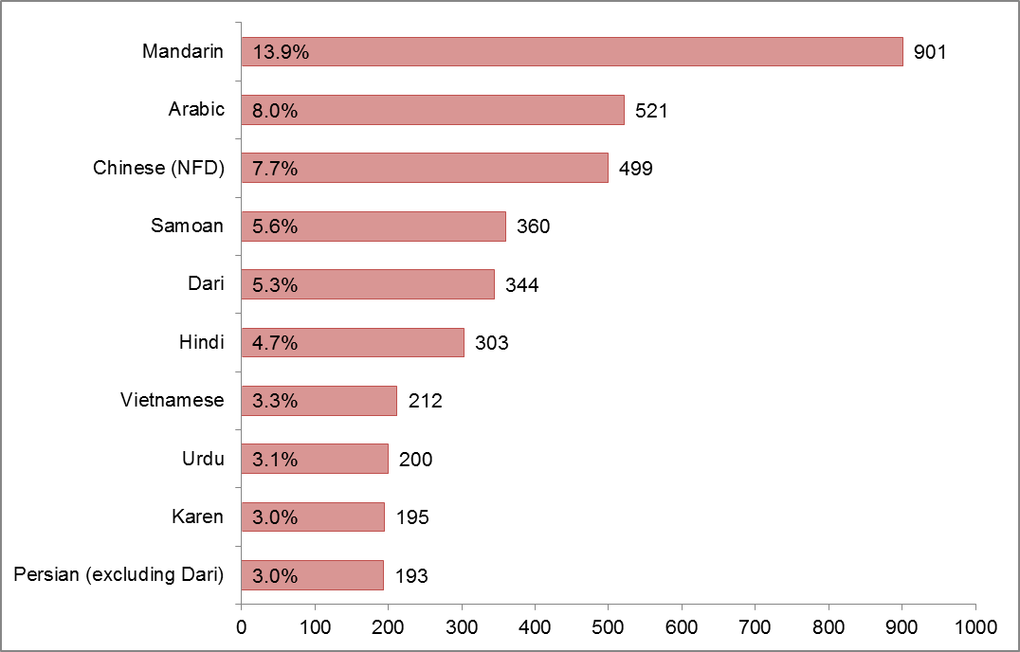
Source: CASES21 2016

Countries of birth
The countries of birth of newly arrived EAL students vary from year to year and reflect world events and Commonwealth immigration policy.
The 6,481 newly arrived EAL students who enrolled in Victorian government schools in 2016 were born in 127 countries.
More than a quarter of these students were born in China (excluding Special Administrative Regions and Taiwan) or India.
Figure 2 below shows the top ten countries of birth of newly arrived students in Victoria in 2016, including the number and the percentage of all newly arrived students.
See Appendix 2 for details of all 127 countries of birth, including distribution across the four regions.

Figure 2: Countries of birth of newly arrived EAL students, government schools, Victoria 2016
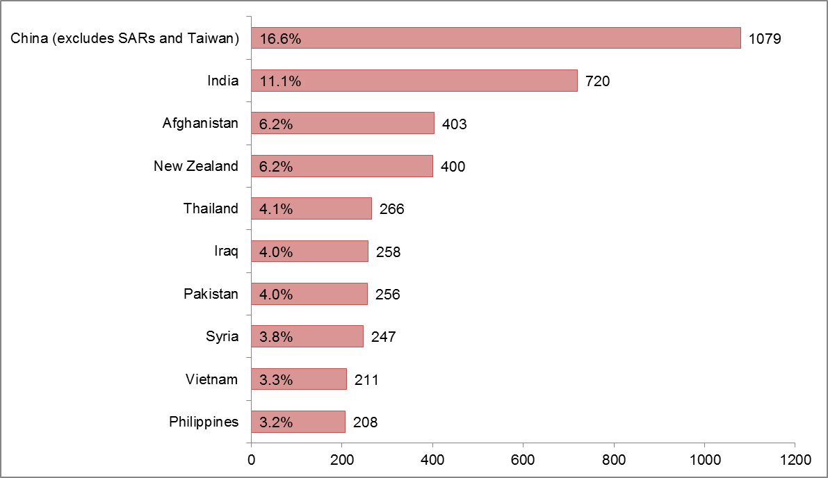
Source: CASES21 2016

Student residency status
Students eligible for EAL services in Victorian government schools include both permanent and temporary residents of Australia. Students may have arrived under the Australian Government’s Migration Program or Humanitarian Program, have been born in Australia or be seeking Australia’s protection.
In Victorian government schools, approximately 66 per cent of newly arrived students in 2016 were permanent residents. As residential status changes from temporary to permanent for some students, the distribution between the two fluctuates within a year.
Table 2 below shows the number and distribution of students by residency status across the four regions and includes a statewide total. The total number of unique students is less than the sum of permanent and temporary figures because, as above, a number of students changed from temporary to permanent visa types during 2016.

Table 2: Residency status of EAL new arrivals, government schools, Victoria 2016
Region | Permanent | Temporary | Total
North Eastern Victoria | 903 | 742 | 1,631
North Western Victoria | 1,019 | 442 | 1,451
South Eastern Victoria | 1,201 | 728 | 1,901
South Western Victoria | 1,208 | 484 | 1,680
State-wide | 4,258 | 2,296 | 6,481
Source: CASES21 2016

Provision across program types
Table 3 below shows the number and distribution of newly arrived students across the types of new arrival programs and regions in 2016. Students spend between six and twelve months in a new arrivals program.
New arrivals not accessing one of the programs below were enrolled in mainstream schools, including schools in regional cities that host English language centres.
The total number of unique students state-wide is less than the sum of students in each region because a number of students moved from one region to another during 2016 and were in programs in both regions.

Table 3: Students in EAL new arrival programs, government schools, Victoria 2016
Program type | NEV  P | NEV  S | NWV  P | NWV  S | SEV  P | SEV  S | SWV  P | SWV  S | State-wide (unique students)
Metropolitan English Language Schools and Centres | 367 | 298 | 214 | 442 | 768 | 659 | 264 | 361 | 3,286
Regional English Language Centres | 49 | 21 | 17 | 8 | 0 | 0 | 109 | 71 | 275
Outpost programs | 0 | 0 | 72 | 0 | 111 | 0 | 209 | 0 | 391
Visiting programs | 61 | 0 | 18 | 0 | 0 | 0 | 16 | 0 | 95
Virtual EAL New Arrivals Program | 12 | 6 | 18 | 0 | 2 | 0 | 10 | 2 | 50
Isolated EAL Student Support program | 3 | 0 | 0 | 0 | 0 | 0 | 5 | 0 | 8

P= Primary student
S= Secondary student
Source: CASES21 2016

Part 2: Provision for EAL students in mainstream schools
Data from the 2015 August school census was used to determine funding for EAL programs in mainstream schools (EAL Index funding) for the 2016 school year, on the basis of the number of students who:
- came from a language background other than English
- spoke a language other than English at home as their main language
- had been enrolled in an Australian school for less than five years
- attracted Student Resource Package funding.
In the 2015 August school census, 27.71 per cent of all students (159,863) were identified as being from a Language Background Other Than English (LBOTE). Of these students, 58,714 met the criteria to receive EAL index funding in a mainstream school.
In 2016, 525 eligible campuses of mainstream schools were provided with EAL Index funding to provide an EAL program. Contingency funding was also allocated to 5 primary schools, 5 secondary schools, one P-9 school and two P-12 schools to provide support for EAL students who had enrolled since the August 2015 census.
Table 4 below shows the number of students in each region who were eligible for EAL funding by year level and region. Approximately 84 per cent of eligible students were in the primary year levels, from Prep to Year 6.

Table 4: Students eligible for EAL funding in mainstream government schools, by year level and region, Victoria, 2016
Year | NEV | NWV | SEV | SWV | Total
Prep | 2,135 | 2,315 | 2,855 | 2,836 | 10,141
Year 1 | 1,983 | 2,225 | 2,617 | 2,644 | 9,469
Year 2 | 1,965 | 2,052 | 2,651 | 2,467 | 9,135
Year 3 | 1,774 | 1,991 | 2,502 | 2,432 | 8,699
Year 4 | 1,609 | 1,842 | 2,215 | 2,167 | 7,833
Year 5 | 519 | 428 | 568 | 561 | 2,076
Year 6 | 487 | 417 | 536 | 515 | 1,955
Year 7 | 429 | 309 | 344 | 425 | 1,507
Year 8 | 452 | 312 | 372 | 407 | 1,543
Year 9 | 443 | 330 | 426 | 459 | 1,658
Year 10 | 507 | 323 | 446 | 489 | 1,765
Year 11 | 461 | 285 | 505 | 498 | 1,749
Year 12 | 341 | 218 | 301 | 324 | 1,184
Total | 13,105 | 13,047 | 16,338 | 16,224 | 58,714

Source: August School Census 2015

Program types
Mainstream schools provide support to EAL students through a number of different types of programs, including:
- timetabled EAL classes taught by specialist EAL teachers
- in-class support (provided by a specialist EAL teacher to a small group of students or single student in a mainstream class)
- withdrawal from a class, in a small group (support provided for either English language learning or curriculum-related content by a specialist EAL teacher)
- withdrawal from class, one-on-one support from a teacher
- team teaching (the joint instruction of a lesson or unit of work by a classroom or subject specialist teacher and an EAL specialist teacher).
In 2016, 515 schools reported on the provision of programs to cater for the needs of primary and secondary students. The most common form of provision for primary students was withdrawal from class, small group support. The most common form of provision for secondary students was through timetabled EAL classes taught by specialist EAL teachers. Many schools provided more than one form of provision, tailored to meet the needs of students according to year level or English language learning need.
Table 5 below shows the types of programs provided in mainstream schools in 2016.

Table 5: EAL program types, mainstream government schools, Victoria 2016
Year levels | Timetabled EAL class | In class support | Withdrawal from class, small group | Withdrawal from class, 1:1 | Team teaching | Other | Total
Primary | 221 | 343 | 439 | 196 | 180 | 126 | 1,505
Secondary | 202 | 69 | 51 | 38 | 25 | 21 | 406
Total | 423 | 412 | 490 | 234 | 205 | 147 | 1,911
Source: Mid-Year School Supplementary Census 2016

EAL student assessment
The English as an Additional Language (EAL) Companion to AusVELS provides a set of standards and a framework for assessing student achievement and developing effective learning programs for students in Victorian schools who are learning English as an Additional Language.
The English language learning progress of EAL students should be assessed against the EAL standards. Table 6 below shows the number of schools that assessed students against the EAL standards and Table 7 shows the number of students assessed against the EAL standards.

Table 6: Government schools that assessed EAL students against the EAL standards, Victoria 2016
School type | NEV | NWV | SEV | SWV | Total
Primary | 93 | 76 | 85 | 74 | 328
Primary/Secondary Combined | 1 | 6 | 3 | 14 | 24
Secondary | 28 | 22 | 22 | 26 | 98
Total | 122 | 104 | 110 | 114 | 450
Source: Mid-Year School Supplementary Census 2016

Table 7: Students assessed against the EAL standards, government schools, Victoria 2016
Student type | NEV | NWV | SEV | SWV | Total
Primary | 4,277 | 4,251 | 6,214 | 6,318 | 21,060
Secondary | 2,355 | 1,600 | 1,979 | 2,309 | 8,243
Total | 6,632 | 5,851 | 8,193 | 8,627 | 29,303
Source: Mid-Year School Supplementary Census 2016

Victorian Certificate of Education EAL Units 3-4
The satisfactory completion of an English study is a compulsory requirement for achieving the Victorian Certificate of Education (VCE). EAL students who are unfamiliar with the English language because they are from language backgrounds other than English or are hearing-impaired may have access to enrolment in VCE EAL. This provision is also available for Aboriginal and Torres Strait Islander students whose first language is not English and who meet the eligibility criteria. Tables 8a and 8b provide the numbers of students who enrolled in VCE EAL Units 3 and 4 in 2016, as a percentage of the whole English group by all schools and government schools respectively. Table 9 provides historical enrolments in VCE EAL Units 3 and 4 for all schools from 2010 to 2016.

Table 8a: Students enrolled in VCE EAL Units 3 and 4 sequence as compared to all students enrolled in the VCE English group by region, all schools, Victoria 2016
Region | EAL | English group | Percentage in EAL
NEV | 618 | 13,394 | 4.6%
NWV | 286 | 9,870 | 2.9%
SEV | 472 | 13,589 | 3.5%
SWV | 381 | 13,017 | 2.9%
*Off-shore providers | 407 | 414 | 98.3%
Total | 2,164 | 50,284 | 4.3%

Table 8b: Students enrolled in VCE EAL Units 3 and 4 sequence as compared to all students enrolled in the VCE English group by region, government schools, Victoria 2016
Region | EAL | English group | Percentage in EAL
NEV | 448 | 6,882 | 6.5%
NWV | 222 | 5,854 | 3.8%
SEV | 367 | 6,784 | 5.4%
SWV | 286 | 6,411 | 4.5%
Total | 1,323 | 25,931 | 5.1%

Table 9: Students enrolled in VCE EAL Units 3 and 4 by region, all schools, between 2010 and 2016
Region | 2010 | 2011 | 2012 | 2013 | 2014 | 2015 | 2016
NEV | 527 | 645 | 637 | 653 | 641 | 673 | 618
NWV | 264 | 247 | 283 | 269 | 269 | 310 | 286
SEV | 441 | 478 | 460 | 492 | 499 | 442 | 472
SWV | 363 | 387 | 430 | 352 | 403 | 433 | 381
*Off-shore providers | 299 | 409 | 364 | 355 | 413 | 497 | 407
Total | 1,894 | 2,166 | 2,174 | 2,121 | 2,225 | 2,355 | 2,164
Source: VCAA 2016. Excludes full-fee paying overseas students
**off-shore providers refers to other countries that provide VCE

Appendix 1: Newly arrived EAL students by language and region, government schools, Victoria 2016
Language | NEV | NWV | SEV | SWV | Victoria (total unique students)
African Languages (NFD) | 1 | 2 | 0 | 7 | 10
African Languages, nec | 0 | 5 | 0 | 1 | 6
Afrikaans | 9 | 4 | 17 | 5 | 35
Albanian | 2 | 1 | 2 | 2 | 7
American Languages | 1 | 0 | 0 | 0 | 1
Amharic | 0 | 5 | 6 | 19 | 30
Anuak | 0 | 0 | 5 | 0 | 5
Arabana | 0 | 0 | 0 | 1 | 1
Arabic | 67 | 275 | 76 | 110 | 521
Armenian | 4 | 0 | 4 | 0 | 7
Assyrian Neo-Aramaic | 0 | 119 | 0 | 49 | 168
Belorussian | 0 | 0 | 0 | 2 | 2
Bengali | 22 | 12 | 8 | 16 | 56
Bisaya | 0 | 0 | 9 | 0 | 9
Bosnian | 0 | 0 | 0 | 2 | 2
Bulgarian | 1 | 0 | 2 | 1 | 4
Burmese | 16 | 1 | 28 | 15 | 58
Burmese and Related Languages (NFD) | 0 | 0 | 0 | 28 | 28
Burmese and Related Languages, nec | 24 | 0 | 0 | 19 | 43
Cantonese | 71 | 17 | 15 | 13 | 112
Cape York Peninsula Languages, nec | 0 | 0 | 0 | 1 | 1
Catalan | 0 | 0 | 0 | 1 | 1
Cebuano | 0 | 3 | 1 | 0 | 4
Chaldean Neo-Aramaic | 0 | 24 | 0 | 0 | 24
Chin Haka | 33 | 0 | 1 | 14 | 47
Chinese (NFD) | 326 | 49 | 73 | 54 | 499
Chinese, nec | 4 | 0 | 0 | 0 | 4
Croatian | 0 | 0 | 0 | 3 | 3
Czech | 0 | 0 | 1 | 1 | 2
Dan (Gio-Dan) | 0 | 0 | 0 | 2 | 2
Danish | 0 | 0 | 1 | 2 | 3
Dari | 7 | 13 | 297 | 27 | 344
Dhanggatti | 0 | 0 | 0 | 1 | 1
Dhivehi | 2 | 0 | 0 | 0 | 2
Dinka | 2 | 1 | 19 | 21 | 43
Dutch | 6 | 3 | 7 | 1 | 17
Estonian | 0 | 0 | 0 | 3 | 3
Fijian | 7 | 0 | 0 | 2 | 9
Fijian Hindustani | 0 | 2 | 0 | 0 | 2
Filipino | 9 | 15 | 30 | 58 | 111
Finnish | 2 | 4 | 9 | 1 | 15
French | 6 | 3 | 32 | 10 | 50
German | 4 | 6 | 14 | 8 | 31
Gilbertese | 0 | 1 | 0 | 0 | 1
Greek | 22 | 7 | 20 | 6 | 51
Gujarati | 23 | 6 | 23 | 14 | 59
Hakka | 0 | 0 | 0 | 2 | 2
Harari | 0 | 2 | 0 | 0 | 2
Hazaraghi | 17 | 5 | 76 | 23 | 120
Hebrew | 2 | 6 | 31 | 1 | 38
Hindi | 84 | 48 | 88 | 87 | 303
Hungarian | 6 | 0 | 1 | 0 | 7
Icelandic | 0 | 0 | 0 | 1 | 1
Igbo | 0 | 0 | 0 | 2 | 2
IIokano | 1 | 0 | 0 | 1 | 2
Ilonggo (Hiligaynon) | 1 | 0 | 0 | 0 | 1
Indo-Aryan (NFD) | 3 | 1 | 1 | 0 | 5
Indonesian | 25 | 19 | 7 | 15 | 63
Iranic (NFD) | 2 | 0 | 0 | 0 | 2
Italian | 2 | 13 | 10 | 4 | 29
Japanese | 4 | 7 | 25 | 1 | 37
Kannada | 5 | 5 | 7 | 8 | 23
Karen | 23 | 26 | 10 | 136 | 195
Khmer | 5 | 1 | 77 | 5 | 87
Kikuyu | 0 | 0 | 1 | 1 | 2
Kirundi (Rundi) | 2 | 0 | 0 | 0 | 2
Koko-Bera | 0 | 0 | 0 | 1 | 1
Konkani | 0 | 2 | 3 | 3 | 8
Korean | 20 | 4 | 7 | 14 | 42
Krio | 2 | 2 | 1 | 0 | 5
Kurdish | 2 | 5 | 0 | 1 | 8
Lao | 2 | 1 | 1 | 0 | 4
Latvian | 1 | 0 | 0 | 0 | 1
Liberian (Liberian English) | 0 | 0 | 1 | 0 | 1
Lithuanian | 0 | 0 | 3 | 0 | 3
Macedonian | 1 | 6 | 4 | 4 | 15
Malay | 9 | 28 | 11 | 3 | 49
Malayalam | 18 | 10 | 38 | 18 | 84
Maltese | 0 | 0 | 0 | 1 | 1
Mandaean (Mandaic) | 0 | 0 | 1 | 0 | 1
Mandarin | 491 | 148 | 212 | 87 | 901
Maori (Cook Island) | 0 | 1 | 6 | 0 | 7
Maori (New Zealand) | 0 | 0 | 1 | 5 | 6
Marathi | 6 | 3 | 12 | 8 | 29
Min Nan | 1 | 3 | 0 | 1 | 5
Mongolian | 0 | 2 | 0 | 6 | 8
Nepali | 7 | 23 | 2 | 11 | 43
Norwegian | 0 | 0 | 6 | 1 | 7
Nuer | 2 | 0 | 3 | 9 | 13
Nyanja (Chichewa) | 0 | 0 | 0 | 1 | 1
Oriya | 1 | 0 | 0 | 0 | 1
Oromo | 0 | 22 | 8 | 4 | 34
Other Southern Asian Languages | 0 | 0 | 0 | 1 | 1
Pampangan | 3 | 0 | 0 | 0 | 3
Papua New Guinea Languages, nec | 0 | 0 | 0 | 1 | 1
Pashto | 12 | 3 | 28 | 5 | 48
Persian (excluding Dari) | 81 | 29 | 69 | 20 | 193
Polish | 1 | 1 | 2 | 0 | 4
Portuguese | 1 | 8 | 5 | 7 | 20
Punjabi | 15 | 37 | 36 | 39 | 125
Rohingya | 0 | 1 | 1 | 0 | 2
Romanian | 0 | 1 | 2 | 0 | 3
Russian | 8 | 4 | 26 | 4 | 42
Samoan | 20 | 103 | 74 | 168 | 360
Serbian | 0 | 0 | 10 | 8 | 18
Shona | 0 | 2 | 2 | 3 | 7
Sindhi | 2 | 2 | 1 | 1 | 6
Sinhalese | 33 | 19 | 46 | 17 | 110
Slovene | 0 | 0 | 2 | 2 | 4
Solomon Islands Pijin | 0 | 0 | 0 | 1 | 1
Somali | 3 | 36 | 4 | 21 | 63
Southeast Asian Austronesian Languages (NFD) | 2 | 1 | 0 | 1 | 4
Southeast Asian Austronesian Languages, nec | 0 | 0 | 1 | 1 | 2
Southern Asian Languages (NFD) | 1 | 2 | 0 | 2 | 5
Spanish | 15 | 24 | 24 | 10 | 70
Swahili | 11 | 1 | 5 | 37 | 54
Swedish | 2 | 1 | 7 | 0 | 10
Tagalog | 8 | 10 | 27 | 46 | 91
Tai, nec | 1 | 0 | 0 | 0 | 1
Tamil | 38 | 20 | 43 | 32 | 132
Telugu | 18 | 8 | 27 | 33 | 85
Tetum | 0 | 0 | 2 | 0 | 2
Thai | 11 | 17 | 30 | 15 | 71
Tibetan | 0 | 1 | 5 | 8 | 11
Tigrinya | 0 | 3 | 0 | 40 | 43
Tok Pisin | 0 | 1 | 1 | 3 | 5
Tongan | 0 | 4 | 2 | 31 | 37
Tulu | 2 | 0 | 0 | 0 | 2
Turkish | 4 | 17 | 6 | 5 | 30
Ukrainian | 1 | 2 | 1 | 0 | 4
Unknown Language | 0 | 2 | 3 | 5 | 10
Urdu | 17 | 88 | 45 | 55 | 200
Vietnamese | 25 | 50 | 54 | 92 | 212
Wu | 2 | 0 | 0 | 1 | 3
Yoruba | 1 | 1 | 1 | 0 | 3
Source: CASES21 2016

Appendix 2: Newly arrived EAL students by country of birth and region, government schools, Victoria 2016
Country of birth | NEV | NWV | SEV | SWV | Victoria (total unique students)
Adelie Land (France) | 1 | 0 | 0 | 0 | 1
Afghanistan | 18 | 14 | 325 | 48 | 403
Albania | 2 | 1 | 1 | 1 | 5
Algeria | 0 | 4 | 0 | 0 | 4
Argentina | 0 | 5 | 5 | 2 | 12
Australia | 0 | 0 | 1 | 0 | 1
Austria | 0 | 1 | 0 | 1 | 2
Bahrain | 2 | 4 | 0 | 0 | 6
Bangladesh | 14 | 11 | 5 | 9 | 37
Belarus | 0 | 0 | 6 | 2 | 8
Belgium | 0 | 0 | 3 | 0 | 3
Bhutan | 0 | 1 | 0 | 1 | 2
Bosnia and Herzegovina | 0 | 0 | 2 | 3 | 5
Brazil | 1 | 11 | 4 | 5 | 19
Brunei Darussalam | 0 | 4 | 0 | 0 | 4
Bulgaria | 0 | 0 | 2 | 1 | 3
Cambodia | 4 | 0 | 71 | 3 | 77
Canada | 1 | 2 | 3 | 0 | 6
Chile | 2 | 3 | 5 | 1 | 11
China (excludes SARs and Taiwan) | 617 | 184 | 248 | 103 | 1,079
Chinese Asia (includes Mongolia) (NFD) | 4 | 1 | 1 | 2 | 6
Colombia | 0 | 0 | 1 | 1 | 2
Congo, Democratic Republic of | 11 | 2 | 0 | 27 | 40
Congo, Republic of | 0 | 0 | 0 | 2 | 2
Cook Islands | 0 | 1 | 4 | 0 | 5
Croatia | 0 | 0 | 0 | 3 | 3
Cyprus | 0 | 0 | 3 | 0 | 3
Czech Republic | 0 | 0 | 1 | 1 | 2
Denmark | 0 | 0 | 1 | 2 | 3
Egypt | 13 | 15 | 10 | 17 | 50
El Salvador | 0 | 1 | 0 | 2 | 3
England | 1 | 2 | 4 | 1 | 8
Eritrea | 0 | 5 | 0 | 15 | 20
Estonia | 0 | 0 | 0 | 3 | 3
Ethiopia | 0 | 32 | 12 | 43 | 87
Fiji | 8 | 4 | 4 | 6 | 21
Finland | 2 | 4 | 7 | 1 | 14
Former Yugoslav Republic of Macedonia (FYROM) | 1 | 5 | 4 | 3 | 13
France | 5 | 2 | 24 | 4 | 35
Germany | 3 | 7 | 12 | 7 | 28
Ghana | 0 | 0 | 0 | 1 | 1
Greece | 22 | 7 | 19 | 6 | 50
Hong Kong (SAR of China) | 87 | 8 | 14 | 7 | 114
Hungary | 6 | 0 | 1 | 0 | 7
India | 180 | 106 | 242 | 212 | 720
Indonesia | 30 | 14 | 6 | 15 | 63
Iran | 83 | 32 | 68 | 21 | 197
Iraq | 11 | 149 | 18 | 81 | 258
Ireland | 1 | 2 | 6 | 0 | 9
Israel | 3 | 4 | 34 | 0 | 39
Italy | 1 | 14 | 8 | 9 | 32
Japan | 9 | 8 | 24 | 1 | 42
Jordan | 3 | 9 | 4 | 6 | 21
Kazakhstan | 1 | 1 | 0 | 0 | 2
Kenya | 1 | 7 | 10 | 19 | 37
Kiribati | 0 | 1 | 0 | 0 | 1
Korea, Republic of (South) | 15 | 4 | 6 | 12 | 34
Kosovo | 0 | 0 | 0 | 1 | 1
Kuwait | 3 | 8 | 2 | 1 | 14
Laos | 2 | 1 | 1 | 0 | 4
Latvia | 1 | 0 | 1 | 0 | 2
Lebanon | 2 | 11 | 6 | 8 | 27
Liberia | 0 | 0 | 1 | 2 | 3
Libya | 0 | 1 | 0 | 0 | 1
Lithuania | 0 | 0 | 2 | 0 | 2
Macau (SAR of China) | 3 | 0 | 0 | 0 | 3
Malawi | 1 | 0 | 0 | 2 | 3
Malaysia | 69 | 28 | 29 | 24 | 145
Maldives | 2 | 0 | 0 | 0 | 2
Malta | 0 | 0 | 0 | 1 | 1
Mauritius | 1 | 1 | 3 | 4 | 8
Mexico | 2 | 2 | 0 | 0 | 3
Mongolia | 0 | 3 | 1 | 6 | 10
Morocco | 2 | 0 | 0 | 0 | 2
Myanmar, The Republic of the Union of | 50 | 8 | 7 | 88 | 152
Namibia | 0 | 0 | 0 | 1 | 1
Nepal | 6 | 22 | 3 | 10 | 41
Netherlands | 6 | 5 | 4 | 2 | 17
New Zealand | 46 | 78 | 77 | 201 | 400
Nigeria | 1 | 1 | 1 | 1 | 4
Norway | 0 | 0 | 5 | 2 | 7
Oman | 0 | 4 | 1 | 1 | 6
Pakistan | 35 | 79 | 99 | 49 | 256
Papua New Guinea | 0 | 3 | 1 | 5 | 9
Philippines | 21 | 29 | 62 | 97 | 208
Poland | 2 | 1 | 2 | 0 | 5
Portugal | 0 | 0 | 1 | 2 | 3
Qatar | 0 | 3 | 1 | 2 | 6
Romania | 0 | 1 | 2 | 0 | 3
Russian Federation | 7 | 0 | 15 | 2 | 24
Samoa | 6 | 66 | 41 | 78 | 187
Samoa, American | 0 | 0 | 2 | 2 | 4
Saudi Arabia | 3 | 10 | 15 | 5 | 33
Serbia | 0 | 0 | 6 | 7 | 13
Seychelles | 0 | 0 | 1 | 0 | 1
Sierra Leone | 0 | 0 | 2 | 0 | 2
Singapore | 12 | 6 | 8 | 8 | 33
Slovenia | 0 | 0 | 2 | 2 | 4
Solomon Islands | 2 | 0 | 0 | 1 | 3
Somalia | 3 | 28 | 1 | 12 | 43
South Africa | 12 | 8 | 16 | 5 | 41
South Sudan | 3 | 0 | 1 | 19 | 23
Southern Asia (NFD) | 1 | 0 | 0 | 0 | 1
Spain | 7 | 9 | 5 | 4 | 22
Sri Lanka | 36 | 21 | 49 | 22 | 123
Sudan | 0 | 2 | 18 | 17 | 37
Sweden | 3 | 2 | 5 | 0 | 9
Switzerland | 0 | 0 | 7 | 6 | 13
Syria | 31 | 181 | 15 | 21 | 247
Taiwan | 10 | 5 | 8 | 1 | 24
Tanzania | 0 | 0 | 0 | 3 | 3
Thailand | 36 | 38 | 57 | 137 | 266
Timor-Leste | 0 | 0 | 2 | 1 | 3
Tonga | 0 | 0 | 1 | 2 | 3
Turkey | 1 | 14 | 6 | 5 | 24
Uganda | 2 | 1 | 0 | 0 | 3
Ukraine | 1 | 4 | 3 | 2 | 9
United Arab Emirates | 8 | 16 | 10 | 9 | 43
United Kingdom, Channel Islands and Isle of Man | 10 | 2 | 12 | 4 | 28
United States of America | 14 | 11 | 8 | 10 | 43
Unknown Country | 1 | 0 | 0 | 0 | 1
Uruguay | 0 | 0 | 2 | 1 | 3
Uzbekistan | 0 | 0 | 1 | 0 | 1
Venezuela, Bolivarian Republic of | 0 | 1 | 3 | 2 | 6
Vietnam | 25 | 49 | 54 | 92 | 211
Yemen | 2 | 1 | 0 | 0 | 3
Zimbabwe | 1 | 1 | 2 | 1 | 5
Source: CASES21 2016

