# Who, what, where, when, why?

**Expressing and developing ideas in images**

Students learn how effective creators of visual texts use a range of visual semiotic (meaning making) choices including symbols, line, vectors, and size to express actions and ideas, to represent the participants (the characters, or things/objects seen), the nature of the events, and the circumstances.

For each discussion question, ask students to expand on their responses by explaining reasons why, and encourage them to use evidence from the image to justify their responses, using visual design metalanguage.

1. What type of text is this image from?
2. What is this image about?
   * who and what is in this image? Who are the main participants – characters, or things/objects – seen?
   * what is happening? What are different participants/objects doing?
   * where and when and why is this happening? What information is provided in the image which tells us about the circumstances surrounding these participants and actions?

# Symbols

Symbols or signs can be used to as short cuts to represent ideas or concepts. Symbolic aspects can include choice of casting, design of hair and make-up, choices of costume, props, and objects. It also includes icons. For example, the Eiffel Tower is a symbol often used to represent the city of Paris, heart symbols are used to represent love, and the colour red to symbolise danger, or perhaps romance, depending on the context.

Symbols can also be used present concepts, and information in diagrams, graphs, timelines and other forms of visual information texts.

**Symbols Example 1**



From INTO THE FOREST by Anthony Browne   
© 2004 Anthony Browne   
Reproduced by permission of Walker Books Australia Pty Ltd

Discussion prompts: What things do you see in this image which you recognise from somewhere else?Why has the author, Anthony Browne, chosen to use these symbols? What might this mean for what is happening this story?

For example, in this image, the small figure is wearing a red hooded cloak and carrying a basket, and there is small cottage in the woods. These items together symbolise the well-known story of Red Riding Hood. These symbols might be used here to signify to the reader that the character in the image is heading into danger.

**Symbols Example 2**



From PIGGYBOOK by Anthony Browne   
© 1986 Anthony Browne   
Reproduced by permission of Walker Books Australia Pty Ltd

Discussion prompts: Why has the author, Anthony Browne, chosen to use pigs as the characters here?What might this mean for what is happening this story? How are the pigs shown? What are they wearing? What do their dirty clothes tell us?

Who is outside the window ? Why do you think the author included a wolf? What does a wolf usually symbolise? How might this story change, if the main characters were represented as wolves instead of pigs?

For example, the casting of pigs as the main characters in this story is symbolically important information, and so are the dirty clothes they are wearing. Animals can be used to represent different things in different cultures and contexts. Pigs are often used to signify uncleanliness, and this is reinforced here by the state of their clothes. In contrast, the presence of a wolf adds another dimension, as the wolf is often cast as the bad character in children's stories.

# Lines

Choices about use of line in an image include: straight or curved, length, angle, intersection of vertical and horizontal lines, and direction. Lines are used in images to indicate movement and direction. Lines can be natural, formed by objects in the image, or artificial lines created by the author, using subject gaze or pointing for example.

Discussion prompts: What sort of lines do you see in this image? Are these lines formed by natural objects in the image or created by the image maker? Where do the lines take your eye? What information does this use of straight/curved/intersecting lines give the audience about the circumstances of this situation? Why has the author chosen to use these lines like this? How would meaning change if these straight/curved/intersecting lines were replaced with a different type of line?

**Straight lines example**



CC0 <https://pixabay.com/en/road-road-marking-street-miles-166543/>

**Curved lines example**



From Are We There Yet? by Alison Lester   
Text and illustrations © Alison Lester, 2004   
Published by Viking Reprinted by permission of Penguin Random House Australia Pty Ltd

**Intersecting lines example /**



CC0 <https://pixabay.com/en/building-low-angle-shot-man-person-1853486/>

# Vectors

A vector shows action and direction in an image through lines. A vector can be a visible line, for example use of lines in the three examples of lines above to indicate direction. A vector can indicate movement in a still image, for example using arrows in a diagram (Example 1).

Lines can also can indicate direction and movement in a still image. For example, as shown in Example 2, sets of lines indicate a dog is jumping and wagging its tail.

Vectors can also be created using the line of a shadow or an object, subject gaze or eyeline, or a pointing arm or finger.

Discussion prompts: What sort of vectors do you see in this image? Are these vectors formed by natural objects in the image or created by the image maker? What information does this use of vectors give the audience about the circumstances surrounding these participants and actions?

**Vectors Example 1**



CC-BY-4.0. [domdomegg](https://en.wikipedia.org/wiki/File:Continental-continental_destructive_plate_boundary.svg) (https://en.wikipedia.org/wiki/File:Continental-continental_destructive_plate_boundary.svg)

**Vectors Example 2**

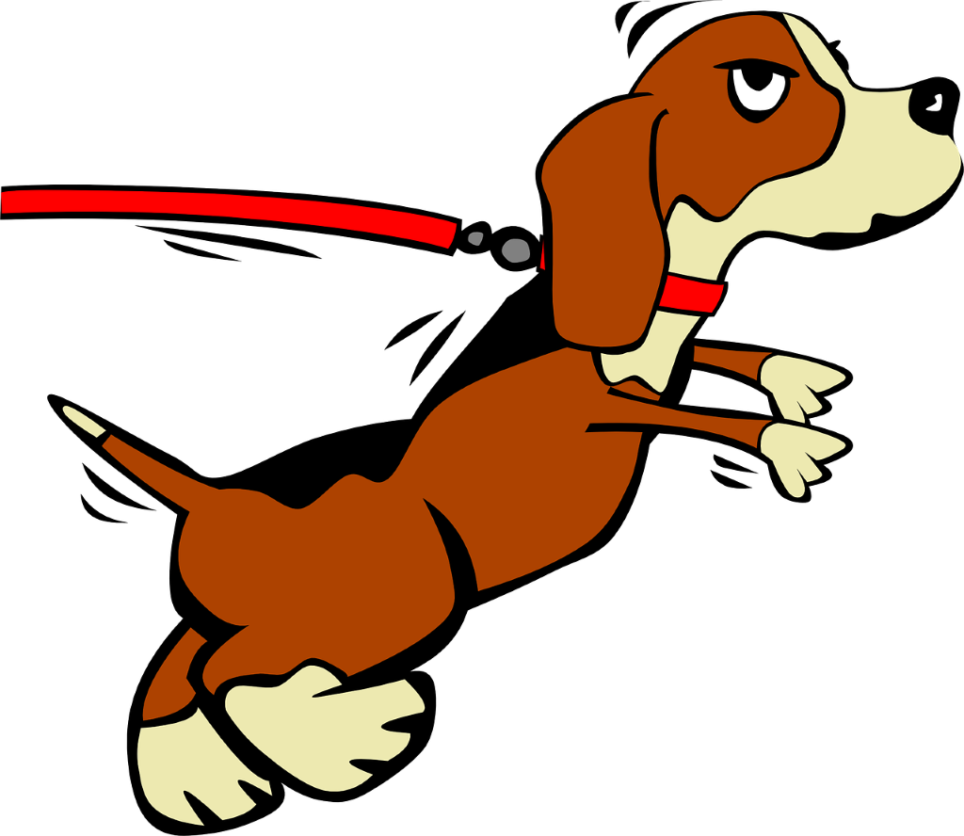

Creative Commons CC0 <https://pixabay.com/en/puppy-leash-leashed-jumping-collar-32025/>

# Size

Choices about size of objects in an image is a comparative process.

Discussion prompts: How big is something in the image in relation to something else? What information does this use of size give the audience about the circumstances of this situation? Why has the author chosen to use size like this? What might this mean? How would meaning in this image change if the size of the objects changed or were reversed?

**Comparative size example 1**



CC0 <https://pixabay.com/en/giant-small-large-crush-fear-1013693/>

**Comparative size example 2**



CC Attribution 3.0 Unported (Attribution required) [Conty](https://commons.wikimedia.org/wiki/File:5_year_Tarbosaurus_%26_IVPPV4878_(shanshanosaurus)_siz%20e_comparison.jpg)

https://commons.wikimedia.org/wiki/File:5_year_Tarbosaurus_%26_IVPPV4878_(shanshanosaurus)_siz e_comparison.jpg