  - Blending sounds into words
The adapted diagram below shows that blending sounds into words is the third skill contributing to phonemic awareness. Phonemic awareness is an important sub-set of phonological awareness because it has a reciprocal relationship with reading (Hoover & Tunmer, 2020, p. 66).
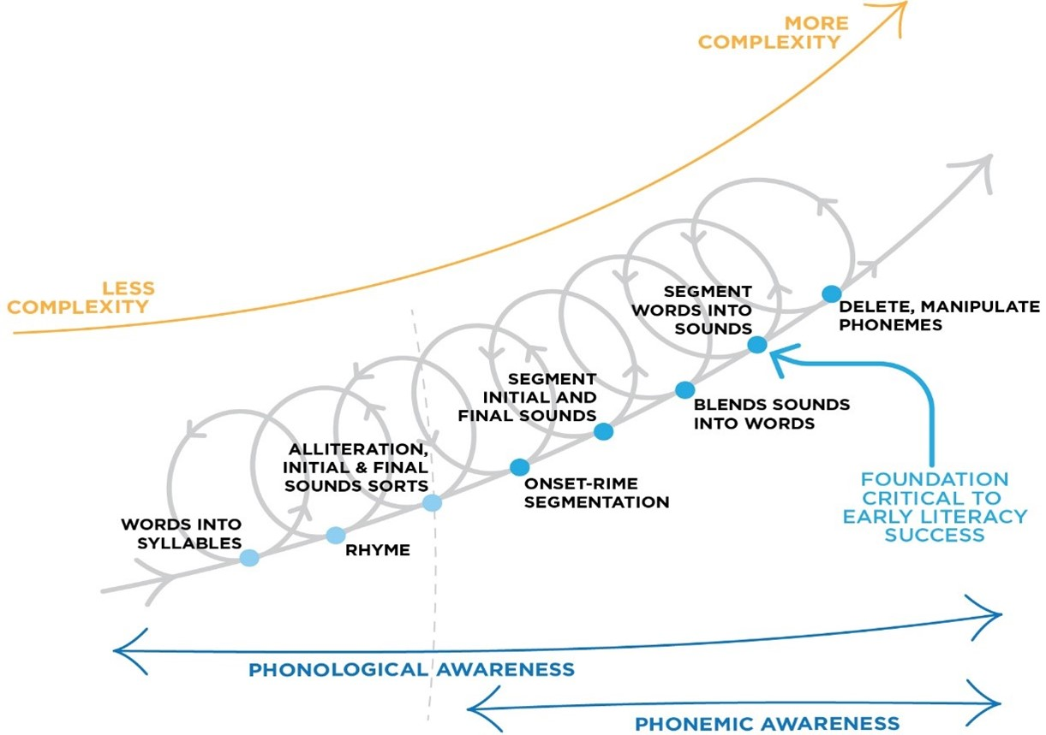
Blending sounds into words is a critical component of phonemic awareness, which mimics the process of sounding out unfamiliar words. For example, to read the word scrap, children have to retrieve the sound for each of the graphemes in the word /s/ /c/ /r/ /a/ /p/, then blend them together to decode the word.
Note about phoneme counters
In these sections, counters will be used to count the sounds (phonemes) in words. Blue counters represent consonants, and red counters represent vowels. It is useful for teachers to use a different colour or shape to distinguish between vowels vs. consonants when students are blending and segmenting sounds. However, the colours chosen for this resource are only one way of doing this, and teachers devise their own systems for differentiating between consonants and vowels.

Consonant Sounds

Vowel Sounds

With students, physical counters or other small objects (e.g. buttons) can be used to represent phonemes. These can be useful to help children count and keep track of the number of phonemes in each word.

For example, the counters can be used to represent the phonemes in the following words:
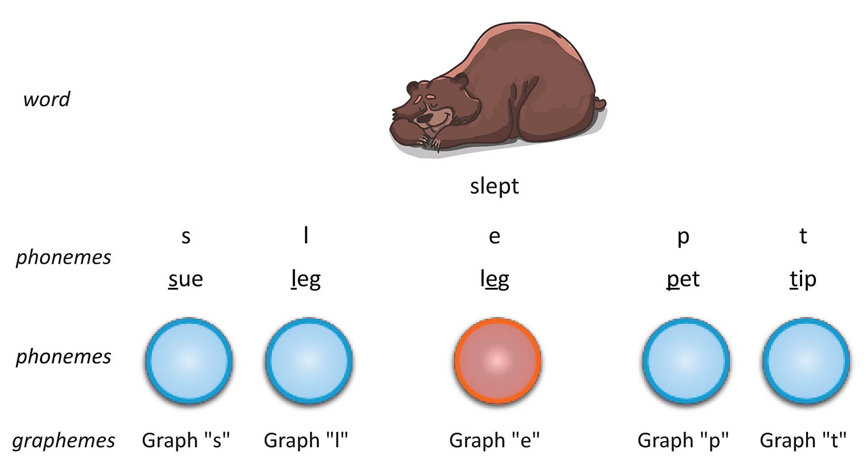
5 Phonemes

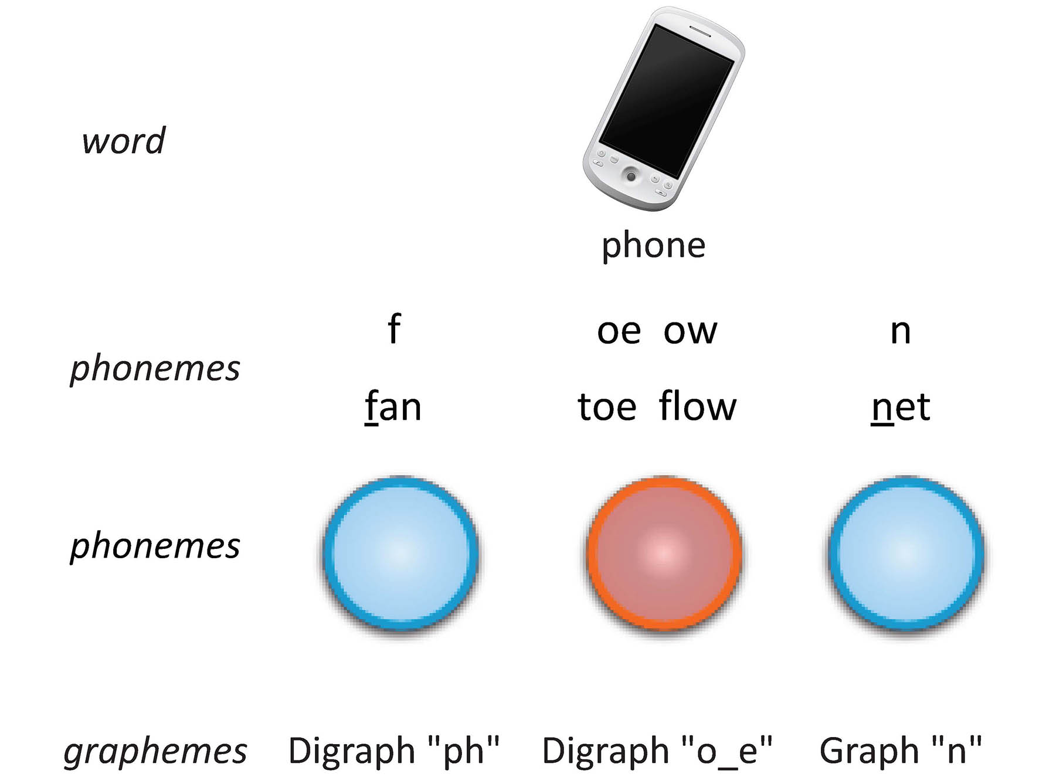
3 Phonemes

Counters can also be used to count phonemes in children's workbooks, or on digital whiteboards, to demonstrate the number of consonant and vowel phonemes in each word.
Blending sounds into words can be achieved by providing activities that present groups of phonemes and ask students to blend them together. These activities can take place as a whole class, small group, or individual work.
When applying blending skills to written words, teachers can incorporate blending activities as part of modelled reading, shared reading, or guided reading, especially when students have difficulty decoding an unfamiliar word.
1. Teachers can say the sounds out-loud:
phonemes | f  fan | oe ow  toe flow | n  net
2. Help students to hear each phoneme:
3. And encourage students to blend the sounds together to make the word:
Here's another example using the word "glide"
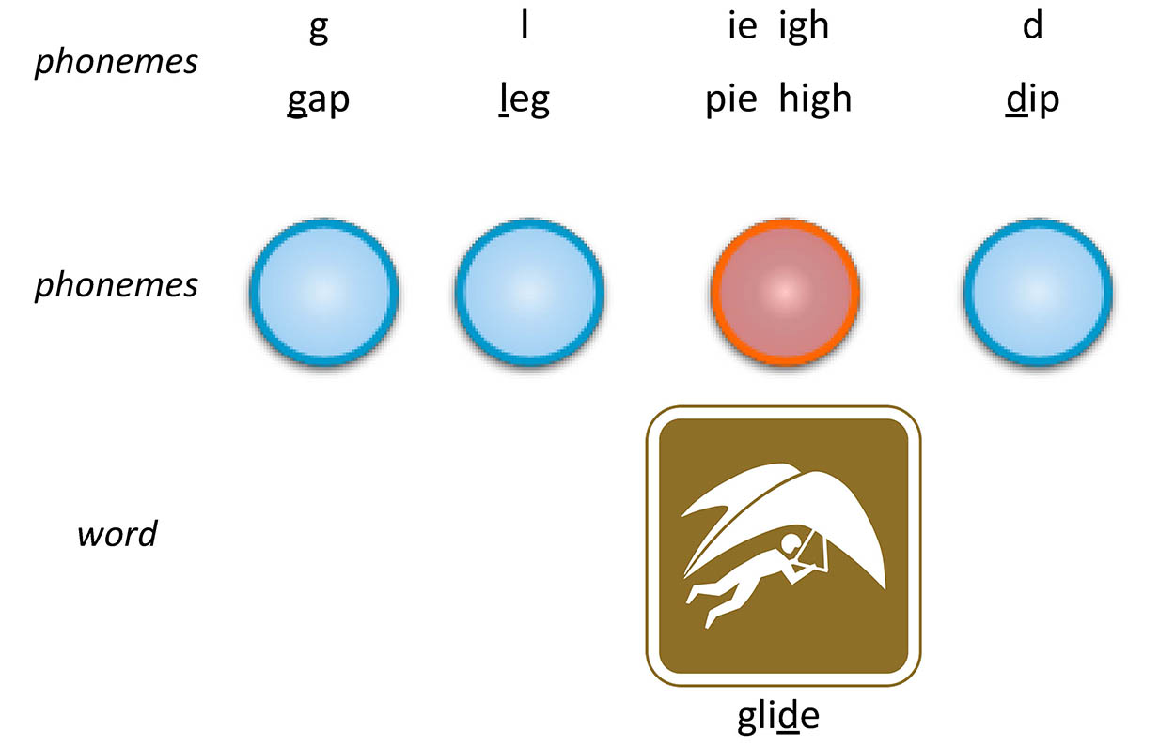
It is also important to promote the blending of sounds into words during reading activities. For example, a student (or class) may come across the written word "shrimp". The word can be broken into its graphemes, which all have corresponding phonemes. These can be counted using counters or on student's hands. Then these phonemes can be blended together to say the spoken word "shrimp".
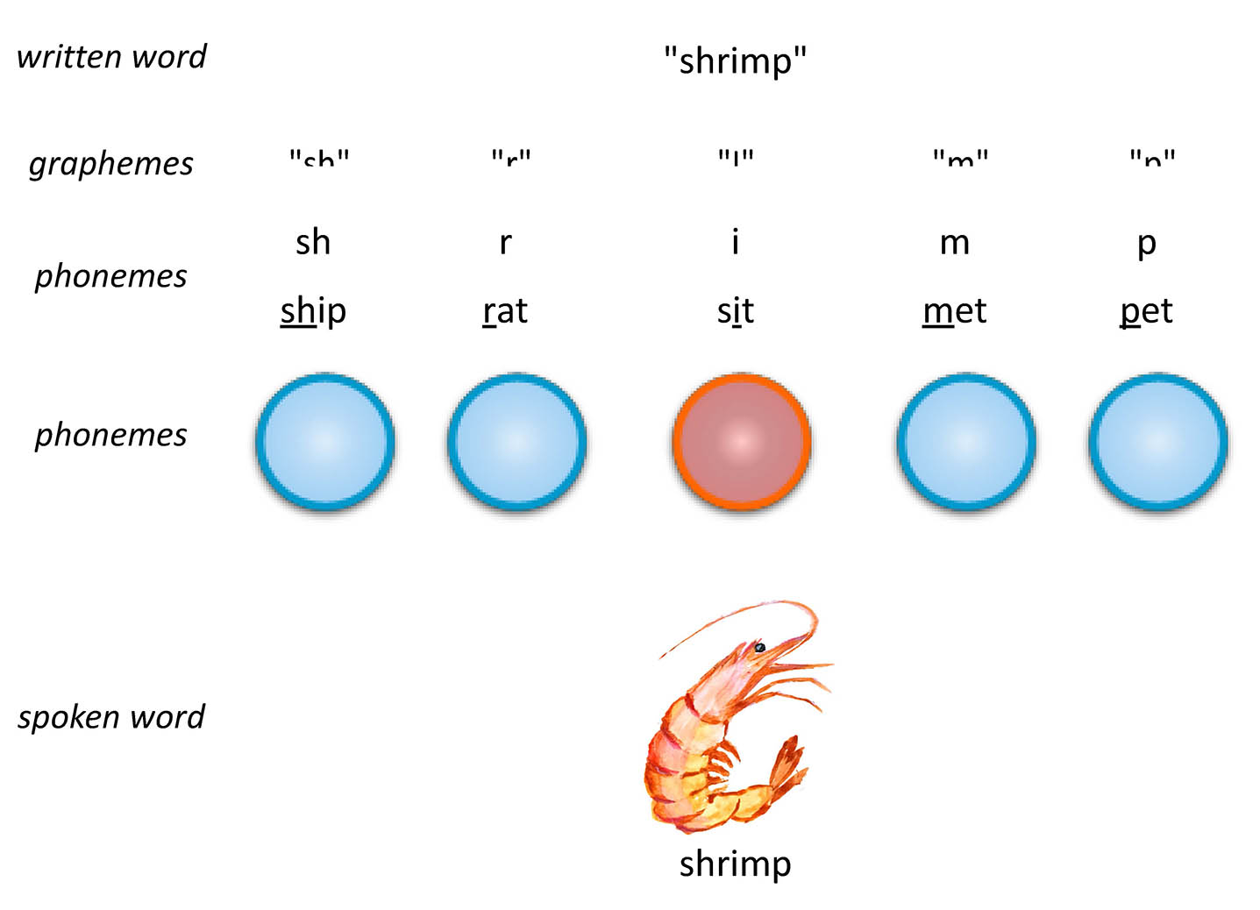
Here is another example using the written word "pancake". Note this word has two syllables, so it can be useful to break the sound into syllables first, using a syllable break (.).
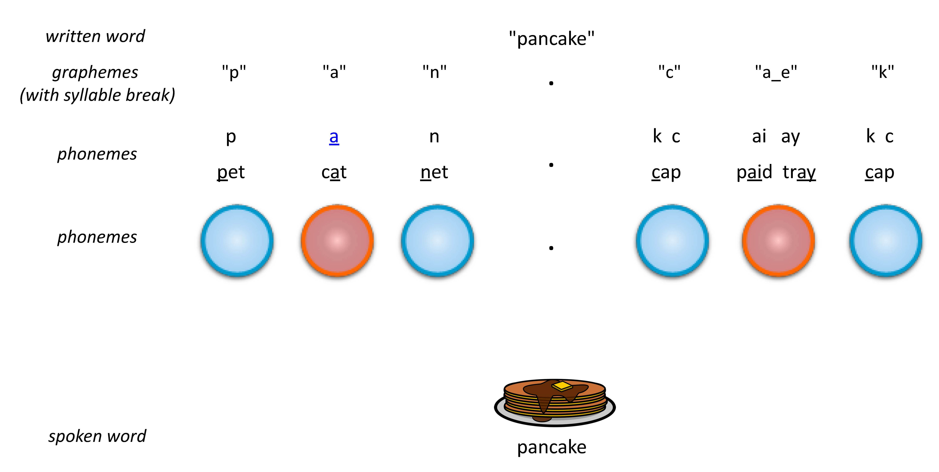
References
Hoover, W. A., & Tunmer, W. E. (2020). The cognitive foundations of reading and its acquisition: A framework with applications connecting teaching and learning. Cham: Springer.
Diagram above adapted from Schuele & Boudreau (2008). Phonological Awareness Intervention: Beyond the Basics. Language, Speech, and Hearing Services in Schools 39, 3-20.

