WORKSHOP ACTIVITY INSTRUCTIONS
________________________________________________________________________________________________________________________________
Activity – Storytelling
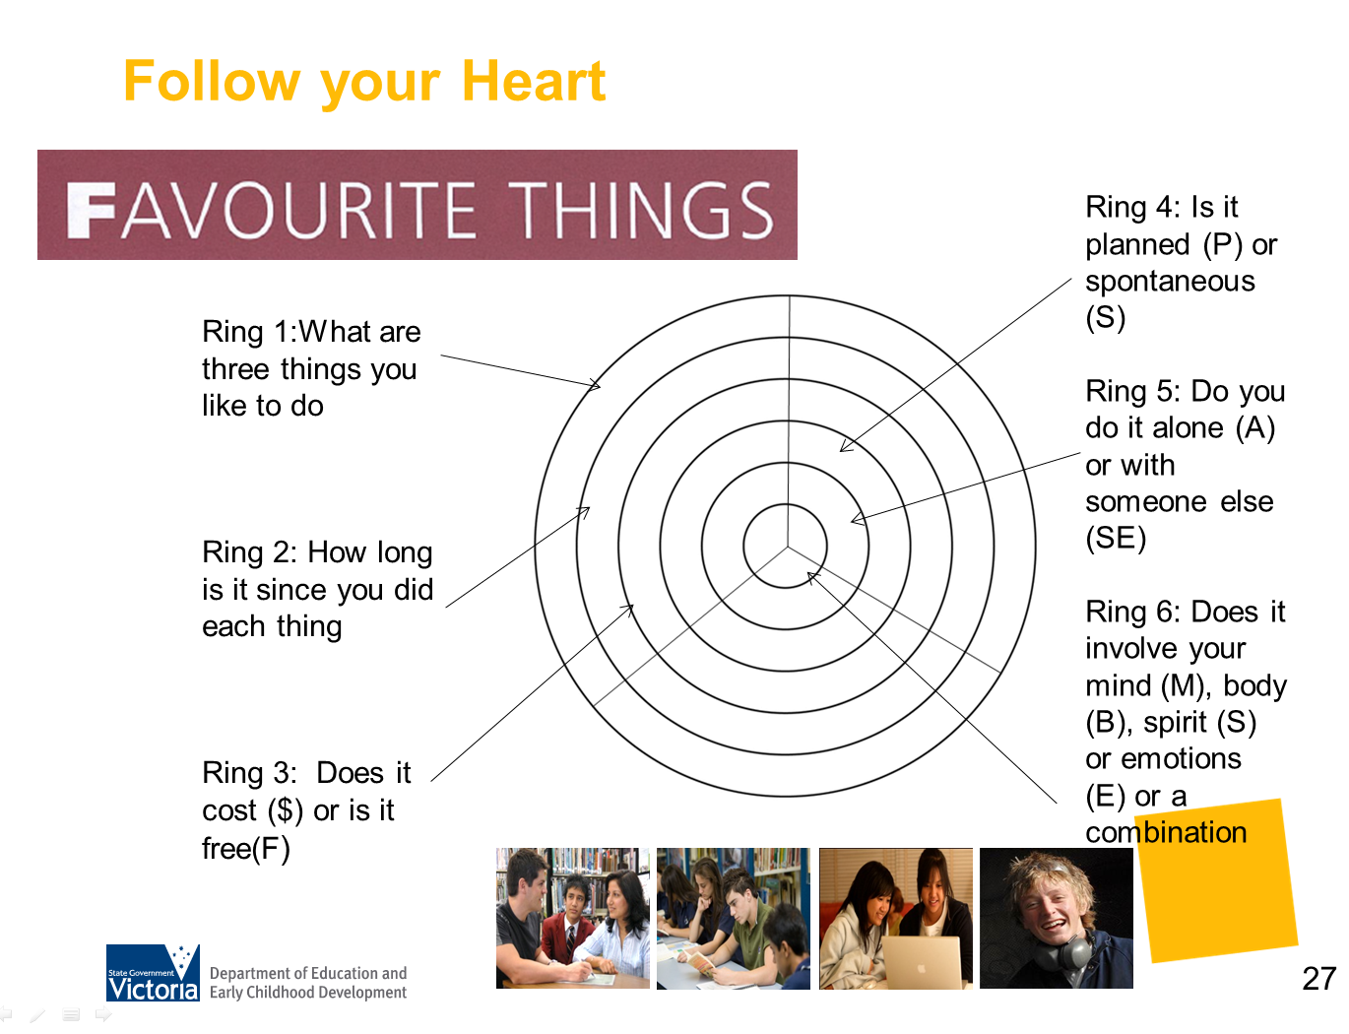
What is the purpose of this activity?
In this exercise, parents are asked to tell a story about themselves and are taught how to reflect and self discover by using the story to illustrate attitudes and skills. The key is to engage the parents in the process, so start where the parent is engaged, in life! This activity could connect to Favourite Things. Ask parents to choose one thing from his or her list to talk more about.

Time: 5-10 minutes

Materials: White board or butcher paper, markers or pens

Preparation:

How do I do this activity?
The story
Ask a parent to volunteer to tell a story, it has to be specific; a particular experience that was a good experience. For example, rather than ‘I enjoy cycling’ they need to tell you of a particular experience they have enjoyed, for example, ‘I enjoyed learning cycling in a charity ride’.

As they tell their story, write it up on a chart or a whiteboard. Put the story in their language and by-pass any negative self-talk, writing up the positive. A technique that may help them talk about their story is the use of STAR (situation, tasks, action, action results).

Use these questions to help parents to talk about their experience and how it relates to the world of work. For example:

- What did you particularly enjoy? (interests)
- What were the challenges? (dealing with difficulties and challenges)
- When did you start? Have you always...?
- What did people think? Did anyone help you? (others’ perspectives and allies)
- Why did you choose this particular time/experience? What stands out in your mind about this time/experience?
- What happened in this experience?
- Tell me a little bit about it?
- What made this experience good for you?
- What else made it good?
- When did this happen? Where?
- Was anyone with you? Who?
- Can you remember anything else about it?

The reflection
Ask the parent ‘What does this say about you as a person?’ The idea is to teach them the skill of reflection – this gives them ownership and helps them to discover their skills. You are teaching them to connect to the world of work by identifying the skills a young person is using in a particular activity; you are also teaching them the language of skills that are used in the world of work, a very important learning vocabulary.

Things to consider when using this activity
Some participants may be hesitant to share their stories due to language barriers or lack of confidence. Presenters may consider conducting this activity with a colleague or preselected participant to remove the pressure to volunteer.

Source: “Hope-Filled Engagement”, Gray Poehnell & Norman E. Admundson http://www.ergoncommunications.com/books/
or
http://www.brightandassociates.com.au/cgi-bin/oscommerce/product_info.php?products_id=58

SAMPLE:
CHARITY BIKE RIDE

- Outdoors  - Sunny  - Exercising  - Feels good  - Ride with friends  - Helping others  - Its fun  - Need to eat well  - Finding time to train | - Dad taught me to ride  - Practiced a lot  - Lots of training  - Friend suffered from this illness  - Worst time of my life watching him suffer  - Makes me exercise  - Good for me
(the statements above reflect the type of answers you will get from your questioning)

- I like to be outside
- Its important to me to help others
- I learn by doing
- I am persistent and willing to work hard
- Its important to me to be with friends
- If I’m determined to make something happen, it will happen

(these are the sort of statements you will get in reflecting of the story – they will reflect values, interests, attributes and skills)

