ACTIVITY INSTRUCTIONS
________________________________________________________________________________________________________________________________
Activity – Stages of Career Development
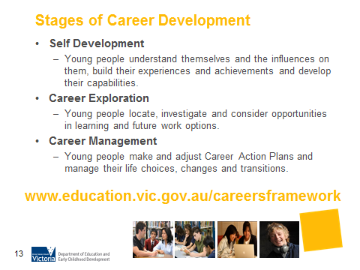
What is the purpose of this activity?

Understanding the three stages of career development that underpin the structure of the Victorian Careers Curriculum Framework will assist parents in having career conversations with their children. This activity provides discussion to show that the stages are not linear but circular and will continue throughout life/career path.

Time: 3 minutes

Materials: None

Preparation:
There are three stages of career development that underpin the structure of the Victorian Careers Curriculum Framework.
- Self-development is an important process for all young people. Young people benefit from positive self-reflection and awareness of positive attributes that will assist them in preparing for the world-of-work, and recognising their existing skills, interests, personal style, values etc. they may already have and use in everyday life.
- Knowing what opportunities are available and the requirements for entry into the workforce through career exploration is a foundation of career development. Before entering any workplace, young people need an understanding of what to expect, and the employer/employee rights and responsibilities, in particular issues of Occupational Health and Safety.
- Career Management is the consolidation of self-development and career exploration by encouraging young people to make and adjust Career Action Plans in order to successfully manage their life choices, changes and transitions.

How do I do this activity?
Discussion:
- Do these stages occur only once or throughout life?
Introduce the concept of the ‘circle’. People’s life/career paths are not linear but circular. It is a journey. The stages of career development will continue throughout our life/career path.
See Holistic Life/Career Counseling pages 70-71, Hope-Filled Engagement.

- Ask participants how they could assist their teenager through these stages.

Things to consider when using this activity:
- The word “stages” may imply that each stage is separate and sequential. Discussion of the stages should make clear that it is common for people to explore the three stages at the same time.

Source:
- www.education.vic.gov.au/careersframework
- Hope-Filled Engagement Gray Poehnell & Norman E. Admundson http://www.ergoncommunications.com/books/
http://www.brightandassociates.com.au/cgi-bin/oscommerce/product_info.php?products_id=58

