WORKSHOP ACTIVITY INSTRUCTIONS
________________________________________________________________________________________________________________________________
Activity – Career Terms and Definitions
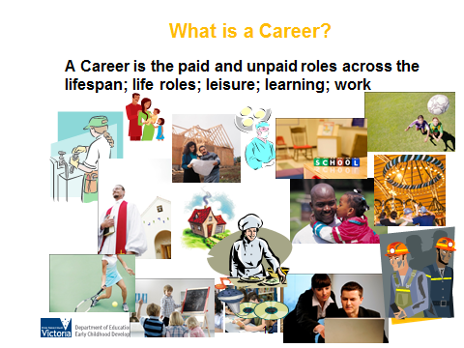
What is the purpose of this activity?
Being clear about career terms and definitions will help parents understanding, assist communication and ensure parents are engaged. This activity provides some of the key terms that will help parents to better understand the contemporary notions of career development.

Time: 10 minutes

Materials: Career Terms and Definitions table, blank table (for matching the answers) and handout attached. Envelopes enough for each pair of parents.

Preparation: Print the following Career Terms and Definitions table (enough copies for each pair). Cut out each term and definition and place into an envelope. Repeat this process so that each group has one envelope.

How do I do this activity?
- Get parents to sit in pairs.
- Give each group an envelope containing separate pieces of paper with the careers terms or definitions printed on them.
- Ask each pair to match a term to the definition and place on the blank template.
- Distribute the handout and ask parents if they matched the terms and definitions correctly.

What are some variations of this activity?
Discuss the term ‘career craft’. What are the first five words that come to mind for ‘craft’? Compare this with the term ‘management’. Does ‘craft’ convey more positive feelings? What does crafting one’s career suggest to you? Read CareerCraft pages 99-105, Hope-Filled Engagement.

Alternative Activity:

Time: 10mins

Materials: “MY CAREER” template, pens or pencils

Preparation: Print the following MY CAREER template (enough copies for each person).

How do I do this activity?
- Give each person a “MY CAREER” template.
- Ask them to think about their life to date and complete each section of the template as it relates to them or their young person.
- Gather feedback and discuss the content as a group.
- Highlight the many aspects to our career and that paid work is one small part; but even if we don’t have anything in the paid work section of the template we still have a career; as demonstrated by the other aspects of our lives.

Considerations when using these activities:
- These activities are designed to not only inform, but to create hope. The alternative activity can be very powerful when used in workshops for parents of young people with a disability.

Career Terms and Definitions
Career | The sequence and variety of work roles (paid and unpaid), which one undertakes throughout a lifetime, including life roles, leisure activities, learning and work.
Career Education | The development of knowledge, skills and attitudes though a planned program of learning experiences in education and training settings which will assist young people to make informed decisions about their study and/or work options and enable effective participation in working life.
Career Development | The process of managing life, learning and work over the lifespan.

Career Terms and Definitions – blank template
Career

Career Education

Career Development

MY CAREER

A Career is the paid and unpaid roles across the lifespan; life roles; leisure; learning; work

Informal Learning | Formal Learning | Unpaid Work | Paid Work | Leisure Activities | Life Roles

