The Team Around the Learner Planning Improvement Tool is designed to help schools to put in place enhancements to current practice for any phase of the TAL approach identified as needing development, once the TAL rubric has been considered.
Instructions:
- Schools are asked to gather feedback from a range of staff to determine where they sit at each stage of the Team Around the Learner phase on the accompanying Rubric (hyperlink)
- Refer to the completed self-assessment on the Rubric to complete the Planning Improvement Tool (hyperlink)
- Once you have identified your strengths, schools are asked to collate and record:
- the evidence that demonstrates the established practice, including current strengths and effectiveness
- the next steps needed to improve practice
- an implementation plan
- the tools/resources required to improve practice
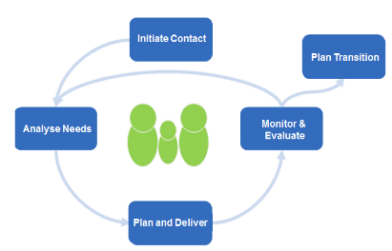
Plan &
Coordinate
Support
Monitor &
Evaluate
Initiate Contact
Analyse Needs
Plan Transition
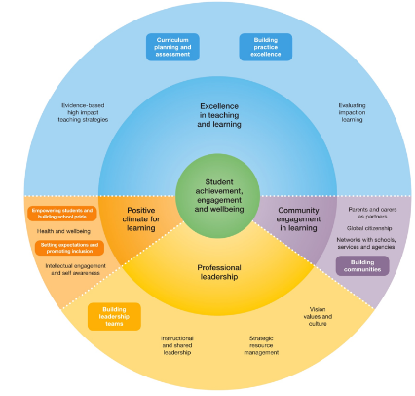
.

The FISO Improvement Cycle closely matches the Team Around the Learner pathway
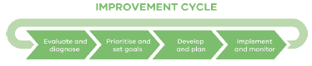

Schools use the FISO Improvement Cycle to:
• Evaluate and diagnose their performance successes and challenges around their key improvement initiatives and strategies
• Prioritise and set goals for improvement strategies and initiatives that have the greatest impact on student learning
• Develop and plan their improvement strategies and initiatives to ensure successful implementation
• Implement and monitor their selected improvement strategies and initiatives and the impact these have on student learning.

FISO IMPROVEMENT CYCLE
Evaluate and diagnose | Prioritise and set goals Develop and plan | Implement and monitor
Initiate Contact
Identified Level | Evidence of current practice/strengths | Next Steps – to move to next level | What we will do? | How will we get there? How will we know when we are successful?
Analyse Needs
Identified Level | Evidence of current practice/strengths | Next Steps – to move to next level | What we will do? | How will we get there? How will we know when we are successful?
Plan & Co-ordinate Support
Identified Level | Evidence of current practice/strengths | Next Steps – to move to next level | What we will do? | How will we get there? How will we know when we are successful?
Monitor & Evaluate Outcomes
Identified Level | Evidence of current practice/strengths | Next Steps – to move to next level | What we will do? | How will we get there? How will we know when we are successful?
Plan Transition (from additional support)
Identified Level | Evidence of current practice/strengths | Next Steps – to move to next level | What we will do? | How will we get there? How will we know when we are successful?

