What is Team Around the Learner?

Team Around the Learner (TAL) provides a structured framework within a Multi-Tiered System of Support (MTSS) for a whole-school approach to support all learners.
TAL brings together a team to support learners at all levels within MTSS.
Tier 1: interventions are universal in design and are intended to provide a preventative framework for student support. The TAL approach in Tier 1 would include the learner, the teacher and the family.
Tier 2: it is identified that some additional support is required. The TAL approach identifies and engages additional team members to provide more complex supports. Within Tier 2, it is common for the school wellbeing team to have a more active role.
Tier 3: interventions occur once it has been identified that the learner requires targeted support. The TAL approach at Tier 3 again seeks external supports, broadening the team to include relevant professional support staff, which may include Student Support Services (SSS), Visiting Teachers (VT), Koorie Engagement Support Officer (KESO) or relevant staff from other Departments including Department of Health and Human Services (DHHS).
All students require some degree of support. The TAL approach can be implemented as early as additional needs are identified. Although not all issues experienced by learners are initially problematic, it is beneficial to support the learner as early as possible to prevent such issues impacting on their learning.
TAL is not a new concept. It describes good practice in supporting learners and makes use of resources and processes that are already in use in schools such as Student Support Group (SSG), Individual Education Plans (IEPs).
TAL enables an effective and consistent model of practice and complements the broader Departmental School-wide Positive Behaviour Support (SWPBS) framework.
TAL reduces duplication and fragmentation in supporting learners by ensuring there is one coordinated plan for improvement that articulates the role of each team member.
TAL is relevant to all sections of the Framework for Improving Student Outcome.
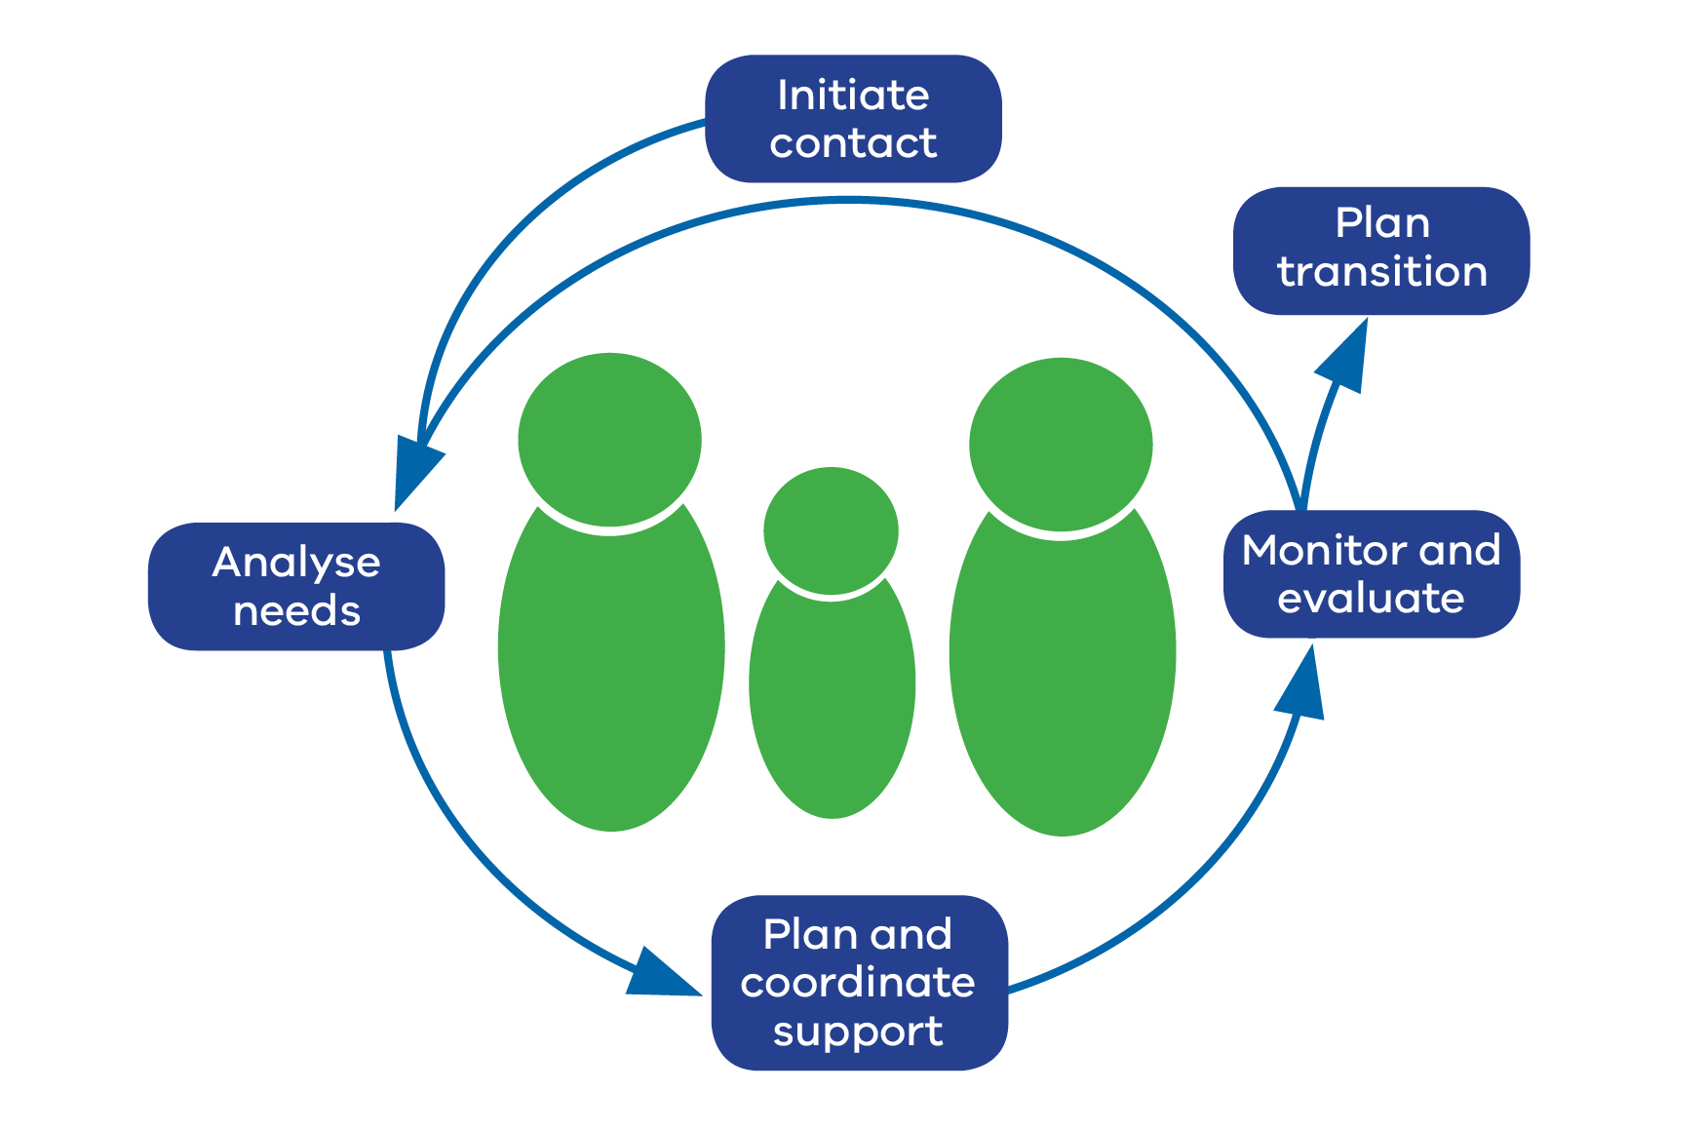

Team Around the Learner Pathway

Initiate Contact
How are relationships formed with the student, family and other professionals so that there is a thorough understanding of the context for this learner?

Analyse Needs
How is information gathered, shared and probed to determine the underlying causes so that the correct interventions and support can be planned?

Plan and Coordinate Support
How does the team decide on the most appropriate interventions for the learner and how does each member of the team commit to providing the support?
What goals and timelines are agreed to?

Monitor and Evaluate
What is the process for monitoring and evaluating the goals for the learner? How often are these reviewed?

Plan Transition
What is the process used for deciding if and when additional support can be gradually reduced as the learner develops greater independence?

Team Around the Learner - key principles
1. The learner and family are at the centre.
2. Learners experience a coordinated and seamless experience.
3. TAL promotes positive engagement.
4. TAL is outcomes focussed.
5. TAL is a collaborative and collective team effort within an effective school-wide framework.

Who is involved?
The team should be made up of the people who can provide the right support at the right time for the learner.
Team members may include the learner, education professionals, health professionals, community members, parents/carers, and external agencies involved in the life of the learner and family.
A Lead Professional coordinates the efforts of the team and ensures that all team members are part of the solution.
The team meets regularly regarding the design, implementation and review of a coordinated plan put in place by the team to meet the individual needs of the learner.
An effective SSG would use a TAL approach.

Reviewing current practice
To assist schools to measure their practice of the TAL approach, a five-level rubric has been developed that describes what the TAL approach might look like in a school.
To complement the rubric, a Planning Improvement Tool has been developed to assist schools.
This tool supports schools to implement improvement plans for any phase of the TAL approach identified as needing further development.
The Planning Improvement Tool asks the school to identify:
- current strengths in their practice
- the evidence they have that clearly demonstrates the established practice
- the next steps they will need to take to improve practice
- the tools they will use to improve practice.

Support Material
TAL recognises the need to support collaborative practice by ensuring high levels of transparency and documentation as the team utilises the TAL approach.

A number of resources are provided to support the implementation of the TAL approach.
These resources are intended to:
- be available to all members of the team that are working together
- support greater clarity across the team of the learners goals and challenges
- enhance the team to work more effectively and efficiently together
- support shared communication across the team.
The following tools and templates are available to support the TAL approach:
- Fact Sheet
- Rubric
- Planning Improvement Tool
- Initial Needs Identification Tool
- Learner Profile
- Behaviour Support Plan
- Transition from Additional Support
- Reflective Practice
- Meeting Agenda/Minutes Template

A series of 12 modules that schools can work through to enhance their understanding of the TAL approach:
- Module 1: Learning Series Overview
- Module 2: Describe the TAL Approach
- Module 3: Who is in the Team?
- Module 4: The Role of the Lead Professional
- Module 5: The Role of the Team
- Module 6: How Does the Team Share Information
- Module 7: Initiate Contact
- Module 8: Analyse Needs
- Module 9: Plan and Coordinate Support
- Module 10: Monitor and Evaluate
- Module 11: Plan Transition From Additional Support
- Module 12: Resources and Tools

For more information, see: Team Around the Learner

