National Apology to Australia's Indigenous Peoples – School Resources
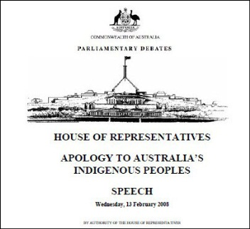
The National Apology to Australia’s Indigenous Peoples on behalf of the Australian Parliament was delivered by the then Prime Minister Kevin Rudd, in Parliament House Canberra, on 13 February 2008.
The National Apology is a significant event in Australia’s history and the anniversary provides opportunities for schools to plan appropriate events or activities to support further understanding and positive relationships with the Indigenous community.

Videos and transcripts
The following resources are available via the Australian Government Website:
- Apology to Australia's Indigenous Peoples Speech - 13 February. This is full transcript which can be downloaded in PDF.
- Prime Minister Kevin Rudd, MP - Apology to Australia's Indigenous peoples. This is the first part of the speech and is available in different video formats.
For further information or to view these resources see: Apology to Australia's Indigenous peoples
The full speech can be viewed in parts using the following links from YouTube:
- Sorry - An Apology to the Stolen Generations (Part 1 of 3)
- Sorry - An Apology to the Stolen Generations (Part 2 of 3)
- Sorry - An Apology to the Stolen Generations (Part 3 of 3)
For information on the historical background to the National Apology, including the first National Sorry Day and the tabling of the Bringing Them Home report, see: Sorry Day and the Stolen Generations

Ideas for events
Suggestions for events and associated planning considerations are available on the National Sorry Day Committee website. For further information see: Apology Anniversary
Suggestions are also provided by the Victorian Aboriginal Education Association Inc. (VAEAI) through its Koorie Education Calendar. For further information see: Resources for Schools and Families

Links to AusVELS curriculum
The following content descriptors from AusVELS History - Historical Knowledge and Understanding can contextualise curriculum activities centred on the National Apology:
- Level 3: Community and Remembrance. Days and weeks celebrated or commemorated in Australia (including Australia Day, ANZAC Day, Harmony Week, National Reconciliation Week, NAIDOC week and National Sorry Day) and the importance of symbols and emblems. Content Descriptor: ACHHK063
- Level 10: Rights and freedoms - Rights and freedoms (1945 – the present). The significance of the following for the civil rights of Aboriginal and Torres Strait Islander peoples: 1962 right to vote federally; 1967 Referendum; Reconciliation; Mabo decision; Bringing Them Home Report (the Stolen Generations), the Apology. Content Descriptor: ACDSEH106

