mEl~ Lm`vQ@y~qW gNQwy
mEl~ Lm`vQy

mEl~ Lm`vQ@y~qW gNQwy v#qgw~ @v|
wm LmEn~@g~ pLmEvn gOr#vry` @lst, LmEn~@g~ jWvQw@y~ mEl~ k`l@y~qW ovEn~@g~ gNQw kOslw` vr\{ny kQrWm pQNQs pvEl~ vlt pY{`n k`r\yx`ryk~ kQrWmt pEUvn.
jWvQw@y~ mEl~ k`l@y~qW gNQw kOslw` vr\{ny kQrWm mgQn~ LmEn~@g~ i@gnEm sh vr\{ny s[h` ovEn~t v#qgw~ aw~wQv`rmk~ s`q` @qnE l#@b|.
Lm@ykO@g~ mEl~ avEr#qE XWgY i@gnW@m| k`lykQ. pr~@y~;N mgQn~ mgQn~ apt @pn~v` qW a#w~@w~ Lqr#vn~t ovEn~@g~ @l`~k@y~ gNn~ yn sAkl~py @w~r#m| g#nW@m| shj h#kQy`v up@w~ sQtm wQ@bn bvy.
gNQw h#kQy`v Lmy`v g#tlE vQs[Wmt, mEql~ prQhrny kQrWmt a#wOlE eqQ@nq` jWvQwyt sRq`nm| kQrWmt upk`rW @v|.

eqQ@nq` ktyEwO wOlQn~ a@p~ LmEn~ gNQw@y~ qk~;yn~ bvt pw~ kQrWm
gNQwy s$m w#nm a#w - @sl~lm| pQt|tnQ@y~, s`p~pEvl sh nQQv@s~
eqQ@nq` ktyEwO sh kWYd` vlt gNQwy h[En~v`qWm, LmEn~t gNn~, rt` sh h#d g#n ign g#nWmt upk`rW @v|.
@m| mgQn~ ovEn~@g~ qQvQ@y~ sn~qr\xy wOl gNQwy smg ar#w~br sm|bn~{w` a#wQkryQ.
h#d, gNn~, rt`, wrm, @vl`v sh mQnEm| h[En`g#nWm gNQw@y~ adAgO @v|. eqQ@nq` jWvQw@y~ aw~q#kWm| wOlt gNQwy a#wOlw~ krg#nWm phsE @mn~m vQ@n`~q`w~mky.
phw @pn~vn ayEr# o@b| Lmy`@g~ @@qnQk jWvQwyt gNQwy @gne~mt obt pEUvn:
- ek~v svn~qWm sh g`yn` kQrWm.
gNn~ g#n n#vw n#vw kQy@vn sQn~qE sh eLQsm kvQ vQ@n`~q`w~mk sh sQw~a#qgn~n` an~qmt LmEn~t gNQwy h[En~v` @qyQ. uq`hrN @ls Five Little Ducks ,Monkeys on the Bed, , Ten Green Bottles sQyl~@l~m gNn~ kQrWm adAgO @v|.

h#d smg @sl~lm| kQrWm
pQn~wOr pY@h~lQk` sh h#d a#[Wm o@b| Lmy`t g#tlE vQs[W@m| kOslw` sh avk`Xy pQLQb[ q#nEm ig#n~vWmt upk`rW @v|. rvEm| @b`~l, swrFs~ j@n~l @h`~ sy@k`n~ n#vwW@m| LkON (stop sign) v#nQ eqQ@nq` qQvQ@y~ h#d a[En` g#nWmt o@b| Lmy`v unn~qE krvWmt obt pEUvn.
- rt` s$qWm
gl~ k#t, n`q#wQ (pegs) @h`~ p`t kdq`sQ k#blQ p`vQc|cQ~ kr rt`vk~ hqn~n.
- o@b| Lmy` smg ivEm| pQhEm| kQrWm
ivEm| pQhEm| mgQn~ gNn~ kQrWmt sh m#nWmt avs~}` uq` kr @qyQ. o@b| Lmy`t bQw~wr gNn~ krn @ls, kQrQ @h`~ pQtQ mnQn @ls kQyn~n. @k~k~ @gdQyk~ pEUs~snE s[h` uqE@n~ wQbQy yEwO u;~Nw~vy g#n Lmy` smg kw` krn~n.
- smRh ek~k`sE kQrWm
gl~, @k`L @h`~ rQkQlQ v#nQ @q~vl~ eLQmh@nn~ ekwO krn~n. e~v` @g`dvl~ vlt @bq` @vn~ kr ek~ ek~ @g`@d| @q~vl~ kWyk~ wQ@b|q#yQ gNn~ krn~n.
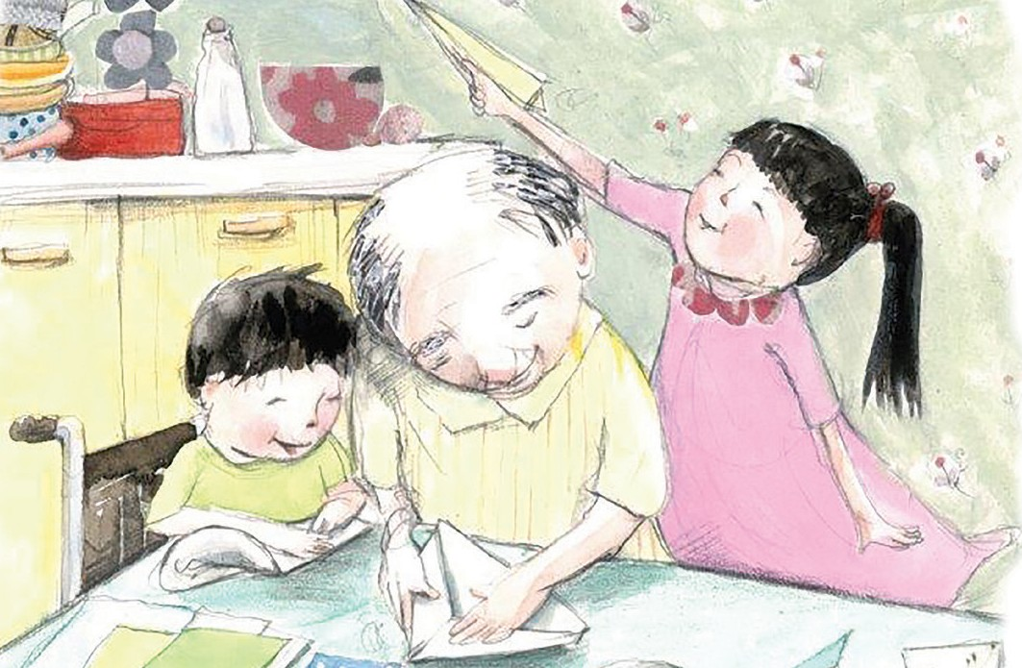

- s`p~pE y`m
a`h`r sh a`h`r qYv& ekwOkr e~v`@y~ mQL sticky notes vl lQy` @h`~ s`p~pE k#t@l`g~ vlQn~ kp`gw~ mQlyn~ @y`q` @l~bl~ krn~n.
- k`sQ sh @n`~t|tE , kdq`sQ sl~lQ @h`~ @sl~lm| sl~lQ x`vQw`kr ob ekt ekwOvW pQhQtEv` gw~ s`p~pEvkQn~ bdE mQlt gn~n` vQt @h`~ vQkOnn vQt em sl~lQ vlQn~ @gvn an~qm g#n kw` krn~n.
- ob gw~ a`h`r qYv& asEr` gn~n` vQt, e~v` @m| an~qmt @pL gsn~n :
- us (usm sQt mQtQm qk~v`),
- mQl (mQl a{Qkm sQt mQl adEm), @h`~
- br (brm sQt s#h#l~lEm qk~v`).
- m#nWm
@k`~tE, p` sLkONE @h`~ a@w~ qQg p`vQc|cQ kr m#nQy h#kQ an~qm vQms` bln~n.
o@b| pvE@l~ au@g~ us m#n, usm sh mQtQm pEq~gly` kvQq#yQ ss[` bln~n.
n`n b`l~qQ@y~ (bath Tub) @vn @vns~ pYm`n vl @k`~p~p wbn~n. @l`kO @k`~p~py pQrvWmt kOd` vwOr @k`~p~p kWyk~ uvmn`q#yQ kw` krn~n.
- gNn~ kQrWm
@vn @vnw~ ilk~km| vlQn~ gNn~ kQrW@m| pEhENEv ptn~ gn~n (uq`hrNyk~ @lst, 6 @h`~ 10 sQt gNQn~n ptn~ gn~n) e@s~ n#w@h`w~, is~srht sh a`ps~st gNQn @ls o@b| Lmy`t kQyn~n.
sQylEm mEl~ Lm`vQy v^w~wQkynt~, pvEl~ sh up@w~ sQt @y`vEn~ LmyQn~ smg ovEn~ krn ktyEwO vlqW e~v`@y~ armENE sh kQYy`m`r\h g#n m`r\@g`p@q~Xyk~ vQk~@t`~rQy`nE mEl~ Lm`vQy i@gnWm sh vr\{ny r`mEv (Victorian Early Years Learning and Development Framework (VEYLDF)) s[hn~ kryQ.
@mhQ s[hn~ kl gNQw aw~q#kWm| VEYLDF smg g#l@p~. v#dQqEr @w`rwOr# s[h` pQvQ@sn~n: http://www.education.vic.gov.au/Documents/childhood/ providers/edcare/veyldframework.pdf

