MATHS IN THE EARLY YEARS
EARLY CHILDHOOD

MATHS MATTERS IN THE EARLY YEARS
As their child’s first teacher, families can help play a key role in developing the maths skills of children in early life.
Developing maths skills early in life gives children an important foundation for their learning and development.
A child’s first years are a time of rapid learning. Research tells us that babies are born with an innate capacity to perceive the concept of numbers in their world.
Numeracy skills help prepare a child for daily life, including general problem solving and handling money.

MAKING OUR CHILDREN MATHS MASTERS THROUGH EVERYDAY ACTIVITIES
Maths is everywhere - in the playground, at the shops and at home.
Introducing maths in everyday activities and through play helps children learn about numbers, patterns and shapes.
It also creates meaningful connections with maths in the context of their lives.
Maths can include noticing shapes, numbers, patterns, size, time and measurement. Incorporating maths into everyday experiences is easy and fun.
You can bring maths into your child’s everyday life by:
- Listening and singing together
Songs and rhymes that repeat counting words introduce children to maths in a fun and engaging way. For example, Five Little Ducks, Monkeys on the Bed or Ten Green Bottles all include counting.
- Playing with shapes
Jigsaw puzzles and drawing shapes helps teach your child problem solving skills and spatial awareness.
You can encourage your child to identify shapes in their everyday life such as a round ball, square window or hexagonal stop sign.
- Making patterns
Make a pattern using pebbles, pegs or pieces of coloured paper.
- Cooking with your child
Cooking provides opportunities to count and measure. Ask your child to count eggs, measure milk and flour as well as talk about the temperature the oven requires to bake a cake.
- Making collections
Collect objects from the outdoors such as stones, leaves and twigs. Sort them into groups and count how many items are in each group.
1

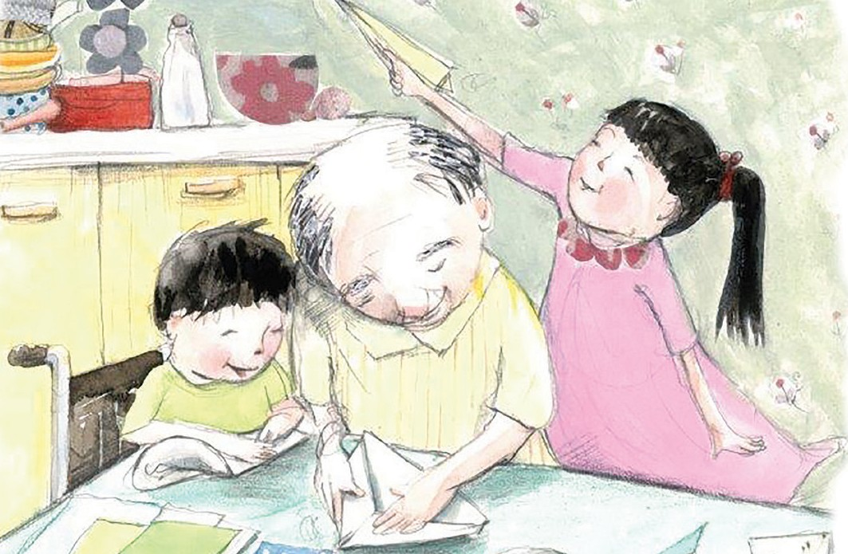

- Shopping
Collect food and grocery items and label them with prices written on sticky notes or prices cut out of shopping catalogues.
- Talk about how we pay for items, using notes and coins and making paper money or using play money to buy and sell goods from a shop that you have set up together.
- As you pack away grocery items, arrange them by:
- height (tallest to the shortest),
- cost (least expensive to most expensive), or by
- weight (heaviest to lightest).
- Measuring
Explore ways of measuring using sticks, footprints or hand lengths.
Measure the height of people in your family, comparing who is the tallest to the shortest.
Provide different sized cups in the bathtub to fill and empty and talk about how many little cups of water you need to fill the big cup.
- Counting
Use different numbers as the starting point for practising counting (for example, start counting from 6 or 10) or asking your child to count forwards and backwards.
The Victorian Early Years Learning and Development Framework (VEYLDF) sets out outcomes and practices to guide early childhood professionals in their work with all families and their young children from birth.
The maths experiences presented here align with the VEYLDF. For further information go to: http://www.education.vic.gov.au/Documents/childhood/ providers/edcare/veyldframework.pdf

