Real Training for Real Jobs

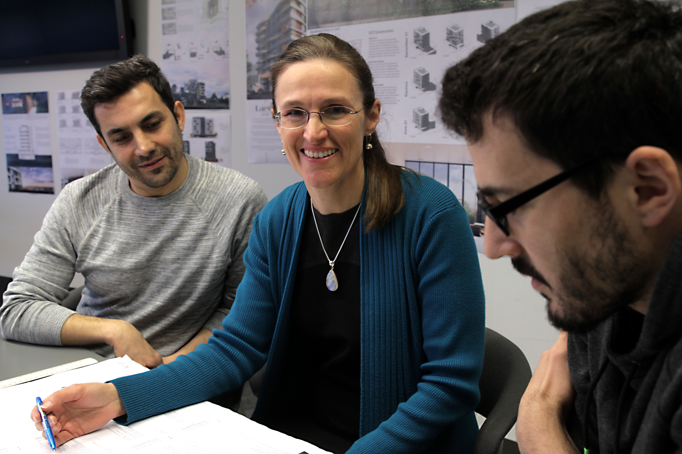
SUSAN MORRIS

FINALIST - 2017 TEACHER/TRAINER OF THE YEAR

Susan shines in building and design
A few years ago there were no certified Passive House courses for designers and builders in Australia.
Enter Susan Morris, the coordinator for building design and sustainability courses and teacher of the Advanced Diploma of Building Design (Architectural) at Box Hill Institute.
In 2011, Susan was awarded an International Specialised Skills Institute Fellowship to research European building sustainability methods, including Net Zero Energy buildings, ‘Passive House’ and to investigate collaborative learning opportunities for students in the building trades and professions.
Susan, who recommended Passive House courses at Box Hill Institute, says that before 2014 people wanting to be trained in these techniques had to travel overseas for their qualification.
Susan was part of a team that developed the Certified Passive House Designer and the Certified Passive House Tradesperson courses. Box Hill Institute is the only accredited Passive House training provider in Australia.
In 2016, Susan developed a collaborative project with industry to engage students in a new-to-Australia technology — cross-laminated timber (CLT) building design and construction — where students worked with this technology in conjunction with the Whitehorse City Council.
Teacher / Trainer of the Year
The Teacher/Trainer of the Year Award recognises innovation and excellence by a teacher/trainer providing nationally recognised training to students in the Victorian training and TAFE system.

To ensure students had all the relevant information to design and create working drawings for a sustainable CLT mid-rise building, Susan enlisted a panel of industry experts who helped with guest lectures and critiquing the students’ work.
Susan’s initiatives including collaborative learning with industry engagement and peer-to-peer learning strategies have led to excellent employability outcomes for building design graduates and student success in winning building design awards.
“My passion is teaching sustainability to the next generation of building designers, and this goes far beyond teaching how to create an energy efficient building.”

ABOUT THE VICTORIAN TRAINING AWARDS
Each year, the prestigious Victorian Training Awards recognise and honour the outstanding achievements of vocational education and training students, teachers, training providers and employers.
The Awards celebrate excellence in the training and TAFE system, highlight student achievements and the businesses’ who train them. Showcases innovation and collaboration between industry and training providers - continuing to put Victoria's top achievers in the spotlight.
Through Skills First, the Victorian Government is delivering a trusted training and TAFE system that delivers real training for real jobs. The Awards bring confidence and pride to vocational educational and training.

AWARD CATEGORIES
Individual Categories
- Vocational Student of the Year
- Apprentice of the Year
- Trainee of the Year
- Koorie Student of the Year
- School-based Apprentice/Trainee of the Year
- Teacher/Trainer of the Year
Training Provider Categories
- Small Training Provider of the Year
- Large Training Provider of the Year
- Community Training Provider of the Year
Employer Categories
- Small Employer of the Year
- Medium Employer of the Year
- Large Employer of the Year
- Employer Award for Apprenticeship Development
Industry Collaboration Award
Lynne Kosky Memorial Award for Lifetime Achievement​
Australian Training Awards
There are five Australian Training Awards categories open for direct entry:
- National Achievement Award
- Excellence in Language, Literacy and Numeracy Practice Award
- International Training Provider of the Year Award
- School Pathways to VET Award
- Australian Apprenticeships - Employer Award

WHY APPLY?
The Awards set the standards for vocational education and training in Victoria; promoting high quality training and workplace skill development.
Being a finalist puts organisations at the forefront, building brand recognition and a strong industry reputation. In turn attracting a better standard of employees.
Students have the opportunity to showcase skills and their journey within the training and TAFE system. Plus students have the chance to network with industry experts and employers from across the state to help build their careers.
Award winners receive $5,000 prize money.
Winners go on to be ambassadors for the Victorian Training Awards and have the opportunity to represent Victoria nationally at the Australian Training Awards (in aligned categories).

For more information visit Victorian Training Awards www.education.vic.gov.au/vta
For all enquires email victorian.training.awards@edumail.vic.gov.au
phone 03 9907 6635.

