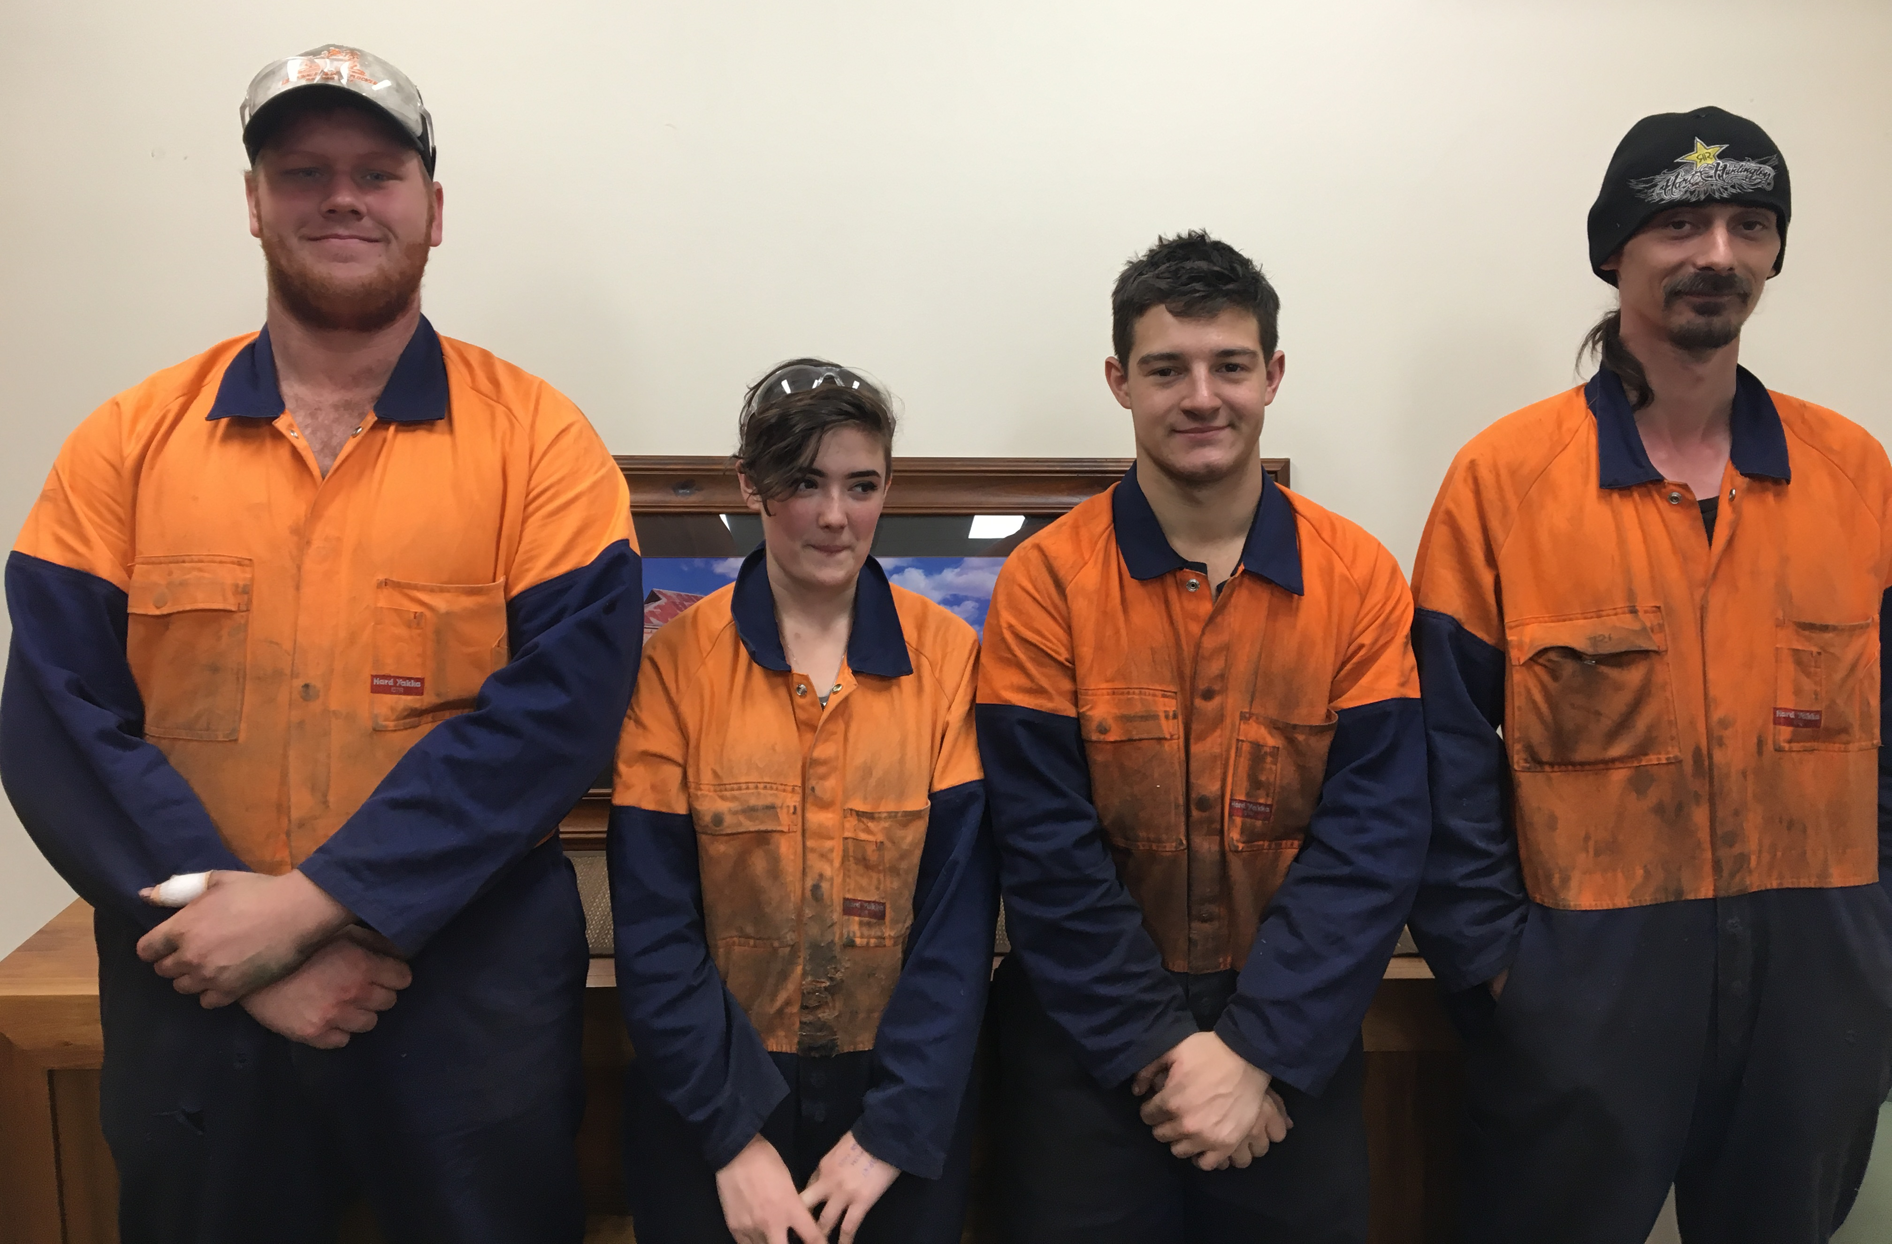
Real Training for Real Jobs
A.F. GASON Pty Ltd

FINALIST - 2017 Employer Award for Apprenticeship Development

  - Gason Apprentice Boot Camp keeping more young people in Ararat
Even though local youth unemployment was high and A.F. Gason was a major employer of skilled tradespeople in the Ararat region, the company was finding it difficult to attract young apprentices.
Founded by Arthur Frank Gason in 1947, the family-owned business designs and manufactures farm machinery and wood heating products and provides industrial services including laser cutting, powder coating and welding to businesses and markets across Australia.
As a local business with 130 employees and a strong community connection, Gason wanted a solution to the lack of local young people attracted to working in a strong local manufacturing industry.
Gason partnered with local schools, Federation University, Central Grampians LLEN and Job Networks, and the annual weeklong Apprentice Boot Camp was born.
Each year Apprentice Boot Camp is offered to eight local young people, with Gason’s HR Manager Andrew Kemp driving them on the bus to Ballarat for intensive skills development at Federation University’s Manufacturing and Engineering Skills Centre (MESC), followed by demonstrations and workplace skill application at Gason.
Four out of the eight young people who took part in the first Apprentice Boot Camp four years ago are now working at Gason.
Thanks mainly to Apprentice Boot Camp, this year six apprentices are undertaking a Certificate III in Engineering (fabrication) and two trainees a Certificate III in Surface Preparation and Coating Application, in partnership with Federation University.
The Apprentice Boot Camp has been a significant driver in Gason building an enviable team of apprentices, helped keep more young people in Ararat and supported the local economy.
“Gason is the perfect example of a smaller regional business ensuring relevance and longevity through diversification and investment in new technology and staff development. We are proud to share the stage with the other finalists of the employer award for apprenticeship development. Becoming a finalist proves that no matter how large or small the business, investment in training and development of your staff, positions your business and your people to thrive”. Andrew Kemp, HR & OHS Manager
Employer Award for Apprenticeship Development
The Employer Award for Apprenticeship Development recognises those employers who have made innovative improvements in training, which provide beneficial outcomes for their apprentices and/ or trainees in Australia and to their local community.

ABOUT THE VICTORIAN TRAINING AWARDS
Each year, the prestigious Victorian Training Awards recognise and honour the outstanding achievements of vocational education and training students, teachers, training providers and employers.
The Awards celebrate excellence in the training and TAFE system, highlight student achievements and the businesses’ who train them. Showcases innovation and collaboration between industry and training providers - continuing to put Victoria's top achievers in the spotlight.
Through Skills First, the Victorian Government is delivering a trusted training and TAFE system that delivers real training for real jobs. The Awards bring confidence and pride to vocational education and training.

AWARD CATEGORIES
Individual Categories
- Vocational Student of the Year
- Apprentice of the Year
- Trainee of the Year
- Koorie Student of the Year
- School-based Apprentice/Trainee of the Year
- Teacher/Trainer of the Year
Training Provider Categories
- Small Training Provider of the Year
- Large Training Provider of the Year
- Community Training Provider of the Year
Employer Categories
- Small Employer of the Year
- Medium Employer of the Year
- Large Employer of the Year
- Employer Award for Apprenticeship Development
Industry Collaboration Award
Lynne Kosky Memorial Award for Lifetime Achievement​

Australian Training Awards
There are five Australian Training Awards categories open for direct entry:
- National Achievement Award
- Excellence in Language, Literacy and Numeracy Practice Award
- International Training Provider of the Year Award
- School Pathways to VET Award
- Australian Apprenticeships - Employer Award

WHY APPLY?
The Awards set the standards for vocational education and training in Victoria; promoting high quality training and workplace skill development.
Being a finalist puts organisations at the forefront, building brand recognition and a strong industry reputation. In turn attracting a better standard of employees.
Students have the opportunity to showcase skills and their journey within the training and TAFE system. Plus students have the chance to network with industry experts and employers from across the state to help build their careers.
Award winners receive $5,000 prize money.
Winners go on to be ambassadors for the Victorian Training Awards and have the opportunity to represent Victoria nationally at the Australian Training Awards (in aligned categories).

For more information visit Victorian Training Awards www.education.vic.gov.au/vta
For all enquires email victorian.training.awards@edumail.vic.gov.au
phone 03 9907 6635.

