Learning progression exemplar - reading comprehension
An annotated progression exemplar for reading comprehension
Average ZPD in the Year 5 class
A High-ability student’s ZPD

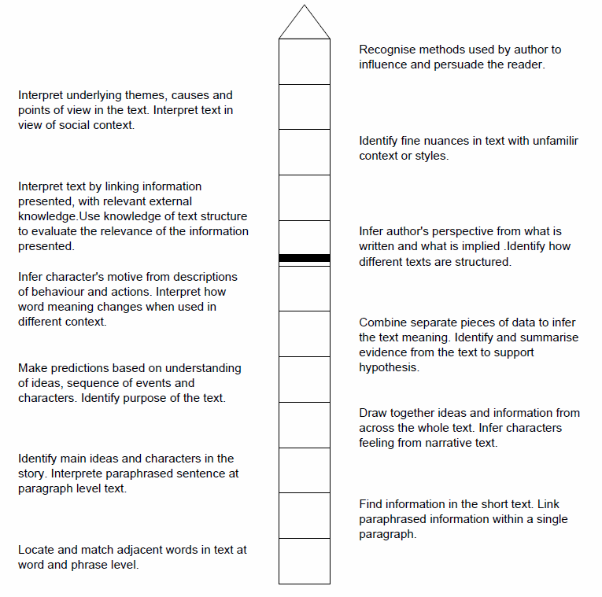
Skills of increasing difficulty
ZPD: the zone at which the student is ready to learn
ZAD: student can do these skills independently.
Student not ready to learn this set of skills.

