Pathway C Level CL Writing
Informative text - Text response about a bike and recount about holiday
Student information | This student is 17 years old and in Year 9. He is of Afghani background and has been in Australia for about a year. He speaks Pashtu. He does not have any prior schooling and attended an English language school before starting in a secondary school in Victoria.
Task | This is a journal writing task set within an intensive English class. It is a task familiar to the student. The first sample is a response to a text about a bike, while the second writing is on the student’s own choice of topic. No scaffolding was provided.
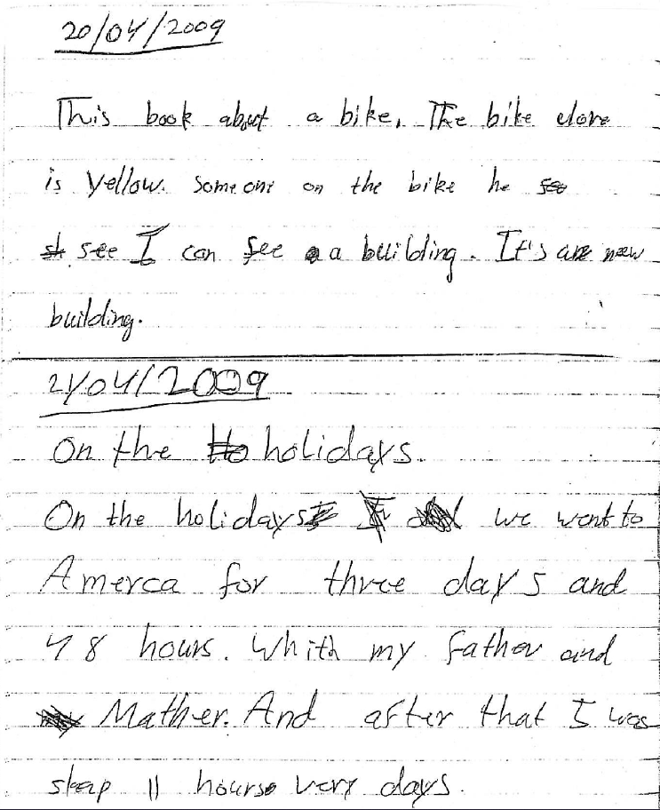
Section | Text |  | This sample of student work demonstrates that the student can:
1 | 20/04/2009  This book about a bike. The bike clore is yellow. Someone on the bike he see I can see a building. It’s an neew building. | - Write short, simple texts for specific purposes related to personal experience (VCEALC525)  - Write familiar words and simple sentences independently, with enough accuracy to convey meaning (VCEALC526)  - Write sentences that reflect oral language with some examples of correct word order (VCEALL536)  - Use basic conjunctions to connect ideas (VCEALL537)  - Use simple verbs (VCEALL538)  - Spell familiar, simple words correctly, using knowledge of letter–sound relationships (VCEALL541)  - Use basic punctuation (VCEALL542)
2 | 21/04/2009  On the holidays  On the holidays we went to Amerca for three days and 48 hours. Whith my father and Mather. And after that I was sleap 11 hours very days.

Overall, this student can also:  - Begin to check accuracy (VCEALA530)  - Draw on conventions for organising information (VCEALL533) | Possible next steps for this student’s learning:  - Using visuals or key vocabulary on flash cards to plan, organise and sequence ideas for writing (VCEALL540)  - Understanding and using a basic structure for a text response (VCEALC525)  - Using a basic structure and guiding questions to write a personal recount (VCEALC527)  - Learning and practising sentences with different grammatical structures, for example, simple compound sentences (VCEALL535)
This student’s performance in this task suggests that he is working within the range of Level CL in Writing. The assessing teacher will need to consider a range of student samples in order to determine whether this student is at the beginning of CL, consolidating CL or at the CL standard in Writing.  At beginning Level C1 students:  - attempt to write down words they have heard or said, but this will usually not be with accurate spelling  - will rely heavily on proformas and other model texts as scaffolding to produce extended pieces of writing longer than a phrase or sentence with teacher guidance, but are not yet aware that different text types are used for different purposes  - tend to focus on producing a final product, rather than recognising that the act of writing is a process that involves planning, revision, and editing.  At consolidating Level C1 students:  - have begun to attempt their own sentences, although the focus is on meaning rather than grammatical accuracy  - produce sentences that tend to follow a basic subject–verb–object pattern, but with varying degrees of accuracy  - create texts that demonstrate a growing awareness of differences between text types, especially in terms of overall organisational features and structure, although their ability to demonstrate this in their own writing is still very rudimentary  - can review their writing and identify aspects that might be changed or revised, with assistance.  At Level CL Achievement Standard students:  - write for a range of basic classroom and personal purposes, making lists and writing simple journal entries, notes, descriptions, recounts of events and instructional texts  - produce basic sentences and short texts based on well-practised spoken English and familiar contexts  - write with varying grammatical accuracy, expressing themselves using familiar vocabulary and modelled structures and features  - order and sequence sentences about familiar topics into simple coherent texts, incorporating basic conventions such as headings and paragraphs  - correct some errors relating to targeted grammatical items, and rework drafts in response to teacher suggestions  - plan their texts and provide some additional information through visual texts, with support  - utilise a range of strategies for finding and spelling words, using spelling patterns and checking resources  - use basic features in software applications to write and present their texts. | Pathways and transitions considerations:  A Year 9 student who is working within the range of Level CL in any one language mode is not ready to transition to the English curriculum regardless of their proficiency in the other two language modes. This student will continue on Pathway C of the EAL curriculum.

