Pathway C Level C4 Writing
Persuasive text - Opposing national ID card
Student information | This student is in Year 10.
Task | Students chose from several possible writing tasks. This student chose to write an expository piece. The writing was completed under exam conditions, in one period in the computer room. The analysis is based on the student’s writing before correction.

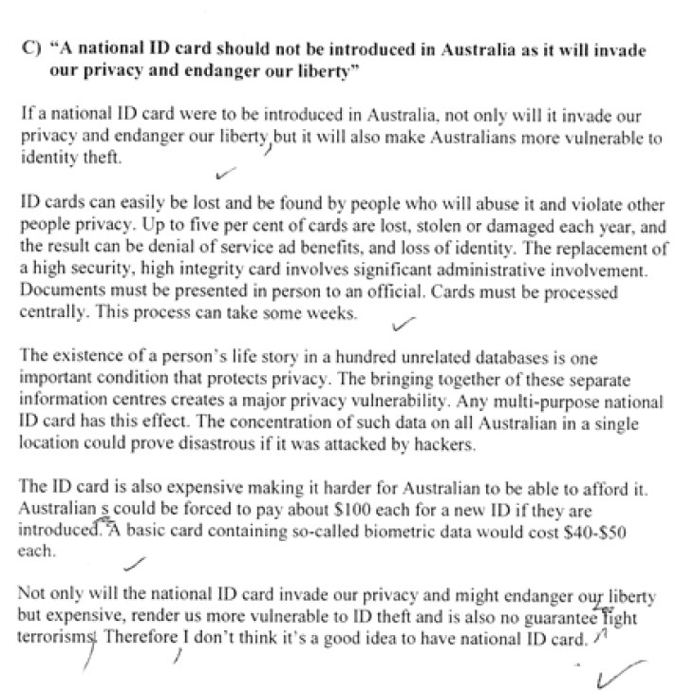

Section | Text |  | This sample of student work demonstrates that the student can:
1 | “A national ID card should not be introduced in Australia as it will invade our privacy and endanger our liberty”
2 | If a national ID card were to be introduced in Australia, not only will it invade our privacy and endanger our liberty but it will also make Australians more vulnerable to identity theft. | - Use an extended range of cohesive devices to improve fluency (VCEALL787)  - Combine simple sentences into complex sentences using embedding structures (VCEALL789)  - Use an expanded vocabulary appropriate for the curriculum area (VCEALL793)
3 | ID cards can easily be lost and be found by people who will abuse it and violate other people privacy. Up to five per cent of cards are lost, stolen or damaged each year, and the result can be denial of service ad benefits, and loss of identity. The replacement of a high security, high integrity card involves significant administrative involvement. Documents must be presented in person to an official. Cards must be processed centrally. This process can take some weeks. | - Demonstrate control of a wide range of verb forms (VCEALL790)  - Use an expanded vocabulary appropriate for the curriculum area (VCEALL793)
4 | The existence of a person’s life story in a hundred unrelated databases is one important condition that protects privacy. The bringing together of these separate information centres creates a major privacy vulnerability. Any multi-purpose national ID card has this effect. The concentration of such data on all Australian in a single location could prove disastrous if it was attacked by hackers. | - Demonstrate control of a wide range of verb forms (VCEALL790)
5 | The ID card is also expensive making it harder for Australian to be able to afford it. Australian s could be forced to pay about $100 each for a new ID if they are introduced. A basic card containing so-called biometric data would cost $40-$50 each. | - Demonstrate control of a wide range of verb forms (VCEALL790)
6 | Not only will the national ID card invade our privacy and might endanger our liberty but expensive, render us more vulnerable to ID theft and is also no guarantee fight terrorisms. Therefore I don’t think it’s a good idea to have national ID card. | - Use an extended range of cohesive devices to improve fluency (VCEALL787)  - Demonstrate control of a wide range of verb forms (VCEALL790)  - Demonstrate control of appropriate grammatical structures that develop the ways to analyse, argue, persuade, describe, classify or explain (VCEALL788)

Overall, this student can also:  - Write an extended argument or discussion on a familiar issue (VCEALC777)  - Understand how writing contexts, audience and purpose influence function and form (VCEALA780) | Possible next steps for this student’s learning:  - Using different cohesive devices to link ideas more clearly (VCEALL787)  - Including citation and references to support argument (VCEALA782)  - Expanding paragraphs and making stronger connections between paragraphs, for example, by using link sentences (VCEALL786)
This student’s performance in this task suggests that he is working within the range of Level C4 In Writing. The assessing teacher will need to consider a range of student samples in order to determine whether this student is at the beginning of C4, consolidating C4 or at the C4 standard in Writing.  At beginning Level C4 students:  - have begun to experiment with variations on the basic generic text types, although early drafts require extensive opportunities for revision  - produce writing in which basic grammatical structures and features are almost always correct, but attempts at more difficult structures may impede meaning  - incorporate a range of different devices, such as charts, diagrams and other illustrations, to support the meaning being conveyed in the body of the written text  - attempt to use idioms, euphemisms, metaphors and other imagery beyond the literal meaning of the text to convey meaning, although this is not always done effectively.  At consolidating Level C4 students:  - are attempting to produce a range of text types  - while their texts, in both written and multimedia forms, may have weaknesses which require improvement, students have a metalanguage for talking about texts that enables them to discuss how the texts might be revised  - attempts to revise texts move beyond a focus on correcting surface level inaccuracies to a more substantive degree of revision which aims to improve the overall communicative intent of the text.  At Level C4 Achievement Standard students:  - write, with appropriate support, the full range of extended fictional and factual text types undertaken across the curriculum  - vary their writing to be consistent with the text type, the context and the needs of the reader, presenting similar content in different ways, with support  - demonstrate reasonably consistent control of a wide range of grammatical features  - incorporate direct and indirect speech, including quotations, appropriately  - employ an extended range of appropriate cohesive devices between sentences and paragraphs, retaining clarity and fluency  - use some abstract noun groups  - review and redraft their writing to enhance fluency, clarity, accuracy and appropriateness for purpose, audience and context in response to feedback and self-assessment  - plan, draft, edit and present their writing in a range of print and digital forms, as appropriate. | Pathways and transitions considerations:  A Year 10 student who is working within the range of C4 in any one language mode is not ready to transition to the English curriculum regardless of their proficiency in the other two language modes. This student will continue on Pathway C of the EAL curriculum in all language modes.  A Year 10 student should consistently demonstrate the final achievement standard in Pathway C (Level C4) in all three language modes before they transition to the English curriculum.  They will need to be equally capable across all three language modes to be able to meet the learning expectations in the English curriculum at the level taught to their mainstream peers, and without substantial language support.  They will need to be sufficiently proficient in understanding and using the academic language across the learning areas to participate in learning activities across the Victorian curriculum.  They will also need to be able to understand and use the academic English of the curriculum in subsequent years without substantial language support, when the cognitive and linguistic demands of the Victorian curriculum increase.  Depending on whether the student meets the eligibility criteria, they may be able to undertake VCE EAL in Year 11 and Year 12.

