Pathway C Level C3 Writing
Imaginative text - Transforming a known text into a different genre
Student information | The student is in Year 10 and speaks Vietnamese. She had been in Australia for less than a year and is in her first term at an English language school.
Task | Students had read a factual text about a butler. They had to transform the information from the text into a different genre. The task was done in the computer room, and students had one period to complete their text.

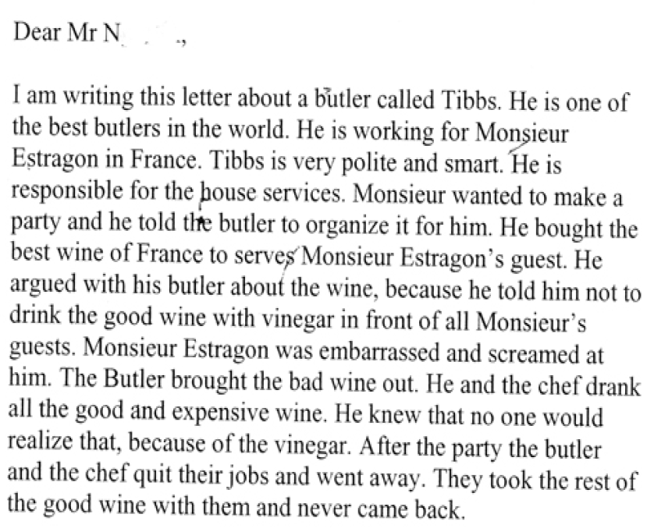
Section | Text |  | This sample of student work demonstrates that the student can:
1 | Dear Mr N  I am writing this letter about a butler called Mr Tibbs. He is one of the best butlers in the world. He is working for Monsieur Estragon in France. Tibbs is very polite and smart. He is responsible for the house services. Monsieur wanted to make a party and he told the butler to organize it for him He bought the best wine of France to serves Monsieur Estragon’s guest. He argued with his butler about the wine, because he told him not to drink the good wine with vinegar in front of all Monsieur’s guests. Monsieur Estragon was embarrassed and screamed at him. The Butler brought the bad wine out. He and the chef drank all the good and expensive wine. He knew that no one would realize that, because of the vinegar. After the party the butler and the chef quit their jobs and went away. They took the rest of the good wine and never came back. | - Understand how the purpose and audience of a text can influence content and form (VCEALA718)  - Plan and sequence information for a specified text (VCEALL723)  - Use basic knowledge of grammatical features at the sentence level to argue, persuade, describe, classify, explain or instruct (VCEALL726)  - Use verb forms appropriate to text type (VCEALL728)  - Construct extended sentences using simple relative clauses and a range of common conjunctions (VCEALL727)  - Use vocabulary to create nuance, mood and feeling (VCEALL730)

This student’s performance in this task suggests that she is working within the range of Level C3 in Writing. The assessing teacher will need to consider a range of student samples in order to determine whether this student is at the beginning of C3, consolidating C3 or at the C3 standard in Writing.  At beginning Level C3 students:  - can generally attempt a wide range of different text types appropriate to purpose and audience as independent writers, but will often require extensive opportunities for revision to increase accuracy based on teacher feedback  - almost always use general punctuation conventions correctly, for example, upper and lower case, full stops, commas and question marks, and have begun to experiment with more complex marks such as quotation marks, dashes, ellipses, semicolons and colons  - show a growing awareness of social and cultural sensibilities in word choice, for instance plump/fat, man/people, but may still miss many more subtle nuances.  At consolidating Level C3 students:  - show attempts at creating mood and feeling in their written texts, as well as the use of some colloquial or idiomatic language and humour, although this might often not be used accurately  - produce writing that shows an increasing engagement with the writing process and an increasing level of complexity in the use of various strategies to plan and organise texts, for instance, graphic organisers or timelines to draft outlines, and an ability to take responsibility for proofreading and revising their texts independently without this always having to be initiated under teacher guidance  - have become comfortable at producing their text in print or on the computer.  At Level C3 Achievement Standard students:  - through guided activities, write texts based on an extensive range of fictional and factual text types from across the curriculum, showing an awareness of purpose and audience  - consistently use the basic structures of these text types, and demonstrate consistent but not complete control of the English grammar appropriate to them  - demonstrate some control of passive voice, a range of tenses and direct speech  - produce paragraphs with topic sentences and incorporate some cohesive devices to make links and contrasts between and within paragraphs through a range of conjunctions, connectives and pronoun references  - pay some attention to whole-text, sentence and word level issues, including punctuation when planning, writing, reviewing and redrafting their writing  - use a range of strategies when spelling new words  - present their writing appropriately, in print and digital forms. | Possible next steps for this student’s learning:  - Using adverbial and adjectival phrases to create nuance, mood and feeling in writing (VCEALL730)  - Practising and using more complex verb forms and sentences (VCEALL728)  - Connecting and signposting ideas in the text using a range of cohesive devices (VCEALL725)
Pathways and transitions considerations:
A Year 10 student who is working within the range of Level C3 in any one language mode is not ready to transition to the English curriculum regardless of their proficiency in the other two language modes. This student will continue on Pathway C of the EAL curriculum.

