Pathway C Level C3 Writing
Informative text - Script for a guided tour
Student information | The student comes from Vietnam and speaks Vietnamese. She has had age equivalent schooling in Vietnam where she also took English classes. She spent 20 weeks in an English language school before attending secondary school. She is in Year 10.
Task | Students have been learning about how coffee is produced with the intention of having them write a text that required the passive voice to be used. They were asked to imagine they had to give a talk to a group of Year 10 students about the production and manufacture of coffee. They were given the start of the script and were asked to finish it. The task was scaffolded with a picture sequencing and vocabulary task and also with supplementary information. This is the student’s first draft completed in class.
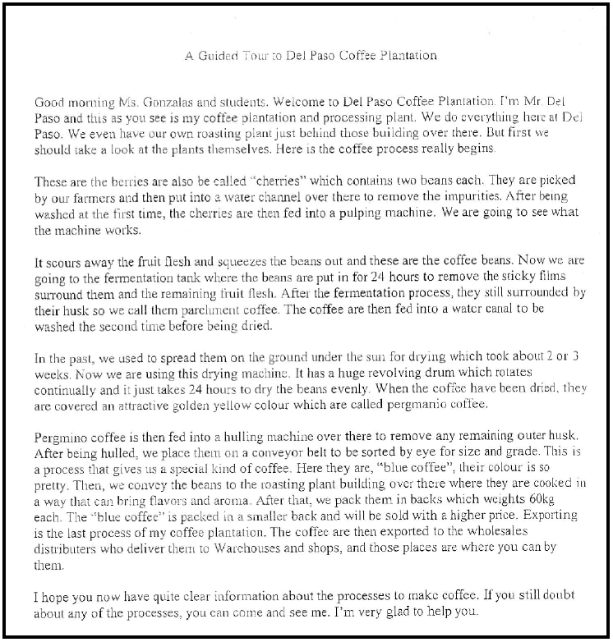
Section | Text |  | This sample of student work demonstrates that the student can:
1 | A Guided Tour to Del Paso Coffee Plantation  Good morning Ms. Gonzalas and students. Welcome to Del Paso Coffee Plantation. I’m Mr. Del Paso and this as you see is my coffee plantation and processing plant. We do everything here at Del Paso. We even have our own roasting plant just behind those buildings over there. But first we should take a look at the plants themselves. Here is the coffee process really begins. | *This is the starter paragraph given to the student and is not the student’s own writing.
2 | These are the berries are also be called “cherries” which contains two beans each. They are picked by our farmers and then put into a water channel over there to remove the impurities. After being washed at the first time, the cherries are then fed into a pulping machine. We are going to see what the machine works. | - Use verb forms appropriate to text type (VCEALL728)
3 | It scours away the fruit flesh and squeezes the beans out and these are the coffee beans. Now we are going to the fermentation tank where the beans are put in for 24 hours to remove the sticky films surround them and the remaining fruit flesh. After the fermentation process, they still surrounded by their husk so we call them parchment coffee. The coffee are then fed into a water canal to be washed the second time before being dried. | - Use verb forms appropriate to text type (VCEALL728)  - Construct extended sentences using simple relative clauses and a range of common conjunctions (VCEALL727)
4 | In the past we used to spread them on the ground under the sun for drying which took about 2 or 3 weeks. Now we are using this drying machine. It has a huge revolving drum which rotates continually and it just takes 24 hours to dry the beans evenly. When the coffee have been dried, they are covered an attractive golden yellow colour which are called pergmanio coffee. | - Use verb forms appropriate to text type (VCEALL728)
5 | Pergmino coffee is then fed into a hulling machine over there to remove any remaining outer husk. After being hulled, we place them on a conveyor belt to be sorted by eye for size and grade. This is a process that gives us a special kind of coffee. Here they are, “blue coffee”, their colour is so pretty. Then, we convey the beans to the toasting plant building over there where they are cooked in a way that can bring flavours and aroma. After that, we pack them in backs which weights 60kg each. The “blue coffee” is packed in a smaller back and will be sold with a higher price. Exporting is the last process of my coffee plantation. The coffee are then exported to the wholesales distributers who deliver them to Warehouses and shops, and those places are where you can by them. | - Use verb forms appropriate to text type (VCEALL728)
6 | I hope you now have quite clear information about the processes to make coffee. If you still doubt about any of the processes, you can come and see me. I’m very glad to help you.

Overall, this student can also:  - Plan and sequence information for a specified text (VCEALL723)  - Use basic knowledge of grammatical features at the sentence level to argue, persuade, describe, classify, explain or instruct (VCEALL726)  - Write cohesive texts for a range of purposes (VCEALL724) | Possible next steps for this student’s learning:  - Editing her writing for the passive voice by highlighting all the verbs and verb phrases and changing them if necessary (VCEALL728)  - Creating a presentation on coffee production and labelling each image with key phrases written in the passive voice (VCEALL726)  - Practising relative pronouns (VCEALL727)  - Practising and delivering a talk on coffee production (VCEALL686)
This student’s performance in this task suggests that she is working within the range of Level C3 in Writing. The assessing teacher will need to consider a range of student samples in order to determine whether this student is at the beginning of C3, consolidating C3 or at the C3 standard in Writing.  At beginning Level C3 students:  - can generally attempt a wide range of different text types appropriate to purpose and audience as independent writers, but will often require extensive opportunities for revision to increase accuracy based on teacher feedback  - almost always use general punctuation conventions correctly, for example, upper and lower case, full stops, commas and question marks, and have begun to experiment with more complex marks such as quotation marks, dashes, ellipses, semicolons and colons  - show a growing awareness of social and cultural sensibilities in word choice, for instance plump/fat, man/people) but may still miss many more subtle nuances.  At consolidating Level C3 students:  - show attempts at creating mood and feeling in their written texts, as well as the use of some colloquial or idiomatic language and humour, although this might often not be used accurately  - produce writing that shows an increasing engagement with the writing process and an increasing level of complexity in the use of various strategies to plan and organise texts, for instance, graphic organisers or timelines to draft outlines, and an ability to take responsibility for proofreading and revising their texts independently without this always having to be initiated under teacher guidance  - have become comfortable at producing their text in print or on the computer.  At Level C3 Achievement Standard students:  - through guided activities, write texts based on an extensive range of fictional and factual text types from across the curriculum, showing an awareness of purpose and audience  - consistently use the basic structures of these text types, and demonstrate consistent but not complete control of the English grammar appropriate to them  - demonstrate some control of passive voice, a range of tenses and direct speech  - produce paragraphs with topic sentences and incorporate some cohesive devices to make links and contrasts between and within paragraphs through a range of conjunctions, connectives and pronoun references  - pay some attention to whole-text, sentence and word level issues, including punctuation when planning, writing, reviewing and redrafting their writing  - use a range of strategies when spelling new words  - present their writing appropriately, in print and digital forms. | Pathways and transitions considerations:  A Year 10 student who is working within the range of Level C3 in any one language mode is not ready to transition to the English curriculum regardless of their proficiency in the other two language modes. This student will continue on Pathway C of the EAL curriculum.

