Pathway C Level C2 Writing
Persuasive text- Single use plastics: Should they be banned?
Student information | The student is 15 years old and in Year 9. He was born in South Korea and speaks Korean as his home language. He has had age-equivalent schooling and can read and write in his home language. The student has been at an English language centre for five weeks and also undertook extra English studies after school back in South Korea.
Task | Students were given the topic Single use plastics: Should they be banned? and asked to write a persuasive essay. This writing was completed as part of a unit of work about persuasive writing where they learnt about identifying opinions, creating logical arguments, selecting relevant evidence such as facts, statistics, expert opinion, personal experience, and using emotive language.  Students were provided with an essay template, a list of linking words and a list of websites about plastic bags to help plan their essay. Students were expected to acknowledge their sources when quoting evidence.  The student typed their essay on the computer. The analysis is based on the student’s work before correction.

Section | Text |  | This sample of student work demonstrates that the student can:
1 |  | - Use mostly standard word order (VCEALL664)  - Spell most commonly encountered words correctly (VCEALL670)  - Organise the content of a topic at paragraph level, with teacher guidance, to reflect given or new information (VCEALL662) *uses a general outline of a topic sentence, elaboration and summary  - Link ideas using a range of basic cohesive devices (VCEALL663)  - Write using a range of tenses with varied accuracy (VCEALL666)  - Use a varied and appropriate vocabulary (VCEALL668)  - Use adverbials to provide simple detail (VCEALL667)  - Develop a small range of skills to create and navigate simple digital texts (VCEALL672)
2 | 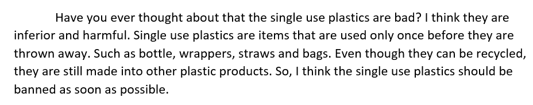
3 | 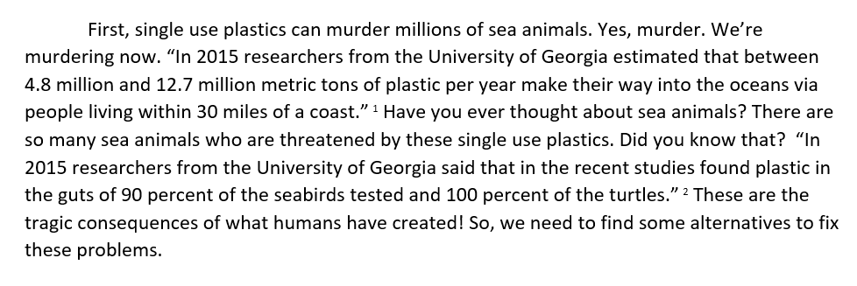
4 | 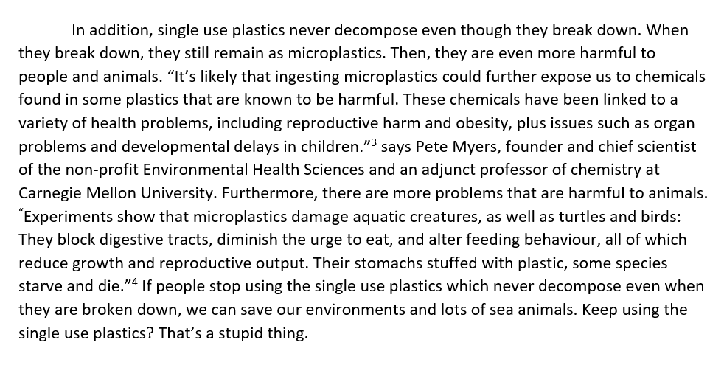
5 | 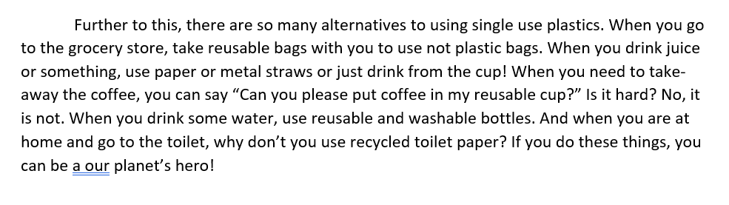
6
7 | 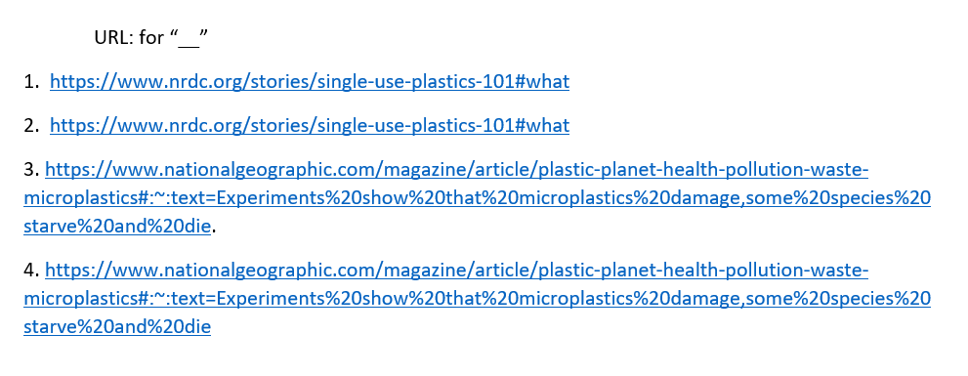

Overall, this student can also:  - Write information texts for general school use, based on modelled language (VCEALC654)  - Use appropriate forms of text for purpose and audience, with guidance (VCEALA656)  - Organise information and write according to the structure of a specified text (VCEALL661) | Possible next steps for this student’s learning:  - Integrating short quotations into written sentences (VCEALL662)  - Learning the differences between informal and formal language, and using them purposefully in writing to improve the persuasiveness of the text (VCEALA656)  - Analysing the flow of information in a sample essay, for example, by arranging the paragraphs in a logical order (VCEALC654)
This student’s performance in this task suggests that he is working within the range of Level C2 in Writing. The assessing teacher will need to consider a range of student samples in order to determine whether this student is at the beginning of C2, consolidating C2 or at the C2 standard in Writing.  At beginning Level C2 students:  - are beginning to be more confident at using a wider range of text types, for example, procedures and reports, although they will often rely on assistance and models  - will begin to produce texts that include a greater and more creative range of adjectives, adverbs, conjunctions and variations in tenses, although not necessarily used accurately  - demonstrate a range of strategies that help them to become independent writers, such as accessing new words from dictionaries or word lists, and spelling words out phonetically or using other spelling strategies, for instance, mnemonics.  At consolidating Level C2 students:  - have begun to use models of text types with a relative degree of independence to produce their own work  - can organise the content of a topic at paragraph and topic sentence level, with assistance  - produce writing that shows improvement in its overall coherence and structure as their repertoire of connectives, conjunctives and grammatical structures continues to expand  - attempt to use direct speech in their texts where appropriate, although it may not be punctuated accurately  - show an awareness of the writing process, including the need to draft, review, and revise, but still require teacher guidance to work through each of these stages productively.  At Level C2 Achievement Standard students:  - write with a degree of autonomy for a range of everyday classroom and personal purposes, such as describing, explaining and recounting  - independently write some basic texts and experiment with presenting their own ideas  - produce texts show varying grammatical accuracy  - incorporate emerging vocabulary and grammatical features to achieve desired effects  - use an increasing range of simple connectives to indicate some basic relationships within and between sentences and paragraphs  - choose appropriate text structures and use headings, tables and images  - use basic text models as a basis for their own texts  - use strategies to organise information in supported research tasks  - review, redraft and improve their writing by discussing alternative ways of arranging and expressing ideas, with teacher support and feedback  - use more advanced features in software applications to write, edit and present their texts. | Pathways and transitions considerations:  A Year 9 student who is working within the range of Level C2 in any one language mode is not ready to transition to the English curriculum regardless of their proficiency in the other two language modes. This student will continue on Pathway C of the EAL curriculum.

