Pathway C Level C2 Writing
Persuasive text- Should mobile phones be banned at school?
Student information | The student is 14 years old and in Year 9. She comes from Hong Kong and speaks Cantonese as her home language. She has had age-equivalent schooling in her home country and is able to read and write in her home language. The student has been in Australia for three months and is studying at an English language school.
Task | This written task was part of a unit of work on current issues. Students had completed reading activities, learnt vocabulary related to the topic, and new grammatical structures such as relative clauses and reported speech. Then they completed a first draft on the topic Should mobile phones be banned in schools? Students were provided with a model text as an example to support their writing.

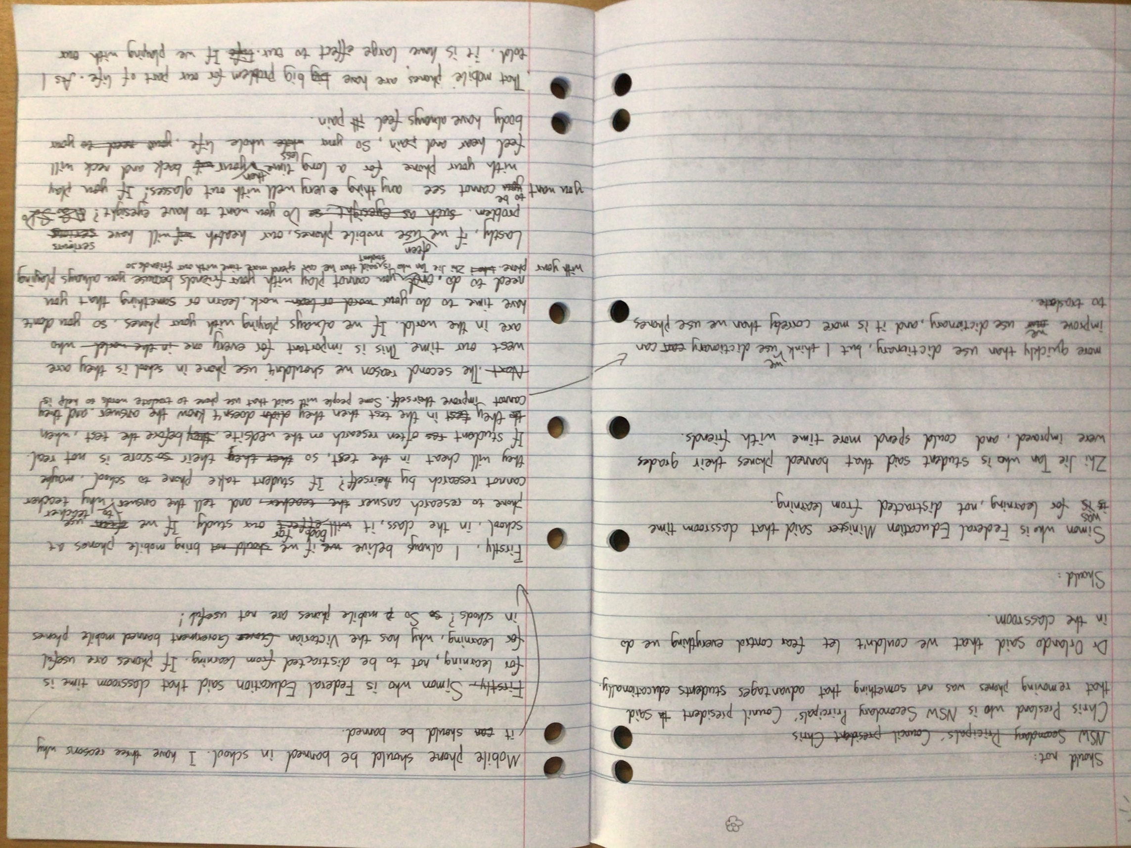

Section | Text |  | This sample of student work demonstrates that the student can:
1 | Simon who is Federal Education said that classroom time is for learning, not to be distracted from learning. If phones are useful for learning, why has the Victorian govern Government banned mobile phones in schools? so So mobile phones are not useful!  Mobile phone should be banned in school. I have three reasons why it can should be banned. | - Use mostly standard word order (VCEALL664)  - Write using a range of tenses with varied accuracy (VCEALL666)  - Link ideas using a range of basic cohesive devices (VCEALL663)  - Use adverbials to provide simple detail (VCEALL667)
2 | Firstly, I always believe we if we should not bring mobile phones at school, in the class, it will effect bad for our study. If we often use phone to research answer the teacher and tell the answer to teacher, why teacher cannot research by theirself? If student take phone to school, maybe they will cheat in the test, so ther they their so score is not real. If student res often research on the website, they before the test, when the they test in the test when they didn doesn’t know the answers. and they cannot improve theirself. Some people will said that use phone to translate words to help is more quickly than use dictionary, but I think we use dictionary can can improve our we use dictionary, and it is more correly than we use phones to traslate.
3 | Next The second reason we shouldn’t use phone in school is they are west our time. This is important for every one in the world who are in the world. If we always playing with your phones, so you don’t have time to do your word or learn work, learn or something that you need to do. and you cannot play with your friends becuase you always playing with your phone Zhi Jie Tan who is student said that he can spend more time with our friends so
4 | Lastly, if we often use mobile phones, our health if will have serious problems. such as eyesight, so Do you want to have eyesight? ASSD you want you to be cannot see anything very well with out glasses? If you play with your phone for a long time then your wil back and neck will feel hear and pain. So your whole less whole life, your need to your body have always feel ill pain.
5 | That mobile phones are have big big problem for most part of life. As I told, it is have large effect to our life. If we playing with our phones before we sleep, it can make us cannot sleep, then next day, your cannot wake up at time, so is bad for our body you we will feel ta tired, your eyes will also have effect. Some people So We we must banned mobile phones in school.

Overall, this student can also:  - Write some creative or personal texts, experimenting with known English (VCEALC655)  - Spell most commonly encountered words correctly (VCEALL670) | Possible next steps for this student’s learning:  - Reviewing writing for present simple tense, in particular the verb to be (VCEALL666)  - Researching and selecting a range of evidence to support arguments (VCEALA656)  - Revising and reorganising the structure of the essay, with a focus on effective introductions and conclusions (VCEALL661)  - Learning how to use the first conditional, for example, If we bring phones to class, it will affect our study (VCEALL665)
This student’s performance in this task suggests that she is working within the range of Level C2 in Writing. The assessing teacher will need to consider a range of student samples in order to determine whether this student is at the beginning of C2, consolidating C2 or at the C2 standard in Writing.  At beginning Level C2 students:  - are beginning to be more confident at using a wider range of text types, for example, procedures and reports, although they will often rely on assistance and models  - will begin to produce texts that include a greater and more creative range of adjectives, adverbs, conjunctions and variations in tenses, although not necessarily used accurately  - demonstrate a range of strategies that help them to become independent writers, such as accessing new words from dictionaries or word lists, and spelling words out phonetically or using other spelling strategies, for instance, mnemonics.  At consolidating Level C2 students:  - have begun to use models of text types with a relative degree of independence to produce their own work  - can organise the content of a topic at paragraph and topic sentence level, with assistance  - produce writing that shows improvement in its overall coherence and structure as their repertoire of connectives, conjunctives and grammatical structures continues to expand  - attempt to use direct speech in their texts where appropriate, although it may not be punctuated accurately  - show an awareness of the writing process, including the need to draft, review, and revise, but still require teacher guidance to work through each of these stages productively.  At Level C2 Achievement Standard students:  - write with a degree of autonomy for a range of everyday classroom and personal purposes, such as describing, explaining and recounting  - independently write some basic texts and experiment with presenting their own ideas  - produce texts show varying grammatical accuracy  - incorporate emerging vocabulary and grammatical features to achieve desired effects  - use an increasing range of simple connectives to indicate some basic relationships within and between sentences and paragraphs  - choose appropriate text structures and use headings, tables and images  - use basic text models as a basis for their own texts  - use strategies to organise information in supported research tasks  - review, redraft and improve their writing by discussing alternative ways of arranging and expressing ideas, with teacher support and feedback  - use more advanced features in software applications to write, edit and present their texts. | Pathways and transitions considerations:  A Year 9 student who is working within the range of Level C2 in any one language mode is not ready to transition to the English curriculum regardless of their proficiency in the other two language modes. This student will continue on Pathway C of the EAL curriculum.

