Pathway C Level C2 Writing
Persuasive text - Letter to the editor on David Sharp issue
Student information | The student was born in China and speaks Chinese as his home language. He has been in Australia for less than a year. He has had age equivalent schooling in China and spent two terms in an English language centre before entering secondary school.
Task | Students responded to an issue that was covered in class over a period of approximately four weeks. They gathered information, reviewed newspaper articles on the issues and engaged in oral discussion and debate. The students completed information and essay grids. No model was provided. The analysis is based on the student’s writing before correction.

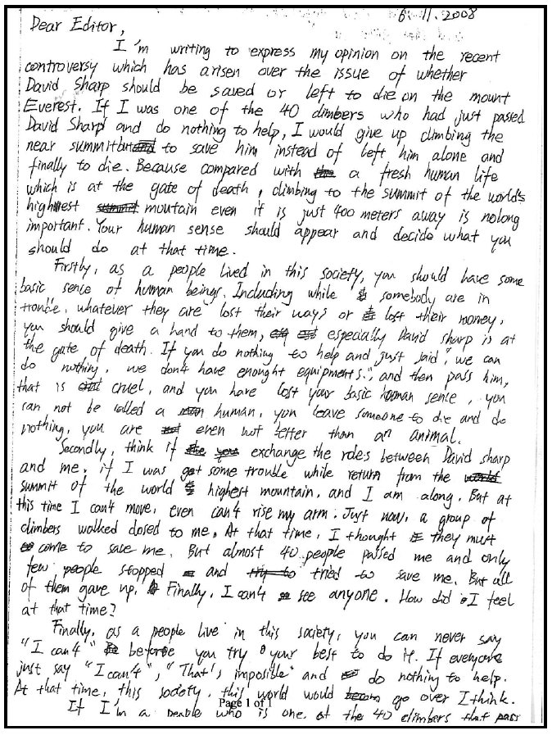
Section | Text |  | This sample of student work demonstrates that the student can:
1 | 6.8.2008  Dear Editor,  I’m writing to express my opinion on the recent controversy which has arisen over the issue of whether David Sharp should be saved or left to die on the mount Everest. If I was one of the 40 climbers who had just passed near summit but and to save him instead of left him alone and finally to die. Because compared with the a fresh human life which is at the gate of death, climbing to the summit of the world’s highest summit mountain even if is just 400 meters away is nolong important. Your human sense should appear and decide what you should do at that time. | - Write using a range of tenses with varied accuracy (VCEALL666)
2 | Firstly, as a people lived in this society, you should have some basic sence of human beings. Including while somebody are in trouble, whatever they are lost their ways or lost their money, you should give a hand to them, esq est especially David Sharp is at the gate of death. If you do nothing to help and just said, “we can do nothing, we don’t have enought equipments.”, and then pass him, that is cul cruel, and you have lost your basic human sence, you can not be called a man human, you leave someone to die and do nothing, you are not even not better than an animal. | - Use a range of punctuation marks consistently and correctly (VCEALL671)
3 | Secondly, think if the you exchange the roles between David sharp and me, if I was got some trouble while return from the world summit of the world highest mountain, and I am along. But at this time I can’t move, even can’t rise my arm. Just now, a group of climbers walked closed to me. At that time, I thought it they must come to save me. But almost 40 people passed me and only few people stopped and try to tried to save me. But all of them gave up. Finally, I can’t see anyone. How did I feel at that time? | - Write using a range of tenses with varied accuracy (VCEALL666)  - Use adverbials to provide simple detail (VCEALL667)
4 | Finally, as a people live in this society, you can never say “I can’t” Be before you try your best to do it. If everyone just say “I can’t”, “That’s imposible” and do nothing to help. At that time, this society, this world would becom go over I think. | - Use a range of punctuation marks consistently and correctly (VCEALL671)
5 | If I’m a people who is one of the 40 climbers that pass

Overall, this student can also:  - Use appropriate forms of text for purpose and audience, with guidance (VCEALA656)  - Write information texts for general school use, based on modelled language (VCEALC654)  - Organise information and write according to the structure of a specified text (VCEALL661)  - Link ideas using a range of basic cohesive devices (VCEALL663)  - Develop writing through the use of compound and complex sentences (VCEALL665) | Possible next steps for this student’s learning:  - Discussing with home language peers to translate idioms or quotations from home language to closest meaning in English (VCEALA660)  - Learning about, and practising using complex sentences involving first and second conditionals (VCEALL665)
This student’s performance in this task suggests that he is working within the range of Level C2 in Writing. The assessing teacher will need to consider a range of student samples in order to determine whether this student is at the beginning of C2, consolidating C2 or at the C2 standard in Writing.  At beginning Level C2 students:  - are beginning to be more confident at using a wider range of text types, for example, procedures and reports, although they will often rely on assistance and models  - will begin to produce texts that include a greater and more creative range of adjectives, adverbs, conjunctions and variations in tenses, although not necessarily used accurately  - demonstrate a range of strategies that help them to become independent writers, such as accessing new words from dictionaries or word lists, and spelling words out phonetically or using other spelling strategies, for instance, mnemonics.  At consolidating Level C2 students:  - have begun to use models of text types with a relative degree of independence to produce their own work  - can organise the content of a topic at paragraph and topic sentence level, with assistance  - produce writing that shows improvement in its overall coherence and structure as their repertoire of connectives, conjunctives and grammatical structures continues to expand  - attempt to use direct speech in their texts where appropriate, although it may not be punctuated accurately  - show an awareness of the writing process, including the need to draft, review, and revise, but still require teacher guidance to work through each of these stages productively.  At Level C2 Achievement Standard students:  - write with a degree of autonomy for a range of everyday classroom and personal purposes, such as describing, explaining and recounting  - independently write some basic texts and experiment with presenting their own ideas  - produce texts show varying grammatical accuracy  - incorporate emerging vocabulary and grammatical features to achieve desired effects  - use an increasing range of simple connectives to indicate some basic relationships within and between sentences and paragraphs  - choose appropriate text structures and use headings, tables and images  - use basic text models as a basis for their own texts  - use strategies to organise information in supported research tasks  - review, redraft and improve their writing by discussing alternative ways of arranging and expressing ideas, with teacher support and feedback  - use more advanced features in software applications to write, edit and present their texts. | Pathways and transitions consideration:  A student who is working within the range of Level C2 in any one language mode is not ready to transition to the English curriculum regardless of their proficiency in the other two language modes. This student will continue on Pathway C of the EAL curriculum.

