Pathway C Level C2 Writing
Imaginative text- Interview with Peisidorus
Student information | The student is 15 years old and in Year 9. He was born in South Korea and speaks Korean as his home language. He has had age-equivalent schooling and can read and write in his home language. In South Korea he also undertook extra English studies after school. The student has been at an English language centre for five weeks.
Task | Students studied a unit on the ancient Olympics. They were provided with a selection of topics to choose from and were asked to write a creative text based on a short story they had read called The New Olympian.  This piece of writing was completed independently with no scaffolding from the teacher. The student typed this piece of writing on the computer. The analysis is based on the student’s writing before correction.

Section | Text |  | This sample of student work demonstrates that the student can:
1 | 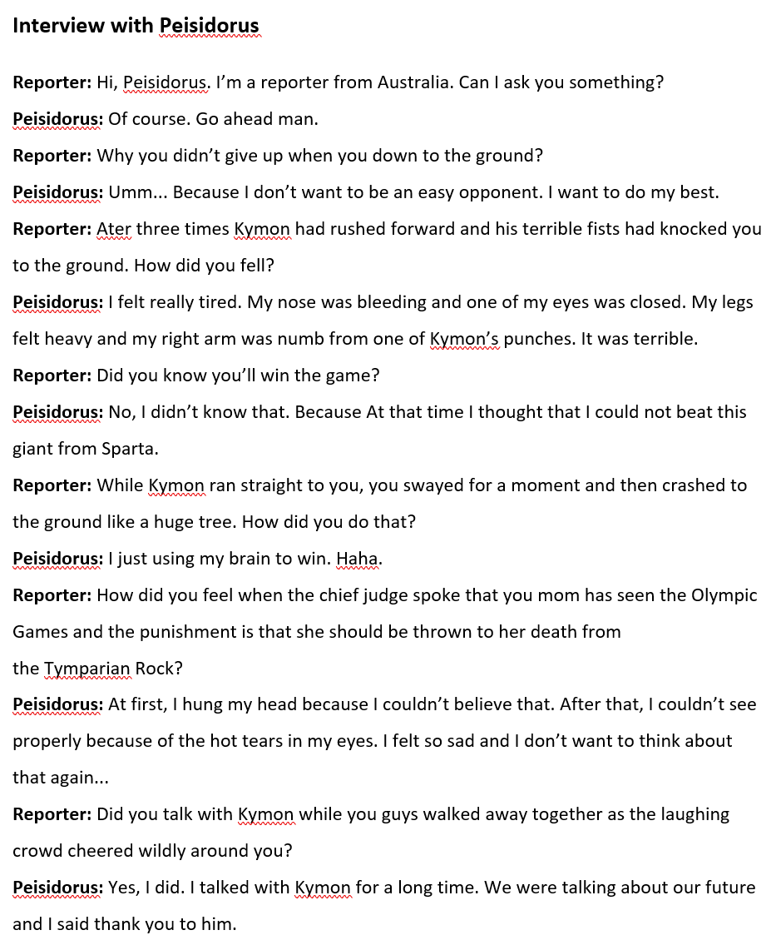 | - Write texts for social purposes (VCEALC653)  - Write some creative or personal texts, experimenting with known English (VCEALC655)  - Use appropriate forms of text for purpose and audience, with guidance (VCEALA656)  - Link ideas using a range of basic cohesive devices (VCEALL663)  - Use mostly standard word order (VCEALL664)  - Develop writing through the use of compound and complex sentences (VCEALL665)  - Write using a range of tenses with varied accuracy (VCEALL666)  - Use adverbials to provide simple detail (VCEALL667)  - Use a varied and appropriate vocabulary (VCEALL668)  - Develop a small range of skills to create and navigate simple digital texts (VCEALL672)

This student’s performance in this task suggests that he is working within the range of Level C2 in Writing. The assessing teacher will need to consider a range of student samples in order to determine whether this student is at the beginning of C2, consolidating C2 or at the C2 standard in Writing.  At beginning Level C2 students:  - are beginning to be more confident at using a wider range of text types, for example, procedures and reports, although they will often rely on assistance and models  - will begin to produce texts that include a greater and more creative range of adjectives, adverbs, conjunctions and variations in tenses, although not necessarily used accurately  - demonstrate a range of strategies that help them to become independent writers, such as accessing new words from dictionaries or word lists, and spelling words out phonetically or using other spelling strategies, for instance, mnemonics.  At consolidating Level C2 students:  - have begun to use models of text types with a relative degree of independence to produce their own work  - can organise the content of a topic at paragraph and topic sentence level, with assistance  - produce writing that shows improvement in its overall coherence and structure as their repertoire of connectives, conjunctives and grammatical structures continues to expand  - attempt to use direct speech in their texts where appropriate, although it may not be punctuated accurately  - show an awareness of the writing process, including the need to draft, review, and revise, but still require teacher guidance to work through each of these stages productively.  At Level C2 Achievement Standard students:  - write with a degree of autonomy for a range of everyday classroom and personal purposes, such as describing, explaining and recounting  - independently write some basic texts and experiment with presenting their own ideas  - produce texts show varying grammatical accuracy  - incorporate emerging vocabulary and grammatical features to achieve desired effects  - use an increasing range of simple connectives to indicate some basic relationships within and between sentences and paragraphs  - choose appropriate text structures and use headings, tables and images  - use basic text models as a basis for their own texts  - use strategies to organise information in supported research tasks  - review, redraft and improve their writing by discussing alternative ways of arranging and expressing ideas, with teacher support and feedback  - use more advanced features in software applications to write, edit and present their texts. | Possible next steps for this student’s learning:  - Learning about the differences between past simple and past perfect (VCEALL666)  - Learning question word order, for example, Why didn’t you give up? (VCEALL664)  - Using a plan and/or narrative scaffold to arrange his ideas in order (VCEALL661)
Pathways and transitions considerations:
A Year 9 student who is working within the range of Level C2 in any one language mode is not ready to transition to the English curriculum regardless of their proficiency in the other two language modes. This student will continue on Pathway C of the EAL curriculum.

