Pathway C Level C2 Writing
Imaginative text - Imaginative recount about face transplant
Student information | The student is from Somalia and Somali is their home language. The student had five or six years of schooling before arriving in Australia and attends an English language school in Victoria.
Task | This task was an end of unit assessment task. The students were asked to write about a French woman who had been in the news because she had been given a face transplant after being attacked by her dog. The class had sequenced the events leading up to the transplant, learned about time clauses such as when, while, after and the use of the passive voice. Students were asked to write a magazine article from the woman’s point of view and to include elements of the language they had been learning about.

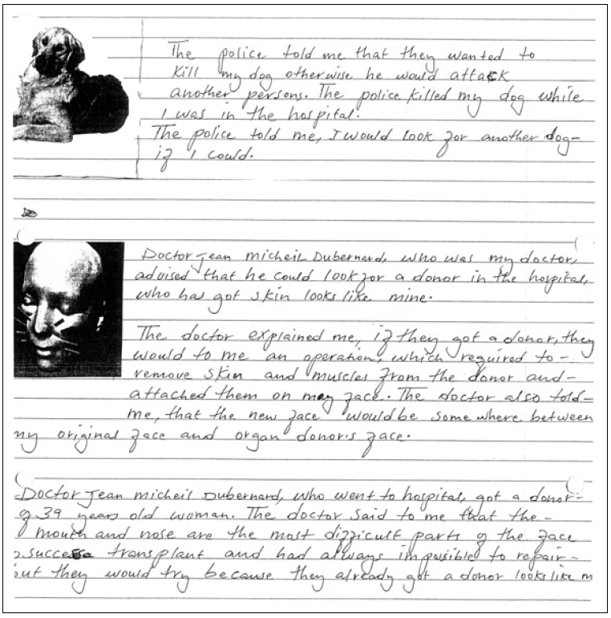

Section | Text |  | This sample of student work demonstrates that the student can:
1 | The police told me that they wanted to kill my dog otherwise he would attack another persons. The police killed my dog while I was in the hospital.  The police told me, I would look for another dog if I could. | - Link ideas using a range of basic cohesive devices (VCEALL663)  - Use adverbials to provide simple detail (VCEALL667)
2 | Doctor Jean Micheil Dubernard, who was my doctor, advised that he could look for a donor in the hospital, who has got skin looks like mine. | - Link ideas using a range of basic cohesive devices (VCEALL663)
3 | The doctor explained me, if they got a donor, they would to me an operation, which required to remove skin and muscles from the donor and attached them on my face. The doctor also told me, that the new face would be somewhere between my original face and organ donor’s face. | - Develop writing through the use of compound and complex sentences (VCEALL665)
4 | Doctor Jean Micheil Dubernard, who went to hospital, got a donor of 39 years old woman. The doctor said to me that the mouth and nose are the most difficult parts of the face success transplant and had always imposible to repair but they would try because they already got a donor looks like me.

Overall, this student can also:  - Write using a range of tenses with varied accuracy (VCEALL666)  - Write some creative or personal texts, experimenting with known English (VCEALC655)  - Use mostly standard word order (VCEALL664) | Possible next steps for this student’s learning:  - Practising using adverbials of time (VCEALL667)  - Using a rubric that includes learned linguistic structures and features to self-assess (VCEALA657)  - Working with a same language peer to discuss complex ideas using home languages, then discussing the translation into English (VCEALA660)  - Learning about gerunds, for example…which would require removing…and attaching…(VCEALL666)
This student’s performance in this task suggests that they are working within the range of Level C2 in Writing. The assessing teacher will need to consider a range of student samples in order to determine whether this student is at the beginning of C2, consolidating C2 or at the C2 standard in Writing.  At beginning Level C2 students:  - are beginning to be more confident at using a wider range of text types, for example, procedures and reports, although they will often rely on assistance and models  - will begin to produce texts that include a greater and more creative range of adjectives, adverbs, conjunction and variations in tenses, although not necessarily used accurately  - demonstrate a range of strategies that help them to become independent writers, such as accessing new words from dictionaries or word lists, and spelling words out phonetically or using other spelling strategies, for instance, mnemonics.  At consolidating Level C2 students:  - have begun to use models of text types with a relative degree of independence to produce their own work  - can organise the content of a topic at paragraph and topic sentence level, with assistance  - produce writing that shows improvement in its overall coherence and structure as their repertoire of connectives, conjunctives and grammatical structures continues to expand  - attempt to use direct speech in their texts where appropriate, although it may not be punctuated accurately  - show an awareness of the writing process, including the need to draft, review, and revise, but still require teacher guidance to work through each of these stages productively.  At Level C2 Achievement Standard students:  - write with a degree of autonomy for a range of everyday classroom and personal purposes, such as describing, explaining and recounting  - independently write some basic texts and experiment with presenting their own ideas  - produce texts show varying grammatical accuracy  - incorporate emerging vocabulary and grammatical features to achieve desired effects  - use an increasing range of simple connectives to indicate some basic relationships within and between sentences and paragraphs  - choose appropriate text structures and use headings, tables and images  - use basic text models as a basis for their own texts  - use strategies to organise information in supported research tasks  - review, redraft and improve their writing by discussing alternative ways of arranging and expressing ideas, with teacher support and feedback  - use more advanced features in software applications to write, edit and present their texts. | Pathways and transitions considerations:  A student who is working within the range of Level C2 in any one language mode is not ready to transition to the English curriculum regardless of their proficiency in the other two language modes. This student will continue on Pathway C of the EAL curriculum.

