Pathway C Level C1 Writing
Persuasive text- Should shops stop using plastic bags?
Student information | The student is 15 years old and is in Year 9. He is from Thailand and speaks Thai as his home language. He has had age-equivalent schooling and can read and write in his home language. He learned English in Thailand. He is currently studying in an English language centre.
Task | The student was asked to write a paragraph on the topic Should shops stop using plastic bags?  The student was provided with heavily scaffolded paragraph plans that guided him through the structure of a paragraph, including a topic sentence, linking words, series of arguments and a concluding sentence.  The student was not provided any other additional support. The analysis is based on the student’s writing before correction.

Section | Text | This sample of student work demonstrates that the student can:
Plan | 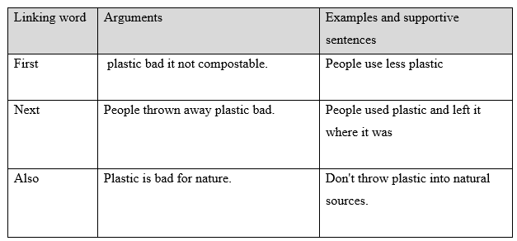 | - Show some organisation of subject matter and attempt the structure of a specified text (VCEALL597)  - Use single-word subject–verb–object word order in simple sentences and noun–pronoun agreements with few errors (VCEALL600)  - Use common punctuation with some consistency (VCEALL607)  - Use grapho-phonic knowledge to attempt to spell unknown words (VCEALL606)  - Write to communicate personal ideas (VCEALC591)  - Use basic digital technology functions (VCEALL608)
Final | 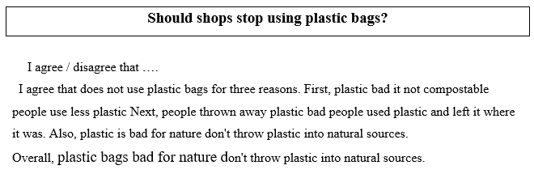

This student’s performance in this task suggests that he is working within the range of Level C1 in Writing. The assessing teacher will need to consider a range of student samples in order to determine whether this student is at the beginning of C1, consolidating C1 or at the C1 standard in Writing.  At beginning Level C1 students:  - attempt to write down words they have heard or said, but this will usually not be with accurate spelling  - will rely heavily on proformas and other model texts as scaffolding to produce extended pieces of writing longer than a phrase or sentence with teacher guidance, but are not yet aware that different text types are used for different purposes  - tend to focus on producing a final product, rather than recognising that the act of writing is a process that involves planning, revision, and editing.  At consolidating Level C1 students:  - have begun to attempt their own sentences, although the focus is on meaning rather than grammatical accuracy  - produce sentences that tend to follow a basic subject–verb–object pattern, but with varying degrees of accuracy  - create texts that demonstrate a growing awareness of differences between text types, especially in terms of overall organisational features and structure, although their ability to demonstrate this in their own writing is still very rudimentary  - can review their writing and identify aspects that might be changed or revised, with assistance.  At Level C1 Achievement Standard students:  - write for a range of basic classroom and personal purposes, making lists and writing simple journal entries, notes, descriptions, recounts of events and instructional texts  - produce basic sentences and short texts based on well-practised spoken English and familiar contexts  - write with varying grammatical accuracy, expressing themselves using familiar vocabulary and modelled structures and features  - order and sequence sentences about familiar topics into simple coherent texts, incorporating basic conventions such as headings and paragraphs  - correct some errors relating to targeted grammatical items, and rework drafts in response to teacher suggestions  - plan their texts and provide some additional information through visual texts, with support  - utilise a range of strategies for finding and spelling words, using spelling patterns and checking resources  - use basic features in software applications to write and present their texts. | Possible next steps for this student’s learning:  - Discussing the plan with a teacher and a peer and incorporating corrections and suggestions (VCEALA594)  - Learning when and how to use negatives correctly (VCEALL602)  - Using a range of learnt sentence starters specifically for persuasive text such as In my opinion..., I believe... and It is important that... (VCEALA596)  - Using conjunctions such as because and so to join clauses and provide explanations and reasons (VCEALL601)  - Learning to incorporate persuasive language, including modal verbs such as should and must and modal adverbs such as definitely (VCEALL603)  - Exploring and using text formatting functions in word processing programs or apps to improve the presentation of final work (VCEALL608)
Pathways and transitions considerations:
A Year 9 student who is working within the range of Level C1 in any one language mode is not ready to transition to the English curriculum regardless of their proficiency in the other two language modes. This student will continue on Pathway C of the EAL curriculum.

