Pathway C Level C1 Writing
Informative text - Quadrilaterals
Student information | This student is 13 years old and learning in an English language school. She is a Karen refugee and has been in Australia for approximately 8 months. She has had interrupted schooling in a refugee camp in Thailand.
Task | This is a ‘thinking paper’ written as part of a unit on quadrilaterals. Students worked in pairs with sets of shapes in different colours. The task was to think, pair, share and write. Students have previously learned have/has got. The class was working at a Year 3 to Year 4 conceptual level. The analysis is based on the student’s writing before correction.
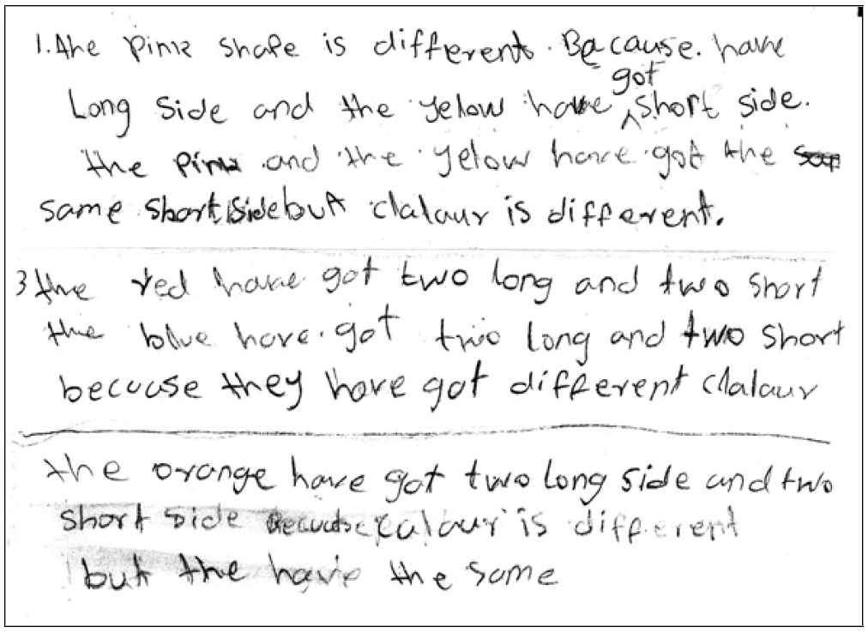
Section | Text | This sample of student work demonstrates that the student can:
1 | - The pink shaPe is different. Because. have Long side and the yellow have got short side.  the Pink and the yellow have got the same short side but clalaur is different. | - Use single-word subject–verb–object word order in simple sentences and noun–pronoun agreements with few errors (VCEALL600)  - Use single clauses, or use simple coordinating and subordinating conjunctions to combine clauses (VCEALL601)  - Incorporate introduced subject-specific vocabulary into simple sentences (VCEALL605)  - Use common punctuation with some consistency (VCEALL607)
2 | - the red have got two long and two short  the blue hove got two long and two short because they have got different clalaur
3 | the orange have got two long side and two short side because calaur is different but the have the same

Overall, this student can also:  - Write short, simple texts for varied social purposes (VCEALC589)  - Show some organisation of subject matter and attempt the structure of a specified text (VCEALL597)  - Draw on experience of language patterns in controlled writing activities to express ideas (VCEALA596) | Possible next steps for this student’s learning:  - Using topic-specific vocabulary such as names of shapes (VCEALL605)  - Understanding and using subject-verb agreement in writing (VCEALL600)  - Writing a description about other two-dimensional or three-dimensional shapes (VCEALC590)  - Revising the use of conjunctions such as because and but (VCEALL601)
This student’s performance in this task suggests that she is working within the range of Level C1 in Writing. The assessing teacher will need to consider a range of student samples in order to determine whether this student is at the beginning of C1, consolidating C1 or at the C1 standard in Writing.  At beginning Level C1 students:  - attempt to write down words they have heard or said, but this will usually not be with accurate spelling  - will rely heavily on proformas and other model texts as scaffolding to produce extended pieces of writing longer than a phrase or sentence with teacher guidance, but are not yet aware that different text types are used for different purposes  - tend to focus on producing a final product, rather than recognising that the act of writing is a process that involves planning, revision, and editing.  At consolidating Level C1 students:  - have begun to attempt their own sentences, although the focus is on meaning rather than grammatical accuracy  - produce sentences that tend to follow a basic subject–verb–object pattern, but with varying degrees of accuracy  - create texts that demonstrate a growing awareness of differences between text types, especially in terms of overall organisational features and structure, although their ability to demonstrate this in their own writing is still very rudimentary  - can review their writing and identify aspects that might be changed or revised, with assistance.  At Level C1 Achievement Standard students:  - write for a range of basic classroom and personal purposes, making lists and writing simple journal entries, notes, descriptions, recounts of events and instructional texts  - produce basic sentences and short texts based on well-practised spoken English and familiar contexts.  - write with varying grammatical accuracy, expressing themselves using familiar vocabulary and modelled structures and features  - order and sequence sentences about familiar topics into simple coherent texts, incorporating basic conventions such as headings and paragraphs  - correct some errors relating to targeted grammatical items, and rework drafts in response to teacher suggestions  - plan their texts and provide some additional information through visual texts, with support  - utilise a range of strategies for finding and spelling words, using spelling patterns and checking resources  - use basic features in software applications to write and present their texts. | Pathways and transitions considerations:  A Year 7 student who is working within the range of Level C1 in any one language mode is not ready to transition to the English curriculum regardless of their proficiency in the other two language modes. This student will continue on Pathway C of the EAL curriculum.

