Pathway B Level BL Writing
Informative text - City excursion
Student information | This student is 11 years old and was born in Sudan. The student speaks Dinka and a little Arabic. They have had very limited schooling in Arabic (possibly one year) before starting at an English language school. The student is not literate in any language. The student had been at the language school for approximately ten months when they wrote this recount. The student is in Year 4.
Task | The student worked independently to write a recount about a city excursion. The student used the ‘have-a-go’ strategy to spell some unknown words. There were questions words such as who and what, and some vocabulary such as potpourri written on the board. The teacher had worked with the student to edit the sentences and spelling.
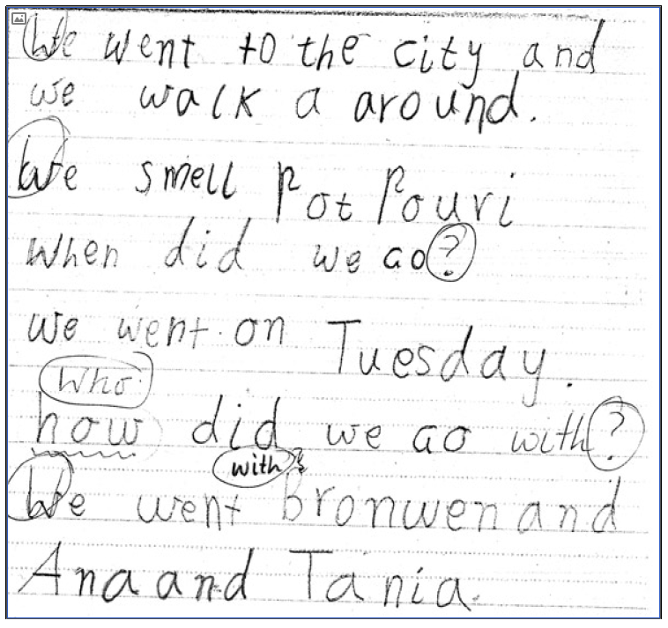
Section | Text |  | This sample of student work demonstrates that the student can:
1 | We went to the city and we walk a around.  We smell potpourri  When did we Go?  we went on Tuesday.  how did we Go with?  We went Bronwen and Ana and Tania. | - Write or dictate in sentences or phrases that match oral sentence structures (VCEALL227)  - Write very short, simple texts (VCEALL228)  - Write some familiar words and complete simple, repetitive modelled sentences in writing (VCEALC217)  - Apply common conventions when copying or writing texts (VCEALL236)  - Copy words, phrases or sentences accurately and carefully (VCEALC216)

This student’s performance in this task suggests that they are working within the range of Level BL in Writing. The assessing teacher will need to consider a range of student samples in order to determine whether this student is at the beginning of BL, consolidating BL or at the BL standard in Writing.  At beginning Level BL students:  - are new to English and new to literacy  - may be reluctant to participate in writing activities and may not understand their purpose  and/or  - may have little or no experience of formal learning and do not have literacy strategies already acquired through developing literacy in a home language  and/or  - may have difficulty with the mechanics of writing, for example, they might not be used to holding pencils or crayons and making ‘marks’ on the page, depending on their prior experiences  - will be able to draw on general learning skills and strategies that they have used to function effectively in their home communities, for example observing, memorising, classifying.  At consolidating Level BL students:  - use drawing as a means of expression  - will show improvements in their ability to form letters and produce copied text  - copy writing from other sources, for example environmental print, other students, the teacher’s model  - will observe shared writing tasks, watching as the teacher writes and will begin to contribute as much as their limited English allows  - talk about their writing and pictures, drawing on their oral English language and may use their home language with same language peers or bilingual teacher  - may exhibit limited concentration during shared writing tasks.  At Level BL Achievement Standard students:  - communicate their ideas and experiences simply through written, drawn, copied or dictated texts  - contribute to whole-class or small-group shared writing activities  - demonstrate an early awareness that written texts in English are presented according to certain conventions, which change according to context and purpose  - write simple sequenced descriptions, recounts and procedures, following models  - write or draw for specific audiences.  - produce writing that reflects their oral structures  - link ideas using common conjunctions and show awareness of the uses of basic punctuation  - demonstrate knowledge of some English letter–sound relationships and spelling of high-frequency words  - show evidence of some planning  - model their writing on shared writing activities and published texts  - use some basic strategies, such as copying words or phrases from lists, using images and asking how to write a word  - begin to form letters and place text appropriately  - copy texts using computer software applications. | Possible next steps for this student’s learning:  - Sequencing the events of the excursion using photographs to support writing an extended text (VCEALC215)  - Editing the writing for simple past tense verbs (VCEALL231)  - Typing out the writing and publishing the final version of the writing (VCEALA222) (VCEALL239)  - Using simple punctuation appropriately such as full stops and capital letters (VCEALL238)
Pathways and transitions considerations
A Year 4 student working within the range of Level BL in any one language mode is not ready to transition to the English curriculum regardless of their proficiency in the other two language modes. This student will continue on Pathway B of the EAL curriculum in all language modes.

