Pathway B Level B3 Writing
Persuasive text- Should Australia’s cricket team have gone to Sri Lanka?
Student information | The student is in Year 5. They were born in Poland and speak Polish as their home language. They started school in Foundation in Victoria.
Task | The students read and examined the structural organisation and linguistic features of an exposition. They had jointly constructed an exposition with the teacher before writing their own text on a topic of their choice.  The analysis is based on the student’s writing before correction.

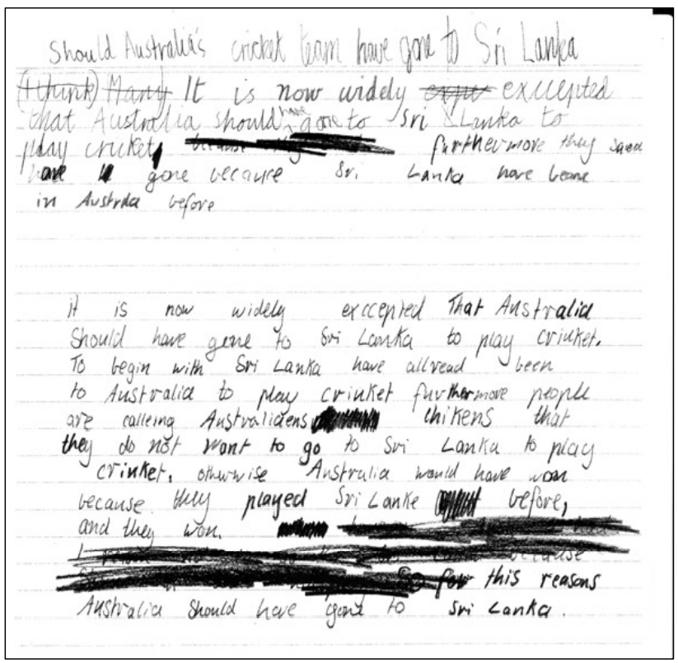
Section | Text |  | This sample of student work demonstrates that the student can:
1 | Should Australia’s cricket team have gone to Sri Lanka | - Use the text type appropriate to the task (VCEALL466) *includes a heading using modal verb should
2 | (I think) Many It is now widely expe exccepted that Australia should have gone to Sri LLanka to play cricket because [text crossed out] furthermore they saed have L gone because Sri Lanka have beone in Austrila before
3 | it is now widely exccepted That Australia Should have gone to Sri Lanka to play criuket.  To begin with Sri Lanka have allread been to Australia to play criuket fuvthermore people are calleing Australiaens [text crossed out] chikens that they do not want to go to Sri Lanka to play criuket. othwwise Australia would have won because they played Sri Lanka [text crossed out] before, and they won.  [text crossed out]  This reasons Australia should have gone to Sri Lanka. | - Use a range of devices to maintain cohesion (VCEALL468) *uses furthermore and otherwise  - Spell most words accurately, drawing on a range of strategies but with some invented spelling still evident (VCEALL477)  - Use a range of sentence structures appropriate to the text, with some errors (VCEALL469)  - Maintain appropriate tense throughout a text (VCEALL470)  - Combine simple sentences using common conjunctions (VCEALL472)  - Create mood and feeling through the selection of appropriate vocabulary and idiom (VCEALL475) *uses the modal verb should to present a point of view

Overall, this student can also:  - Write texts that present a point of view on topics discussed in class (VCEALC456) | Possible next steps for this student’s learning:  - Using a planning template to organise arguments for and against (VCEALA460) (VCEALA461)  - Elaborating on arguments by including examples and reasons (VCEALA459)  - Working with a partner to give and receive feedback on draft text, including in their home language if possible and appropriate (VCEALA462) (VCEALA464)  - Keeping a personal list of commonly misspelt words in an individual improvement journal, with teacher feedback and support (VCEALL474)
This student’s performance in this task suggests that they are working within the range of Level B3 in Writing. The assessing teacher will need to consider a range of student samples in order to determine whether this student is at the beginning of B3, consolidating B3 or at the B3 standard in Writing.  At beginning Level B3 students:  - write simple texts based on models which include basic organisational features of familiar text types  - begin to use more written-like language in their writing and include some technical language in factual texts  - continue to connect ideas using a range of common conjunctions  - extend noun groups by including adjectives before the noun  - plan and make simple revisions of their writing.  At consolidating Level B3 students:  - are beginning to construct more complex examples of logically organised genres with increasing independence  - begin to include more complex language and sentence structures in their writing  - use common technical vocabulary in factual texts more consistently  - use subject–verb–object agreement and tense with increasing control  - accurately spell common words used in the classroom and use their knowledge of sounds and letter patterns to spell unfamiliar words.  At Level B3 Achievement Standard students:  - communicate for a range of purposes on a variety of familiar topics, using a basic repertoire of text types  - write sequenced and ordered factual texts, and narrative texts that maintain a cohesive storyline and characterisation  - demonstrate an awareness of how effective writing is tailored to a purpose, the requirements of the topic and the needs of the reader  - gather and present information appropriately in texts  - write texts that demonstrate some overall cohesion and coherence  - can combine and sequence simple sentences and paragraphs using common conjunctions and pronouns  - generally maintain appropriate tense throughout their texts  - discuss and reflect on their own writing, incorporating feedback when planning, reviewing or presenting their texts  - revise texts during writing and proofread after a first draft has been written, improving spelling, punctuation and sentence structure  - present their writing appropriately, in print and digital forms. | Pathways and transitions considerations:  A Year 5 student who is working within the range of B3 in any one language mode is not ready to transition to the English curriculum regardless of their proficiency in the other two language modes. This student will continue on Pathway B of the EAL curriculum in all language modes.  A Year 5 student should consistently demonstrate the final achievement standard in Pathway B (Level B3) in all three language modes before they transition to the English curriculum.  They will need to be equally capable across all three language modes to be able to meet the learning expectations in the English curriculum at the level taught to their mainstream peers, and without substantial language support.  They will need to be sufficiently proficient in understanding and using the academic language across the learning areas to participate in learning activities across the Victorian curriculum.  They will also need to be able to understand and use the academic English of the curriculum in subsequent years without substantial language support, when the cognitive and linguistic demands of the Victorian curriculum increase.

