Pathway B Level B3 Writing
Informative text - Seasons Reasons
Student information | This student is in Year 6. They were born in New Zealand and speak Somali at home. They began school in New Zealand and started school in Victoria in Year 3.
Task | The student had been learning about the seasons and how they occur. They had read a range of texts on the topic and had examined models of explanations. The student researched the topic before writing this text independently. The text reproduced here has received some correction by the teacher. The analysis is based on the student’s writing before correction.
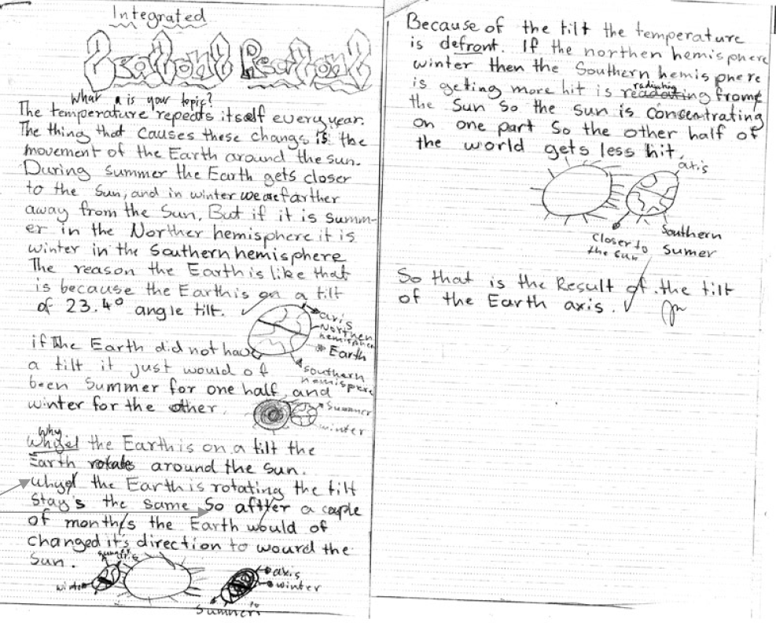
Section | Text | This sample of student work demonstrates that the student can:
1 | Seasons Reasons
2 | The temperature repeats itself every year.  The thing that causes these changes is the movement of the Earth around the sun.  During summer the Earth gets closer to the Sun, and in winter we are farther away from the Sun.  But if it is summ-er in the Norther hemisphere it is winter in the Southern hemisphere  The reason the Earth is like that is because the Earth is on a tilt of 23.4 angle tilt. | - Write using extended descriptive phrases (VCEALL471)  - Use a range of punctuation marks consistently and correctly (VCEALL478)
3 | if The Earth did not have a tilt it just would of been Summer for one half, and winter for the other. | - Use a range of punctuation marks consistently and correctly (VCEALL478)
4 | Whyel the Earth is on a tilt the Earth rotates around the Sun.  Whyel the Earth is rotating the tilt stays the same So aftter a caple of months the Earth would of changed it’s direction to wourd the Sun. | - Spell most words accurately, drawing on a range of strategies but with some invented spelling still evident (VCEALL477)  - Combine simple sentences using common conjunctions (VCEALL472)
5 | Because of the tilt the temperature is defront.  If the northern hemisphere winter then the Southern hemisphere is getting more hit is readating frome the Sun so the sun is concentrating on one part So the other half the world gets less hit. | - Use a range of sentence structures appropriate to the text, with some errors (VCEALL469)  - Spell most words accurately, drawing on a range of strategies but with some invented spelling still evident (VCEALL477)  - Combine simple sentences using common conjunctions (VCEALL472)
6 | So that is the Result of the tilt of the Earth axis.

Overall, this student can also:  - Use a range of visual material or other cues to support factual texts (VCEALC454)  - Maintain appropriate tense throughout a text (VCEALL470)  - Format texts appropriately for the purpose (VCEALL476)  - Present work appropriately for purpose and audience (VCEALA458)  - Use the text type appropriate to the task (VCEALL466)  - Organise texts in simple, logically ordered paragraphs with topic sentences (VCEALL467)  - Use a range of key vocabulary appropriately (VCEALL474)  - Use a range of devices to maintain cohesion (VCEALL468) | Possible next steps for this student’s learning:  - Using nominalisation in their writing (VCEALL471)  - Writing in the passive voice (VCEALL469)  - Using strategies to remember the spelling of subject-specific vocabulary and sight words (VCEALA463)  - Planning and organising ideas in paragraphs (VCEALL467)
This student’s performance in this task suggests that they are working within the range of Level B3 in Writing. The assessing teacher will need to consider a range of student samples in order to determine whether this student is at the beginning of B3, consolidating B3 or at the B3 standard in Writing.  At beginning Level B3 students:  - write simple texts based on models which include basic organisational features of familiar text types  - begin to use more written-like language in their writing and include some technical language in factual texts  - continue to connect ideas using a range of common conjunctions  - extend noun groups by including adjectives before the noun  - plan and make simple revisions of their writing.  At consolidating Level B3 students:  - are beginning to construct more complex examples of logically organised genres with increasing independence  - begin to include more complex language and sentence structures in their writing  - use common technical vocabulary in factual texts more consistently  - use subject–verb–object agreement and tense with increasing control  - accurately spell common words used in the classroom and use their knowledge of sounds and letter patterns to spell unfamiliar words.  At Level B3 Achievement Standard students:  - communicate for a range of purposes on a variety of familiar topics, using a basic repertoire of text types  - write sequenced and ordered factual texts, and narrative texts that maintain a cohesive storyline and characterisation  - demonstrate an awareness of how effective writing is tailored to a purpose, the requirements of the topic and the needs of the reader  - gather and present information appropriately in texts  - write texts that demonstrate some overall cohesion and coherence  - can combine and sequence simple sentences and paragraphs using common conjunctions and pronouns  - generally maintain appropriate tense throughout their texts  - discuss and reflect on their own writing, incorporating feedback when planning, reviewing or presenting their texts  - revise texts during writing and proofread after a first draft has been written, improving spelling, punctuation and sentence structure  - present their writing appropriately, in print and digital forms. | Pathways and transitions considerations:  Assuming that this Year 6 student is consistently demonstrating the final achievement standard in Pathway B (Level B3) in the other two language modes, they will need to demonstrate that they are also consistently working at the achievement standard in Writing in order to transition to the English curriculum.  They will need to be equally capable across all three language modes to be able to meet the learning expectations in the English curriculum at the level taught to their mainstream peers, and without substantial language support.  They will need to be sufficiently proficient in understanding and using the academic language across the learning areas to participate in learning activities across the Victorian curriculum.  They will also need to be able to understand and use the academic English of the curriculum in subsequent years without substantial language support, when the cognitive and linguistic demands of the Victorian curriculum increases.

