Pathway B Level B3 Writing
Informative text - Pancakes
Student information | The student was born in China and speaks Mandarin. They had equivalent aged schooling in China and attended an English language school for two terms before enrolling in a mainstream primary school. The student is in Year 4.
Task | The students had been explicitly taught about procedural recounts with a focus on using the past tense. After making pancakes in the class, the students were asked to write a procedural recount. There were some words and phrases on the whiteboard for reference. The students wrote the text independently and it was later corrected by the teacher. The analysis is based on the student’s writing before correction.
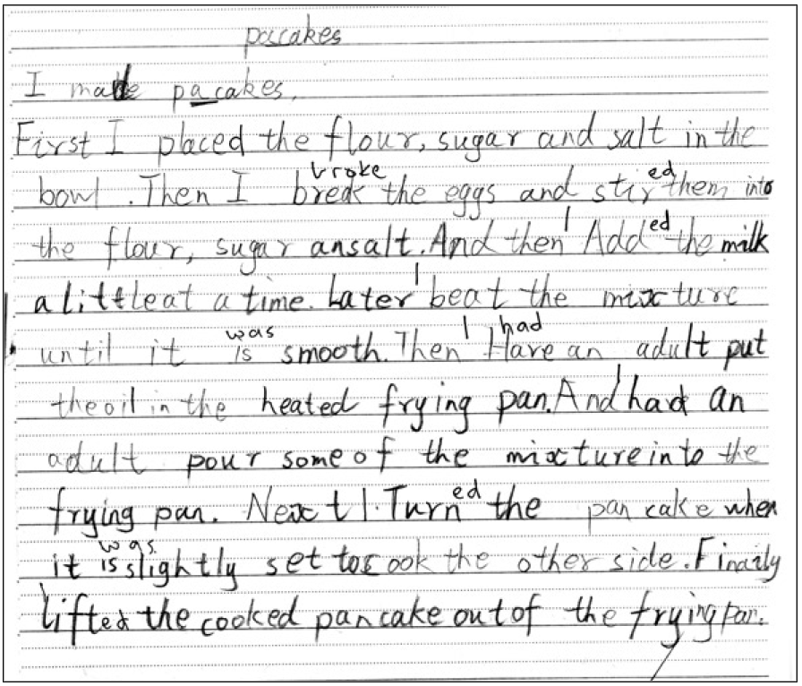
Section | Text |  | This sample of student work demonstrates that the student can:
1 | pacakes  I make pacakes. | - Format texts appropriately for the purpose (VCEALL476)
2 | First I place the flour, sugar and salt in the bowl. Then I break the eggs and stir them into the flour, sugar ansalt. And then Add the milk a little at a time. Later beat the mixture until it is smooth. Then Have an adult put the oil in the heated frying pan. And had an adult pour some of the mixture into the frying pan. Next Turn the pancake when it is slightly set to cook the other side. Finaily lift the cooked pancake out of the frying pan. | - Use a range of devices to maintain cohesion (VCEALL468)  - Combine simple sentences using common conjunctions (VCEALL472)  - Organise texts in simple, logically ordered paragraphs with topic sentences (VCEALL467)  - Write using extended descriptive phrases (VCEALL471)  - Spell most words accurately, drawing on a range of strategies but with some invented spelling still evident (VCEALL477)

This student’s performance in this task suggests that they are working within the range of Level B3 in Writing. The assessing teacher will need to consider a range of student samples in order to determine whether this student is at the beginning of B3, consolidating B3 or at the B3 standard in Writing.  At beginning Level B3 students:  - write simple texts based on models which include basic organisational features of familiar text types  - begin to use more written-like language in their writing and include some technical language in factual texts  - continue to connect ideas using a range of common conjunctions  - extend noun groups by including adjectives before the noun  - plan and make simple revisions of their writing.  At consolidating Level B3 students:  - are beginning to construct more complex examples of logically organised genres with increasing independence  - begin to include more complex language and sentence structures in their writing  - use common technical vocabulary in factual texts more consistently  - use subject–verb–object agreement and tense with increasing control  - accurately spell common words used in the classroom and use their knowledge of sounds and letter patterns to spell unfamiliar words.  At Level B3 Achievement Standard students:  - communicate for a range of purposes on a variety of familiar topics, using a basic repertoire of text types  - write sequenced and ordered factual texts, and narrative texts that maintain a cohesive storyline and characterisation  - demonstrate an awareness of how effective writing is tailored to a purpose, the requirements of the topic and the needs of the reader  - gather and present information appropriately in texts  - write texts that demonstrate some overall cohesion and coherence  - can combine and sequence simple sentences and paragraphs using common conjunctions and pronouns  - generally maintain appropriate tense throughout their texts  - discuss and reflect on their own writing, incorporating feedback when planning, reviewing or presenting their texts  - revise texts during writing and proofread after a first draft has been written, improving spelling, punctuation and sentence structure  - present their writing appropriately, in print and digital forms. | Possible next steps for this student’s learning:  - Comparing the sentences structures in recounts and procedural texts to form a general understanding about sentence structures in the different genres, for example, including or excluding personal pronouns in recounts and procedural texts respectively (VCEALL466) (VCEALC455)  - Reading and editing own writing for past tense verbs (VCEALL470)  - Using a template to plan own writing and include the orientation, series of events and conclusion (VCEALA461)
Pathways and transitions considerations:
Assuming that this Year 4 student is consistently demonstrating the final achievement standard in Pathway B (Level B3) in the other two language modes, they will need to demonstrate that they are also consistently working at the achievement standard in Writing in order to transition to the English curriculum.
They will need to be equally capable across all three language modes to be able to meet the learning expectations in the English curriculum at the level taught to their mainstream peers, and without substantial language support.
They will need to be sufficiently proficient in understanding and using the academic language across the learning areas to participate in learning activities across the Victorian curriculum.
They will also need to be able to understand and use the academic English of the curriculum in subsequent years without substantial language support, when the cognitive and linguistic demands of the Victorian curriculum increases, for example in Years 5 and 6.

