Pathway B Level B2 Writing
Persuasive text - Melbourne is the best city
Student information | The student is 10 years old and in Year 5. She was born in Brazil and speaks Portuguese. She has had age-equivalent schooling in Brazil and is able to read and write in Portuguese. She has been at an English language school in Australia for two terms and her parents are able to support her to learn English at home.
Task | Students have been learning about Australia including the states and territories, capital cities and places of interest. Students also looked at voicing opinions (agree and disagree) and supporting their opinions with reasons. For this task students were given the topic as their opinion and asked to write a text to persuade their friends or family to come and visit Melbourne. The class had explored the structure of a persuasive text prior to writing. Key vocabulary was provided on flash cards with pictures.  The student completed the task independently using the flashcards and text structure discussed.  The analysis is based on the student’s writing before correction.

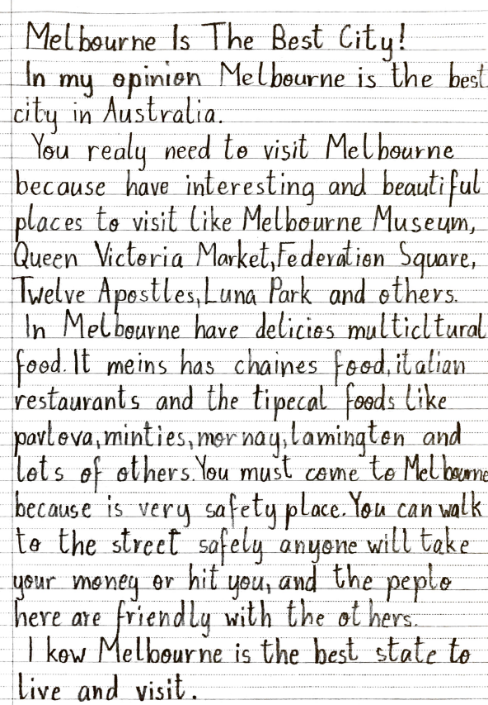
Section | Text |  | This sample of student work demonstrates that the student can:
Title | Melbourne Is The Best City! | - Write using language that is beginning to reflect the features of written language more than the features of spoken language (VCEALA379)  - Use knowledge of written or spoken home language texts to form new English texts (VCEALA385) *pattern of spelling errors indicates possible transferral of knowledge from home language, for example delicios, meins and chaines  - Use heading and text formats appropriate to the task (VCEALL387)  - Write sentences with some common errors (VCEALL390)  - Use a range of verb forms correctly (VCEALL391)  - Use a number of common conjunctions to link ideas to create compound and complex sentences (VCEALL393)  - Use modelled vocabulary appropriately (VCEALL395)  - Select some descriptive vocabulary appropriate to context (VCEALL396)  - Spell frequently used words with common patterns with increased accuracy (VCEALL398)  - Experiment with complex punctuation (VCEALL399)
Body | In my opinion Melbourne is the best city in Australia.  You realy need to visit Melbourne because have interesting and beautiful places to visit like Melbourne Museum, Queen Victoria Market, Federation Square, Twelve Apostles, Luna Park and others.  In Melbourne have delicios multicltural food. It meins has chaines food, italian restuarants and the tipecal foods like pavlova, minties, mornay, lamington and lots of others. You must come to Melbourne because is very safety place. You can walk to the street safely anyone will take your money or hit you, and the peplo here are friendly with the others.
Conclusion | I kow Melbourne is the best state to live and visit.

Overall, this student can also:  - Write simple texts that present a point of view (VCEALC377)  - Create a small range of texts based on modelling (VCEALA380) | Possible next steps for this student’s learning:  - Using the TEEL framework (Topic sentence, Explanation, Evidence, Linking sentence) to help provide more information in one paragraph (VCEALL388)  - Using a writing plan based on the TEEL framework to organise the content for all the paragraphs in an essay so that there is a cohesion throughout the whole essay (VCEALA381)  - Using comparative language and superlative language such as is better than... and has the most amazing... (VCEALL392)
This student’s performance in this task suggests that she is working within the range of Level B2 in Writing. The assessing teacher will need to consider a range of student samples in order to determine whether this student is at the beginning of B2, consolidating B2 or at the B2 standard in Writing.  At beginning Level B2 students:  - write their own simple texts for different purposes in guided contexts  - draw on models provided and use repetitive structures in an attempt to write longer texts  - produce writing that is still reflective of their everyday spoken English and which includes marked EAL features (for example, sometimes leaving out articles and verb endings and making errors with verb tenses) as they become more confident in experimenting with oral and written English.  - attempt to spell new words using their own pronunciation and write familiar words accurately.  At consolidating Level B2 students:  - continue to write their own simple creative and informational texts for classroom purposes with support and they begin to include some details that help orient the reader  - produce writing that begins to include features of written-like language however it is still influenced mostly by their spoken language  - produce writing that shows varying control over grammatical features such as subject–verb agreement, tense, noun-pronoun reference and articles  - spell most monosyllabic and many high frequency words accurately.  At Level B2 Achievement Standard students:  - write for a range of purposes on familiar topics  - write simple, organised texts demonstrating a developing use of specific vocabulary and simple sentence structures  - demonstrate an understanding of the purposes of common text types, and their structures and features  - produce written texts that include basic information and detail  - use a number of common conjunctions to link ideas, using pronoun references with some noun–pronoun agreement, simple phrases to express basic comparisons, and some basic punctuation with consistency  - make plausible attempts to spell new words based on known English letter–sound relationships and use a range of strategies for spelling words, checking word lists or keeping personal dictionaries  - base new sentences on known sentence structures  - draw on a developing knowledge of the writing process to plan and write simple texts, and with support, redraft them  - use more advanced software functions to write, edit and present their texts. | Pathways and transitions considerations:  A Year 5 student working within the range of Level B2 in any one language mode is not ready to transition to the English curriculum regardless of their proficiency in the other two language modes. This student will continue on Pathway B of the EAL curriculum in all language modes.

