Pathway B Level B2 Writing
Persuasive text- All children should learn to ride a bike
Student information | The student is 10 years old and in Year 5. He was born in Afghanistan and speaks Dari. He has had a few years of schooling in Afghanistan and is able to read but not write in his home language. He has been at a language school in Australia for three terms and both parents are not able to support him in English at home.
Task | This writing task was a summative task at the end of a unit focusing on the structure and linguistic features of persuasive texts. Prior to the assessment task, students were provided with a checklist with all the linguistic features as a reminder, including modal verbs, sentence openers and adverbs.  This task was completed during remote learning.  The analysis is based on the student’s writing before correction.

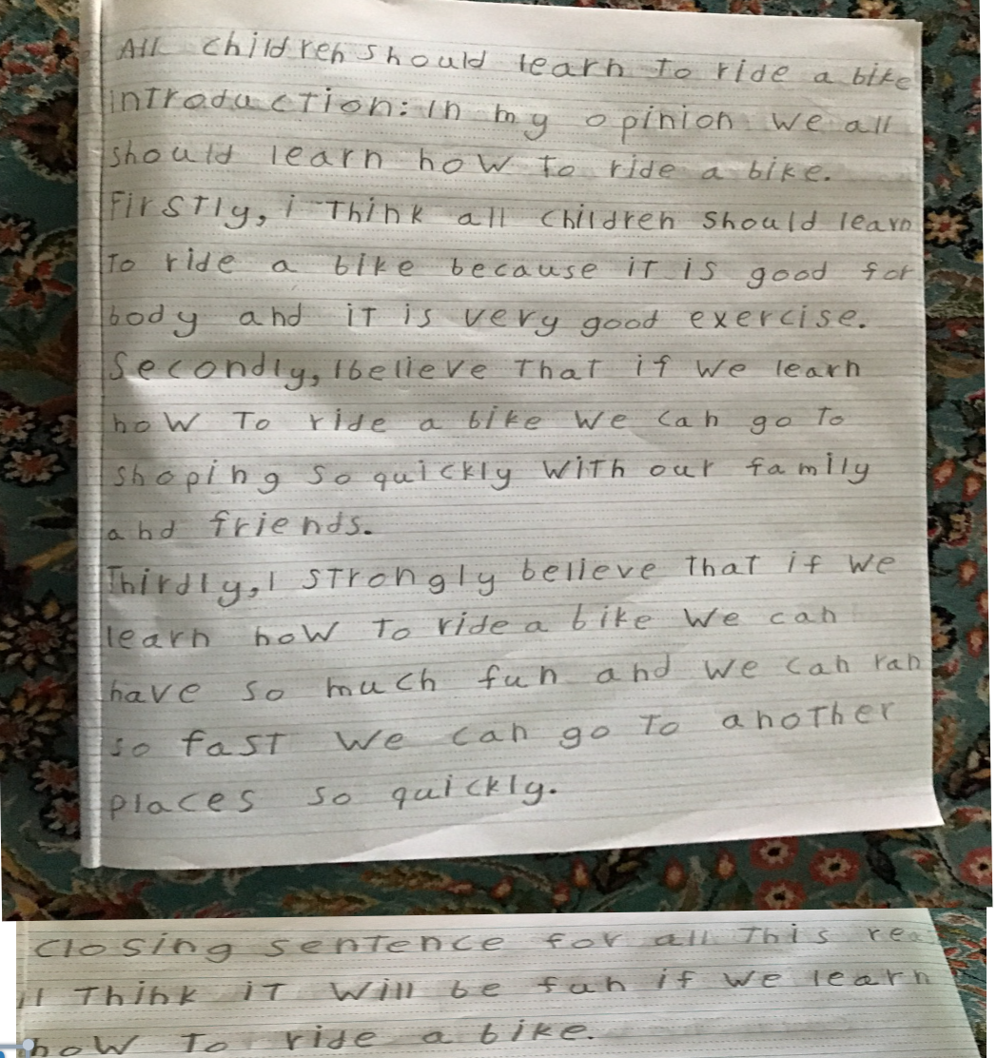
Section | Text |  | This sample of student work demonstrates that the student can:
1 | All children should learn to ride a bike  introduction: In my opinion we all should learn how to ride a bike.  Firstly, i Think all children should learn to ride a bike because iT is good for body and iT is very good exercise.  Secondly, I believe That if we learn how to ride a bike we can go to shoping So quickly with our family and friends.  Thirdly, I strongly believe that if we learn how to ride a bike we can have so much fun and we can ran so fast we can go to another places so quickly.  Closing sentence for all this reas I Think It will be fun if we learn how to ride a bike. | - Write simple texts that present a point of view (VCEALC377)  - Write using language that is beginning to reflect the features of written language more than the features of spoken language (VCEALA379)  - Use heading and text formats appropriate to the task (VCEALL387)  - Write simple paragraphs with a logical sequence of sentences (VCEALL388)  - Use simple time sequence markers and pronoun references to connect ideas in a text (VCEALL389)  - Use a range of verb forms correctly (VCEALL391) *uses modal verbs and simple present tense verbs  - Use simple extended descriptive phrases (VCEALL392) *uses the adverbs strongly and quickly  - Use a number of common conjunctions to link ideas to create compound and complex sentences (VCEALL393)  - Use appropriate layouts to separate ideas and incorporate visual features in texts (VCEALL397) *creates a separate line for each idea  - Spell frequently used words with common patterns with increased accuracy (VCEALL398)

This student’s performance in this task suggests that he is working within the range of Level B2 in Writing. The assessing teacher will need to consider a range of student samples in order to determine whether this student is at the beginning of B2, consolidating B2 or at the B2 standard in Writing.  At beginning Level B2 students:  - write their own simple texts for different purposes in guided contexts  - draw on models provided and use repetitive structures in an attempt to write longer texts  - produce writing that is still reflective of their everyday spoken English and which includes marked EAL features (for example, sometimes leaving out articles and verb endings and making errors with verb tenses) as they become more confident in experimenting with oral and written English.  - attempt to spell new words using their own pronunciation and write familiar words accurately.  At consolidating Level B2 students:  - continue to write their own simple creative and informational texts for classroom purposes with support and they begin to include some details that help orient the reader  - produce writing that begins to include features of written-like language however it is still influenced mostly by their spoken language  - produce writing that shows varying control over grammatical features such as subject–verb agreement, tense, noun-pronoun reference and articles  - spell most monosyllabic and many high frequency words accurately.  At Level B2 Achievement Standard students:  - write for a range of purposes on familiar topics  - write simple, organised texts demonstrating a developing use of specific vocabulary and simple sentence structures  - demonstrate an understanding of the purposes of common text types, and their structures and features  - produce written texts that include basic information and detail  - use a number of common conjunctions to link ideas, using pronoun references with some noun–pronoun agreement, simple phrases to express basic comparisons, and some basic punctuation with consistency  - make plausible attempts to spell new words based on known English letter–sound relationships and use a range of strategies for spelling words, checking word lists or keeping personal dictionaries  - base new sentences on known sentence structures  - draw on a developing knowledge of the writing process to plan and write simple texts, and with support, redraft them  - use more advanced software functions to write, edit and present their texts. | Possible next steps for this student’s learning:  - Using bilingual writing notes and a planning template to help expand ideas and provide more details when writing (VCEALA386)  - Using a checklist to proofread and edit their own writing, either independently or with a partner (VCEALA382)  - Creating lists of synonyms for different adjectives such as excellent, great, fantastic to expand their use of vocabulary (VCEALL396)  - Practising correct letter size for lower and upper case letters and uses capital letters correctly (VCEALL319) *content descriptor from B1 Writing
Pathways and transitions considerations:
A Year 5 student working within the range of Level B2 in any one language mode is not ready to transition to the English curriculum regardless of their proficiency in the other two language modes. This student will continue on Pathway B of the EAL curriculum in all language modes.

