Pathway B Level B1 Writing
Informative text - Writing about self (2)
Student information | The student was born in India and speaks Punjabi and Hindi as his home languages. He has had age equivalent schooling before starting school in Victoria. He has had three terms in an English language school.
Task | The student was asked to write about himself. The student is familiar with the topic and form of writing. It had been modelled and the class jointly constructed a text in previous lessons. The student wrote this text independently.
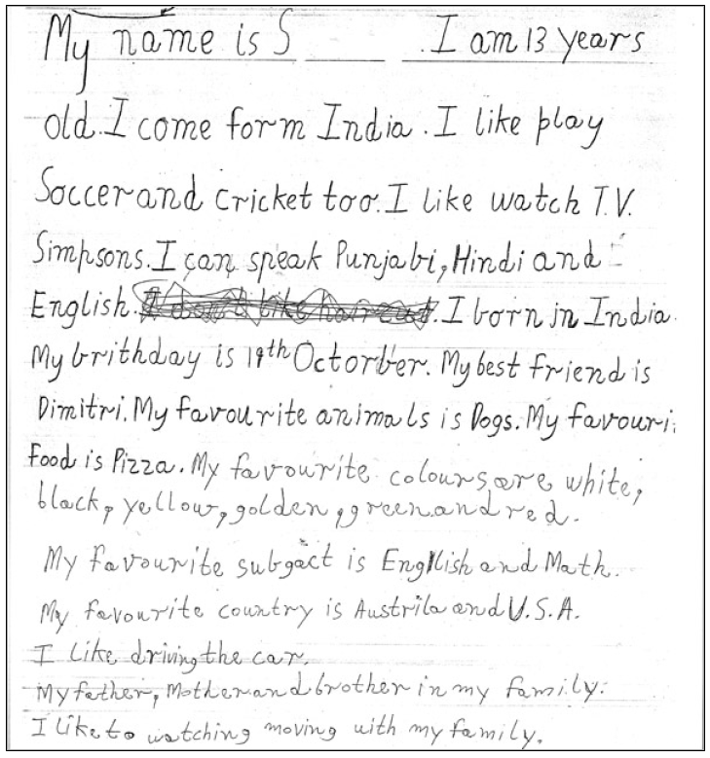
Section | Text |  | This sample of student work demonstrates that the student can:
1 | My name is S. I am 13 years old. I come form India. I like play Soccer and cricket too. I like watch T.V. Simpsons. I can speak Punjabi, Hindi and English. I don’t like hair cut. I born in India. My birthday is 19th October. My best friend is Dimitri. My favourite animals is Dogs. My favouri Food is Pizza. My favourite colours are white, black, yellow, golden, green and red.  My favourite subgact is English and Math.  My favourite country is Austrila and U.S.A.  I like driving the car.  My father, Mother and brother in my family.  I like to watching moving with my family. | - Write simple imaginative or personal texts modelled on familiar forms and repetitive patterns (VCEALC298)  - Sequence ideas simply, using short sentences or statements (VCEALL309)  - Use simple sentences and phrases with correct subject–verb–object pattern (VCEALL310)  - Write using language that largely reflects features of spoken language (VCEALA299)  - Use basic punctuation, such as full stops and capital letters, appropriately (VCEALL319)  - Spell accurately common words encountered in the classroom (VCEALL318)  - Use simple layouts to present texts logically (VCEALL317)

This student’s performance in this task suggests that she is working within the range of Level B1 in Writing. The assessing teacher will need to consider a range of student samples in order to determine whether this student is at the beginning of B1, consolidating B1 or at the B1 standard in Writing.  At beginning Level B1 students:  - use drawing as a means of expression  - attempt to copy writing from other sources, for example environmental print, other students, the teacher’s model  - will observe shared writing tasks, watching as the teacher writes but most likely will not contribute because of their limited English  - may exhibit limited concentration during shared writing tasks  - talk about their writing and pictures drawing on their oral English language and may use their home language with same language peers or bilingual teacher.  At consolidating Level B1 students:  - begin to form letters and place text appropriately  - communicate their ideas and experiences simply through writing, drawing, copied or dictated texts  - demonstrate knowledge of some sound–letter relationships, and show evidence of some planning  - produce writing that reflects their use of oral structures  - demonstrate an early awareness that written texts in English are presented according to certain conventions which change according to context and purpose  - write or draw for specific audiences  - write simple sequenced descriptions, recounts, and procedures, following models  - link ideas using common conjunctions and show awareness of the need for basic punctuation  - model their writing on shared writing activities and published texts, and use some basic strategies, such as copying words or phrases from lists, using illustrations, and asking how to write a word  - contribute to whole-class or small-group shared writing activities.  At Level B1 Achievement Standard students:  - write and present simple texts for a variety of basic classroom and personal purposes  - communicate familiar ideas, events and experiences, writing simple narratives, recounts, descriptions and reports, with support  - use some of the basic structures and features common to these text types, demonstrating their beginning awareness that purpose influences the way texts are written and presented  - produce written texts that incorporate the basic grammatical features of their spoken English  - spell some common words correctly and their attempts at spelling show a beginning understanding of the patterns of English letter–sound relationships  - use some simple strategies for spelling words, such as checking word lists or books  - plan and edit their texts, providing additional information through visual images, with support  - use the basic features of computer software applications to write and present their texts. | Possible next steps for this student’s learning:  - Elaborating on writing by including additional circumstantial information such as circumstances of place, time and manner or by expanding noun groups (VCEALL312)  - Using a range of conjunctions to create simple compound and complex sentences (VCEALL313)  - Understanding, practising and using subject-verb agreement consistently, for example My favourite animals are dogs (VCEALL311)  - Using some simple negatives such as does not and its contracted form doesn’t (VCEALL311)
Pathways and transitions considerations:
A Year 4 student working within the range of Level B1 in any one language mode is not ready to transition to the English curriculum regardless of their proficiency in the other two language modes. This student will continue on Pathway B of the EAL curriculum in all language modes.

