Pathway A Level A2 Writing
Informative text - Weekend recount about ants
Student information | This student is in Foundation. He was born in China and speaks Mandarin at home.
Task | The students in this class regularly write a recount about their weekend. The analysis is based on the student’s writing before correction.

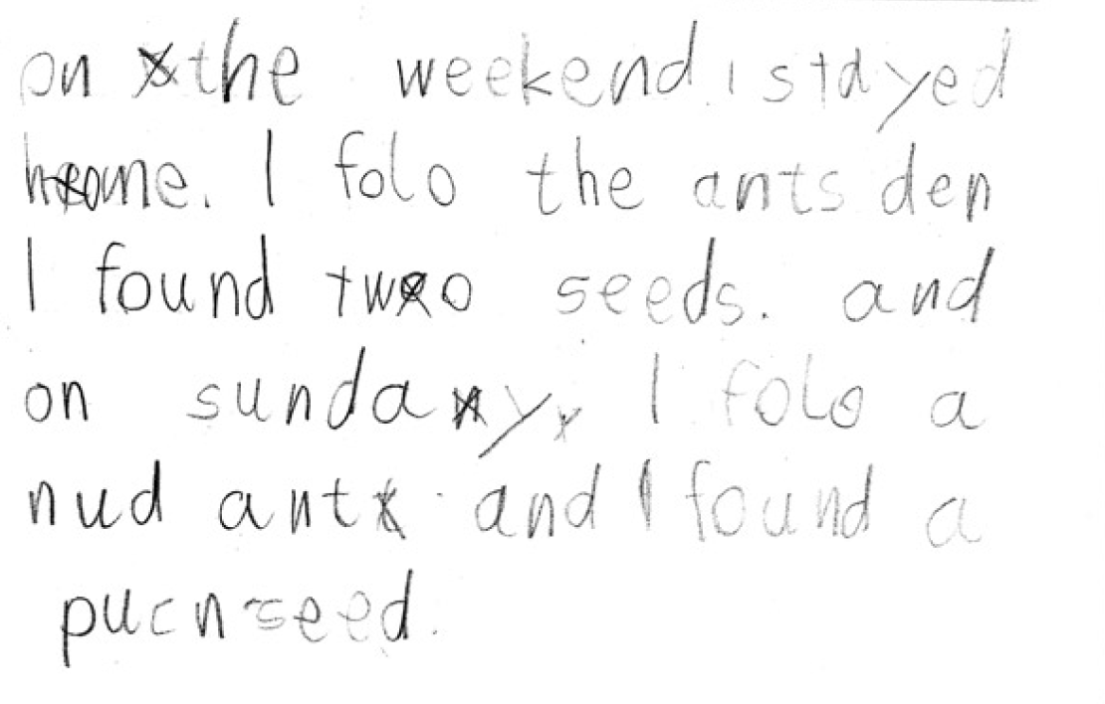
[On the weekend I stayed home. I followed the ants then I found two seeds. And on Sunday I followed another ant and found a pumpkin seed.]

Section | Text | This sample of student work demonstrates that the student can:
1 | On the weekend I stayed home. | - Use a small range of basic verb forms accurately (VCEALL154)
2 | I folo the ants den I found two seeds.  and on sunday I folo a nud ant and I found a puncseed. | - Write simple sentences with minimal reliance on copying (VCEALA140)  - Write beyond the immediate environment and beyond known language with support from the teacher (VCEALC137)  - Use a small range of basic verb forms accurately (VCEALL154)  - Spell with accuracy familiar words and words with common letter patterns (VCEALL159)

Overall, this student can also:  - Demonstrate understanding that handwritten texts usually need to be planned, edited and presented (VCEALA143)  - Use a variety of simple text structures (VCEALL149)  - Use high-frequency words encountered in classroom activities (VCEALL155)  - Use some punctuation consistently (VCEALL158) | Possible next steps for this student’s learning:  - Using adjectives to build short noun phrases (VCEALL153)  - Using capital letters to start a sentence and for proper nouns (VCEALL157)  - Constructing subject-verb-object sentences with additional circumstantial information (VCEALL152)  - Using time markers to help sequence recount and add more detail (VCEALL151)
This student’s performance in this task suggests that he is working within the range of Level A2 in Writing. The assessing teacher will need to consider a range of student samples in order to determine whether this student is at the beginning of A2, consolidating A2 or at the A2 standard in Writing.  At beginning Level A2 students:  - are beginning to write their own very short, simple texts  - write texts using sentence structures based on oral structures and very simple repetitive texts  - write with less need for teacher transcription as they develop an ability to use some basic conventions of writing in English  - draw heavily on phonetic strategies during their attempts at spelling.  At consolidating Level A2 students:  - can develop a simple plan for writing using pictures or drawings  - are beginning to write texts about familiar topics and experiences which include related ideas  - are becoming more aware of audience and purpose, but still require significant teacher  - support and modelling and environmental print  - use invented spelling and write some words spelt conventionally from a known spelling vocabulary.  At Level A2 Achievement Standard students:  - communicate in an expanding range of predictable social and learning situations  - express ideas and identify key points of information in classroom discussions about familiar topics, and in new topics when they are well supported by visual material, an appropriate pace of delivery, and discussion that links their prior knowledge to the new context  - follow a short sequence of instructions related to classroom procedures and learning activities  - negotiate familiar social and learning situations, using English appropriate to the situation  - adjust their speech choices in response to audience and topic  - combine known conversational formulas and vocabulary, including some from texts read in class, and apply some grammatical rules to make original utterances of varying grammatical accuracy  - sustain communication by negotiating turn-taking and by using strategies such as asking a speaker to repeat or to speak slowly, or asking what a word means. | Pathways and transitions considerations:  A Foundation student who is working within the range of A2 in any one language mode is not ready to transition to the English curriculum regardless of their proficiency in the other two language modes. This student will continue on Pathway A of the EAL curriculum in all language modes.  A Foundation student should consistently demonstrate the final achievement standard in Pathway A (Level A2) in all three language modes before they transition to the English curriculum.  They will need to be equally capable across all three language modes to be able to meet the learning expectations in the English curriculum at the level taught to their mainstream peers, and without substantial language support.  They will need to be sufficiently proficient in understanding and using the academic language across the learning areas to participate in learning activities across the Victorian curriculum.  They will also need to be able to understand and use the academic English of the curriculum in subsequent years without substantial language support, when the cognitive and linguistic demands of the Victorian curriculum increase, for example in Years 3 and 4.

