Pathway A Level A2 Writing
Persuasive text - Advertisement for a circus
Student information | The student was born in Sudan and speaks Dinka as her home language. She spent some time in a refugee camp before coming to Australia. She started school in Victoria in Foundation and is currently in Year 2. She is currently living with her grandmother while her parents live in Sudan.
Task | The class had been doing a unit of work on circuses. The students contributed to a shared writing text before writing their own advertisement for the circus.  The analysis is based on the student’s writing before correction.

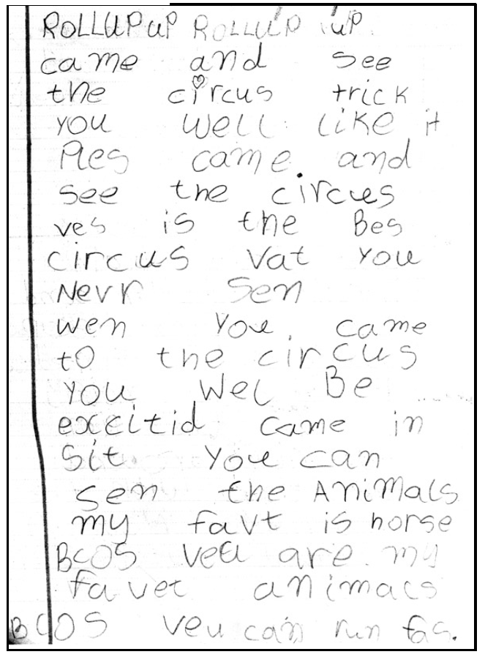
Section | Text |  | This sample of student work demonstrates that the student can:
1 | RolluPuP RolluP uP  came and see the circus trick you well like it  Ples came and see the circus ves is the Bes circus vat you never sen  wen you came to the circus you wel Be excited  came in sit You can sen the Animals  my favt is horse Bcos veu are my favet animals Bcos veu can run fas. | - Write sustained texts using sentences based on simple repetitive, modelled patterns (VCEALL151) *writes a compound sentence with the conjunction because, (although with spelling error) for example, my favt is horse Bcos (they)…can run fas.  - Write sentences and phrases that reflect simple written-like structures (VCEALL152)  - Use a small range of basic verb forms accurately (VCEALL154) *uses a mixture of tenses between past and future  - Use high-frequency words encountered in classroom activities (VCEALL155)  - Use some curriculum or content area vocabulary (VCEALL156)  - Write legibly (VCEALL157)  - Spell with accuracy familiar words and words with common letter patterns (VCEALL159)

Overall, this student can also:  - Write short, simple texts independently (VCEALC136)  - Write beyond the immediate environment and beyond known language with support from the teacher (VCEALC137)  - Write simple sentences with minimal reliance on copying (VCEALA140)  - Use a variety of simple text structures (VCEALL149) | Possible next steps for this student’s learning:  - Using capital letters at the beginning of sentences and full stops at the end (VCEALL158)  - Organising main ideas in texts by leaving a line between different ideas (VCEALL160)  - Adding adjectives to provide more information and increase the persuasiveness of the text, for example, the big amazing circus (VCEALL153)
This student’s performance in this task suggests that they are working within the range of Level A2 in Writing. The assessing teacher will need to consider a range of student samples in order to determine whether this student is at the beginning of A2, consolidating A2 or at the A2 standard in Writing.  At beginning Level A2 students:  - are beginning to write their own very short, simple texts  - write texts using sentence structures based on oral structures and very simple repetitive texts  - write with less need for teacher transcription as they develop an ability to use some basic conventions of writing in English  - draw heavily on phonetic strategies during their attempts at spelling.  At consolidating Level A2 students:  - can develop a simple plan for writing using pictures or drawings  - are beginning to write texts about familiar topics and experiences which include related ideas  - are becoming more aware of audience and purpose, but still require significant teacher  - support and modelling and environmental print  - use invented spelling and write some words spelt conventionally from a known spelling vocabulary.  At Level A2 Achievement Standard students:  - communicate ideas, events and experiences through simple texts based on familiar spoken and written language  - write for a variety of personal and classroom purposes, using known and modelled structures and features  - write everyday texts and simple stories, recounts and factual texts based on their own and shared class experiences  - use their developing oral base and reading repertoire when writing their own texts  - write texts using simple but coherently linked sentences, basic structures and well-known vocabulary  - use some common irregular past tense verbs correctly, and link clauses using basic conjunctions and connectives  - attempt to spell new words, based on known spelling patterns and base words  - use vocabulary lists, modelled texts and familiar books to find how to write new words  - write letters legibly and make some changes to their texts when editing  - use advanced features of software applications to write and present their texts. | Pathways and transitions considerations:  A Year 2 student who is working within the range of A2 in any one language mode is not ready to transition to the English curriculum regardless of their proficiency in the other two language modes. This student will continue on Pathway A of the EAL curriculum in all language modes.  A Year 2 student should consistently demonstrate the final achievement standard in Pathway A (Level A2) in all three language modes before they transition to the English curriculum.  They will need to be equally capable across all three language modes to be able to meet the learning expectations in the English curriculum at the level taught to their mainstream peers, and without substantial language support.  They will need to be sufficiently proficient in understanding and using the academic language across the learning areas to participate in learning activities across the Victorian curriculum.  They will also need to be able to understand and use the academic English of the curriculum in subsequent years without substantial language support, when the cognitive and linguistic demands of the Victorian curriculum increase, for example in Year 3 and 4.  The teacher may also exercise their professional judgement to place the student on Pathway B of the EAL curriculum rather than transitioning them to the English curriculum. The teacher reviews the student’s language proficiency across the Victorian curriculum learning areas and determine where the student is best placed on Pathway B in each of the three language modes. The student will then start on Pathway B of the EAL curriculum in all language modes.

