Pathway A Level A1 Writing
Persuasive text- Socks I like
Student information | The student is 5 years old and in Foundation. He is from Iran and speaks Persian at home. Both parents speak and understand some English. He is currently studying in an English language school.
Task | The students have been learning about clothing. They have been learning to describe the colour and size of different items of clothing. In this task, the students read a story about a boy who went shopping and spoke about the different types of socks he liked or disliked. Each student was given a different coloured sock which they had to decide whether they liked or disliked, then explain why. The teacher modelled the sentence structure This is a _________ sock. I like __________ because _________.  The student dictated his sentences for the teacher to write on a mini whiteboard. The student copied the scribed sentences.  The analysis is based on the student’s writing before correction.
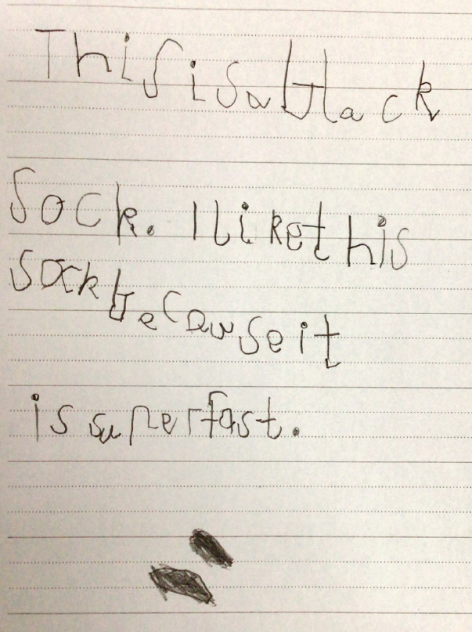

Section | Text |  | This sample of student work demonstrates that the student can:
1 | This is a black Sock. I like this sock because it is superfast. | - Copy well-known symbols, words, phrases or short texts (VCEALC055)  - Illustrate a simple text (VCEALC058)

This student’s performance in this task suggests that he is working within the range of Level A1 in Writing. The assessing teacher will need to consider a range of student samples in order to determine whether this student is at the beginning of A1, consolidating A1 or at the A1 standard in Writing.  At beginning Level A1, students:  - do not recognise English print and may show little interest in writing  and/or  - draw pictures to communicate meaning and may discuss their pictures using labels or a simple phrase  and/or  - may have difficulty with the mechanics of writing, for example, they might not be used to holding pencils or crayons and making marks on the page, depending on prior experiences.  At consolidating Level A1, students:  - attempt to copy writing from other sources, for example environmental print, other students, the teacher’s model  - use drawing as a means of expression  - will observe shared writing tasks, watching as the teacher writes but most likely will not contribute because of their limited English  - may exhibit limited concentration during shared writing tasks  - talk about their writing and pictures drawing on their oral English language and may use their home language with same language peers or bilingual teacher  - from script-different backgrounds will need more time to develop the directional concepts of left to right and top to bottom when writing.  At Level A1 Achievement Standard, students:  - communicate their ideas and experiences simply through drawings, copied writing, dictated texts and their own basic writing, showing evidence of a developing understanding of the writing process  - contribute to shared writing activities  - demonstrate an early awareness that written texts in English are presented through conventions, which change according to context and purpose  - write and draw for basic purposes and, with support, produce simple descriptions, recounts and procedures  - produce writing that reflects their oral structures and they link ideas using basic conjunctions  - show awareness of the need for basic punctuation  - demonstrate knowledge of some sound–symbol relationships  - show evidence of some basic planning  - model their writing on shared writing activities and published texts, often copying words or phrases from books or word lists  - form letters and place text appropriately on the page  - use basic features of software applications to write and present their texts. | Possible next steps for this student’s learning:  - Participating in a range of hands-on activities that focus on letter formation, size, spacing and placement for both upper and lower case letters (VCEALL078)  - Participating in a range of hands-on activities to learn about initial letter sounds (VCEALL077)  - Contributing ideas and words in shared writing activities, for example, when writing a class book (VCEALA062)
Pathways and transitions considerations:
A Foundation student working within the range of Level A1 in any one language mode is not ready to transition to the English curriculum regardless of their proficiency in the other two language modes. This student will continue on Pathway A of the EAL curriculum in all language modes.

