Pathway A Level A1 Writing
Informative text - Describing leaves (1)
Student information | The student was born in China and speaks Chinese as their home language. The student began Foundation in Victoria and is currently in a Foundation class.
Task | Students learned about the seasons. Sentence starters were written on the board as a prompt for the students to complete after a class discussion.
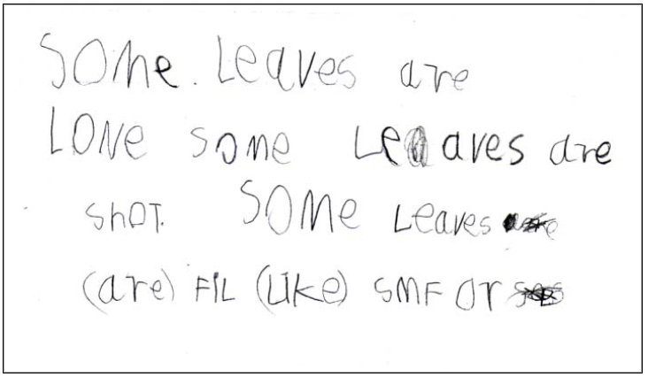

Section | Text |  | This sample of student work demonstrates that the student can:
1 | Some leaves are loNe some leaves are shoT. Some leaves are (are) fil (like) smf or | - Copy well-known symbols, words, phrases or short texts (VCEALC055) *copied Some leaves  - Write new words with an initial letter or several letters (VCEALL077) *attempted to spell long, short, feel and smooth  - Write simple repetitive modelled sentences (VCEALL072)  - Write some high-frequency words related to personal experience and school context (VCEALL076)  - Experiment with some familiar punctuation (VCEALL079)  - Use some conventions for printed English (VCEALL081)  - Copy well-known symbols, words, phrases or short texts (VCEALC055)

This student’s performance in this task suggests that they are working within the range of Level A1 in Writing. The assessing teacher will need to consider a range of student samples in order to determine whether this student is at the beginning of A1, consolidating A1 or at the A1 standard in Writing.  At beginning Level A1 students:  - do not recognise English print and may show little interest in writing  and/or  - draw pictures to communicate meaning and may discuss their pictures using labels or a simple phrase  and/or  - may have difficulty with the mechanics of writing, for example, they might not be used to holding pencils or crayons and making ‘marks’ on the page, depending on prior experiences.  At consolidating Level A1 students:  - attempt to copy writing from other sources, for example environmental print, other students, the teacher’s model  - use drawing as a means of expression  - will observe shared writing tasks, watching as the teacher writes but most likely will not contribute because of their limited English  - may exhibit limited concentration during shared writing tasks  - talk about their writing and pictures drawing on their oral English language and may use their home language with same language peers or bilingual teacher  - from script-different backgrounds will need more time to develop the directional concepts of left to right and top to bottom when writing.  At Level A1 Achievement Standard students:  - communicate their ideas and experiences simply through drawings, copied writing, dictated texts and their own basic writing, showing evidence of a developing understanding of the writing process  - contribute to shared writing activities  - demonstrate an early awareness that written texts in English are presented through conventions, which change according to context and purpose  - write and draw for basic purposes and, with support, produce simple descriptions, recounts and procedures  - produce writing that reflects their oral structures and they link ideas using basic conjunctions  - show awareness of the need for basic punctuation  - demonstrate knowledge of some sound–symbol relationships  - show evidence of some basic planning  - model their writing on shared writing activities and published texts, often copying words or phrases from books or word lists  - form letters and place text appropriately on the page  - use basic features of software applications to write and present their texts. | Possible next steps for this student’s learning:  - Drawing and labelling pictures with common adjective-noun combinations, for example, smooth leaves and long leaves (VCEALC058)  - Practising correct letter size and formation (VCEALL078)  - Practising using common punctuation at the end of sentences such as full stops (VCEALL079)  - Learning and using a range of relating verbs, for example, be and have (VCEALL075)
Pathways and transitions considerations:
A Foundation student working within the range of Level A1 in any one language mode is not ready to transition to the English curriculum regardless of their proficiency in the other two language modes. This student will continue on Pathway A of the EAL curriculum in all language modes.

