Annotated work samples – At a glance Written samples
Pathway C Level C1 Writing Pathway C Level C1 Writing
The genre and title of the work sample
The EAL Pathway, Level and language mode
Pathways and transitions advice based on the student’s language proficiency level and other factors.

The Level that this student is working within the range of.

Imaginative text- Ake and Paolina
Section providing the context for the task and information about the student.
Student information | This student is 17 years old. She is a Karen refugee and has been in Australia for approximately four months. She speaks Karen. She has been to a missionary school where she learned a range of English vocabulary.
Task | This was a diagnostic creative writing task. Students had read the story of Ake and Paolina from True New Stories. The student had the written story with her, but none of this writing came from that text. The rest come from her own ideas or recall of the story. The writing about dolphins came from her memory of the text Free the Dolphins that the class had studied. The student did not actually fulfil the task requirements, as it was supposed to be written in the first person.
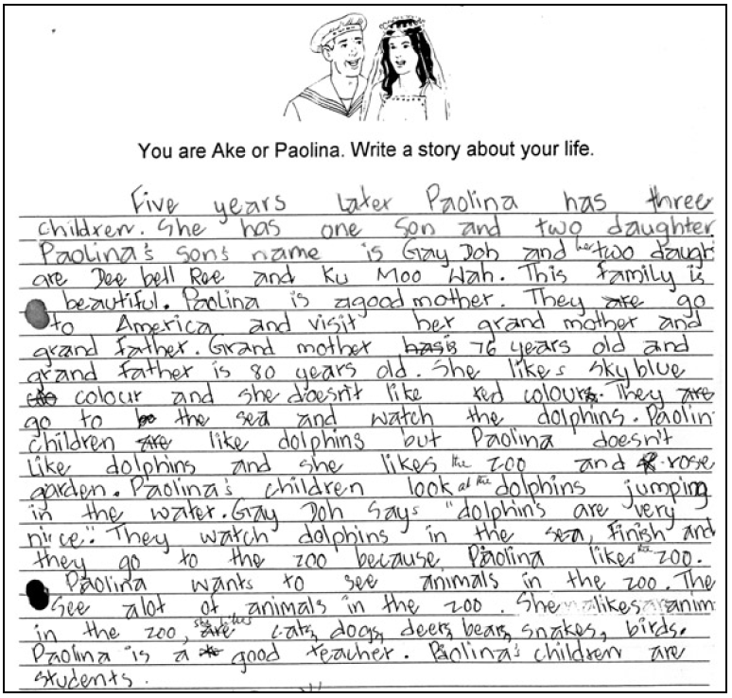
The content descriptions from the EAL curriculum that the student demonstrates in this section of the example.

The written or spoken text of the student being assessed is in bold font.

Written sample reproduced in full.
Section | Text | This sample of student work demonstrates that the student can:
1 | Five years later Paolina has three children. She has one son and two daughter. Paulina’s son’s name is Gay Doh and two daughter are Dee bell Roe and Ku Moo Wah. This family is beautiful. Paolina is a good mother. They are go to America and visit her grand mother and grand father. Grand mother has is 76 years old and grand father is 80 years old. She likes sky blue coo colour and she doesn’t like red colours. They are go to the sea and watch the dolphins. Paolina children are like dolphins but Paolina doesn’t like dolphins and she likes zoo and R rose garden. Paolina’s children look dolphins jumping in the water. Gay Doh say dolphins are very nice. They watch dolphins in the sea, finish and they go to the zoo because Paolina like zoo. Paolina wants to see animals in the zoo. The see a lot of animals in the zoo. She likes animals in the zoo, are cats, dogs, deers, bears, snakes, birds. Paolina is a good teacher. Paolina’s children are students. | - Write to communicate personal ideas (VCEALC591)  - Write short, simple texts for varied social purposes (VCEALC589)  - Use single-word subject–verb–object word order in simple sentences and noun–pronoun agreements with few errors (VCEALL600)  - Experiment with different tenses and use some common irregular past tense verbs correctly (VCEALL602)  - Use grapho-phonic knowledge to attempt to spell unknown words (VCEALL606)  - Use common punctuation with some consistency (VCEALL607)  - Use simple cohesive devices to structure writing (VCEALL599)
Suggestions for possible next steps in this student’s learning. This is not a definitive list. The suggestions are linked to EAL curriculum codes.

Pathways and transitions advice based on the student’s language proficiency level and other factors.

The pathway and level this student is working within. The dot point descriptors for beginning and consolidating are drawn from the Victorian Curriculum F-10 EAL Reporting Resource. The Achievement Standard is drawn from the Victorian Curriculum F-10 EAL.

This student’s performance in this task suggests that she is working within the range of Level C1 in Writing. The assessing teacher will need to consider a range of student samples in order to determine whether this student is at the beginning of C1, consolidating C1 or at the C1 standard in Writing.  At beginning Level C1 students:  - attempt to write down words they have heard or said, but this will usually not be with accurate spelling  - will rely heavily on proformas and other model texts as scaffolding to produce extended pieces of writing longer than a phrase or sentence  with teacher guidance, but are not yet aware that different text types are used for different purposes  - tend to focus on producing a final product, rather than recognising that the act of writing is a process that involves planning, revision, editing.  At consolidating Level C1 students:  - have begun to attempt their own sentences, although the focus is on meaning rather than grammatical accuracy  - produce sentences that tend to follow a basic subject–verb–object pattern, but with varying degrees of accuracy  - create texts that demonstrate a growing awareness of differences between text types, especially in terms of overall organisational features and structure, although their ability to demonstrate this in their own writing is still very rudimentary  - can review their writing and identify aspects that might be changed or revised, with assistance.  At Level C1 Achievement Standard students:  - write for a range of basic classroom and personal purposes, making lists and writing simple journal entries, notes, descriptions, recounts of events and instructional texts  - produce basic sentences and short texts based on well-practised spoken English and familiar contexts.  - write with varying grammatical accuracy, expressing themselves using familiar vocabulary and modelled structures and features  - order and sequence sentences about familiar topics into simple coherent texts, incorporating basic conventions such as headings and paragraphs  - correct some errors relating to targeted grammatical items, and rework drafts in response to teacher suggestions  - plan their texts and provide some additional information through visual texts, with support  - utilise a range of strategies for finding and spelling words, using spelling patterns and checking resources  - use basic features in software applications to write and present their texts. | Possible next steps for this student’s learning:  - Writing an imaginative text from the first-person perspective (VCEALA592)  - Using past tense verbs (VCEALL602)  - Understanding the text structure of a narrative including orientation, complication and resolution (VCEALC589)  - Planning and drafting a story using a narrative text structure and linguistic features (VCEALC591)  - Understanding and using paragraphs in writing (VCEALL598)
Pathways and transitions considerations:
A Year 10 student who is working within the range of Level C1 in any one language mode is not ready to transition to the English curriculum regardless of their proficiency in the other two language modes. This student will continue on Pathway C of the EAL curriculum.

