School Jobs Vic

Job Search

# Contents

Contents 2

Navigation 3

Search Job 6

Saved searches 7

View and update a saved search 8

School Jobs Vic is the department’s recruitment platform for Victorian government school jobs. School Jobs Vic allows you to:

* Search and apply for advertised vacancies
* Be notified of relevant new vacancies by setting up a job alert via **My Saved Searches.**
* Create a profile in the Applicant Pool for school recruiters to search and consider for short term vacancies
* Be matched to jobs based on your preferences in your Applicant Pool profile (available to classroom teachers)

# Navigation

Applicants can access School Jobs Vic through the following link: <https://www.vic.gov.au/school-jobs>

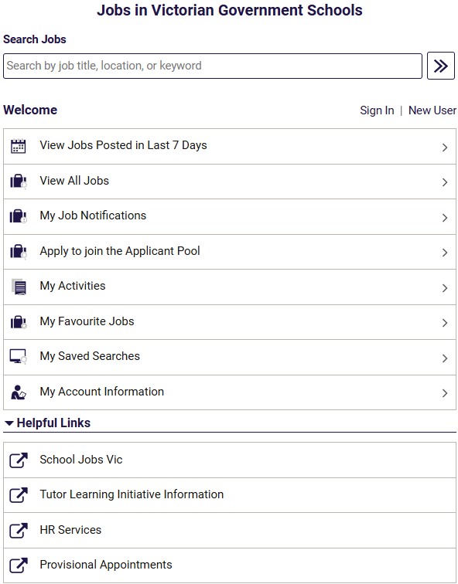

On the School Jobs Vic careers portal, Applicants wanting to search for jobs, can either:

* Click on ‘View Jobs Posted in Last 7 Days’
* Click on ‘View All Jobs’
* Enter either job title, location or keyword into the search section.

**Note:** Internal applicants that have a DE log in ID, can also enter through eduPay. Once logged on to eduPay, internal applicants can navigate via **Employee | Careers | School Jobs**; in order to go to School Jobs Vic through seamless sign on.

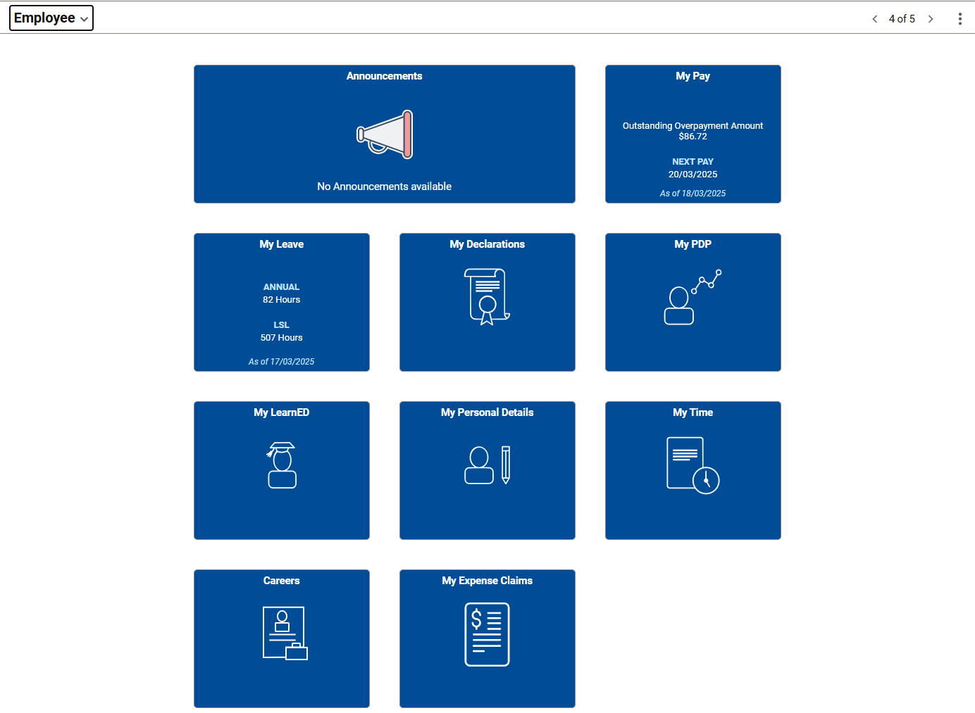

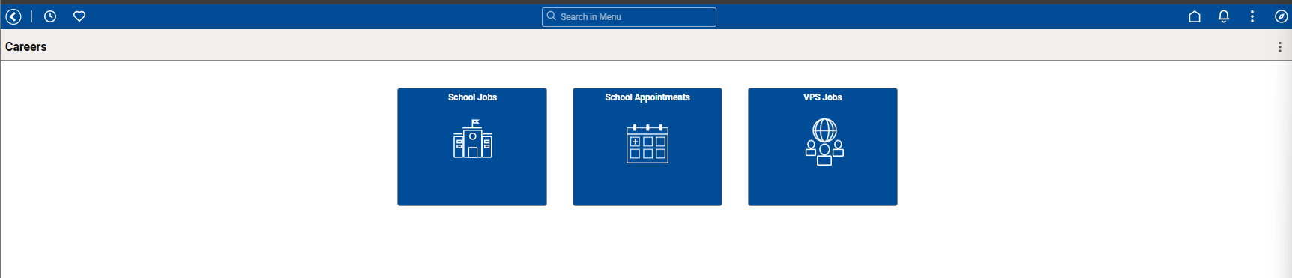

Clicking on **School Jobs** will direct applicants to the School Jobs Vic careers portal.

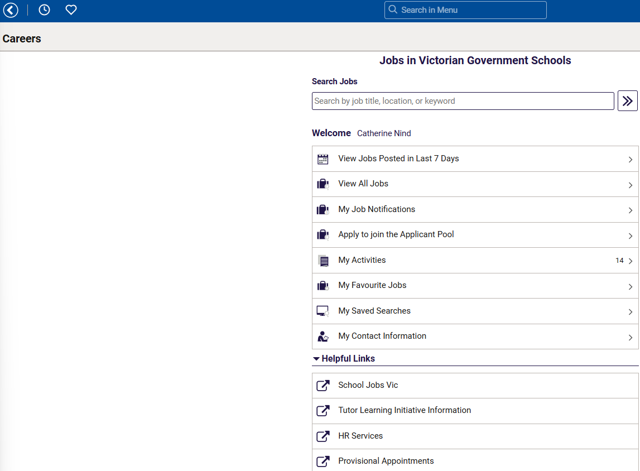

# Search Job

From the School Jobs Vic careers portal, applicants will see a list of advertised jobs based on the search criteria.

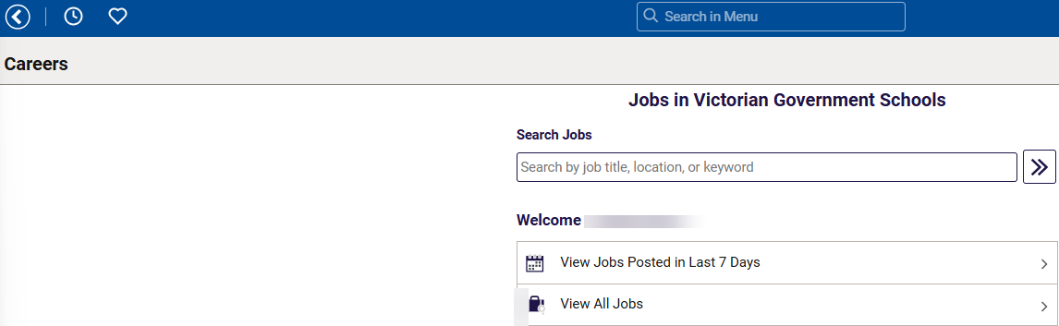

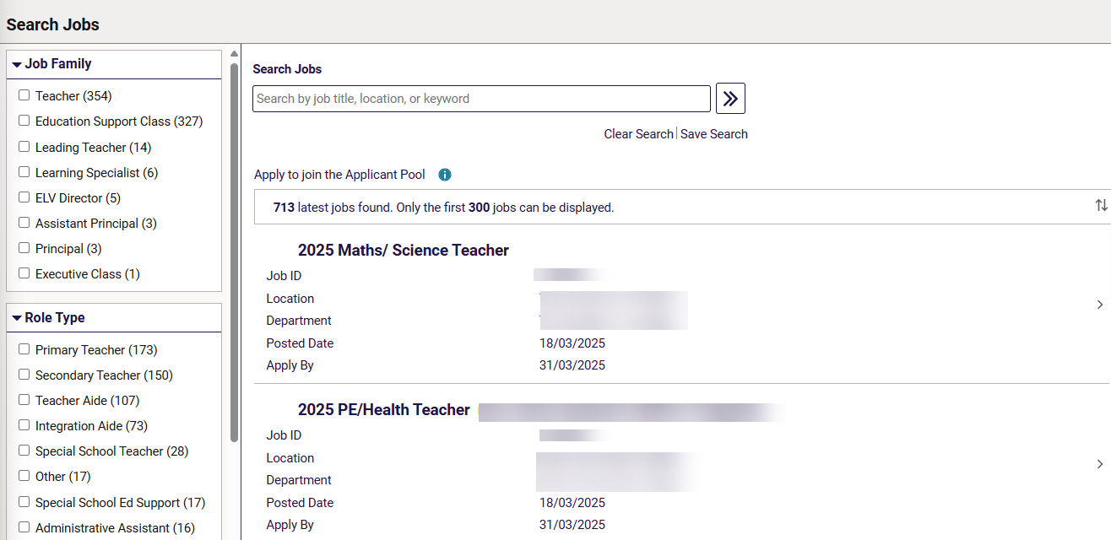

On the left, applicants can select the different selection criteria of their job search. The list of criteria selected would appear under the **Search Jobs** box. Applicants can also sort the results using the up/down arrow icon. Applicants can use the Search Jobs filed if there is a specific job they wish to apply for.

Clicking on the job opening title will take you to the Job description page.

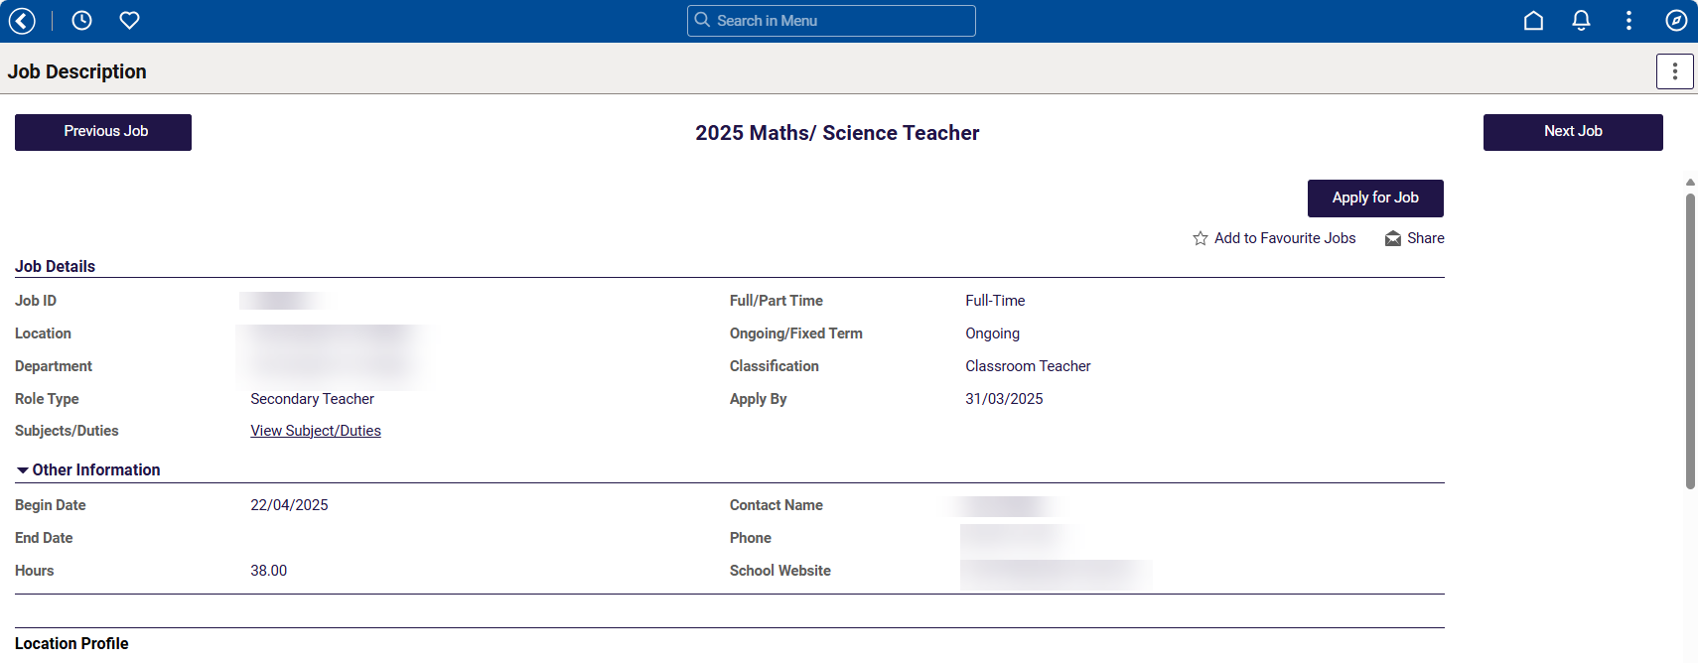

# Saved searches

Applicants can choose to save their search criteria. This can be done by clicking on **Save Search**.

Select your criteria and click Save Search.

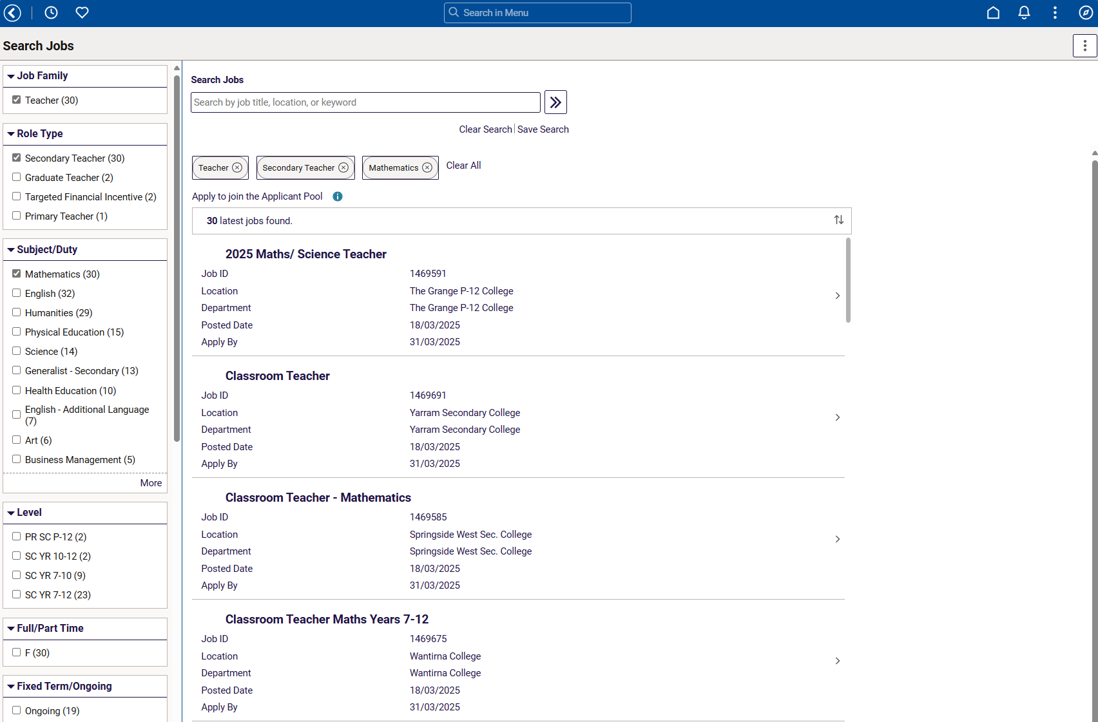

Select Enter your criteria and click **Save Search**.

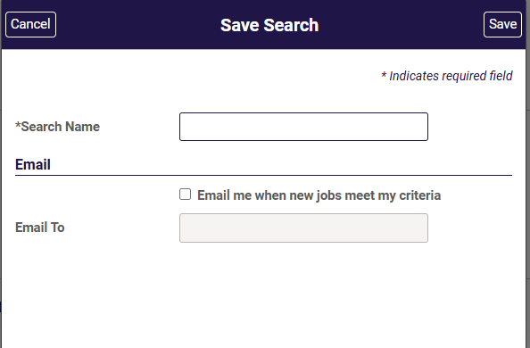

Enter the search name and click the **Save** button.

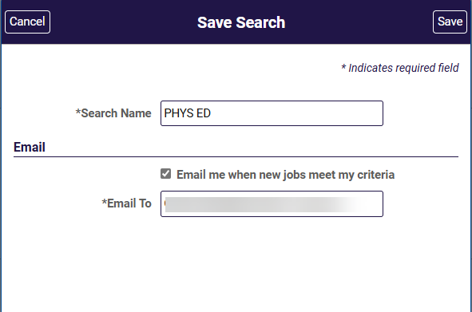

Applicants can choose to have this search criteria as their Job Search agent and will be emailed when new jobs meet the saved criteria.

**Note:** All search notifications expire after 12 months by default.

# View and update a saved search

To view an existing saved search, navigate to the **School Jobs Vic careers portal.** Click the **My Saved Searches** link.

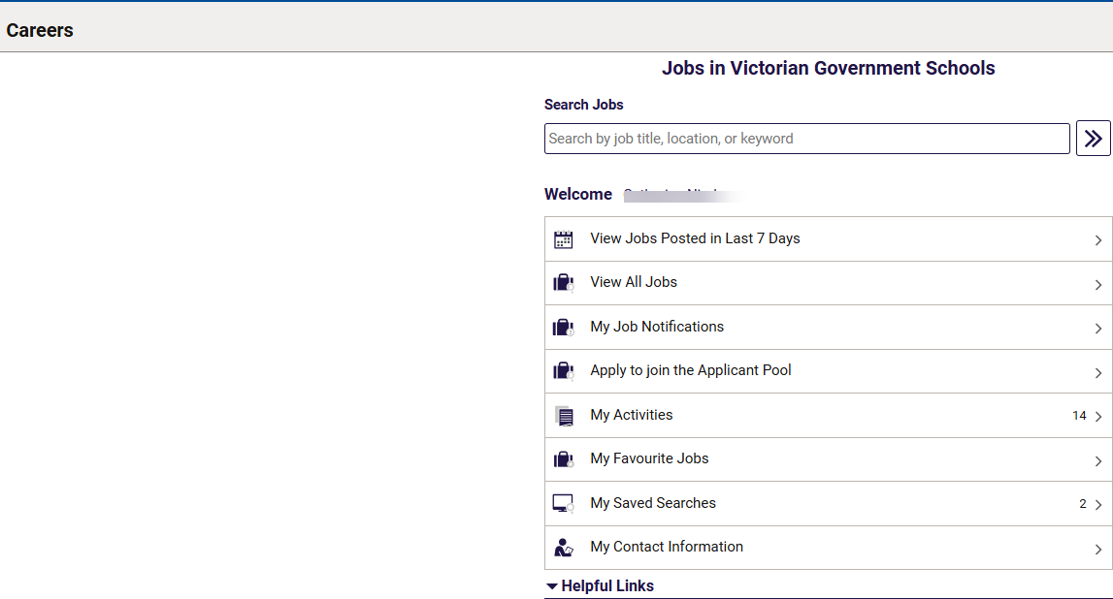

A list of all your saved searches will appear.

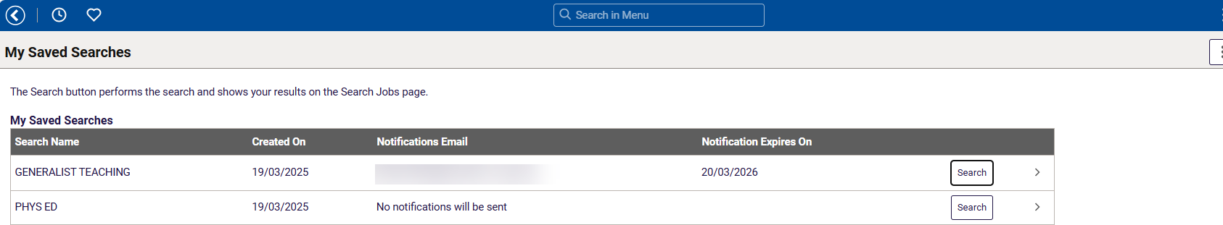

To run a saved search, click **Search** button. This will take you to the search results based on your criteria.

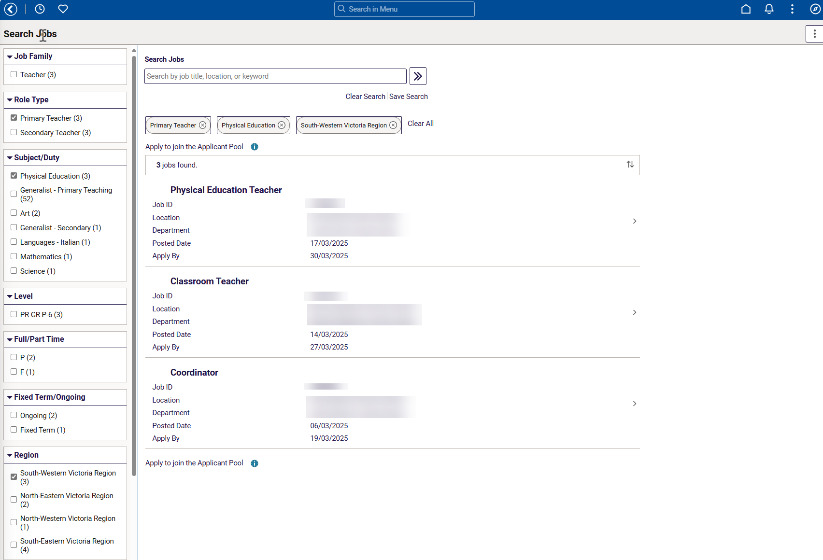

To change details of your saved search criteria, click on the **>** icon. 

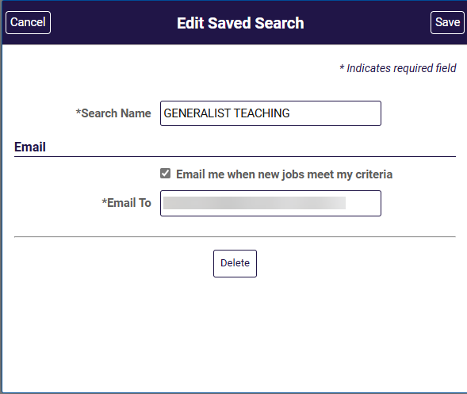

You can change search name, determine if you want the search to be emailed, or delete the search.