ROL Applicant portal – Job Search
Recruitment Online is the Department’s online job advertisement and recruitment management system for Victorian Government school jobs. Recruitment Online allows you to:
- search for and apply for current vacancies
- be notified of relevant new vacancies by setting up a job alert via ‘My Saved Searches’
- apply for a job
- choose to be included in the Job Opportunities section for Schools to search for potential applicants

NAVIGATION
All Applicants can enter through to DET’s Recruitment Online portal (Jobs in Victorian Government Schools) via link on HRWeb: http://www.education.vic.gov.au/hrweb/careers/Pages/advacsSCH.aspx
From this Careers page, Applicants wanting to search for jobs, can either:
- Click on ‘View Jobs Posted in Last 7 Days’
- Click on ‘View All Jobs’
- Entering either job title, location or keyword into the search section
Note: Internal Applicants that have a DET log in ID, can also enter through eduPay. Once logged on to eduPay, Internal Applicants can navigate via Careers > Schools; in order to go to ROL through seamless sign on.
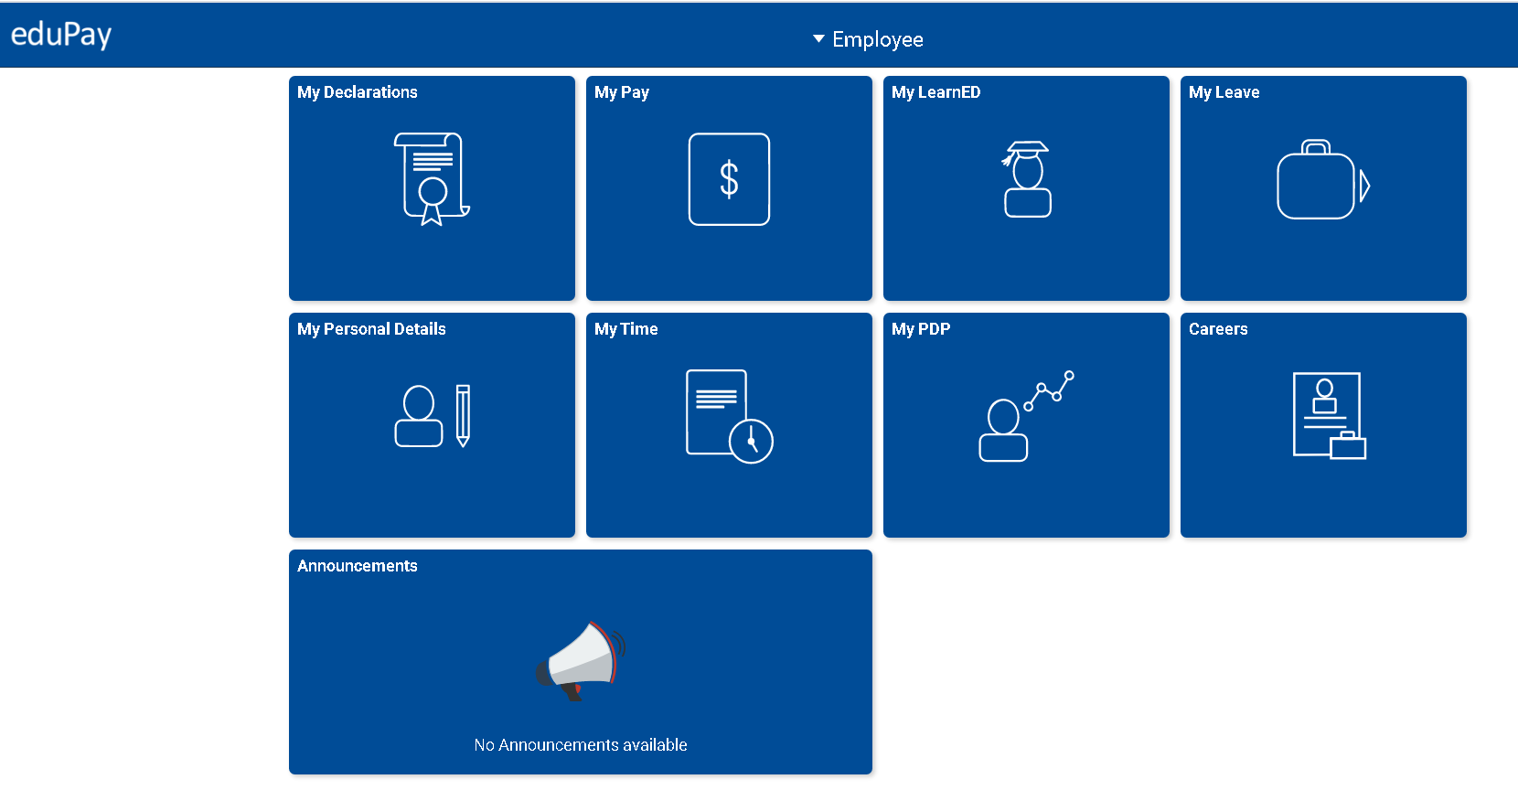
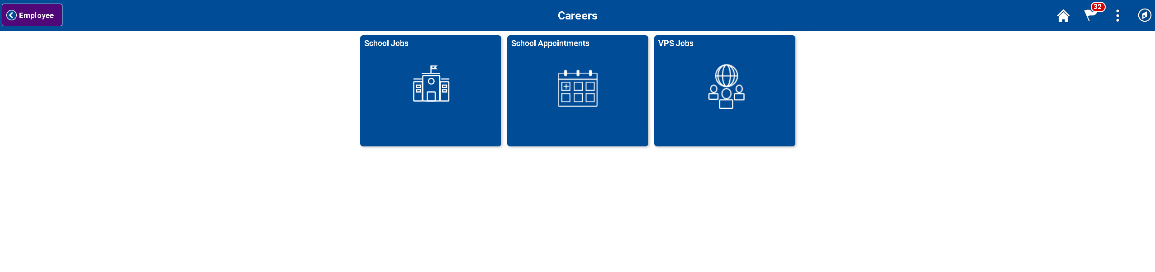

Clicking the different tiles would take the internal applicant to the respective sites. Clicking on ‘School Jobs’ will direct Applicant to the Careers home page.
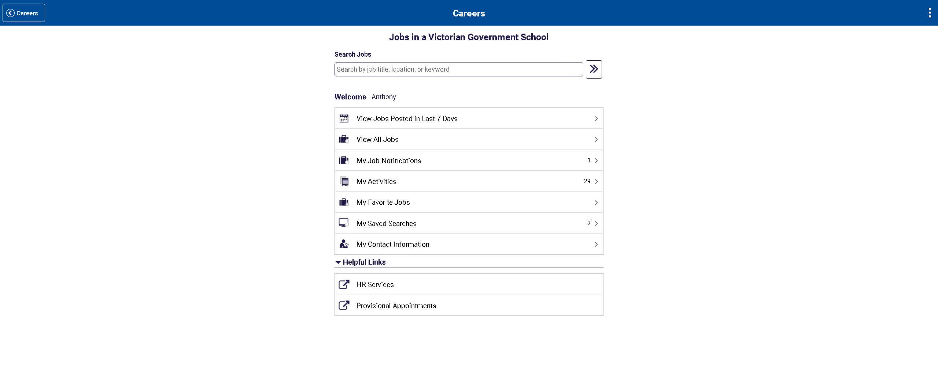

search jobs
- From the Careers Homepage, Applicants will see a list of advertised jobs based on the search criteria

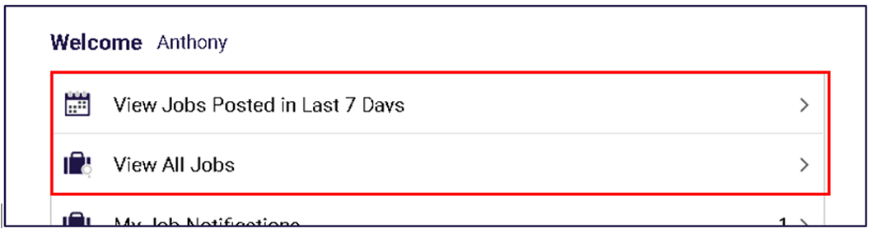

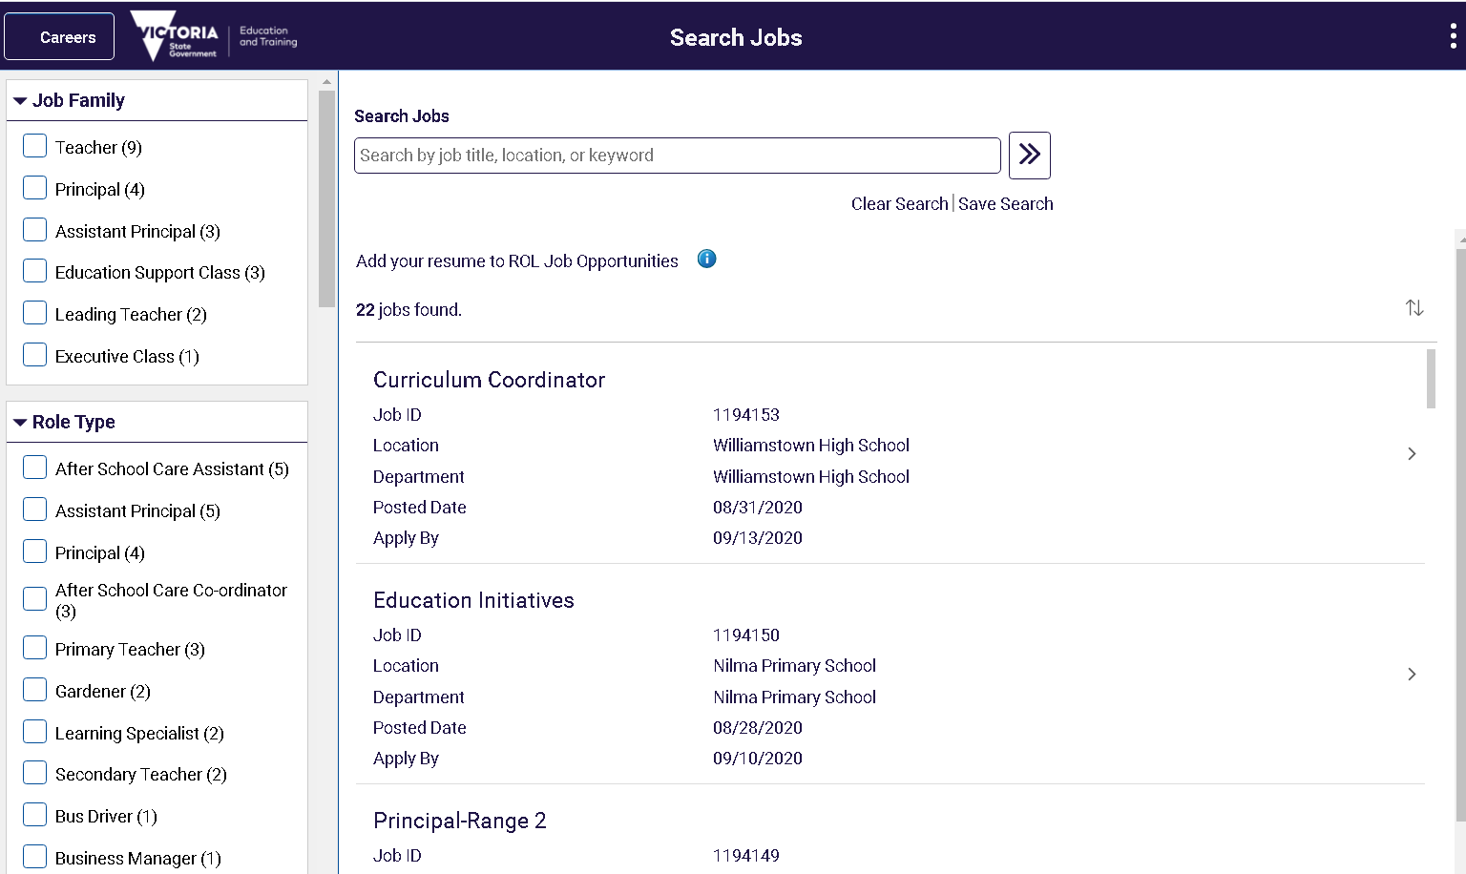

- On the left, Applicants can select the different selection criteria of their job search. The list of criteria selected would appear under the ‘Search Jobs’ box. Applicants can also sort the results using the up/down arrow icon.

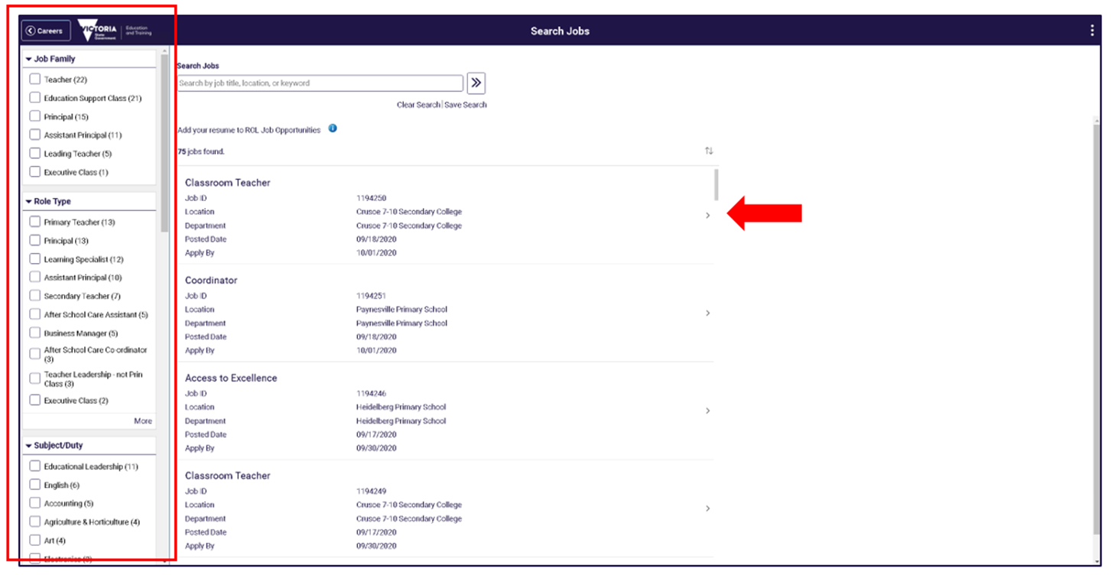
- Clicking on the job opening title will take you to the Job description page.

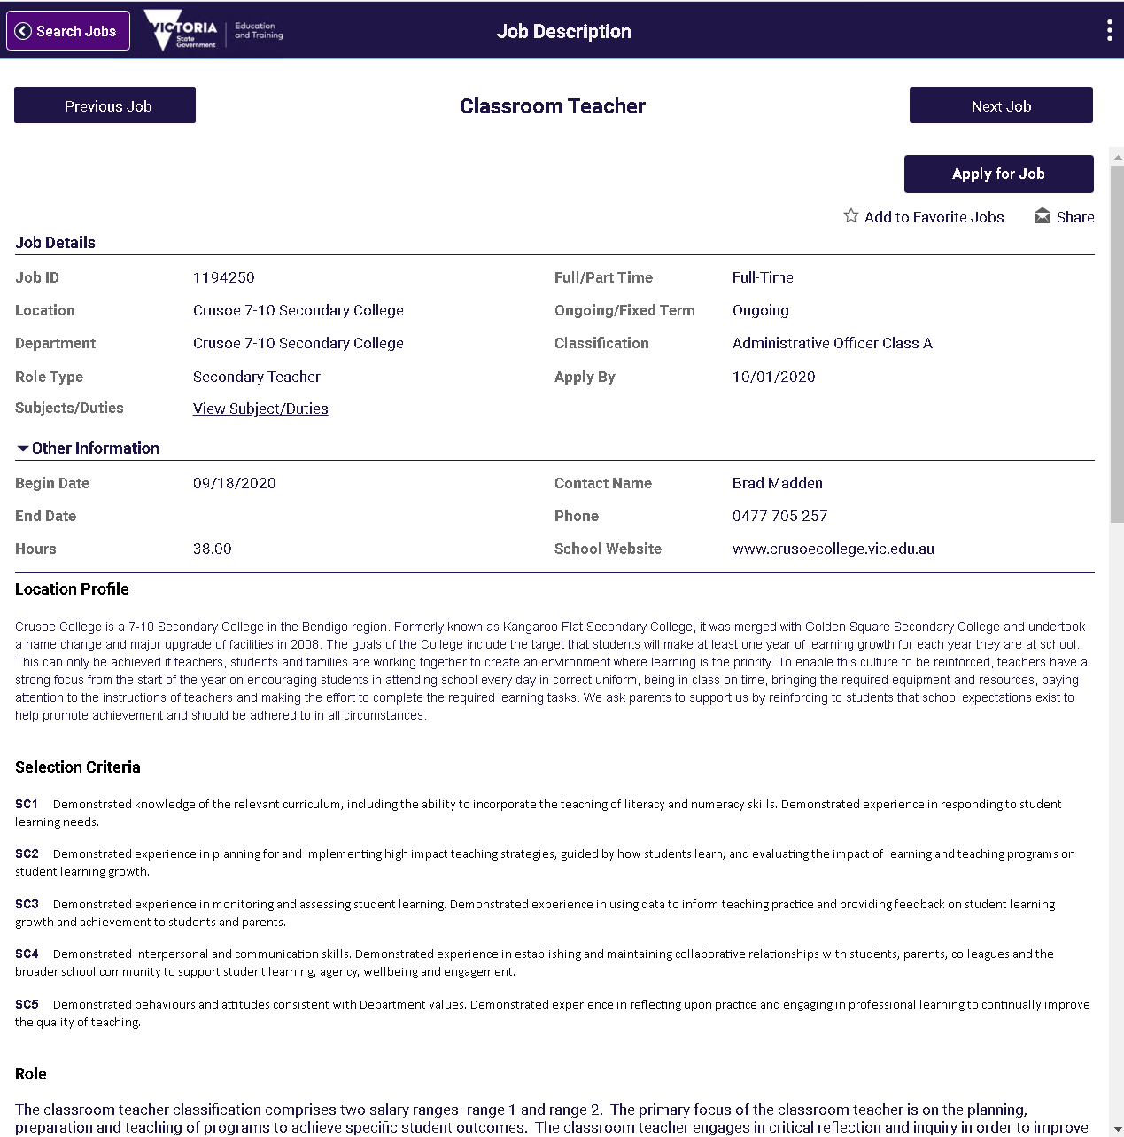

saved searches and job search agent
- Applicants can choose to save their search criteria. This can be done by clicking on ‘Save Search’
- If you have already created a Recruitment Online Applicant profile, you will be prompted to enter your login details. If you have not already created an Applicant Profile, you will be prompted to create an account.

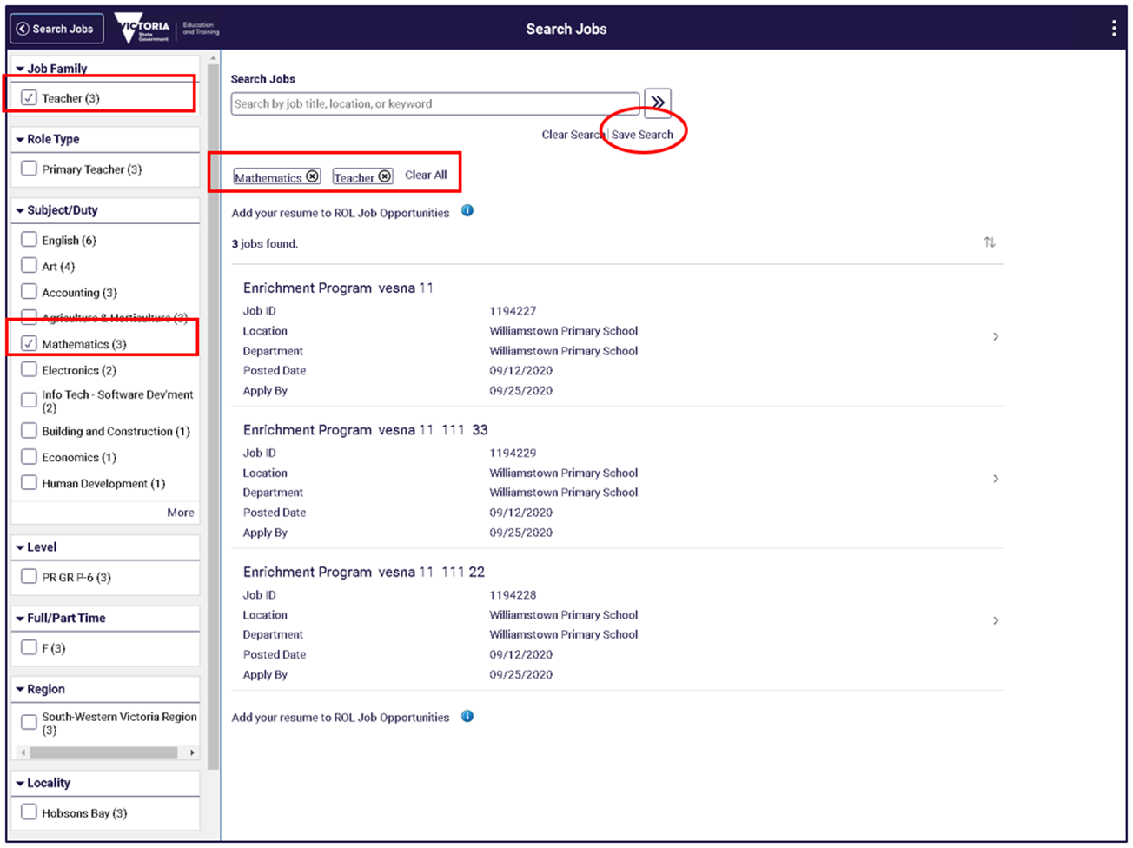
- After logging in, you will be asked to name your job search. Enter a name of the search and click “Save” button.

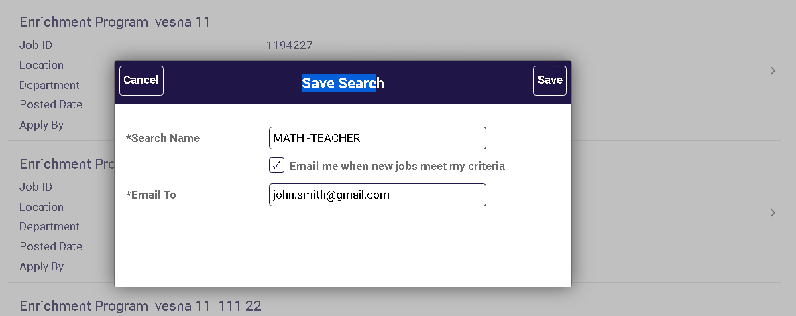

- Applicants can choose to have this search criteria as your Job Search agent and emailed when new jobs meet your criteria. If you do, all search notification expires after 12 months by default.

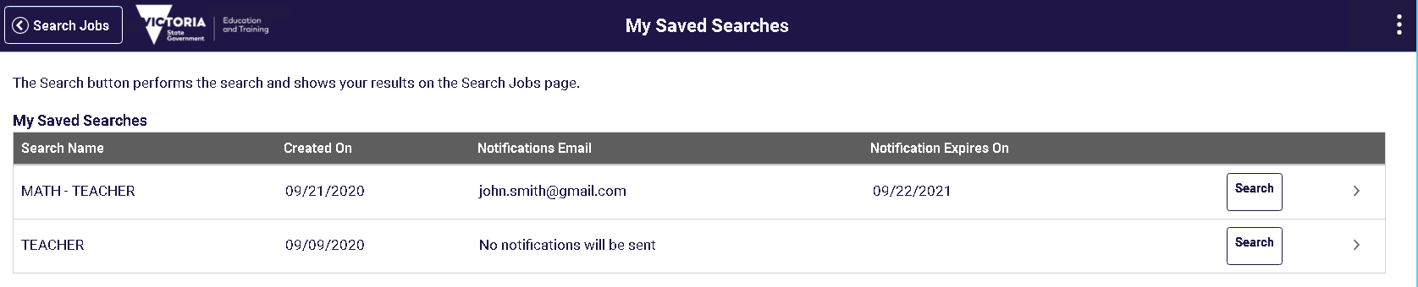

view and update saved searches
- To view an existing saved search, navigate to ‘My Saved Searches’ from the Career page. A list of all your saved searches will appear.
- To run a saved search, click “Search” button. This will take you to the search results based on your criteria.

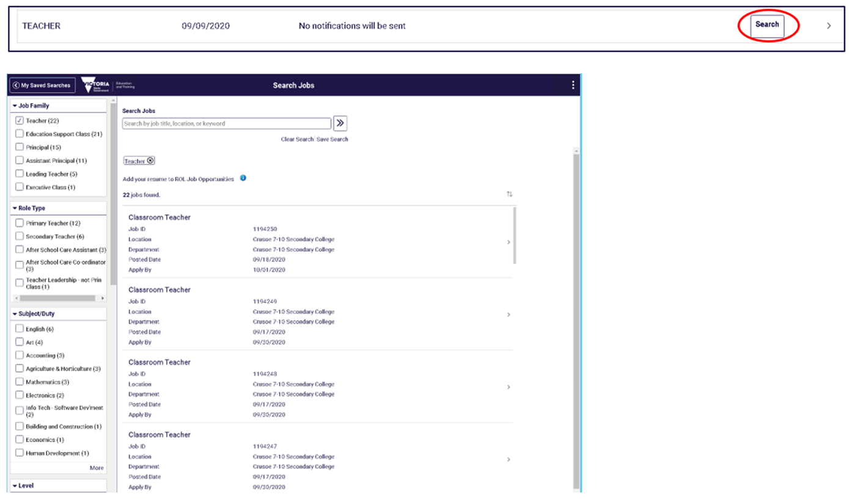
- To change details of your saved search criteria, click on the ‘>’ icon. You would be able to change search name, determine if you want the search to be emailed, or ‘Delete’ the search.

